**FPT University – Capstone Project Fall 2021**



**MINISTRY OF**

**EDUCATION AND TRAINING**

**FPT UNIVERSITY**

**Capstone Project Document**

**Warehouse Management System For Sang Tam**

|  |  |
| --- | --- |
| **GFA21SE14** | |
| **Group Members** | Võ Hoàng Phúc - SE130239 (Leader)  Trần Đăng Khoa - SE130544 (Member)  Trần Trung Kiên - SE130510 (Member)  Nguyễn Huy Hoàng - SE130543 (Member) |
| **Supervisor** | Lại Đức Hùng (Mr) |
| **Capstone Project Code** | FA21SE39 |

**– HCM CITY, September 2021 –**

**Table of Contents**

**I. Project Introduction** 20

**1. Overview** 20

1.1 Project Information 20

1.2 Project Team 20

a. Supervisor 20

b. Team Members 20

**2. Product Background** 20

3. Existing Systems 21

3.1 Traditional 21

4. Business Opportunity 21

**5. Software Product Vision** 22

**6. Project Scope & Limitations** 22

6.1 Major Features 22

6.2 Limitations & Exclusions 22

**II. Project Management Plan** 22

**1. Overview** 22

*1.1 WBS & Estimation* 22

*1.2 Project Objectives* 24

*1.3 Project Risks* 24

**2. Management Approach** 24

2.1 Project Process 24

2.2 Quality Management 25

2.3 Training Plan 25

**3. Master Schedule** 25

**4. Project Organization** 26

4.1 Team & Structures 26

4.2 Roles & Responsibilities 26

**5. Project Communication** 27

5.1 Communication Plan 27

5.2 External Interface 27

a. FU Contacts 27

b. Customer Contacts 27

**6. Configuration Management** 28

6.1 Tools & Infrastructures 28

6.2 Document Management 28

6.3 Source Code Management 28

**III. System Requirement Specification** 28

**1. Overall Description** 28

1.1 Product Overview 28

1.2 Business Rules 28

**2. User Requirements** 30

2.1 Overview 30

a. Use Case Diagram 30

b. System Actors 30

c. Use Cases List 31

2.2 <<Manage Account>> 36

a. <<Create account>> 36

b. <<Search account>> 38

c. <<View list account>> 40

d. << View account detail>> 42

e. <<Edit account>> 44

2.3 <<Manage Warehouse>> 46

a. <<Create warehouse>> 46

b. <<Search warehouse>> 49

c. <<View list warehouse>> 51

d. <<View warehouse detail>> 52

e. <<Edit warehouse>> 54

2.4 <<Manage Store Warehouse>> 57

a. <<Create store warehouse>> 57

b. <<Search store warehouse>> 60

c. <<View list store warehouse>> 62

d. <<View store warehouse detail>> 64

e. <<Edit store warehouse>> 66

2.5 <<Login>> 68

2.6 <<Logout>> 70

2.7 <<Search product>> 72

2.8 <<Create product>> 74

2.9 <<Edit product>> 77

2.8 <<View list product>> 81

2.9 << View product detail >> 82

2.10 << Manage order >> 84

a. <<Create order>> 84

b. <<Search order>> 87

c. <<View list order>> 89

d. <<View order detail>> 90

e. <<Edit order>> 92

f. <<Cancel order>> 95

2.11 << Manage invoice >> 98

a. <<Create invoice>> 98

b. <<Search invoice>> 101

c. <<View list invoice>> 103

d. <<View invoice detail>> 105

e. << Edit invoice>> 107

f. << Confirm invoice>> 109

g. <<Print invoice>> 112

h. <<Cancel invoice>> 114

2.12 << Reject order >> 116

2.13 << Confirm order >> 118

2.14 << View sales report >> 120

2.15 <<Export sales report to excel >> 121

2.16 << Manage import goods print>> 123

a. <<Create imported goods print>> 123

b. <<Search imported goods print>> 126

c. <<View list imported goods print>> 128

d. <<View imported goods print detail>> 129

e. <<Confirm imported goods print>> 131

f. <<Edit imported goods print>> 134

g. <<Cancel imported goods print>> 137

h. <<Print imported goods print>> 140

2.17 << Manage import goods print>> 142

a. <<Create exported goods print>> 142

b. <<Search exported goods print>> 144

c. <<View list exported goods print>> 146

d. <<View exported goods print detail>> 148

e. <<Confirm exported goods print>> 150

f. <<Edit exported goods print>> 152

g. <<Cancel exported goods print>> 155

h. <<Print exported goods print>> 158

2.18 << View list inventory >> 160

2.19 << Generate to excel of inventory >> 161

2.20 << View exported goods report >> 164

2.21 << Generate to excel of export goods report >> 166

2.22 <<View imported goods report >> 168

2.23 << Generate to excel of imported goods report >> 170

2.24 << Manage inventory transfer print>> 172

a. <<Create inventory transfer print >> 172

b. <<Search inventory transfer print >> 175

c. <<View list inventory transfer print >> 177

d. <<View inventory transfer print detail>> 178

e. <<Confirm inventory transfer print >> 180

f. <<Edit inventory transfer print >> 183

g. <<Cancel inventory transfer print >> 186

h. <<Print inventory transfer print >> 189

2.25 << Manage wholesale invoice >> 191

a. <<Create wholesale invoice>> 191

b. <<Search wholesale invoice>> 193

c. <<View list wholesale invoice>> 195

d. <<View wholesale invoice detail>> 196

e. << Edit wholesale invoice>> 198

f. << Confirm wholesale invoice>> 201

g. <<Print wholesale invoice>> 203

h. <<Cancel wholesale invoice>> 205

2.26 <<Manage customer>> 207

a. <<Create customer>> 207

b. <<Search customer >> 210

c. <<View list customer >> 212

d. <<View customer detail>> 213

e. <<Edit customer>> 215

2.27 << Manage purchase order>> 218

a. <<Create purchase order >> 218

b. <<Search purchase order >> 220

c. <<View list purchase order>> 222

d. <<View purchase order detail>> 224

e. <<Confirm purchase order >> 226

f. <<Edit purchase order >> 228

g. <<Cancel purchase order >> 230

h. <<Print purchase order>> 233

2.28 << Manage imported inventory print >> 234

a. <<Create imported inventory print >> 234

b. <<Search imported inventory print >> 237

c. <<View list imported inventory print >> 239

d. <<View imported inventory print detail >> 241

e. <<Confirm imported inventory print >> 243

f. <<Edit imported inventory print >> 245

g. <<Cancel imported inventory print >> 247

h. <<Print imported inventory print >> 249

2.29 <<Manage supplier>> 251

a. <<Create supplier >> 251

b. <<Search supplier >> 254

c. <<View list supplier >> 256

d. <<View supplier detail>> 257

e. <<Edit supplier >> 259

2.30 <<Manage account receivable >> 261

a. <<View list account receivable>> 261

b. << Create account receivable >> 263

c. << Generate to excel of account receivable report >> 265

d. << Create debt recovery >> 268

f. << View debt recovery history>> 270

2.31 <<Manage account payable>> 273

a. <<View list account payable>> 273

b. << Create account payable >> 274

c. << Generate to excel of account payable>> 277

d. << Create debt payment >> 279

e. << View debt payment history>> 282

2.36 << View imported inventory report >> 284

2.37 << Generate to excel of imported inventory report >> 286

3. Functional Requirements 288

3.1 System Functional Overview 288

a. Screen Flow 288

b. Screen Details 293

c. Screen Authorization 300

d. Non-Screen Functions 303

e. Entity Relationship Diagram 303

4. Non-Functional Requirements 306

4.1 External Interfaces 306

a. User Interfaces 306

b. Software Interfaces 306

c. Hardware Interfaces 306

d. Communications Interfaces 306

4.2 Quality Attributes 306

a. Usability 306

b. Reliability 306

c. Performance 306

d. Dependability 306

d1. Security 306

d2. Safety 306

e. Supportability 306

f. Design Constraints 307

5. Other Requirements 307

5.1 Messages List 307

IV. Software Design Document 308

1. Overall Description 308

1.1 Assumptions 308

1.2 Design Constraints 309

2. System Architecture Design 309

2.1 Overall Architecture 309

2.2 System Architecture 309

2.3 Package Diagram 310

3. System Detailed Design 310

3.1 Class Diagram 310

3.2 Class Specification 311

3.2.1 AccountPayable Class 312

3.2.2 AccountPayableDetail Class 313

3.2.3 AccountReceivable Class 313

3.2.4 AccountReceivableDetail Class 314

3.2.5 AccountReceivableDetail Class 315

3.2.6 Area Class 315

3.2.7 Brand Class 315

3.2.8 Category Class 316

3.2.9 Color Class 316

3.2.10 Customer Class 316

3.2.11 Employee Class 317

3.2.12 EmployeeStore Class 318

3.2.13 ExportedGoodsPrint Class 318

3.2.14 ExportedGoodsPrintItem Class 319

3.2.15 ImportedGoodsPrint Class 319

3.2.16 ExportedGoodsPrintItem Class 320

3.2.17 ImportedInventoryPrint Class 320

3.2.18 ImportedInventoryPrintPruduct Class 321

3.2.19 InventoryTransferPrint Class 322

3.2.20 InventoryTransferPrintItem Class 322

3.2.21 Invoice Class 323

3.2.22 InvoiceItem Class 324

3.2.23 InvoiceProduct Class 324

3.2.24 ItemClass 325

3.2.25 OrderClass 325

3.2.26 Order_Product Class 326

3.2.27 Product Class 327

3.2.28 PurchaseOrder Class 328

3.2.29 PurchaseOrder_Product Class 329

3.2.30 Store Class 329

3.2.31 Supplier Class 330

3.2.32 Warehouse Class 330

3.2.33 WholesaleInvoice_Item Class 331

3.2.34 WholesaleInvoice_Product Class 331

3.2.35 Supplier Class 332

3.3 Sequence Diagram 333

3.3.1. Create employee 333

3.3.2. Edit employee 333

3.3.3. Get list employee 334

3.3.4. Get employee detail 334

3.3.5. Add store 335

3.3.6. Edit store 335

3.3.7. Get list store 335

3.3.8. Get store detail 336

3.3.9. Add warehouse 337

3.3.10. Edit warehouse 337

3.3.11. Get list warehouse 337

3.3.12. Get warehouse detail 338

3.3.13 Create order 339

3.3.14 Edit order 339

3.3.15 Get list order 340

3.3.16 Get order detail 340

3.3.17 Create invoice 341

3.3.18 Edit invoice 341

3.3.19 Get list invoice 342

3.3.20 Get invoice detail 342

3.3.21 Get list product by seller 343

3.3.22 Get product detail by seller 343

3.3.23 Get list order by store manager 343

3.3.24 Get list product by store manager 344

3.3.25 Get product detail by store manager 344

3.3.26 Get list customer 345

3.3.27 Get customer detail 346

3.3.28 Create wholesale invoice 346

3.3.29 Get list wholesale invoice 346

3.3.30 Get wholesale invoice detail 347

3.3.31 Get list inventory transfer print 347

3.3.32 Get inventory transfer print detail 348

3.3.33 Get list imported goods print 349

3.3.34 Get imported goods print detail 349

3.3.35 Get list exported goods print 350

3.3.36 Get exported goods print detail 350

3.3.37 Get list product 350

3.3.38 Get list account payable 351

3.3.39 Get list account receivable 351

3.3.40. Get list store by receivable accountant 352

3.3.41 Get list customer by receivable accountant 353

3.3.42 Get list purchase order 353

3.3.43 Get purchase order detail 354

3.3.44 Create imported inventory print 354

3.3.45 Get list imported inventory print 355

3.3.46 Get imported inventory print detail 355

3.3.47 Create supplier 356

3.3.48 Get list supplier 356

3.3.49 Get supplier detail 356

3.3.50 Edit supplier 357

3.3.51 Create product 358

3.3.52 Edit product 358

3.3.53 Get list product by receivable accountant 359

3.3.54 Get product detail by receivable accountant 359

3.3.55 Login 359

4. Data & Database Design 360

4.1 Database Design 360

4.1.1. Employee 360

4.1.2. Area 361

4.1.3. AccountPayable 361

4.1.4. AccountPayable_Detail 361

4.1.5. AccountReceivable 361

4.1.6. AccountReceivable_Detail 362

4.1.7. Brand 362

4.1.8. Category 362

4.1.9. Color 362

4.1.10. Customer 363

4.1.11. Employee_Store 363

4.1.12. ExportedGoodPrint 363

4.1.13. ExportedGoodsPrint_Item 363

4.1.14. ImportedGoodsPrint 364

4.1.15. ImportedGoodsPrint_Item 364

4.1.16. ImportedInventoryPrint 364

4.1.17. ImportedInventoryPrint_Product 365

4.1.18. InventoryTransferPrint 365

4.1.19. InventoryTransferPrint_Item 365

4.1.20. Invoice 365

4.1.21. Invoice_Item 366

4.1.22. Invoice_Product 366

4.1.23. Item 366

4.1.23. Order 367

4.1.24. Order_Product 367

4.1.25. Product 367

4.1.26. PurchaseOrder 368

4.1.27. PurchaseOrder_Product 368

4.1.28. Role 368

4.1.29. Size 369

4.1.30. Store 369

4.1.31. Supplier 369

4.1.32. Unit 369

4.1.33. Warehouse 369

4.1.35. WholesaleInvoice_Item 370

4.1.36. WholesaleInvoice_Product 370

4.1.37. WholesaleInvoices 370

V. Project Management Plan 371

1. Overall Description 371

1.1 Test Model 371

1.2 Testing Levels 371

2. Test Plan 372

2.1 Test Stages 372

2.2 Resources 373

a. Human Resources 373

b. Environment 373

2.3 Test Milestones 373

2.4 Deliverables 374

3. Test Cases 374

VI. Release Package & User Guides 374

1. Deliverable Package 374

1.1 Source codes & documents 374

1.2 Known Issues, Limitations & Restrictions 374

2. Installation Guides 374

2.1 System Requirements 374

2.1.1 Hardware requirements 374

2.1.2 Software requirements 375

2.2 Setup Files 375

2.3 Installation Instruction 375

a. Create database on AWS 375

b. Deploy Project up AWS with Elastic Beanstalk 376

3. User Manual 376

3.1 Application Usage 376

3.1.1. Overview 376

3.1.2. Login 376

3.1.3. Create account - Admin 377

3.1.4. Create store - Admin 378

3.1.5. Create warehouse - Admin 379

3.1.6. Create invoice - Seller 379

3.1.7. Create order - Seller 380

3.1.8. Create imported goods print – Sale Accountant, Warehouse Accountant 381

3.1.9. Create exported goods print – Sale Accountant, Warehouse Accountant 382

3.1.10. Create transfer inventory print – Warehouse Accountant 382

3.2 Troubleshooting 383

**List of Figure**

Figure 1: Team & Structures 25

Figure 2: Use case diagram 29

Figure 3: <Admin> Screen flow 288

Figure 4: <Seller> Screen Flow 289

Figure 5: <Store Manager> Screen Flow 290

Figure 6: <Sale Accountant> Screen Flow 290

Figure 7:<Warehouse Accountant> Screen Flow 292

Figure 8:<Receivable Accountant> Screen Flow 292

Figure 9: Entity Relationship Diagram 302

Figure 10: System Architecture 308

Figure 11: Package Diagram 309

Figure 12: Create employee 332

Figure 13: Edit employee 332

Figure 14: Get list employee 333

Figure 15: Get employee detail 333

Figure 16: Add store 334

Figure 17: Edit store 334

Figure 18: Get list store 335

Figure 19: Get store detail 335

Figure 20: Add warehouse 336

Figure 21: Edit warehouse 336

Figure 22: Get list warehouse 337

Figure 23: Get warehouse detail 337

Figure 24: Create order 338

Figure 25: Edit order 338

Figure 26: Get list order 339

Figure 27: Get order detail 339

Figure 28: Create invoice 340

Figure 29: Edit invoice 340

Figure 30: Get list invoice 341

Figure 31: Get invoice detail 341

Figure 32: Get list product by seller 342

Figure 33: Get product detail by seller 342

Figure 34: Get list order by store manager 343

Figure 35: Get list product by store manager 343

Figure 36: Get product detail by store manager 344

Figure 37: Get list customer 344

Figure 38: Get customer detail 345

Figure 39: Create wholesale invoice 345

Figure 40: Get list wholesale invoice 346

Figure 41: Get wholesale invoice detail 346

Figure 42: Get list inventory transfer print 347

Figure 43: Get inventory transfer print detail 347

Figure 44: Get list imported goods print 348

Figure 45: Get imported goods print detail 348

Figure 46: Get list exported goods print 349

Figure 47: Get exported goods print detail 349

Figure 48: Get list product 350

Figure 49: Get list account payable 350

Figure 50: Get list account receivable 351

Figure 51: Get list store by receivable accountant 351

Figure 52: Get list customer by receivable accountant 352

Figure 53: Get list purchase order 352

Figure 54: Get purchase order detail 353

Figure 55: Create imported inventory print 353

Figure 56: Get list imported inventory print 354

Figure 57: Get imported inventory print detail 354

Figure 58: Create supplier 355

Figure 59: Get list supplier 355

Figure 60: Get supplier detail 356

Figure 61: Edit supplier 356

Figure 62: Create product 357

Figure 63: Edit product 357

Figure 64: Get list product by receivable accountant 358

Figure 65: Get list product by receivable accountant 358

Figure 66: Login 358

Figure 67: Database Design 359

Figure 68: Agile Testing 370

Figure 69: Testing Types 371

Figure 70: Test Stages 372

Figure 71: Successfully created 375

Figure 72: Login Screen 376

Figure 73: Manager account screen - Admin 376

Figure 74: Create account screen - Admin 377

Figure 75: Manager store screen - Admin 377

Figure 76: Create store screen - Admin 377

Figure 77: Manage warehouse screen - Admin 378

Figure 78: Create warehouse screen - Admin 378

Figure 79: Manage invoice creen - Seller 379

Figure 80: Create invoice screen - Seller 379

Figure 81: Manage order screen - Seller 379

Figure 82: Create order screen - Seller 380

Figure 83: Manage imported goods print screen - Sale Accountant, Warehouse Accountant 380

Figure 84: Create imported goods print screen – Sale Accountant, Warehouse Accountant 380

Figure 85: Manage exported goods print srceen – Sale Accountant, Warehouse Accountant 381

Figure 86: Create exported goods print screen – Sale Accountant, Warehouse Accountant 381

Figure 87: Manage transfer inventory print screen – Warehouse Accountant 382

Figure 88: Create transfer inventory print 382

**List of Tables**

Table 1: Supervisor 20

Table 2: Team members 20

Table 3: WBS & Estimation 24

Table 4: Project Objectives 24

Table 5: Project Risks 24

Table 6: Training Plan 25

Table 7: Role & Responsibilities 27

Table 8: Communicate Plan 27

Table 9: FU Contacts 27

Table 10: Customer Contacts 28

Table 11: Tools & Infrastructures 28

Table 12: Business Rule 29

Table 13: System Actors 31

Table 14: Use case list 35

Table 15: Create account 38

Table 16: Search account 40

Table 17: View list account 42

Table 18: View account detail 43

Table 19: Edit account 46

Table 20: Create warehouse 49

Table 21: Search warehosue 51

Table 22: View list warehouse 52

Table 23: View warehouse detail 54

Table 24: Edit warehouse 57

Table 25: Create store warehouse 60

Table 26: Search store warehouse 62

Table 27: View store warehouse detail 64

Table 28: View store warehouse detail 66

Table 29: Edit store warehouse 68

Table 30: Login 70

Table 31: Logout 72

Table 32: Search product 74

Table 33: Create product 77

Table 34: Edit product 81

Table 35: View list product 82

Table 36: View product detail 84

Table 37: Create order 87

Table 38: Search order 88

Table 39: View list order 90

Table 40: View order detail 92

Table 41: Edit order 95

Table 42: Cancel order 98

Table 43: Create invoice 101

Table 44: Search invoice 103

Table 45: View list invoice 105

Table 46: View invoice detail 106

Table 47: Edit invoice 109

Table 48: Confirm invoice 112

Table 49: Print invoice 114

Table 50: Cancel invoice 116

Table 51: Reject order 118

Table 52: Confirm order 120

Table 53: View sales report 121

Table 54: Export sales report to excel 123

Table 55: Create imported goods print 126

Table 56: Search imported goods print 128

Table 57: View list imported goods print 129

Table 58: View imported goods print detail 131

Table 59: Confirm imported goods print 134

Table 60: Edit imported goods print 137

Table 61: Cancel imported goods print 140

Table 62: Print imported goods print 141

Table 63: Create exported goods print 144

Table 64: Search exported goods print 146

Table 65: View list exported goods print 148

Table 66: View exported goods print detail 150

Table 67: Confirm exported goods print 152

Table 68: Edit exported goods print 155

Table 69: Cancel exported goods print 158

Table 70: Print exported goods print 160

Table 71: View list inventory 161

Table 72: Generate to excel of inventory 164

Table 73: View exported goods print report 166

Table 74: Generate to excel of export goods report 168

Table 75: View imported goods report 170

Table 76: Generate to excel of import goods report 172

Table 77: Create inventory transfer print 175

Table 78: Search inventory transfer print 177

Table 79: View list inventory transfer print detail 178

Table 80: View inventory transfer print detail 180

Table 81: Edit inventory transfer print 183

Table 82: Edit inventory transfer print 186

Table 83: Cancel inventory transfer print 189

Table 84: Print inventory transfer print 190

Table 85: Create wholesale invoice 193

Table 86: Search wholesale invoice 195

Table 87: View list wholesale invoice 196

Table 88: View wholesale invoice detail 198

Table 89: Edit whosale invoice 201

Table 90: Confirm wholesale invoice 203

Table 91: Print wholesale invoice 205

Table 92: Cancel wholesale invoice 207

Table 93: Create Customer 210

Table 94: Search Customer 212

Table 95: View list customer 213

Table 96: View customer detail 215

Table 97: Edit customer 218

Table 98: Create purchase order 220

Table 99: Search purchase order 222

Table 100: View list purchase order 224

Table 101: View purchase order detail 226

Table 102: Confirm purchase order 228

Table 103: Edit purchase order 230

Table 104: Cancel purchase order 232

Table 105: Cancel purchase order 234

Table 106: Create imported inventory print 237

Table 107: Search imported inventory print 239

Table 108: View list imported inventory print 241

Table 109: View imported inventory detail 243

Table 110: Confirm imported inventory print 245

Table 111: Edit imported inventory print 247

Table 112: Cancel imported inventory print 249

Table 113: Print imported inventory print 251

Table 114: Create supplier 254

Table 115: Search supplier 255

Table 116: View list supplier 257

Table 117: View supplier detail 259

Table 118: Edit supplier 261

Table 119: View list account receivable 263

Table 120: Create account receivable 265

Table 121: Generate to excel of account receivable 268

Table 122: Create debt recovery 270

Table 123: View debt recovery history 273

Table 124: View list account payable 274

Table 125: Create account payable 277

Table 126: Generate to excel of account payable 279

Table 127: Create debt payment 282

Table 128: View debt payment history 284

Table 129: View imported inventory report 286

Table 130: Generate to excel of imported inventory report 288

Table 131: Screen Details 300

Table 132: Screen Authorization 302

Table 133: Non-screen Functions 303

Table 134: Entity Relationship 305

Table 135: Messages list 308

Table 136: Assumptions 309

Table 137: Package Diagram 310

Table 138: Class diagram 311

Table 139: Class Specification 312

Table 140: AccountPayable Class 313

Table 141: AccountPayableDetail Class 313

Table 142: AccountReceivable Class 314

Table 143: AccountReceivableDetail Class 315

Table 144: AccountReceivableDetail Class 315

Table 145: Area Class 315

Table 146: Brand Class 316

Table 147: Category Class 316

Table 148: Color Class 316

Table 149: Customer Class 317

Table 150: Brand Class 318

Table 151: EmployeeStore Class 318

Table 152: ExportedGoodsPrint Class 319

Table 153: ExportedGoodsPrintItem Class 319

Table 154: ImportedGoodsPrint Class 320

Table 155: ExportedGoodsPrintItem Class 320

Table 156: ImportedInventoryPrint Class 321

Table 157: ImportedInventoryPrintPruduct Class 322

Table 158: InventoryTransferPrint Class 322

Table 159: InventoryTransferPrintItem Class 323

Table 160: Invoice Class 324

Table 161: InvoiceItem Class 324

Table 162: InvoiceProduct Class 325

Table 163: Item Class 325

Table 164: OrderClass 326

Table 165: Order_Product Class 326

Table 166: Product Class 328

Table 167: PurchaseOrder Class 329

Table 168: PurchaseOrder_Product Class 329

Table 169: Store Class 330

Table 170: Supplier Class 330

Table 171: Warehouse Class 331

Table 172: WholesaleInvoice_Item Class 331

Table 173: WholesaleInvoice_Product Class 332

Table 174: Supplier Class 333

Table 175: Employee 361

Table 176: Area 361

Table 177: AccountPayable 361

Table 178: AccountPayable_Detail 361

Table 179: AccountReceivable 362

Table 180: AccountReceivable_Detail 362

Table 181: Brand 362

Table 182: Category 362

Table 183: Color 362

Table 184: Customer 363

Table 185: Employee_Store 363

Table 186: ExportedGoodPrint 363

Table 187: ExportedGoodsPrint_Item 364

Table 188: ImportedGoodsPrint 364

Table 189: ImportedGoodsPrint_Item 364

Table 190: ImportedInventoryPrint 365

Table 191: ImportedInventoryPrint_Product 365

Table 192: InventoryTransferPrint 365

Table 193: InventoryTransferPrint_Item 365

Table 194: Invoice 366

Table 195: Invoice_Item 366

Table 196: Invoice_Product 366

Table 197: Item 366

Table 198: Order 367

Table 199: Order_Product 367

Table 200: Product 368

Table 201: PurchaseOrder 368

Table 202: PurchaseOrder_Product 368

Table 203: Role 369

Table 204: Size 369

Table 205: Store 369

Table 206: Supplier 369

Table 207: Unit 369

Table 208: Warehouse 370

Table 209: WholesaleInvoice_Item 370

Table 210: WholesaleInvoice_Product 370

Table 211: WholesaleInvoices 371

Table 212: Human Resources 373

Table 213: Environment 373

Table 214: Test Milestones 374

Table 215: Deliverables 374

Table 216: Source codes & documents 374

Table 217: Hardware requirements 375

Table 218:Software requirements 375

# **I. Project Introduction**

## **1. Overview**

### 1.1 Project Information

* Project name: <<Warehouse management system for Sang Tam>>
* Project code: <<FA21SE39>>
* Group name: <<GFA21SE14>>
* Software type: <<Software Type: Website>>

### 1.2 Project Team

#### a. Supervisor

|  |  |  |  |
| --- | --- | --- | --- |
| **Full Name** | **Email** | **Phone Number** | **Title** |
| Lai Duc Hung |  |  | Lecturer |

Table 1: Supervisor

#### b. Team Members

|  |  |  |  |
| --- | --- | --- | --- |
| **Full Name** | **Email** | **Mobile** | **Role** |
| Vo Hoang Phuc | phucvhse130239@fpt.edu.vn |  | Leader |
| Tran Dang Khoa | khoatdse130544@fpt.edu.vn |  | Member |
| Tran Trung Kien | kienttse130510@fpt.edu.vn |  | Member |
| Nguyen Huy Hoang | hoangnhse130543@fpt.edu.vn |  | Member |

Table 2: Team members

## **2. Product Background**

Sang Tam is a company specializing in providing suitcases, backpacks and travel products. Coming to Lug, you will experience excellent services with the full Lug ecosystem. With over 15 years of experience, we want to increasingly bring to our customers a commitment to the most perfect service. With the desire to become a professional working environment, a place where young people want to go the most. Our products and services provide suitcase products from 20 international brands, provide backpacks from famous brands suitable for all ages, provide by-products travel events.

Sang Tam Company is in need of a warehouse management system - goods management for their products. The purpose is to build an effective warehouse management program from import to export. Reduce loss of goods, effectively rotate goods, handle inventory, control inventory data and have a reasonable allocation, and manage debts accurately.

## **3. Existing Systems**

### 3.1 Traditional

**Description**: When there is an order or add a new product to the warehouse. Accounting must manage them and have to perform actions such as deleting, inserting, updating information. When they create orders, they use Excel and Word tools to save invoices and a list of products.

**Advantages**:

- Cost saving: Excel is a free software to install on the machine, so the shop owner will save a lot of initial investment costs. To use the best way, you just need to spend some money to buy a license from MS Office.

- Separate management file: When managing goods by Excel, data will be stored on separate files. This helps store owners to monitor and control the situation of goods in the store in the most detailed and easy way.

- Simple data update: With just simple operations, employees can update goods data, making import and export statistics faster and more convenient.

**Disadvantages**:

Easy to confuse when the file object is large. When having to manage too much data, managing goods on Excel will reveal some of its limitations such as slow speed or error-prone. Especially when working with large file objects, employees can easily get confused on Excel. This will lead to system-wide errors and take a lot of time and effort to fix the consequences.

Difficult to manage, low security. Merchandise management files in Excel are usually stored on the store's shared computer, so anyone can modify the data in the software. Moreover, Excel does not have a history memo feature, so it is difficult for store owners to manage and detect if there is a problem. It is this very poor security ability, so managing goods with Excel easily leads to the loss of the store.

Difficult to combine reporting with sales. When managing goods using Excel, it is difficult for store owners to combine sales activities and tracking reports. Because Excel's features are quite limited, when having to perform many operations at the same time, the system will easily encounter errors, confusion and affect the store's business.

Inventory control is difficult. Because Excel can only be used on computers, the operation of inventory using Excel is very difficult and inconvenient. It will be difficult for the store owner to compare the data with the actual goods, from which the inventory control will take a lot of time and effort without achieving the desired results.

## 4. Business Opportunity

Sang Tam Company requires a warehouse and goods management system. The system will help save management time, have high accuracy, and synchronize 100% of data throughout the supply chain, from the manufacturer to each store and retail customer. This system will make sales operations faster, more accurate, efficient, and manageable. Accounting ability, storekeepers easily grasp the actual inventory quantity of the store. Along with the stored data, the software easily recommends the number of orders to match the business situation. This helps businesses increase sales; Distributors will no longer worry about the lack of goods for business.

## **5. Software Product Vision**

At present, the software can:

* Make a reasonable import and export plan.
* The diverse and clear reporting system makes it easy for warehouse staff to manage: instant inventory, hold stock, slow-moving goods, goods below the minimum or above the maximum level.
* Warehouse management software helps save human resources.
* Warehouse management software provides instant detailed reports.
* Fast, accurate warehouse transactions in terms of quantity and value of goods.
* Ability to self-synchronize data with the accounting department.

In the future, the software products will support functions:

* Develop a mobile application for shippers and track orders via GPS.
* Import and export automation.

## **6. Project Scope & Limitations**

### 6.1 Major Features

FE-01: Manage all products at the main warehouse and store warehouse by QR code

FE-02: Import and export goods

FE-03: Purchase goods from suppliers

FE-04: Import inventory goods at the main warehouse

FE-05: Manage receivable account and payable account

FE-06: Manage inventory transfer between main warehouse and store warehouse

FE-07: Manage warehouse and store warehouse information

### 6.2 Limitations & Exclusions

LI-1: Many processes are integrated into a system - an error in one place entails errors in others. In this way, a human error can cause the whole system to be inaccurate. To prevent such situations, there are certain operations that the system will not allow you to perform (e.g. issuing more goods than what is available in the warehouse).

# **II. Project Management Plan**

## **1. Overview**

### *1.1 WBS & Estimation*

|  |  |  |  |
| --- | --- | --- | --- |
| **#** | **WBS Item** | **Complexity** | **Est. Effort** |
| 1 | Requirements |  |  |
| *1.1* | *Get customer's requirements* | Simple | **1** |
| *1.2* | *Analyze customer requirements* | Simple | **1** |
| 2 | Design user case diagram | Simple | **2** |
| 3 | Design ERD | Simple | **2** |
| 4 | Design Physical Diagram | Medium | **3** |
| 5 | User Interface |  |  |
| *5.1* | *Design UI Mockup* | Medium | **3** |
| *5.2* | *Implement UI Prototype* | Complex | **6** |
| 6 | Draw Class Diagram | Medium | **3** |
| 7 | Draw Sequence Diagram | Medium | **3** |
| 8 | Implement features |  |  |
| *8.1* | *Implement Basic Features* | Medium | **3** |
| *8.2* | *Implement Seller Features* | Complex | **6** |
| *8.3* | *Implement Store Manager Features* | Complex | **6** |
| *8.4* | *Implement Accountant Warehouse Features* | Complex | **6** |
| *8.5* | *Implement Accountant Debt Features* | Complex | **6** |
| *8.6* | *Implement Admin Features* | Medium | **3** |
| 9 | Implement System Handler | Complex | **6** |
| 10 | QA & Testing System | Medium | **3** |
| 11 | Document |  |  |
| *11.1* | *Report 1* | Simple | **1** |
| *11.2* | *Report 2* | Simple | **1** |
| *11.3* | *Report 3* | Medium | **3** |
| *11.4* | *Report 4* | Medium | **3** |
| *11.5* | *Report 5* | Medium | **3** |
| *11.6* | *Report 6* | Medium | **3** |
| *11.7* | *Report 7* | Simple | **1** |
| **Total Estimated Effort (man-days)** | | | **78** |

Table 3: WBS & Estimation

### *1.2 Project Objectives*

|  |  |  |  |  |
| --- | --- | --- | --- | --- |
| **#** | **Quality Stage** | **No. of Defects** | **% of Defect** | **Notes** |
| 1 | Reviewing |  | 3% |  |
| 2 | Unit Test |  | 2% |  |
| 3 | Integration Test |  | 2% |  |
| 4 | System Test |  | 3% |  |
| 5 | User Acceptance Test |  | 4% |  |
| ***Total*** | | ***Xxx*** | ***100%*** |  |

Table 4: Project Objectives

### *1.3 Project Risks*

|  |  |  |  |  |
| --- | --- | --- | --- | --- |
| **#** | **Risk Description** | **Impact** | **Possibility** | **Response Plans** |
| 1 | Lack of experience in running the Scrum model | severe | high | Learn more and learn from experienced seniors |

Table 5: Project Risks

## **2. Management Approach**

### 2.1 Project Process

As the project problems are mentioned above, we choose Scrum Model to manage project development with each sprint being 6 working days

This model will help us:

* Good quality control and product development time
* Daily meetings make it easy to control the quality of the features.
* Flexibility with changing requirements of stakeholders.
* Improving software reduces risk, and thereby increases the chance to deliver the best possible product.

### 2.2 Quality Management

* *Defect Prevention*
* *Reviewing*
* *Unit Testing*
* *Integration Testing*
* *System Testing*

### 2.3 Training Plan

|  |  |  |  |
| --- | --- | --- | --- |
| **Training Area** | **Participants** | **When, Duration** | **Waiver Criteria** |
| Java Spring Boot | Phuc, Hoang, Khoa | 5/9/2021 ( 1 month) | Mandatory |
| JavaScript | Hoang, Khoa, Kien | 5/9/2021 ( 1 month) | Mandatory |
| Git, Github | Phuc, Hoang, Khoa, Kien | 10/9/2021 (2 days) | Mandatory |

Table 6: Training Plan

## **3. Master Schedule**

[Refer to WMS Project_SampleHighLevelProjectSchedule](https://docs.google.com/spreadsheets/d/1rtCtzmlRQFoFB_qRZK2dHSOOsSYvFOAZIzxMIjWIBUM/edit#gid=1387178622)

## **4. Project Organization**

### 4.1 Team & Structures

Figure 1: Team & Structures

### 4.2 Roles & Responsibilities

|  |  |
| --- | --- |
| **Role** | **Responsibility** |
| Project Manager | Responsible for planning, organizing, and directing the completion of a specific project. The project must be on time, on budget, and within the scope. |
| Analysis Leader | Get requirement customer |
| Analysis Member | Analysis requirement customer |
| Design Leader | Manage and supervise the design team |
| Design Member | Design Database, Design GUI |
| Technical Leader | Closely follow the work, ensure the quality, progress and take responsibility for the entire project leading  Review members' codes and quickly detect errors if any |
| Test Leader | Manage and supervise the testing team that they are authorized to manage and be in charge of |
| Test Member | Perform tests and find out the hidden problems  Check the codes to be checked  Working with scripts and automation tools  Analyze and document problems and provide collaborative feedback. |

Table 7: Role & Responsibilities

## **5. Project Communication**

### 5.1 Communication Plan

|  |  |  |  |  |
| --- | --- | --- | --- | --- |
| **Communication Item** | **Who/ Target** | **Purpose** | **When, Frequency** | **Type, Tool, Method(s)** |
| Meeting minutes with supervisor | Lai Duc Hung | Review project capstone | 7:30 PM, Every Wednesday | Google Meet |
| Meeting minutes with customer | Huynh Anh Vu | Exchange information about software requirements | 10:00 PM, Every Wednesday | Google Meet |

Table 8: Communicate Plan

### 5.2 External Interface

#### a. FU Contacts

|  |  |  |  |
| --- | --- | --- | --- |
| **Function** | **Contact Person**  **(name, position)** | **Contact address**  **(email, telephone)** | **Responsibility** |
| Supervisor | Lai Duc Hung |  | - Provide document template - Give instruction to the project team - Review deliverables - Supervise project status |

Table 9: FU Contacts

#### b. Customer Contacts

|  |  |  |  |
| --- | --- | --- | --- |
| **Function** | **Contact Person**  **(name, position)** | **Contact address**  **(email, telephone)** | **Responsibility** |
| Supervisor | Huynh Thi Thanh Tam |  | - Provide document template - Give instruction to the project team - Review deliverables - Supervise project status |
| Supporter | Huynh Anh Vu |  | - Provide document template  - Receive report project  - Answer questions about the project |

Table 10: Customer Contacts

## **6. Configuration Management**

### 6.1 Tools & Infrastructures

|  |  |
| --- | --- |
| **Programming languages** | Java, Angular 7 |
| **Framework** | Java Spring Boot |
| **API** | API |
| **DBMS** | SQL Server |
| **IDEs/Editors** | Visual Studio Code, IntelliJ Idea |
| **UML tools** | Start UML |
| **Version Control** | Git hub |
| **Deployment server** | Amazon Web Service |
| **Project management tool** | Microsoft Project |

Table 11: Tools & Infrastructures

### 6.2 Document Management

Storing in the Google Drive account of the team and using Google Docs to manage versions.

### 6.3 Source Code Management

Storing in Github Repository and using git client tools to push, pull, commit code.

# **III. System Requirement Specification**

# **1. Overall Description**

### 1.1 Product Overview

Warehouse Management System (WMS) is a system that helps track inventory levels, orders to move warehouses, sales and import purchases from suppliers. The system helps to control and manage warehouse management effectively from import to export, reducing loss of goods. Efficiently circulate goods, control inventory data and have a reasonable allocation. Optimize picking and shipping, replenishment, inventory management, and report rendering data quickly and accurately. The overall goal of warehouse management system software is to achieve a paperless environment that automatically directs your employees into optimal picking, moving, and shipping products.

### 1.2 Business Rules

|  |  |
| --- | --- |
| **ID** | **Rule Definition** |
| **BR-1** | Export correct reports. |
| **BR-2** | Exactly check the product life cycle with the QR code of that product. |
| **BR-3** | Display orders list with status "chưa xác nhận" status must be displayed first. |
| **BR-4** | Scan code QR code product to automatically increase the number of products in an invoice |
| **BR-5** | Unpaid debt must display first and bold state, clearly showing the expiration date of that debt |
| **BR-6** | Recovering passwords for non-admin users must contact Admin to restore. If the user is Admin restores with their Gmail address |
| **BR-7** | At the create new store creation step, the main store is only one. |
| **BR-8** | Only the administrator can perform this feature |
| **BR-9** | The screen must show all the information |
| **BR-10** | Users must login with the Admin account provided |

Table 12: Business Rule

## **2. User Requirements**

### 2.1 Overview

#### a. Use Case Diagram



Figure 2: Use case diagram

#### b. System Actors

|  |  |  |  |
| --- | --- | --- | --- |
| **#** | **Actor** | **Description** |  |
| 1 | Admin | Admin is the one who can manage information of accounts, warehouses and stores | |
| 2 | Warehouse Accountant | Warehouse accountant is the manager of import or export warehouse and sell goods in the main warehouse | |
| 3 | Receivable Accountant | The receivable accountant is the manager of the receivable account, payable account, order from supplier, and import inventory in the main warehouse | |
| 4 | Seller | The seller is the person who places the order to transfer goods from the main warehouse and sales to customers at the store | |
| 5 | Store Manager | The store manager is the person who will browse orders from the main warehouse. In addition, they can view inventory in the store. | |
| 6 | Sale Accountant | Sales accountants are people who can export or import warehouses at stores, and view inventory at the store | |
| 7 | Unauthenticated User | Unauthenticated users who are not logged into the system must to logged in to perform functions | |
| 8 | Authenticated User | Users authenticate are people who are logged into the system to view the product in the warehouse | |

Table 13: System Actors

#### c. Use Cases List

|  |  |  |  |
| --- | --- | --- | --- |
| ID | Use Case | Primary Actors | Secondary Actors |
| 1 | Create account | Admin |  |
| 2 | Search account | Admin |  |
| 3 | View list account | Admin |  |
| 4 | View account detail | Admin |  |
| 5 | Edit account | Admin |  |
| 6 | Create warehouse | Admin |  |
| 7 | Search warehouse | Admin |  |
| 8 | View list warehouse | Admin |  |
| 9 | View warehouse detail | Admin |  |
| 10 | Edit warehouse | Admin |  |
| 11 | Create store warehouse | Admin |  |
| 12 | Search store warehouse | Admin, Receivable Accountant |  |
| 13 | View list store warehouse | Admin, Receivable Accountant |  |
| 14 | View store warehouse detail | Admin, Receivable Accountant |  |
| 15 | Edit store warehouse | Admin |  |
| 16 | Login | Unauthenticated User, Admin |  |
| 17 | Logout | Authenticated User, Admin |  |
| 18 | Search product | Authenticated User |  |
| 19 | View list product | Authenticated User |  |
| 20 | View product detail | Authenticated User |  |
| 21 | Create order | Seller |  |
| 22 | Search order | Seller, Store Manager, Warehouse Accountant |  |
| 23 | View list order | Seller, Store Manager, Warehouse Accountant |  |
| 24 | View order detail | Seller, Store Manager, Warehouse Accountant |  |
| 25 | Edit order | Seller |  |
| 26 | Cancel order | Seller, Warehouse Accountant |  |
| 27 | Create invoice | Seller |  |
| 28 | Edit invoice | Seller |  |
| 29 | Search invoice | Seller |  |
| 30 | Confirm invoice | Seller |  |
| 31 | View invoice detail | Seller |  |
| 32 | View list invoice | Seller |  |
| 33 | Print invoice | Seller |  |
| 34 | Cancel invoice | Seller |  |
| 35 | Confirm order | Store manager |  |
| 36 | Reject order | Store manager |  |
| 37 | View sales report | Store manager |  |
| 38 | Export sales report to excel | Store manager |  |
| 39 | Create imported goods print | Sale Accountant, Warehouse Accountant |  |
| 40 | Search imported goods print | Sale Accountant, Warehouse Accountant |  |
| 41 | View list imported goods print | Sale Accountant, Warehouse Accountant |  |
| 42 | View imported goods print detail | Sale Accountant, Warehouse Accountant |  |
| 43 | Confirm imported goods print | Sale Accountant, Warehouse Accountant |  |
| 44 | Edit imported goods print | Sale Accountant, Warehouse Accountant |  |
| 45 | Cancel imported goods print | Sale Accountant, Warehouse Accountant |  |
| 46 | Print imported goods print | Sale Accountant, Warehouse Accountant |  |
| 47 | Create exported goods print | Sale Accountant, Warehouse Accountant |  |
| 48 | Search exported goods print | Sale Accountant, Warehouse Accountant |  |
| 49 | View list exported goods print | Sale Accountant, Warehouse Accountant |  |
| 50 | View exported goods print detail | Sale Accountant, Warehouse Accountant |  |
| 51 | Confirm exported goods print | Sale Accountant, Warehouse Accountant |  |
| 52 | Edit exported goods print | Sale Accountant, Warehouse Accountant |  |
| 53 | Cancel exported goods print | Sale Accountant, Warehouse Accountant |  |
| 54 | Print exported goods print | Sale Accountant, Warehouse Accountant |  |
| 55 | View list inventory | Sale Accountant, Warehouse Accountant, Receivable Accountant |  |
| 56 | Generate to excel of inventory | Sale Accountant, Warehouse Accountant, Receivable Accountant |  |
| 57 | View exported goods report | Sale Accountant, Warehouse Accountant |  |
| 58 | Generate to excel of export goods report | Sale Accountant, Warehouse Accountant |  |
| 59 | View imported goods report | Sale Accountant, Warehouse Accountant |  |
| 60 | Generate to excel of import goods report | Sale Accountant, Warehouse Accountant |  |
| 61 | Create inventory transfer print | Warehouse Accountant |  |
| 62 | Search inventory transfer print | Warehouse Accountant |  |
| 63 | View list inventory transfer print | Warehouse Accountant, Sale Accountant |  |
| 64 | View inventory transfer print detail | Warehouse Accountant |  |
| 65 | Confirm inventory transfer print | Warehouse Accountant |  |
| 66 | Edit inventory transfer print | Warehouse Accountant |  |
| 67 | Cancel inventory transfer print | Warehouse Accountant |  |
| 68 | Print inventory transfer print | Warehouse Accountant |  |
| 69 | Create wholesale invoice | Warehouse Accountant |  |
| 70 | Search wholesale invoice | Warehouse Accountant |  |
| 71 | View list wholesale invoice | Warehouse Accountant |  |
| 72 | View wholesale invoice detail | Warehouse Accountant |  |
| 73 | Confirm wholesale invoice | Warehouse Accountant |  |
| 74 | Edit wholesale invoice | Warehouse Accountant |  |
| 75 | Cancel wholesale invoice | Warehouse Accountant |  |
| 76 | Print wholesale invoice | Warehouse Accountant |  |
| 77 | Create customer | Warehouse Accountant |  |
| 78 | Search customer | Warehouse Accountant |  |
| 79 | View list customer | Warehouse Accountant, Receivable Accountant |  |
| 80 | View customer detail | Warehouse Accountant, Receivable Accountant |  |
| 81 | Edit customer | Warehouse Accountant |  |
| 82 | Create purchase order | Receivable Accountant |  |
| 83 | Search purchase order | Receivable Accountant |  |
| 84 | View list purchase order | Receivable Accountant |  |
| 85 | View purchase order detail | Receivable Accountant |  |
| 86 | Edit purchase order | Receivable Accountant |  |
| 87 | Cancel purchase order | Receivable Accountant |  |
| 88 | Print purchase order | Receivable Accountant |  |
| 89 | Confirm purchase order | Receivable Accountant |  |
| 90 | Create imported inventory print | Receivable Accountant |  |
| 91 | Search imported inventory print | Receivable Accountant |  |
| 92 | View list imported inventory print | Receivable Accountant |  |
| 93 | View imported inventory print detail | Receivable Accountant |  |
| 94 | Confirm imported inventory print | Receivable Accountant |  |
| 95 | Edit imported inventory print | Receivable Accountant |  |
| 96 | Cancel imported inventory print | Receivable Accountant |  |
| 97 | Print imported inventory print | Receivable Accountant |  |
| 98 | Create supplier | Receivable Accountant |  |
| 99 | Search supplier | Receivable Accountant |  |
| 100 | View list supplier | Receivable Accountant |  |
| 101 | View supplier detail | Receivable Accountant |  |
| 102 | Edit supplier | Receivable Accountant |  |
| 103 | Create product | Receivable Accountant |  |
| 104 | Edit product | Receivable Accountant |  |
| 105 | View list account receivable | Receivable Accountant |  |
| 106 | Create account receivable | Receivable Accountant |  |
| 107 | Create debt recovery | Receivable Accountant |  |
| 108 | View debt recovery history | Receivable Accountant |  |
| 109 | View list account payable | Receivable Accountant |  |
| 110 | Create account payable | Receivable Accountant |  |
| 111 | Create debt payment | Receivable Accountant |  |
| 112 | View debt payment history | Receivable Accountant |  |
| 113 | View account receivable report | Receivable Accountant |  |
| 114 | Generate to excel of account receivable | Receivable Accountant |  |
| 115 | Generate to excel of account payable | Receivable Accountant |  |
| 116 | View imported inventory report | Receivable Accountant |  |
| 117 | Generate to excel of imported inventory report | Receivable Accountant |  |

Table 14: Use case list

### 2.2 <<Manage Account>>

#### a. <<Create account>>

|  |  |  |  |
| --- | --- | --- | --- |
| UC ID and Name: | **UC-01 Create account** | | |
| Created By: | KhoaTD | Date Created: | 10-10-2021 |
| Primary Actor: | Administrator | Secondary Actors: |  |
| Trigger: | The user wants to create an account | | |
| Description: | The user creates an account | | |
| Preconditions: | The user logged into the system with role Admin | | |
| Post-conditions: | New account will be created  The user can log into the system with the newly created account | | |
| Normal Flow: | |  |  |  | | --- | --- | --- | | **Step** | **Actor Action** | **System Response** | | 1 | The user clicks on “Quản Lý Tài Khoản” in tab menu. | The system moves to “Quản Lý Tài Khoản” screen and display list account. | | 2 | The user clicks on “Tạo tài khoản”. | The system moves to “Tạo tài khoản” screen. | | 3 | The user enters account information with the following information:   * Tài khoản * Mật khẩu * Nhập lại mật khẩu * Email * Họ và tên * Giới tính * Ngày tháng năm sinh * Chức vụ * Nơi làm việc * Trạng thái | The system validates the information that user entered   * Tài khoản: *free text input, length 8 – 50.* * Mật khẩu: *free text input, length 8 – 50.* * Nhập lại mật khẩu: *free text input, length 8 – 50.* * Email: free text input, length 8 – 250. * Họ và tên: *free text input, length 8 – 50.* * Giới tính: select input. * Ngày tháng năm sinh: date select. * Chức vụ: select input. * Nơi làm việc: *select warehouse.* * Trạng thái: select input.   [Exception 1] | | 4 | 1. The user clicks on “Lưu” button if the user wants to edit the account. 2. The user clicks on “Quay về” button if the user doesn’t want to edit the account. | 1. The system shows a message to notify “Đã tạo tài khoản thành công” and move to “Quản Lý Tài Khoản” screen. 2. The system moves to “Quản Lý Tài Khoản” screen and display list account. | |  |  |  | | | |
| Alternative Flows: | N/A | | |
| Exceptions: | |  |  |  | | --- | --- | --- | | **No** | **Cause** | **System Response** | | 1 | The user entered the invalid information.The user clicks on “Tạo” button. | The system shows a message to notify the user that input data is in the wrong format and requires the user inputs another information | | 2 | The user creates an account that failed for any reason | The system informs the user that a problem has occurred when create a new account | | | |
| Priority: | High | | |
| Frequency of Use: | High | | |
| Business Rules: | **BR-8** | | |
| Other Information: | N/A | | |
| Assumptions: | N/A | | |

Table 15: Create account

#### b. <<Search account>>

|  |  |  |  |
| --- | --- | --- | --- |
| UC ID and Name: | **UC-02 Search account** | | |
| Created By: | KienTT | Date Created: | 10-10-2021 |
| Primary Actor: | Administrator | Secondary Actors: |  |
| Trigger: | The user wants to search the list account. | | |
| Description: | The user searches list account in the system | | |
| Preconditions: | The user logged into the system with the role Admin | | |
| Post-conditions: | The user can view list account | | |
| Normal Flow: | |  |  |  | | --- | --- | --- | | **Step** | **Actor Action** | **System Response** | | 1 | The user clicks on “Quản Lý Tài Khoản” in tab menu | The system moves to “Quản Lý Tài Khoản” screen and displays a list of account | | 2 | The user inputs keyword in text search then click button “Search” | The system display a list account of related keywords | | | |
| Alternative Flows: | N/A | | |
| Exceptions: | |  |  |  | | --- | --- | --- | | **No** | **Cause** | **System response** | | 1 | The system encountered the problem | The system informs the user that a problem has occurred when retrieving data | | | |
| Priority: | High | | |
| Frequency of Use: | High | | |
| Business Rules: | **BR-8** | | |
| Other Information: | N/A | | |
| Assumptions: | N/A | | |

Table 16: Search account

#### c. <<View list account>>

|  |  |  |  |
| --- | --- | --- | --- |
| UC ID and Name: | **UC-03 View list account** | | |
| Created By: | PhucVH | Date Created: | 10-10-2021 |
| Primary Actor: | Administrator | Secondary Actors: |  |
| Trigger: | The user wants to view the list account. | | |
| Description: | The user views list account in the system | | |
| Preconditions: | The user logged into the system with role Admin | | |
| Post-conditions: | The user can view list account | | |
| Normal Flow: | |  |  |  | | --- | --- | --- | | Step | Actor Action | System Response | | 1 | The user clicks on “Tài khoản” in the tab menu. | The system moves to the “Quản Lý Tài Khoản” screen and displays a list of accounts. | | | |
| Alternative Flows: | N/A | | |
| Exceptions: |  | | |
| Priority: | High | | |
| Frequency of Use: | High | | |
| Business Rules: | **BR-8** | | |
| Other Information: | N/A | | |
| Assumptions: | N/A | | |

Table 17: View list account

#### d. << View account detail>>

|  |  |  |  |
| --- | --- | --- | --- |
| UC ID and Name: | **UC-04 View account detail** | | |
| Created By: | KienTT | Date Created: | 10-10-2021 |
| Primary Actor: | Administrator | Secondary Actors: |  |
| Trigger: | The user wants to view account details | | |
| Description: | The user views account details in the system | | |
| Preconditions: | The user logged into the system with role Admin | | |
| Post-conditions: | The user can view account detail | | |
| Normal Flow: | |  |  |  | | --- | --- | --- | | **Step** | **Actor Action** | **System Response** | | 1 | The user clicks on “Quản Lý Tài Khoản” in tab menu. | The system moves to “Quản Lý Tài Khoản” screen and display list account. | | 2 | The user clicks account on the “Tài Khoản” column that they want to view in list account. | The system moves to “Tài Khoản Chi Tiết” screen and display account detail. | | | |
| Alternative Flows: | N/A | | |
| Exceptions: | |  |  |  | | --- | --- | --- | | **No** | **Cause** | **System response** | |  | The system encountered the problem | The system informs the user that a problem has occurred when retrieving data | | | |
| Priority: | High | | |
| Frequency of Use: | High | | |
| Business Rules: | **BR-10** | | |
| Other Information: | N/A | | |
| Assumptions: | N/A | | |

Table 18: View account detail

#### e. <<Edit account>>

|  |  |  |  |
| --- | --- | --- | --- |
| UC ID and Name: | **UC-05 Edit account** | | |
| Created By: | HoangNH | Date Created: | 10-10-2021 |
| Primary Actor: | Administrator | Secondary Actors: |  |
| Trigger: | The user wants to edit account | | |
| Description: | The user edits account details in the system | | |
| Preconditions: | The user logged into the system with role Admin | | |
| Post-conditions: | **-** The account will be edited  **-** The user can view newly account information | | |
| Normal Flow: | |  |  |  | | --- | --- | --- | | **Step** | **Actor Action** | **System Response** | | 1 | The user click on “Quản Lý Tài Khoản” in tab menu. | The system moves to “Quản Lý Tài Khoản” screen and display list account. | | 2 | The user clicks on “Edit” button icon of the account that they want to edit in the list account. | The system moves to “Chỉnh Sửa Tài Khoản” screen. | | 3 | The user inputs the newly in formation | The system validates the information that user entered  Tài khoản: free text input, length 8 – 50.  Mật khẩu: free text input, length 8 – 50.  Nhập lại mật khẩu: free text input, length 8 – 50.  Email: free text input, length 3 – 250.  Họ và tên: free text input, length 8 – 50.  Giới tính: select input.  Ngày tháng năm sinh: date select.  Chức vụ: select input.  Nơi làm việc:select input.  Trạng thái: select input.  [Exception 1] | | 4 | 1. The user clicks on “Lưu” button if the user wants to edit the account. 2. The user clicks on “Quay về” button if the user doesn’t want to edit the account. | 1. The system shows a message to notify “Đã chỉnh sửa tài khoản thành công” and move to “Quản Lý Tài Khoản” screen. 2. The system moves to “Quản lý Tài Khoản” screen and display list account. | | | |
| Alternative Flows: | N/A | | |
| Exceptions: | |  |  |  | | --- | --- | --- | | **No** | **Cause** | **System response** | | 1 | The user entered the invalid information | The system shows a message to notify the user that input data is in the wrong format and requires the user inputs another information | | 2 | The user edits an account failed for any reason | The system informs the user that a problem has occurred when edit an account | | | |
| Priority: | High | | |
| Frequency of Use: | High | | |
| Business Rules: | **BR-8** | | |
| Other Information: | N/A | | |
| Assumptions: | N/A | | |

Table 19: Edit account

### 2.3 <<Manage Warehouse>>

#### a. <<Create warehouse>>

|  |  |  |  |
| --- | --- | --- | --- |
| UC ID and Name: | **UC-06 Create warehouse** | | |
| Created By: | PhucVH | Date Created: | 10-10-2021 |
| Primary Actor: | Administrator | Secondary Actors: |  |
| Trigger: | The user wants to create a warehouse | | |
| Description: | The user creates warehouse | | |
| Preconditions: | The user logged into the system with role Admin | | |
| Post-conditions: | New warehouse will be created | | |
| Normal Flow: | |  |  |  | | --- | --- | --- | | **Step** | **Actor Action** | **System Response** | | 1 | The user clicks on “Quản Lý Kho” in tab menu. | The system moves to “Quản Lý Kho” screen and display list account. | | 2 | The user clicks on “Tạo Kho Hàng” | The system moves to “Tạo Kho Hàng” screen | | 3 | The user enters warehouse information with the following information:   * Mã kho * Tên kho * Vị trí kho * Trạng thái * Cửa hàng | The system validates the information that user entered   * Mã kho: *free text input, length 8 – 50.* * Tên kho: *free text input, length 8 – 50.* * Vị trí kho: *free text input, length 8 – 300.* * Trạng thái: select input * Cửa hàng: select input   [Exception 1] | | 4 | 1. The user clicks on “Lưu” button if the user wants to create a new warehouse. 2. The user clicks on “Quay về” button if the user doesn’t want to create a new warehouse. | 1. The system shows a message to notify “Đã tạo kho thành công” and move to “Quản Lý Kho Hàng” screen. 2. The system moves to “Quản Lý Kho Hàng” screen and display list warehouse. | | | |
| Alternative Flows: | N/A | | |
| Exceptions: | |  |  |  | | --- | --- | --- | | **No** | **Cause** | **System response** | | 1 | The user entered the invalid information | The system shows a message to notify the user that input data is in the wrong format and requires the user inputs another information | | 2 | The user creates a new warehouse failed for any reason | The system informs the user that a problem has occurred when create a new warehouse | | | |
| Priority: | High | | |
| Frequency of Use: | High | | |
| Business Rules: | **BR-8** | | |
| Other Information: | N/A | | |
| Assumptions: | N/A | | |

Table 20: Create warehouse

#### b. <<Search warehouse>>

|  |  |  |  |
| --- | --- | --- | --- |
| UC ID and Name: | **UC-07 Search warehouse** | | |
| Created By: | HoangNH | Date Created: | 10-10-2021 |
| Primary Actor: | Administrator | Secondary Actors: |  |
| Trigger: | The user wants to search in the list warehouse . | | |
| Description: | The user searches list warehouse in the list warehouse . | | |
| Preconditions: | The user logged into the system with role Admin | | |
| Post-conditions: | The user can view list warehouse | | |
| Normal Flow: | |  |  |  | | --- | --- | --- | | **Step** | **Actor Action** | **System Response** | | 1 | The user clicks on “Quản Lý Kho” in tab menu | The system moves to “Quản Lý Kho” screen and display list warehouse | | 2 | Input keyword in text search then click button “Search” | The system display list warehouse of related to keywords | | | |
| Alternative Flows: | N/A | | |
| Exceptions: | |  |  |  | | --- | --- | --- | | **No** | **Cause** | **System response** | | 1 | The system encountered the problem | The system informs the user that a problem has occurred when retrieving data | | | |
| Priority: | High | | |
| Frequency of Use: | High | | |
| Business Rules: | **BR-8** | | |
| Other Information: | N/A | | |
| Assumptions: | N/A | | |

Table 21: Search warehosue

#### c. <<View list warehouse>>

|  |  |  |  |
| --- | --- | --- | --- |
| UC ID and Name: | **UC-08 View list warehouse** | | |
| Created By: | PhucVH | Date Created: | 10-10-2021 |
| Primary Actor: | Administrator | Secondary Actors: |  |
| Trigger: | The user wants to view the list warehouse. | | |
| Description: | The user views list warehouse in the system | | |
| Preconditions: | The user logged into the system with role Admin | | |
| Post-conditions: | The user can view list warehouse | | |
| Normal Flow: | |  |  |  | | --- | --- | --- | | **Step** | **Actor Action** | **System Response** | | 1 | User clicks on “Quản Lý Kho” in tab menu | The system moves to “Quản Lý Kho” screen and display list warehouse | | | |
| Alternative Flows: | N/A | | |
| Exceptions: | |  |  |  | | --- | --- | --- | | **No** | **Cause** | **System response** | | 1 | The system encountered the problem | The system informs the user that a problem has occurred when retrieving data | | | |
| Priority: | High | | |
| Frequency of Use: | High | | |
| Business Rules: | **BR-8** | | |
| Other Information: | N/A | | |
| Assumptions: | N/A | | |

Table 22: View list warehouse

#### d. <<View warehouse detail>>

|  |  |  |  |
| --- | --- | --- | --- |
| UC ID and Name: | **UC-09 View warehouse detail** | | |
| Created By: | PhucVH | Date Created: | 10-10-2021 |
| Primary Actor: | Administrator | Secondary Actors: |  |
| Trigger: | The user wants to view warehouse details | | |
| Description: | The user views warehouse details in the system | | |
| Preconditions: | The user logged into the system with role Admin | | |
| Post-conditions: | The user can view warehouse detail | | |
| Normal Flow: | |  |  |  | | --- | --- | --- | | **Step** | **Actor Action** | **System Response** | | 1 | The user clicks on “Quản Lý Kho” in tab menu | The system moves to “Quản Lý Kho” screen and display list warehouse. | | 2 | The user clicks on the id of a warehouse that they want to view in list warehouse. | The system moves to “Chi Tiết Kho Hàng” screen and display warehouse detail | | | |
| Alternative Flows: | N/A | | |
| Exceptions: | |  |  |  | | --- | --- | --- | | **No** | **Cause** | **System response** | | 1 | The system encountered the problem | The system informs the user that a problem has occurred when retrieving data | | | |
| Priority: | High | | |
| Frequency of Use: | High | | |
| Business Rules: | **BR-10** | | |
| Other Information: | N/A | | |
| Assumptions: | N/A | | |

Table 23: View warehouse detail

#### e. <<Edit warehouse>>

|  |  |  |  |
| --- | --- | --- | --- |
| UC ID and Name: | **UC-10 Edit warehouse** | | |
| Created By: | KienTT |  |  |
| Primary Actor: | Administrator |  |  |
| Trigger: | The user wants to edit warehouse | | |
| Description: | The user edits warehouse in the system | | |
| Preconditions: | The user logged into the system with role Admin | | |
| Post-conditions: | - The warehouse will be edited  - The user can view newly warehouse information | | |
| Normal Flow: | |  |  |  | | --- | --- | --- | | **Step** | **Actor Action** | **System Response** | | 1 | The user clicks on “Quản Lý Kho” in tab menu | The system moves to “Quản Lý Kho” screen and display list warehouse | | 2 | The user clicks on “Edit” button icon of the warehouse that they want to edit in list warehouse | The system moves to “Chỉnh Sửa Kho Hàng” screen | | 3 | The user inputs the newly in formation | The system validates the information that user entered   * Mã kho: free text input, length 8 – 50. * Tên kho: free text input, length 8 – 50. * Vị trí kho: free text input, length 8 – 300. * Trạng thái: select input * Cửa hàng: select input | | 4 | 1. The user clicks on “Lưu” button if they want to edit warehouse 2. The user clicks on “Quay về” button if they don’t want to edit warehouse. | 1. The system shows a message to notify “Đã chỉnh sửa kho hàng thành công” and move to “” screen. 2. The system moves to “Quản lý kho hàng” screen and displays list warehouse. | | | |
| Alternative Flows: | N/A | | |
| Exceptions: | |  |  |  | | --- | --- | --- | | **No** | **Cause** | **System response** | | 1 | The user entered the invalid information | The system shows a message to notify the user that input data is in the wrong format and requires the user inputs another information | | 2 | The user edits a warehouse failed for any reason | The system informs the user that a problem has occurred when edit a warehouse | | | |
| Priority: | High | | |
| Frequency of Use: | High | | |
| Business Rules: | **BR-8** | | |
| Other Information: | N/A | | |
| Assumptions: | N/A | | |

Table 24: Edit warehouse

### 2.4 <<Manage Store Warehouse>>

#### a. <<Create store warehouse>>

|  |  |  |  |
| --- | --- | --- | --- |
| UC ID and Name: | **UC-11 Create store warehouse** | | |
| Created By: | KhoaTD | Date Created: | 10-10-2021 |
| Primary Actor: | Administrator | Secondary Actors: |  |
| Trigger: | The user wants to create a store warehouse | | |
| Description: | The user creates store warehouse | | |
| Preconditions: | The user logged into the system with role Administrator | | |
| Post-conditions: | - New store warehouse will be created  - The user can view the newly created store warehouse | | |
| Normal Flow: | |  |  |  | | --- | --- | --- | | **Step** | **Actor Action** | **System Response** | | 1 | The user clicks on “Quản Lý Cửa Hàng” in tab menu | The system moves to “Quản Lý Cửa Hàng” screen and display list store warehouse. | | 2 | The user clicks on “Tạo Cửa Hàng” button | The system moves to “Tạo Cửa Hàng” screen | | 3 | The user enters store warehouse information with the following information:   * Mã cửa hàng * Tên cửa hàng * Địa chỉ cửa hàng * Trạng thái | The system validates the information that user entered   * Mã cửa hàng: *free text input, length 8 – 20.* * Tên cửa hàng: *free text input, length 8 – 250.* * Địa chỉ cửa hàng: *free text input, length 8 –250.* * Trạng thái: select input   [Exception 1] | | 4 | 1. The user clicks on “Lưu” button if the user wants to create a new store warehouse. 2. The user clicks on “Quay về” button if the user doesn’t want to create a new store warehouse. | 1. The system shows a message to notify “Đã tạo kho thành công” and move to “Quản Lý Cửa Hàng” screen. 2. The system moves to “Quản Lý Cửa Hàng” screen and display list store warehouse. | | | |
| Alternative Flows: | N/A | | |
| Exceptions: | |  |  |  | | --- | --- | --- | | **No** | **Cause** | **System response** | | 1 | The user entered the invalid information | The system shows a message to notify the user that input data is in the wrong format and requires the user inputs another information | | 2 | The user create a store warehouse failed for any reason | The system informs the user that a problem has occurred when create a store warehouse | | | |
| Priority: | High | | |
| Frequency of Use: | High | | |
| Business Rules: | **BR-7, BR-8** | | |
| Other Information: | N/A | | |
| Assumptions: | N/A | | |

Table 25: Create store warehouse

#### b. <<Search store warehouse>>

|  |  |  |  |
| --- | --- | --- | --- |
| UC ID and Name: | **UC-12 Search store warehouse** | | |
| Created By: | HoangNH | Date Created: | 10-10-2021 |
| Primary Actor: | Administrator, Receivable Accountant | Secondary Actors: |  |
| Trigger: | The user wants to search in the list store warehouse. | | |
| Description: | The user searches the list warehouse in the list store warehouse. | | |
| Preconditions: | The user logged into the system with role Administrator or Receivable Accountant | | |
| Post-conditions: | The user can view list store warehouse | | |
| Normal Flow: | |  |  |  | | --- | --- | --- | | **Step** | **Actor Action** | **System Response** | | 1 | The user clicks on “Quản Lý Cửa Hàng”in tab menu | The system moves to “Quản Lý Cửa Hàng” screen and display list store warehouse. | | 2 | Input keyword in text search then click button “Search” | The system display list store warehouse of related to keywords | | | |
| Alternative Flows: | N/A | | |
| Exceptions: | |  |  |  | | --- | --- | --- | | **No** | **Cause** | **System response** | | 1 | The system encountered the problem | The system informs the user that a problem has occurred when retrieving data | | | |
| Priority: | High | | |
| Frequency of Use: | High | | |
| Business Rules: | **BR-8** | | |
| Other Information: | N/A | | |
| Assumptions: | N/A | | |

Table 26: Search store warehouse

#### c. <<View list store warehouse>>

|  |  |  |  |
| --- | --- | --- | --- |
| UC ID and Name: | **UC-13 View list store warehouse** | | |
| Created By: | HoangNH | Date Created: | 10-10-2021 |
| Primary Actor: | Administrator, Receivable Accountant | Secondary Actors: |  |
| Trigger: | The user wants to view the list store warehouse. | | |
| Description: | The user views list store warehouse in the system | | |
| Preconditions: | **PRE-1:** The user logged into the system with role Administrator, Receivable Accountant | | |
| Post-conditions: | **POST-1:** The user can view list store warehouse | | |
| Normal Flow: | |  |  |  | | --- | --- | --- | | **Step** | **Actor Action** | **System Response** | | 1 | User clicks on *“*Quản Lý Cửa Hàng”in tab menu | The system moves to “Quản Lý Cửa Hàng” screen and display list store warehouse | | | |
| Alternative Flows: | N/A | | |
| Exceptions: | |  |  |  | | --- | --- | --- | | **No** | **Cause** | **System response** | | 1 | The system encountered the problem | The system informs the user that a problem has occurred when retrieving data | | | |
| Priority: | High | | |
| Frequency of Use: | High | | |
| Business Rules: | **BR-8** | | |
| Other Information: | N/A | | |
| Assumptions: | N/A | | |

Table 27: View store warehouse detail

#### d. <<View store warehouse detail>>

|  |  |  |  |
| --- | --- | --- | --- |
| UC ID and Name: | **UC-14 View store warehouse detail** | | |
| Created By: | PhucVH | Date Created: | 10-10-2021 |
| Primary Actor: | Administrator, Receivable Accountant | Secondary Actors: |  |
| Trigger: | The user wants to view store warehouse details | | |
| Description: | The user views store warehouse details in the system | | |
| Preconditions: | **PRE-1:** The user logged into the system with role Administrator, Receivable Accountant | | |
| Post-conditions: | **POST-1:** The user can view store warehouse detail | | |
| Normal Flow: | |  |  |  | | --- | --- | --- | | **Step** | **Actor Action** | **System Response** | | 1 | User clicks on *“*Quản Lý Cửa Hàng”in tab menu | The system moves to “Quản Lý Cửa Hàng” screen and display list store warehouse | | 2 | The user clicks on the id of a store warehouse that they want to view in list store warehouse. | The system moves to “Chi tiết cửa hàng” screen and display warehouse detail | | | |
| Alternative Flows: | N/A | | |
| Exceptions: | |  |  |  | | --- | --- | --- | | **No** | **Cause** | **System response** | | 1 | The system encountered the problem | The system informs the user that a problem has occurred when retrieving data | | | |
| Priority: | High | | |
| Frequency of Use: | High | | |
| Business Rules: | **BR-10** | | |
| Other Information: | N/A | | |
| Assumptions: | N/A | | |

Table 28: View store warehouse detail

#### e. <<Edit store warehouse>>

|  |  |  |  |
| --- | --- | --- | --- |
| UC ID and Name: | **UC-15 Edit store warehouse** | | |
| Created By: | KienTT |  |  |
| Primary Actor: | Administrator |  |  |
| Trigger: | The user wants to edit store warehouse | | |
| Description: | The user edits store warehouse in the system | | |
| Preconditions: | The user logged into the system with role Admin | | |
| Post-conditions: | - The store warehouse will be edited  - The user can view newly store warehouse information | | |
| Normal Flow: | |  |  |  | | --- | --- | --- | | **Step** | **Actor Action** | **System Response** | | 1 | The user clicks on “Quản Lý Kho” in tab menu | The system moves to “Quản Lý Kho” screen and display list warehouse | | 2 | The user clicks on “Edit” button icon of the warehouse that they want to edit in list warehouse | The system moves to “Chỉnh Sửa Kho Hàng” screen | | 3 | The user inputs the newly in formation | The system validates the information that user entered   * Mã cửa hàng: free text input, length 8 – 50. * Tên cửa hàng: free text input, length 8 – 50. * Địa chỉ cửa hàng: free text input, length 8 – 300. * Trạng thái: select input   [Exception 1] | | 4 | 1. The user clicks on “Lưu” button if they want to edit warehouse 2. The user clicks on “Quay về” button if they don’t want to edit warehouse. | 1. The system shows a message to notify “Đã chỉnh sửa kho hàng thành công” and move to “” screen. 2. The system moves to “Quản lý cửa hàng” screen and displays list warehouse. | | | |
| Alternative Flows: | N/A | | |
| Exceptions: | |  |  |  | | --- | --- | --- | | **No** | **Cause** | **System response** | | 1 | The user entered the invalid information | The system shows a message to notify the user that input data is in the wrong format and requires the user inputs another information | | 2 | The user edits a store warehouse failed for any reason | The system informs the user that a problem has occurred when edit a store warehouse | | | |
| Priority: | High | | |
| Frequency of Use: | High | | |
| Business Rules: | **BR-8** | | |
| Other Information: | N/A | | |
| Assumptions: | N/A | | |

Table 29: Edit store warehouse

### 2.5 <<Login>>

|  |  |  |  |
| --- | --- | --- | --- |
| UC ID and Name: | **UC-16 Login** | | |
| Created By: | KienTT | Date Created: | 10-10-2021 |
| Primary Actor: | Unauthenticated user, Administrator | Secondary Actors: |  |
| Trigger: | N/A | | |
| Description: | After the admin created an account. Users can login with this account. | | |
| Preconditions: | - The user has not logged in the system  - The user performs log in steps | | |
| Post-conditions: | The user can use the system's functions within the account's authority | | |
| Normal Flow: | |  |  |  | | --- | --- | --- | | **Step** | **Actor Action** | **System Response** | | 1 | The user enters username and password. | The system validates the information that user entered   * Tài khoản: free text input, length 8 – 50. * Mật khẩu: free text input, length 8 – 50.   [Exception 1] | | 2 | The user clicks on “Đăng nhập” button. | The system moves to the home screen. | | | |
| Alternative Flows: | N/A | | |
| Exceptions: | |  |  |  | | --- | --- | --- | | **No** | **Cause** | **System response** | | 1 | a. The user doesn’t enter username and password  b. The user clicks “Đăng nhập” button | The system shows a message to notify “Bạn hãy nhập đầy đủ thông tin tên đăng nhập và mật khẩu” | | 2 | a. The user enters invalid [Tài khoản] or [Mật khẩu] field.  b. The user clicks “Đăng nhập” button | The system shows a message to notify “Tên đăng nhập hoặc mật khẩu sai” | | | |
| Priority: | High | | |
| Frequency of Use: | High | | |
| Business Rules: | **BR-17** | | |
| Other Information: | N/A | | |
| Assumptions: | N/A | | |

Table 30: Login

### 2.6 <<Logout>>

|  |  |  |  |
| --- | --- | --- | --- |
| UC ID and Name: | **UC-17 Logout** | | |
| Created By: | PhucVH | Date Created: | 10-10-2021 |
| Primary Actor: | Authenticated user, Admin | Secondary Actors: |  |
| Trigger: | N/A | | |
| Description: | The user wants to logout from the page | | |
| Preconditions: | The user logged into the system | | |
| Post-conditions: | The screen display the Login page | | |
| Normal Flow: | |  |  |  | | --- | --- | --- | | **Step** | **Actor Action** | **System Response** | | 1 | The user click on Profile icon in page and user click on “Đăng xuất” button | The system moves to “Login” screen. | | | |
| Alternative Flows: | N/A | | |
| Exceptions: | |  |  |  | | --- | --- | --- | | **Step** | **Actor Action** | **System Response** | | 1 | The system encountered the problem | The system informs the user that a problem has occurred when retrieving data | | | |
| Priority: | High | | |
| Frequency of Use: | High | | |
| Business Rules: | N/A | | |
| Other Information: | N/A | | |
| Assumptions: | N/A | | |

Table 31: Logout

### 2.7 <<Search product>>

|  |  |  |  |
| --- | --- | --- | --- |
| UC ID and Name: | **UC-18 Search product** | | |
| Created By: | PhucVH | Date Created: | 10-10-2021 |
| Primary Actor: | Authenticated User | Secondary Actors: |  |
| Trigger: | The user wants to search the list product. | | |
| Description: | The user searches list product in the system | | |
| Preconditions: | The user logged into the system with the role Authenticated User | | |
| Post-conditions: | The user can view list product | | |
| Normal Flow: | |  |  |  | | --- | --- | --- | | **Step** | **Actor Action** | **System Response** | | 1 | The user clicks on “Sản Phẩm”in tab menu | The system moves to “Sản phẩm” screen and display list product | | 2 | Input keyword in text search then click button “Search” | The system display list product of related to keywords | | | |
| Alternative Flows: | N/A | | |
| Exceptions: | N/A | | |
| Priority: | High | | |
| Frequency of Use: | High | | |
| Business Rules: | N/A | | |
| Other Information: | N/A | | |
| Assumptions: | N/A | | |

Table 32: Search product

### 2.8 <<Create product>>

|  |  |  |  |
| --- | --- | --- | --- |
| UC ID and Name: | **UC-102 Create product** | | |
| Created By: | PhucVH | Date Created: | 10-10-2021 |
| Primary Actor: | Receivable Accountant | Secondary Actors: |  |
| Trigger: | The user wants to create a product | | |
| Description: | The user creates product | | |
| Preconditions: | The user logged into the system with role Admin | | |
| Post-conditions: | New product will be created | | |
| Normal Flow: | |  |  |  | | --- | --- | --- | | **Step** | **Actor Action** | **System Response** | | 1 | The user clicks on “Sản Phẩm” in tab menu. | The system moves to “Sản Phẩm” screen and display list product. | | 2 | The user clicks on “Tạo Sản Phẩm” | The system moves to “Tạo Kho Hàng” screen | | 3 | The user enters product information with the following information:   * Mã sản phẩm * Tên sản phẩm * Màu sắc * Kích cỡ * Thương hiệu * Thông tin sản phẩm * Đơn vị sản phẩm * Giá nhập * Giá bán lẻ * Giá bán sỉ * Trạng thái * Nhóm vật tư * Tài khoản vật tư * Tài khoản giá vốn * Tài khoản đổi tượng * Tài khoản hàng bán trả lại * Gia công sản xuất * Nhà xuất khẩu * Xuất xứ * Tiêu chuẩn nhượng quyền thương hiệu * Tổ chức sản xuất | The system validates the information that user entered   * Mã sản phẩm: *free text input, length 8 – 100.* * Tên sản phẩm: *free text input, length 8 – 100.* * Màu sắc: *Choose list color.* * Kích cỡ: *Choose list size* * Thương hiệu: *Choose list “Brand”* * Thông tin sản phẩm: *free text input, length 8 – 4000* * Đơn vị sản phẩm: *Choose list “Unite”* * Giá nhập: *input number* * Giá bán lẻ: input number * Giá bán sỉ: input number * Trạng thái: Choose status “Đang kinh doanh” or “Ngừng kinh doanh” * Nhóm vật tư: Chooes list “Category” * Tài khoản vật tư: input number * Tài khoản giá vốn: input number * Tài khoản đổi tượng: input number * Tài khoản hàng bán trả lại: input number * Gia công sản xuất: *free text input, length 8 – 50* * Xuất xứ: *free text input, length 8 – 50* * Tiêu chuẩn nhượng quyền thương hiệu : *free text input, length 8 – 50* * Tổ chức sản xuất hiệu : *free text input, length 8 – 50*   [Exception 1] | | 4 | a. The user clicks on “Lưu” button if the user wants to create a new product.  b. The user clicks on “Quay về” button if the user doesn’t want to create a new product. | a. The system shows a message to notify “Đã tạo sản phẩm thành công” and move to “Sản phẩm” screen.  b. The system moves to “Sản phẩm” screen and display list product. | | | |
| Alternative Flows: | N/A | | |
| Exceptions: | |  |  |  | | --- | --- | --- | | **No** | **Cause** | **System response** | | 1 | The user entered the invalid information | The system shows a message to notify the user that input data is in the wrong format and requires the user inputs another information | | 2 | The user creates a new product failed for any reason | The system informs the user that a problem has occurred when create a new product | | | |
| Priority: | High | | |
| Frequency of Use: | High | | |
| Business Rules: | **BR-8** | | |
| Other Information: | N/A | | |
| Assumptions: | N/A | | |

Table 33: Create product

### 2.9 <<Edit product>>

|  |  |  |  |
| --- | --- | --- | --- |
| UC ID and Name: | **UC-103 Edit product** | | |
| Created By: | KienTT | Date Created: | 11/10/2021 |
| Primary Actor: | Receivable Accountant | Secondary Actors: |  |
| Trigger: | The user wants to edit product | | |
| Description: | The user edits product in the system | | |
| Preconditions: | The user logged into the system with role Receivable Accountant | | |
| Post-conditions: | The product will be edited  The user can view newly product information | | |
| Normal Flow: | |  |  |  | | --- | --- | --- | | **Step** | **Actor Action** | **System Response** | | 1 | The user clicks on “Sản Phẩm” in tab menu | The system moves to “Sản Phẩm” screen and display list warehouse | | 2 | The user clicks on “Edit” button icon of the product that they want to edit in list product | The system moves to “Chỉnh Sửa Sản Phẩm” screen | | 3 | The user inputs the newly in formation:   * Tên sản phẩm * Màu sắc * Kích cỡ * Thương hiệu * Thông tin sản phẩm * Đơn vị sản phẩm * Giá nhập * Giá bán lẻ * Giá bán sỉ * Trạng thái * Nhóm vật tư * Tài khoản vật tư * Tài khoản giá vốn * Tài khoản đổi tượng * Tài khoản hàng bán trả lại * Gia công sản xuất * Nhà xuất khẩu * Xuất xứ * Tiêu chuẩn nhượng quyền thương hiệu * Tổ chức sản xuất | The system validates the information that user entered   * Mã sản phẩm: *free text input, length 8 – 100.* * Tên sản phẩm: *free text input, length 8 – 100.* * Màu sắc: *Choose list color.* * Kích cỡ: *Choose list size* * Thương hiệu: *Choose list “Brand”* * Thông tin sản phẩm: *free text input, length 8 – 4000* * Đơn vị sản phẩm: *Choose list “Unite”* * Giá nhập: *input number* * Giá bán lẻ: input number * Giá bán sỉ: input number * Trạng thái: Choose status “Đang kinh doanh” or “Ngừng kinh doanh” * Nhóm vật tư: Chooes list “Category” * Tài khoản vật tư: input number * Tài khoản giá vốn: input number * Tài khoản đổi tượng: input number * Tài khoản hàng bán trả lại: input number * Gia công sản xuất: *free text input, length 8 – 50* * Xuất xứ: *free text input, length 8 – 50* * Tiêu chuẩn nhượng quyền thương hiệu : *free text input, length 8 – 50* * Tổ chức sản xuất hiệu : *free text input, length 8 – 50*   [Exception 1] | | 4 | a. The user clicks on “Lưu” button if they want to edit product  b. The user clicks on “Quay về” button if they don’t want to edit product. | a. The system shows a message to notify “Đã chỉnh sửa sản phẩm thành công” and move to “Sản phẩm” screen.  b. The system moves to “Sản phẩm” screen and displays list product. | | | |
| Alternative Flows: | N/A | | |
| Exceptions: | |  |  |  | | --- | --- | --- | | **No** | **Cause** | **System response** | | 1 | The user entered the invalid information | The system shows a message to notify the user that input data is in the wrong format and requires the user inputs another information | | 2 | The user edits a product failed for any reason | The system informs the user that a problem has occurred when edit a product | | | |
| Priority: | High | | |
| Frequency of Use: | High | | |
| Business Rules: | **BR-8** | | |
| Other Information: | N/A | | |
| Assumptions: | N/A | | |

Table 34: Edit product

### 2.8 <<View list product>>

|  |  |  |  |
| --- | --- | --- | --- |
| UC ID and Name: | UC-19 View list product | | |
| Created By: | PhucVH | Date Created: | 10-10-2021 |
| Primary Actor: | Authenticated User | Secondary Actors: |  |
| Trigger: | The user wants to view the list product | | |
| Description: | The user views list product in the system | | |
| Preconditions: | The user logged into the system with role Authenticated User | | |
| Post-conditions: | The list account screen is display | | |
| Normal Flow: | |  |  |  | | --- | --- | --- | | **Step** | **Actor Action** | **System Response** | | 1 | The user clicks on *“*Sản Phẩm”in tab menu | The system moves to “Sản Phẩm” screen and display list product | | | |
| Alternative Flows: | N/A | | |
| Exceptions: | N/A | | |
| Priority: | High | | |
| Frequency of Use: | High | | |
| Business Rules: | N/A | | |
| Other Information: | N/A | | |
| Assumptions: | N/A | | |

Table 35: View list product

### 2.9 << View product detail >>

|  |  |  |  |
| --- | --- | --- | --- |
| UC ID and Name: | **UC-20 View product detail** | | |
| Created By: | KienTT | Date Created: | 10-10-2021 |
| Primary Actor: | Authenticated User | Secondary Actors: |  |
| Trigger: | The user wants to view product details | | |
| Description: | The user views product details in the system | | |
| Preconditions: | The user logged into the system with role Authenticated User | | |
| Post-conditions: | The account detail screen is display | | |
| Normal Flow: | |  |  |  | | --- | --- | --- | | **Step** | **Actor Action** | **System Response** | | 1 | The user clicks on “Sản Phẩm”in tab menu | The system moves to “Sản Phẩm” screen and display list product | | 2 | The user clicks on the id of product that they want to view detail in list product | The system moves to “Sản Phẩm Chi Tiết” screen and display product detail | | | |
| Alternative Flows: | N/A | | |
| Exceptions: | N/A | | |
| Priority: | High | | |
| Frequency of Use: | High | | |
| Business Rules: | N/A | | |
| Other Information: | N/A | | |
| Assumptions: | N/A | | |

Table 36: View product detail

### 2.10 << Manage order >>

#### a. <<Create order>>

|  |  |  |  |
| --- | --- | --- | --- |
| UC ID and Name: | **UC-21 Create order** | | |
| Created By: | PhucVH | Date Created: | 10-10-2021 |
| Primary Actor: | Seller | Secondary Actors: |  |
| Trigger: | The user wants to create an order | | |
| Description: | The user creates an order | | |
| Preconditions: | The user logged into the system with role Seller | | |
| Post-conditions: | - New order will be created  - The user can view the newly created order | | |
| Normal Flow: | |  |  |  | | --- | --- | --- | | **Step** | **Actor Action** | **System Response** | | 1 | The user clicks on “Đơn Đặt Hàng”in tab menu | The system moves to “Đơn Đặt Hàng” screen and display list order | | 2 | The user clicks on “Tạo Đơn Đặt Hàng”button | The system moves to “Tạo Đơn Đặt Hàng” screen | | 3 | The user enters order information with the following information:  - Mã cửa hàng  - Tên cửa hàng  - Địa chỉ cửa hàng  - Nội dung  - Mã sản phẩm  - Số lượng | The system validates the information that user entered  - Mã cửa hàng: free text input, length 8 – 50.  - Tên cửa hàng: free text input, length 8 – 50.  - Địa chỉ cửa hàng: free text input, length 8 – 300.  - Địa chỉ cửa hàng: free text input, length 8 – 300.  [Exception 1] | | 4 | a. The user clicks on “Lưu” button if they want to create a new order  b. The user clicks on “Hủy bỏ” button if they don’t want to create a new order | a.The system shows a message to notify “Đã tạo đơn hàng thành công” and move to “Đơn đặt hàng” screen.  b. The system moves to “Đơn đặt hàng” screen and display list order. | | | |
| Alternative Flows: | N/A | | |
| Exceptions: | |  |  |  | | --- | --- | --- | | **No** | **Cause** | **System response** | | 1 | The user entered the invalid information | The system shows a message to notify the user that input data is in the wrong format and requires the user inputs another information | | 2 | The user create order failed for any reason | The system informs the user that a problem has occurred when create an order | | | |
| Priority: | High | | |
| Frequency of Use: | High | | |
| Business Rules: | N/A | | |
| Other Information: | N/A | | |
| Assumptions: | N/A | | |

Table 37: Create order

#### b. <<Search order>>

|  |  |  |  |
| --- | --- | --- | --- |
| UC ID and Name: | **UC-22 Search order** | | |
| Created By: | PhucVH | Date Created: | 10-10-2021 |
| Primary Actor: | Seller, Store manager, Warehouse Accountant | Secondary Actors: |  |
| Trigger: | The user wants to search in the list order . | | |
| Description: | The user searches order in the list order . | | |
| Preconditions: | The user logged into the system with role Admin | | |
| Post-conditions: | Display list of orders related to keywords | | |
| Normal Flow: | |  |  |  | | --- | --- | --- | | **Step** | **Actor Action** | **System Response** | | 1 | The user clicks on “Đơn đặt hàng” in tab menu | The system moves to “Đơn đặt hàng” screen and display list order | | 2 | Input keyword in text search then click button “Search” | The system displays list order of related to keywords | | | |
| Alternative Flows: | N/A | | |
| Exceptions: | N/A | | |
| Priority: | High | | |
| Frequency of Use: | High | | |
| Business Rules: | N/A | | |
| Other Information: | N/A | | |
| Assumptions: | N/A | | |

Table 38: Search order

#### <<View list order>>

|  |  |  |  |
| --- | --- | --- | --- |
| UC ID and Name: | **UC-23 View list order** | | |
| Created By: | PhucVH | Date Created: | 10-10-2021 |
| Primary Actor: | Seller, Store manager, Warehouse Accountant | Secondary Actors: |  |
| Trigger: | The user wants to view the list order. | | |
| Description: | The user views list order in the system | | |
| Preconditions: | The users logged into the system with role Seller or Store Manager or Warehouse Accountant | | |
| Post-conditions: | The list order screen is display | | |
| Normal Flow: | |  |  |  | | --- | --- | --- | | **Step** | **Actor Action** | **System Response** | |  | The user clicks on “Đơn Đặt Hàng” in tab menu | The system moves to “Đơn đặt hàng” screen and display list order. | | | |
| Alternative Flows: | N/A | | |
| Exceptions: | N/A | | |
| Priority: | High | | |
| Frequency of Use: | High | | |
| Business Rules: | N/A | | |
| Other Information: | N/A | | |
| Assumptions: | N/A | | |

Table 39: View list order

#### <<View order detail>>

|  |  |  |  |
| --- | --- | --- | --- |
| UC ID and Name: | UC-24 View order detail | | |
| Created By: | PhucVH | Date Created: | 10-10-2021 |
| Primary Actor: | Seller, Store manager, Warehouse Accountant | Secondary Actors: |  |
| Trigger: | The user wants to view order details | | |
| Description: | The user views store order details in the system | | |
| Preconditions: | The user logged into the system with role Admin | | |
| Post-conditions: | The order detail screen is display | | |
| Normal Flow: | |  |  |  | | --- | --- | --- | | **Step** | **Actor Action** | **System Response** | | 1 | The user clicks on “Đơn đặt hàng”in tab menu. | The system moves to “Đơn đặt hàng” screen and display list order. | | 2 | The user clicks on the id of an order that they want to view in list order. | The system moves to “Chi Tiết Đơn Đặt Hàng” screen and display order detail. | | | |
| Alternative Flows: | N/A | | |
| Exceptions: | N/A | | |
| Priority: | High | | |
| Frequency of Use: | High | | |
| Business Rules: | N/A | | |
| Other Information: | N/A | | |
| Assumptions: | N/A | | |

Table 40: View order detail

#### e. <<Edit order>>

|  |  |  |  |
| --- | --- | --- | --- |
| UC ID and Name: | **UC-25 Edit order** | | |
| Created By: | KienTT | Date Created: | 10-10-2021 |
| Primary Actor: | Seller | Secondary Actors: |  |
| Trigger: | The user wants to edit order | | |
| Description: | The user edits order in the system | | |
| Preconditions: | The user logged into the system with role Admin | | |
| Post-conditions: | The product will be edited  The user can view newly product information | | |
| Normal Flow: | |  |  |  | | --- | --- | --- | | Step | Actor Action | System Response | | 1 | The user clicks on “Đơn Đặt Hàng” in tab menu | The system moves to “Đơn Đặt Hàng” screen and display list order | | 2 | The user click on the “Edit” button icon of the warehouse that they want to edit in list order | The system moves to “Chỉnh Sửa Đơn Hàng” screen | | 3 | The user enters order information want to edit with the following information:  - Mã cửa hàng  - Tên cửa hàng  - Địa chỉ cửa hàng  - Nội dung | The system validates the information that user entered:  - Mã cửa hàng: free text input, length 8 – 50.  - Tên cửa hàng: free text input, length 8 – 50.  - Địa chỉ cửa hàng: free text input, length 8 – 300.  - Địa chỉ cửa hàng: free text input, length 8 – 300.  [Exception 1] | | 4 | a. The user clicks on “Lưu” button if they want to create a new order  b. The user clicks on “Hủy bỏ” button if they don’t want to create a new order | The system moves to “Đơn Đặt Hàng” screen and display list order in “Đơn Đặt Hàng” screen. | | | |
| Alternative Flows: | N/A | | |
| Exceptions: | |  |  |  | | --- | --- | --- | | No | Cause | System response | | 1 | The user entered the invalid information | The system shows a message to notify the user that input data is in the wrong format and requires the user inputs another information | | 2 | The user edits an order failed for any reason | The system informs the user that a problem has occurred when edit an order | | | |
| Priority: | High | | |
| Frequency of Use: | High | | |
| Business Rules: | N/A | | |
| Other Information: | N/A | | |
| Assumptions: | N/A | | |

Table 41: Edit order

#### f. <<Cancel order>>

|  |  |  |  |
| --- | --- | --- | --- |
| UC ID and Name: | **UC-26 Cancel order** | | |
| Created By: | PhucVH |  |  |
| Primary Actor: | Seller, Warehouse Accountant |  |  |
| Trigger: | The user wants to cancel order | | |
| Description: | The user cancels order in the system | | |
| Preconditions: | The user logged into the system with role Seller | | |
| Post-conditions: | N/A | | |

|  |  |  |  |  |  |  |  |  |  |  |  |  |  |
| --- | --- | --- | --- | --- | --- | --- | --- | --- | --- | --- | --- | --- | --- |
| Normal Flow: | |  |  |  | | --- | --- | --- | | **Step** | **Actor Action** | **System Response** | | 1 | The user clicks on “Đơn Đặt Hàng” in tab menu | The system moves to “Đơn Đặt Hàng” screen and display list order | | 2 | The user clicks on “Cancel” button icon of the order that they want to cancel in list order | The system displays “ Bạn có muốn hủy hóa đơn không? ” in dialog | | 3 | a. The user clicks “Đồng ý” button if they want to cancel  b. The user clicks “Hủy bỏ” button if they don’t want to cancel | a. The system display message “Đã hủy thành công” moves to “Đơn Đặt Hàng” screen and display list order  b. The system moves to “Đơn Đặt Hàng” screen and display list order | |
| Alternative Flows: | N/A |
| Exceptions: | N/A |
| Priority: | High |
| Frequency of Use: | High |
| Business Rules: | N/A |
| Other Information: | N/A |
| Assumptions: | N/A |

Table 42: Cancel order

### 2.11 << Manage invoice >>

#### a. <<Create invoice>>

|  |  |  |  |
| --- | --- | --- | --- |
| UC ID and Name: | **UC-27 Create invoice** | | |
| Created By: | PhucVH | Date Created: | 10-10-2021 |
| Primary Actor: | Seller | Secondary Actors: |  |
| Trigger: | The user wants to create an invoice | | |
| Description: | The user creates an invoice | | |
| Preconditions: | The user logged into the system with role Seller | | |
| Post-conditions: | - New invoice will be created  - The user can view the newly created invoice | | |
| Normal Flow: | |  |  |  | | --- | --- | --- | | **Step** | **Actor Action** | **System Response** | | 1 | The user clicks on “Hóa Đơn Bán Hàng” in tab menu | The system moves to “Hóa Đơn Bán Hàng” screen and display list invoices | | 2 | The user clicks on “Tạo Hóa Đơn” | The system moves to “Tạo Hóa Đơn” screen | | 3 | The user enters invoice information with the following information:   * Khách hàng * Ghi chú * Số điện thoại | The system validates the information that user entered   * Khách hàng: free text input, length 8 – 50. * Ghi chú: free text input, length 8 – 150. * Số điện thoại : enter phone number   [Exception 1] | | 4 | a. The user clicks on “Lưu” button if they want to create an invoice  b. The user clicks on “Quay về” button if they don’t want to create an invoice | a. The system shows a message to notify “Đã tạo hóa đơn thành công” and move to “Hóa Đơn Bán Hàng” screen.  b. The system moves to “Hóa Đơn Bán Hàng” screen and display list invoice. | | | |
| Alternative Flows: | N/A | | |
| Exceptions: | |  |  |  | | --- | --- | --- | | **No** | **Cause** | **System response** | | 1 | The user entered the invalid information | The system shows a message to notify the user that input data is in the wrong format and requires the user inputs another information | | 2 | The user create an invoice failed for any reason | The system informs the user that a problem has occurred when create an invoice | | | |
| Priority: | High | | |
| Frequency of Use: | High | | |
| Business Rules: | N/A | | |
| Other Information: | N/A | | |
| Assumptions: | N/A | | |

Table 43: Create invoice

#### b. <<Search invoice>>

|  |  |  |  |
| --- | --- | --- | --- |
| UC ID and Name: | **UC-29 Search invoice** | | |
| Created By: | PhucVH | Date Created: | 10-10-2021 |
| Primary Actor: | Seller | Secondary Actors: |  |
| Trigger: | The user wants to search in the list invoice . | | |
| Description: | The user searches list warehouse in the list invoice. | | |
| Preconditions: | The user logged into the system with role Seller | | |
| Post-conditions: | Display list of invoices related to keywords | | |
| Normal Flow: | |  |  |  | | --- | --- | --- | | **Step** | **Actor Action** | **System Response** | | 1 | The user clicks on “Hóa Đơn Bán Hàng” in tab menu | The system moves to “Hóa Đơn Bán Hàng” screen and display list invoice | | 2 | Input keyword in text search then click button “Search” | The system displays list of invoices related to keywords | | | |
| Alternative Flows: | N/A | | |
| Exceptions: | N/A | | |
| Priority: | High | | |
| Frequency of Use: | High | | |
| Business Rules: | N/A | | |
| Other Information: | N/A | | |
| Assumptions: | N/A | | |

Table 44: Search invoice

#### c. <<View list invoice>>

|  |  |  |  |
| --- | --- | --- | --- |
| UC ID and Name: | UC-32 View list invoice | | |
| Created By: | PhucVH | Date Created: | 10-10-2021 |
| Primary Actor: | Seller | Secondary Actors: |  |
| Trigger: | The user wants to view the list invoice. | | |
| Description: | The user views list invoice in the system | | |
| Preconditions: | The user logged into the system with role Seller | | |
| Post-conditions: | The list invoice screen is display | | |
| Normal Flow: | |  |  |  | | --- | --- | --- | | **Step** | **Actor Action** | **System Response** | | 1 | The user clicks on “Hóa Đơn Bán Hàng” in tab menu | The system moves to “Hóa Đơn Bán Hàng” screen and display list invoice | | | |
| Alternative Flows: | N/A | | |
| Exceptions: | N/A | | |
| Priority: | High | | |
| Frequency of Use: | High | | |
| Business Rules: | N/A | | |
| Other Information: | N/A | | |
| Assumptions: | N/A | | |

Table 45: View list invoice

#### d. <<View invoice detail>>

|  |  |  |  |
| --- | --- | --- | --- |
| UC ID and Name: | UC-31 View invoice detail | | |
| Created By: | PhucVH | Date Created: | 10-10-2021 |
| Primary Actor: | Seller | Secondary Actors: |  |
| Trigger: | The user wants to view invoice details | | |
| Description: | The user views invoice details in the system | | |
| Preconditions: | The user logged into the system with role Seller | | |
| Post-conditions: | The invoice detail screen is display | | |
| Normal Flow: | |  |  |  | | --- | --- | --- | | **Step** | **Actor Action** | **System Response** | | 1 | The user clicks on “Hóa đơn bán hàng” in tab menu | The system moves to “Hóa Đơn Bán Hàng” screen and display list invoice | | 2 | The user clicks on the id of an invoice that they want to view in list invoice | The system moves to “Chi Tiết Hóa Đơn” screen and display invoice detail | | | |
| Alternative Flows: | N/A | | |
| Exceptions: |  | | |
| Priority: | High | | |
| Frequency of Use: | High | | |
| Business Rules: | N/A | | |
| Other Information: | N/A | | |
| Assumptions: | N/A | | |

Table 46: View invoice detail

#### e. << Edit invoice>>

|  |  |  |  |
| --- | --- | --- | --- |
| UC ID and Name: | UC-28 Edit invoice | | |
| Created By: | PhucVH | Date Created: | 10-10-2021 |
| Primary Actor: | Seller | Secondary Actors: |  |
| Trigger: | The user wants to edit invoice | | |
| Description: | The user edits invoice in the system | | |
| Preconditions: | The user logged into the system with role Seller | | |
| Post-conditions: | The invoice will be edited  The user can view newly invoice information | | |
| Normal Flow: | |  |  |  | | --- | --- | --- | | **Step** | **Actor Action** | **System Response** | | 1 | The user clicks on “Hóa Đơn Bán Hàng”in tab menu | The system moves to “Hóa Đơn Bán Hàng” screen and display list invoice | | 2 | The user clicks on “Edit” button icon of the invoice that they want to edit in list invoice | The system moves to “Chỉnh Sửa Hóa Đơn” screen | | 3 | The user enters order information want to edit with the following information   * Khách hàng * Ghi chú * Số điện thoại | The system validates the information that user entered   * Khách hàng: free text input, length 8 – 50. * Ghi chú: free text input, length 8 – 150. * Số điện thoại : enter phone number   [Exception 1] | | 4 | a. The user clicks on “Lưu” button if they want to edit invoice  b. The user clicks on “Hủy bỏ” button if they don’t want to edit invoice | The system moves to “Hóa Đơn Bán Hàng” screen and display invoice in “Hóa Đơn Bán Hàng” screen | | | |
| Alternative Flows: | N/A | | |
| Exceptions: | |  |  |  | | --- | --- | --- | | **No** | **Cause** | **System response** | | 1 | The user entered the invalid information | The system shows a message to notify the user that input data is in the wrong format and requires the user inputs another information | | 2 | The user edits an invoice failed for any reason | The system informs the user that a problem has occurred when edit an invoice | | | |
| Priority: | High | | |
| Frequency of Use: | High | | |
| Business Rules: | **BR-11** | | |
| Other Information: | N/A | | |
| Assumptions: | N/A | | |

Table 47: Edit invoice

#### f. << Confirm invoice>>

|  |  |  |  |
| --- | --- | --- | --- |
| UC ID and Name: | UC-30 Confirm invoice | | |
| Created By: | PhucVH | Date Created: | 10-10-2021 |
| Primary Actor: | Seller | Secondary Actors: |  |
| Trigger: | The user wants to confirm invoice | | |
| Description: | The user confirm invoice in the system | | |
| Preconditions: | The user logged into the system with role Seller | | |
| Post-conditions: | N/A | | |
| Normal Flow: | |  |  |  | | --- | --- | --- | | **Step** | **Actor Action** | **System Response** | | 1 | The user clicks on “Hóa đơn bán hàng” in tab menu | The system moves to “Hóa đơn bán hàng” screen and display list invoice. | | 2 | The user clicks on “Confirm” button icon of invoice that they want to confirm in list invoices | The system displays “ Bạn có muốn xác nhận hóa đơn bán hàng không? ” in dialog. | | 3 | a. The user clicks “Đồng ý” button if they want to confirm  b. The user clicks “Hủy bỏ” button if they don’t want to confirm | a. The system display message “Đã xác nhận thành công” moves to “Hóa đơn bán hàng” screen and display list invoice  b. The system moves to “Hóa đơn bán hàng” screen and display list invoice | | | |
| Alternative Flows: | N/A | | |
| Exceptions: | N/A | | |
| Priority: | High | | |
| Frequency of Use: | High | | |
| Business Rules: | N/A | | |
| Other Information: | N/A | | |
| Assumptions: | N/A | | |

Table 48: Confirm invoice

#### g. <<Print invoice>>

|  |  |  |  |
| --- | --- | --- | --- |
| UC ID and Name: | UC-33 Print invoice | | |
| Created By: | PhucVH | Date Created: | 10-10-2021 |
| Primary Actor: | Seller | Secondary Actors: |  |
| Trigger: | The user wants to print invoice | | |
| Description: | The user prints invoice in the system | | |
| Preconditions: | The user logged into the system with role Seller | | |
| Post-conditions: | N/A | | |
| Normal Flow: | |  |  |  | | --- | --- | --- | | **Step** | **Actor Action** | **System Response** | | 1 | The user clicks on “Hóa Đơn Bán Hàng” in tab menu | The system moves to “Hóa Đơn Bán Hàng” screen and display list invoice | | 2 | The user ticks to check box in list invoice that they want to print | The system displays | | | |
| Alternative Flows: | N/A | | |
| Exceptions: | N/A | | |
| Priority: | High | | |
| Frequency of Use: | High | | |
| Business Rules: | N/A | | |
| Other Information: | N/A | | |
| Assumptions: | N/A | | |

Table 49: Print invoice

#### h. <<Cancel invoice>>

|  |  |  |  |
| --- | --- | --- | --- |
| UC ID and Name: | UC-34 Cancel invoice | | |
| Created By: | PhucVH | Date Created: | 10-10-2021 |
| Primary Actor: | Seller | Secondary Actors: |  |
| Trigger: | The user wants to cancel invoice | | |
| Description: | The user cancels invoice in the system | | |
| Preconditions: | The user logged into the system with role Seller | | |
| Post-conditions: | N/A | | |
| Normal Flow: | |  |  |  | | --- | --- | --- | | **Step** | **Actor Action** | **System Response** | | 1 | The system moves to “Hóa Đơn Bán Hàng” screen and display list invoice | The system moves to “Hóa Đơn Bán Hàng” screen and display list invoice | | 2 | The user clicks on “Cancel” button icon of the invoice that they want to cancel in list invoice | The system displays “ Bạn có muốn hủy hóa đơn không? ” in dialog. | | 3 | a. The user clicks “Đồng ý” button if they want to cancel  b. The user clicks “Hủy bỏ” button if they don’t want to cancel | a. The system display message “Đã hủy thành công” moves to “Hóa đơn bán hàng” screen and display list invoice  b. The system moves to “Hóa đơn bán hàng” screen and display list invoice | | | |
| Alternative Flows: | N/A | | |
| Exceptions: | N/A | | |
| Priority: | High | | |
| Frequency of Use: | High | | |
| Business Rules: | N/A | | |
| Other Information: | N/A | | |
| Assumptions: | N/A | | |

Table 50: Cancel invoice

### 2.12 << Reject order >>

|  |  |  |  |
| --- | --- | --- | --- |
| UC ID and Name: | UC-36 Reject Order | | |
| Created By: | PhucVH | Date Created: | 10-10-2021 |
| Primary Actor: | Store manager | Secondary Actors: |  |
| Trigger: | The user wants reject order | | |
| Description: | The user rejects order in the system | | |
| Preconditions: | The user logged into the system with role Store manager | | |
| Post-conditions: | The status of order is changed. | | |
| Normal Flow: | |  |  |  | | --- | --- | --- | | **Step** | **Actor Action** | **System Response** | | 1 | The user clicks on “Đơn đặt hàng” in tab menu | The system moves to “Đơn đặt hàng” screen and display list order. | | 2 | The user clicks on “Reject” button icon of order that they want to reject in list order | The system displays “ Bạn có muốn từ chối đơn đặt hàng không? ” in dialog. | | 3 | a. The user clicks “Đồng ý” button if they want to reject  b. The user clicks “Hủy bỏ” button if they don’t want to reject | a. The system display message “Đã từ chối thành công” moves to “Đơn Đặt Hàng” screen and display list order  b. The system moves to “Đơn Đặt Hàng” screen and display list order | | | |
| Alternative Flows: | N/A | | |
| Exceptions: | N/A | | |
| Priority: | High | | |
| Frequency of Use: | High | | |
| Business Rules: | N/A | | |
| Other Information: | N/A | | |
| Assumptions: | N/A | | |

Table 51: Reject order

### 2.13 << Confirm order >>

|  |  |  |  |
| --- | --- | --- | --- |
| UC ID and Name: | UC-35 Confirm Order | | |
| Created By: | PhucVH | Date Created: | 10-10-2021 |
| Primary Actor: | Store manager | Secondary Actors: |  |
| Trigger: | The user wants confirm order | | |
| Description: | The user confirms order in the system | | |
| Preconditions: | The user logged into the system with role Store manager | | |
| Post-conditions: | The status of order is changed. | | |
| Normal Flow: | |  |  |  | | --- | --- | --- | | **Step** | **Actor Action** | **System Response** | | 1 | The user clicks on “Đơn đặt hàng” in tab menu | The system moves to “Đơn đặt hàng” screen and display list order. | | 2 | The user clicks on “Confirm” button icon of order that they want to confirm in list order | The system displays “ Bạn có muốn xác nhận đơn đặt hàng không? ” in dialog. | | 3 | a. The user clicks “Đồng ý” button if they want to confirm  b. The user clicks “Hủy bỏ” button if they don’t want to confirm | a. The system display message “Đã xác nhận thành công” moves to “Đơn Đặt Hàng” screen and display list order  b. The system moves to “Đơn Đặt Hàng” screen and display list order | | | |
| Alternative Flows: | N/A | | |
| Exceptions: | N/A | | |
| Priority: | High | | |
| Frequency of Use: | High | | |
| Business Rules: | N/A | | |
| Other Information: | N/A | | |
| Assumptions: | N/A | | |

Table 52: Confirm order

### 2.14 << View sales report >>

|  |  |  |  |
| --- | --- | --- | --- |
| UC ID and Name: | UC-37 View sales report | | |
| Created By: | PhucVH | Date Created: | 10-10-2021 |
| Primary Actor: | Store manager | Secondary Actors: |  |
| Trigger: | The user wants to view sales report. | | |
| Description: | The user views sales report in the system | | |
| Preconditions: | The user logged into the system with role Store Manager | | |
| Post-conditions: | The sales report screen is display | | |
| Normal Flow: | |  |  |  | | --- | --- | --- | | **Step** | **Actor Action** | **System Response** | | 1 | The user clicks on “Báo Cáo Bán Hàng” in tab menu | The system moves to “Báo Cáo Bán Hàng” screen and display sales report | | | |
| Alternative Flows: | N/A | | |
| Exceptions: | N/A | | |
| Priority: | High | | |
| Frequency of Use: | High | | |
| Business Rules: | N/A | | |
| Other Information: | N/A | | |
| Assumptions: | N/A | | |

Table 53: View sales report

### 2.15 <<Export sales report to excel >>

|  |  |  |  |
| --- | --- | --- | --- |
| UC ID and Name: | UC-38 Export sales report to excel | | |
| Created By: | PhucVH | Date Created: | 10-10-2021 |
| Primary Actor: | Store manager | Secondary Actors: |  |
| Trigger: | The user wants to export sales report to excel. | | |
| Description: | The user exports sales report to excel in the system | | |
| Preconditions: | The user logged into the system with role Store Manager | | |
| Post-conditions: | N/A | | |
| Normal Flow: | |  |  |  | | --- | --- | --- | | **Step** | **Actor Action** | **System Response** | | 1 | The user clicks on “Báo Cáo Bán Hàng” in tab menu | The system moves to “Báo Cáo Bán Hàng” screen and display sales report | | 2 | The user clicks on “Excel” button icon to export slaes report | The system exports to excel and download file excel of sales report | | | |
| Alternative Flows: | N/A | | |
| Exceptions: | N/A | | |
| Priority: | High | | |
| Frequency of Use: | High | | |
| Business Rules: | N/A | | |
| Other Information: | N/A | | |
| Assumptions: | N/A | | |

Table 54: Export sales report to excel

### 2.16 << Manage import goods print>>

#### a. <<Create imported goods print>>

|  |  |  |  |
| --- | --- | --- | --- |
| UC ID and Name: | UC-39 Create imported goods print | | |
| Created By: | PhucVH | Date Created: | 10-10-2021 |
| Primary Actor: | Warehouse Accountant, Sale Accountant | Secondary Actors: |  |
| Trigger: | The user wants to create imported goods print | | |
| Description: | The user creates imported goods print | | |
| Preconditions: | The user logged into the system with role Warehouse Accountant, Sale Accountant | | |
| Post-conditions: | - New invoice will be created  - The user can view the newly created invoice | | |
| Normal Flow: | |  |  |  | | --- | --- | --- | | **Step** | **Actor Action** | **System Response** | | 1 | The user clicks on “Kho” in tab menu, then click “Nhập kho” | The system moves to “Phiếu Nhập Kho” screen and display list imported goods print | | 2 | The user clicks on “Tạo phiếu nhập kho” | The system moves to “Tạo Phiếu Nhập Kho” screen | | 3 | The user enters imported goods print information with the following information:   * Nội dung * Mã SKU | The system validates the information that user entered   * Nội dung : free text input, length 8 – 250. * Mã SKU: Enter number   [Exception 1] | | 4 | a. The user clicks on “Lưu” button if they want to create a imported goods print  b. The user clicks on “Hủy bỏ” button if they don’t want to create a imported goods print. | a. The system shows a message to notify “Đã tạo phiếu nhập kho thành công” and move to “Phiếu Nhập Kho” screen.  b. The system moves to “Phiếu Nhập Kho” screen and display list imported goods print. | | | |
| Alternative Flows: | N/A | | |
| Exceptions: | |  |  |  | | --- | --- | --- | | **No** | **Cause** | **System response** | | 1 | The user entered the invalid information | The system shows a message to notify the user that input data is in the wrong format and requires the user inputs another information | | 2 | The user create a imported goods print failed for any reason | The system informs the user that a problem has occurred when create a imported goods print | | | |
| Priority: | High | | |
| Frequency of Use: | High | | |
| Business Rules: | N/A | | |
| Other Information: | N/A | | |
| Assumptions: | N/A | | |

Table 55: Create imported goods print

#### b. <<Search imported goods print>>

|  |  |  |  |
| --- | --- | --- | --- |
| UC ID and Name: | UC-40 Search imported goods print | | |
| Created By: | PhucVH | Date Created: | 10-10-2021 |
| Primary Actor: | Warehouse Accountant, Sale Accountant | Secondary Actors: |  |
| Trigger: | The user wants to search in the list imported goods print. | | |
| Description: | The user searches list imported goods print in the list | | |
| Preconditions: | The user logged into the system with role Warehouse Accountant or Sale Accountant | | |
| Post-conditions: | Display list of imported goods print related to keywords | | |
| Normal Flow: | |  |  |  | | --- | --- | --- | | **Step** | **Actor Action** | **System Response** | | 1 | The user clicks on “Kho” in tab menu, then click “Nhập kho” | The system moves to “Phiếu Nhập Kho” screen and display list imported goods print | | 2 | Input keyword in text search then click button “Search” | The system displays list of imported goods print related to keywords | | | |
| Alternative Flows: | N/A | | |
| Exceptions: | N/A | | |
| Priority: | High | | |
| Frequency of Use: | High | | |
| Business Rules: | N/A | | |
| Other Information: | N/A | | |
| Assumptions: | N/A | | |

Table 56: Search imported goods print

#### c. <<View list imported goods print>>

|  |  |  |  |
| --- | --- | --- | --- |
| UC ID and Name: | UC-41 View list imported goods print | | |
| Created By: | PhucVH | Date Created: | 10-10-2021 |
| Primary Actor: | Warehouse Accountant, Sale Accountant | Secondary Actors: |  |
| Trigger: | The user wants to view list imported goods print. | | |
| Description: | The user views list imported goods print | | |
| Preconditions: | The user logged into the system with role Warehouse Accountant or Sale Accountant | | |
| Post-conditions: | Display list of imported goods print | | |
| Normal Flow: | |  |  |  | | --- | --- | --- | | **Step** | **Actor Action** | **System Response** | | 1 | The user clicks on “Kho” in tab menu, then click “Nhập kho” | The system moves to “Phiếu Nhập Kho” screen and display list imported goods print | | | |
| Alternative Flows: | N/A | | |
| Exceptions: | N/A | | |
| Priority: | High | | |
| Frequency of Use: | High | | |
| Business Rules: | N/A | | |
| Other Information: | N/A | | |
| Assumptions: | N/A | | |

Table 57: View list imported goods print

#### d. <<View imported goods print detail>>

|  |  |  |  |
| --- | --- | --- | --- |
| UC ID and Name: | UC-42 View imported goods print detail | | |
| Created By: | PhucVH | Date Created: | 10-10-2021 |
| Primary Actor: | Sale Accountant, Warehouse Accountant | Secondary Actors: |  |
| Trigger: | The user wants to view imported goods print details | | |
| Description: | The user views imported goods print details in the system | | |
| Preconditions: | The user logged into the system with role Seller | | |
| Post-conditions: | The imported goods print detail screen is display | | |
| Normal Flow: | |  |  |  | | --- | --- | --- | | **Step** | **Actor Action** | **System Response** | | 1 | The user clicks on “Kho” in tab menu, then click “Nhập kho” | The system moves to “Phiếu Nhập Kho” screen and display list imported goods print | | 2 | The user clicks on the id of a imported goods print that they want to view in list imported goods print | The system moves to “Phiếu Nhập Kho” screen and display imported goods print detail | | | |
| Alternative Flows: | N/A | | |
| Exceptions: | N/A | | |
| Priority: | High | | |
| Frequency of Use: | High | | |
| Business Rules: | N/A | | |
| Other Information: | N/A | | |
| Assumptions: | N/A | | |

Table 58: View imported goods print detail

#### e. <<Confirm imported goods print>>

|  |  |  |  |
| --- | --- | --- | --- |
| UC ID and Name: | UC-43 Confirm imported goods print | | |
| Created By: | PhucVH | Date Created: | 10-10-2021 |
| Primary Actor: | Sale Accountant, Warehouse Accountant | Secondary Actors: |  |
| Trigger: | The user wants to confirm imported goods print | | |
| Description: | The user confirms imported goods print in the system | | |
| Preconditions: | The user logged into the system with role Sale Accountant or Warehouse Accountant | | |
| Post-conditions: | N/A | | |
| Normal Flow: | |  |  |  | | --- | --- | --- | | **Step** | **Actor Action** | **System Response** | | 1 | The user clicks on “Kho” in tab menu, then click “Nhập kho” | The system moves to “Phiếu Nhập Kho” screen and display list imported goods print | | 2 | The user clicks on “Confirm” button icon of imported goods print that they want to confirm in list imported goods print | The system displays “ Bạn có muốn xác nhận phiếu nhập kho không? ” in dialog. | | 3 | a. The user clicks “Đồng ý” button if they want to confirm  b. The user clicks “Hủy bỏ” button if they don’t want to confirm | a. The system display message “Đã xác nhận thành công” moves to “Phiếu Nhập Kho” screen and display list imported goods print  b. The system moves to “Phiếu Nhập Kho” screen and display list imported goods print | | | |
| Alternative Flows: | N/A | | |
| Exceptions: | N/A | | |
| Priority: | High | | |
| Frequency of Use: | High | | |
| Business Rules: | N/A | | |
| Other Information: | N/A | | |
| Assumptions: | N/A | | |

Table 59: Confirm imported goods print

#### f. <<Edit imported goods print>>

|  |  |  |  |
| --- | --- | --- | --- |
| UC ID and Name: | UC-44 Edit imported goods print | | |
| Created By: | PhucVH | Date Created: | 10-10-2021 |
| Primary Actor: | Sale Accountant, Warehouse Accountant | Secondary Actors: |  |
| Trigger: | The user wants to edit imported goods print | | |
| Description: | The user edits imported goods print in the system | | |
| Preconditions: | The user logged into the system with role Sale Accountant or Warehouse Accountant | | |
| Post-conditions: | N/A | | |
| Normal Flow: | |  |  |  | | --- | --- | --- | | **Step** | **Actor Action** | **System Response** | | 1 | The user clicks on “Kho” in tab menu, then click “Nhập kho” | The system moves to “Phiếu Nhập Kho” screen and display list imported goods print | | 2 | The user clicks on “Edit” button icon of the imported goods print that they want to edit in list imported goods print | The system moves to “Chỉnh Sửa Phiếu Nhập Kho” screen | | 3 | The user enters imported goods print information want to edit with the following information   * Nội dung | The system validates the information that user entered   * Nội dung : free text input, length 8 – 250   [Exception 1] | | 4 | a. The user clicks on “Lưu” button if they want to edit imported goods print  b. The user clicks on “Hủy bỏ” button if they don’t want to edit imported goods print | The system moves to “Phiếu Nhập Kho” screen and display imported goods print in “Phiếu Nhập Kho” screen | | | |
| Alternative Flows: | N/A | | |
| Exceptions: | |  |  |  | | --- | --- | --- | | **No** | **Cause** | **System response** | | 1 | The user entered the invalid information | The system shows a message to notify the user that input data is in the wrong format and requires the user inputs another information | | 2 | The user edits a imported goods print failed for any reason | The system informs the user that a problem has occurred when edit a imported goods print | | | |
| Priority: | High | | |
| Frequency of Use: | High | | |
| Business Rules: | N/A | | |
| Other Information: | N/A | | |
| Assumptions: | N/A | | |

Table 60: Edit imported goods print

#### g. <<Cancel imported goods print>>

|  |  |  |  |
| --- | --- | --- | --- |
| UC ID and Name: | UC-45 Cancel imported goods print | | |
| Created By: | PhucVH | Date Created: | 10-10-2021 |
| Primary Actor: | Sale Accountant, Warehouse Accountant | Secondary Actors: |  |
| Trigger: | The user wants to cancel imported goods print | | |
| Description: | The user cancels imported goods print in the system | | |
| Preconditions: | The user logged into the system with role Sale Accountant or Warehouse Accountant | | |
| Post-conditions: | N/A | | |
| Normal Flow: | |  |  |  | | --- | --- | --- | | **Step** | **Actor Action** | **System Response** | | 1 | The user clicks on “Kho” in tab menu, then click “Nhập kho” | The system moves to “Phiếu Nhập Kho” screen and display list imported goods print | | 2 | The user clicks on “Cancel” button icon of the imported goods print that they want to cancel in list imported goods print | The system displays “ Bạn có muốn hủy phiếu nhập kho không? ” in dialog. | | 3 | a. The user clicks “Đồng ý” button if they want to cancel  b. The user clicks “Hủy bỏ” button if they don’t want to cancel | a. The system display message “Đã hủy thành công” moves to “Phiếu Nhập Kho” screen and display list imported goods print  b. The system moves to “Phiếu Nhập Kho” screen and display list imported goods print | | | |
| Alternative Flows: | N/A | | |
| Exceptions: | N/A | | |
| Priority: | High | | |
| Frequency of Use: | High | | |
| Business Rules: | N/A | | |
| Other Information: | N/A | | |
| Assumptions: | N/A | | |

Table 61: Cancel imported goods print

#### h. <<Print imported goods print>>

|  |  |  |  |
| --- | --- | --- | --- |
| UC ID and Name: | UC-46 Print imported goods print | | |
| Created By: | PhucVH | Date Created: | 10-10-2021 |
| Primary Actor: | Seller | Secondary Actors: |  |
| Trigger: | The user wants to print imported goods print | | |
| Description: | The user prints imported goods print in the system | | |
| Preconditions: | The user logged into the system with role Seller | | |
| Post-conditions: | N/A | | |
| Normal Flow: | |  |  |  | | --- | --- | --- | | **Step** | **Actor Action** | **System Response** | | 1 | The user clicks on “Kho” in tab menu, then click “Nhập kho” | The system moves to “Phiếu Nhập Kho” screen and display list imported goods print | | 2 | The user ticks to check box in list imported goods print that they want to print | The system displays pdf files for printing | | | |
| Alternative Flows: | N/A | | |
| Exceptions: | N/A | | |
| Priority: | High | | |
| Frequency of Use: | High | | |
| Business Rules: | N/A | | |
| Other Information: | N/A | | |
| Assumptions: | N/A | | |

Table 62: Print imported goods print

### 2.17 << Manage import goods print>>

#### a. <<Create exported goods print>>

|  |  |  |  |
| --- | --- | --- | --- |
| UC ID and Name: | UC-47 Create exported goods print | | |
| Created By: | PhucVH | Date Created: | 10-10-2021 |
| Primary Actor: | Warehouse Accountant, Sale Accountant | Secondary Actors: |  |
| Trigger: | The user wants to create exported goods print | | |
| Description: | The user creates exported goods print | | |
| Preconditions: | The user logged into the system with role Warehouse Accountant, Sale Accountant | | |
| Post-conditions: | N/A | | |
| Normal Flow: | |  |  |  | | --- | --- | --- | | **Step** | **Actor Action** | **System Response** | | 1 | The user clicks on “Kho” in tab menu, then click “Nhập kho” | The system moves to “Phiếu Xuất Kho” screen and display list exported goods print | | 2 | The user clicks on “Tạo phiếu xuất kho” | The system moves to “Tạo Phiếu Xuất Kho” screen | | 3 | The user enters exported goods print information with the following information:   * Nội dung * Mã SKU | The system validates the information that user entered   * Nội dung : free text input, length 8 – 250. * Mã SKU: Enter number   [Exception 1] | | 4 | . a. The user clicks on “Lưu” button if they want to create a exported goods print  b. The user clicks on “Hủy bỏ” button if they don’t want to create a exported goods print. | The system moves to “Phiếu Xuất Kho” screen and display exported goods print in “Phiếu Nhập Kho” screen | | | |
| Alternative Flows: | N/A | | |
| Exceptions: | N/A | | |
| Priority: | High | | |
| Frequency of Use: | High | | |
| Business Rules: | N/A | | |
| Other Information: | N/A | | |
| Assumptions: | N/A | | |

Table 63: Create exported goods print

#### b. <<Search exported goods print>>

|  |  |  |  |
| --- | --- | --- | --- |
| UC ID and Name: | UC-48 Search exported goods print | | |
| Created By: | PhucVH | Date Created: | 10-10-2021 |
| Primary Actor: | Warehouse Accountant, Sale Accountant | Secondary Actors: |  |
| Trigger: | The user wants to search in the list exported goods print. | | |
| Description: | The user searches list exported goods print in the list | | |
| Preconditions: | The user logged into the system with role Warehouse Accountant or Sale Accountant | | |
| Post-conditions: | Display list of exported goods print related to keywords | | |
| Normal Flow: | |  |  |  | | --- | --- | --- | | **Step** | **Actor Action** | **System Response** | | 1 | The user clicks on “Kho” in tab menu, then click “Xuất kho” | The system moves to “Phiếu Xuất Kho” screen and display list exported goods print | | 2 | Input keyword in text search then click button “Search” | The system displays list of exported goods print related to keywords | | | |
| Alternative Flows: | N/A | | |
| Exceptions: | N/A | | |
| Priority: | High | | |
| Frequency of Use: | High | | |
| Business Rules: | N/A | | |
| Other Information: | N/A | | |
| Assumptions: | N/A | | |

Table 64: Search exported goods print

#### c. <<View list exported goods print>>

|  |  |  |  |
| --- | --- | --- | --- |
| UC ID and Name: | UC-49 View list exported goods print | | |
| Created By: | PhucVH | Date Created: | 10-10-2021 |
| Primary Actor: | Warehouse Accountant, Sale Accountant | Secondary Actors: |  |
| Trigger: | The user wants to view list exported goods print. | | |
| Description: | The user views list exported goods print | | |
| Preconditions: | The user logged into the system with role Warehouse Accountant or Sale Accountant | | |
| Post-conditions: | Display list of exported goods print | | |
| Normal Flow: | |  |  |  | | --- | --- | --- | | **Step** | **Actor Action** | **System Response** | | 1 | The user clicks on “Kho” in tab menu, then click “Xuất kho” | The system moves to “Phiếu Xuất Kho” screen and display list exported goods print | | | |
| Alternative Flows: | N/A | | |
| Exceptions: | N/A | | |
| Priority: | High | | |
| Frequency of Use: | High | | |
| Business Rules: | N/A | | |
| Other Information: | N/A | | |
| Assumptions: | N/A | | |

Table 65: View list exported goods print

#### d. <<View exported goods print detail>>

|  |  |  |  |
| --- | --- | --- | --- |
| UC ID and Name: | UC-50 View exported goods print detail | | |
| Created By: | PhucVH | Date Created: | 10-10-2021 |
| Primary Actor: | Sale Accountant, Warehouse Accountant | Secondary Actors: |  |
| Trigger: | The user wants to view exported goods print details | | |
| Description: | The user views exported goods print details in the system | | |
| Preconditions: | The user logged into the system with role Seller | | |
| Post-conditions: | The exported goods print detail screen is display | | |
| Normal Flow: | |  |  |  | | --- | --- | --- | | **Step** | **Actor Action** | **System Response** | | 1 | The user clicks on “Kho” in tab menu, then click “Xuất kho” | The system moves to “Phiếu Xuất Kho” screen and display list exported goods print | | 2 | The user clicks on the id of a exported goods print that they want to view in list exported goods print | The system moves to “Phiếu Xuất Kho” screen and display exported goods print detail | | | |
| Alternative Flows: | N/A | | |
| Exceptions: |  | | |
| Priority: | High | | |
| Frequency of Use: | High | | |
| Business Rules: | N/A | | |
| Other Information: | N/A | | |
| Assumptions: | N/A | | |

Table 66: View exported goods print detail

#### e. <<Confirm exported goods print>>

|  |  |  |  |
| --- | --- | --- | --- |
| UC ID and Name: | UC-51 Confirm exported goods print | | |
| Created By: | PhucVH | Date Created: | 10-10-2021 |
| Primary Actor: | Sale Accountant, Warehouse Accountant | Secondary Actors: |  |
| Trigger: | The user wants to confirm exported goods print | | |
| Description: | The user confirms exported goods print in the system | | |
| Preconditions: | The user logged into the system with role Sale Accountant or Warehouse Accountant | | |
| Post-conditions: | N/A | | |
| Normal Flow: | |  |  |  | | --- | --- | --- | | **Step** | **Actor Action** | **System Response** | | 1 | The user clicks on “Kho” in tab menu, then click “Xuất kho” | The system moves to “Phiếu Xuất Kho” screen and display list exported goods print | | 2 | The user clicks on “Confirm” button icon of exported goods print that they want to confirm in list exported goods print | The system displays “ Bạn có muốn xác nhận phiếu xuất kho không? ” in dialog. | | 3 | a. The user clicks “Đồng ý” button if they want to confirm  b. The user clicks “Hủy bỏ” button if they don’t want to confirm | a. The system display message “Đã xác nhận thành công” moves to “Phiếu Xuất Kho” screen and display list exported goods print  b. The system moves to “Hóa đơn bán hàng” screen and display list exported goods print | | | |
| Alternative Flows: | N/A | | |
| Exceptions: | N/A | | |
| Priority: | High | | |
| Frequency of Use: | High | | |
| Business Rules: | N/A | | |
| Other Information: | N/A | | |
| Assumptions: | N/A | | |

Table 67: Confirm exported goods print

#### f. <<Edit exported goods print>>

|  |  |  |  |
| --- | --- | --- | --- |
| UC ID and Name: | UC-52 Edit exported goods print | | |
| Created By: | PhucVH | Date Created: | 10-10-2021 |
| Primary Actor: | Sale Accountant, Warehouse Accountant | Secondary Actors: |  |
| Trigger: | The user wants to edit exported goods print | | |
| Description: | The user edits exported goods print in the system | | |
| Preconditions: | The user logged into the system with role Sale Accountant or Warehouse Accountant | | |
| Post-conditions: | N/A | | |
| Normal Flow: | |  |  |  | | --- | --- | --- | | **Step** | **Actor Action** | **System Response** | | 1 | The user clicks on “Kho” in tab menu, then click “Xuất Kho” | The system moves to “Phiếu Xuất Kho” screen and display list exported goods print | | 2 | The user clicks on “Edit” button icon of the exported goods print that they want to edit in list exported goods print | The system moves to “Chỉnh Sửa Phiếu Xuất Kho” screen | | 3 | The user enters exported goods print information want to edit with the following information   * Nội dung | The system validates the information that user entered   * Nội dung : free text input, length 8 – 250.   [Exception 1] | | 4 | a. The user clicks on “Lưu” button if they want to edit exported goods print  b. The user clicks on “Hủy bỏ” button if they don’t want to edit exported goods print | The system moves to “Phiếu Nhập Kho” screen and display exported goods print in “Phiếu Nhập Kho” screen | | | |
| Alternative Flows: | N/A | | |
| Exceptions: | |  |  |  | | --- | --- | --- | | **No** | **Cause** | **System response** | | 1 | The user entered the invalid information | The system shows a message to notify the user that input data is in the wrong format and requires the user inputs another information | | 2 | The user edits a exported goods print failed for any reason | The system informs the user that a problem has occurred when edit a exported goods print | | | |
| Priority: | High | | |
| Frequency of Use: | High | | |
| Business Rules: | N/A | | |
| Other Information: | N/A | | |
| Assumptions: | N/A | | |

Table 68: Edit exported goods print

#### g. <<Cancel exported goods print>>

|  |  |  |  |
| --- | --- | --- | --- |
| UC ID and Name: | UC-53 Cancel exported goods print | | |
| Created By: | PhucVH | Date Created: | 10-10-2021 |
| Primary Actor: | Sale Accountant, Warehouse Accountant | Secondary Actors: |  |
| Trigger: | The user wants to cancel exported goods print | | |
| Description: | The user cancels exported goods print in the system | | |
| Preconditions: | The user logged into the system with role Sale Accountant or Warehouse Accountant | | |
| Post-conditions: | N/A | | |
| Normal Flow: | |  |  |  | | --- | --- | --- | | **Step** | **Actor Action** | **System Response** | | 1 | The user clicks on “Kho” in tab menu, then click “Xuất Kho” | The system moves to “Phiếu Xuất Kho” screen and display list exported goods print | | 2 | The user clicks on “Cancel” button icon of the exported goods print that they want to cancel in list exported goods print | The system displays “ Bạn có muốn hủy phiếu xuất kho không? ” in dialog. | | 3 | a. The user clicks “Đồng ý” button if they want to cancel  b. The user clicks “Hủy bỏ” button if they don’t want to cancel | a. The system display message “Đã hủy thành công” moves to “Phiếu Xuất Kho” screen and display list exported goods print  b. The system moves to “Phiếu Xuất Kho” screen and display list exported goods print | | | |
| Alternative Flows: | N/A | | |
| Exceptions: | N/A | | |
| Priority: | High | | |
| Frequency of Use: | High | | |
| Business Rules: | N/A | | |
| Other Information: | N/A | | |
| Assumptions: | N/A | | |

Table 69: Cancel exported goods print

#### h. <<Print exported goods print>>

|  |  |  |  |
| --- | --- | --- | --- |
| UC ID and Name: | UC-54 Print exported goods print | | |
| Created By: | PhucVH | Date Created: | 10-10-2021 |
| Primary Actor: | Sale Accountant, Warehouse Accountant | Secondary Actors: |  |
| Trigger: | The user wants to print exported goods print | | |
| Description: | The user prints exported goods print in the system | | |
| Preconditions: | The user logged into the system with role Sale Accountant or Warehouse Accountant | | |
| Post-conditions: | N/A | | |
| Normal Flow: | |  |  |  | | --- | --- | --- | | **Step** | **Actor Action** | **System Response** | | 1 | The user clicks on “Kho” in tab menu, then click “Xuất Kho” | The system moves to “Phiếu Xuất Kho” screen and display list exported goods print | | 2 | The user ticks to check box in list exported goods print that they want to print | The system displays pdf files for printing | | | |
| Alternative Flows: | N/A | | |
| Exceptions: | N/A | | |
| Priority: | High | | |
| Frequency of Use: | High | | |
| Business Rules: | N/A | | |
| Other Information: | N/A | | |
| Assumptions: | N/A | | |

Table 70: Print exported goods print

### 2.18 << View list inventory >>

|  |  |  |  |
| --- | --- | --- | --- |
| UC ID and Name: | UC-55 View list inventory | | |
| Created By: | PhucVH | Date Created: | 10-10-2021 |
| Primary Actor: | Warehouse Accountant, Sale Accountant, Receivable Accountant | Secondary Actors: |  |
| Trigger: | The user wants to view list inventory. | | |
| Description: | The user views list inventory | | |
| Preconditions: | The user logged into the system with role Warehouse Accountant or Sale Accountant or Receivable Accountant | | |
| Post-conditions: | Display list of inventory | | |
| Normal Flow: | |  |  |  | | --- | --- | --- | | **Step** | **Actor Action** | **System Response** | | 1 | The user clicks on “Kho” in tab menu, then click “Tổng Hợp Tồn Kho” | The system moves to “Tổng Hợp Tồn Kho” screen and display list inventory | | | |
| Alternative Flows: | N/A | | |
| Exceptions: | N/A | | |
| Priority: | High | | |
| Frequency of Use: | High | | |
| Business Rules: | N/A | | |
| Other Information: | N/A | | |
| Assumptions: | N/A | | |

Table 71: View list inventory

### 2.19 << Generate to excel of inventory >>

|  |  |  |  |
| --- | --- | --- | --- |
| UC ID and Name: | UC-56 Generate to excel of inventory | | |
| Created By: | PhucVH | Date Created: | 10-10-2021 |
| Primary Actor: | Warehouse Accountant, Sale Accountant, Receivable Accountant | Secondary Actors: |  |
| Trigger: | The user wants to generate to excel of inventory. | | |
| Description: | The user generates to excel of inventory in the system | | |
| Preconditions: | The user logged into the system with role Warehouse Accountant or Sale Accountant or Receivable Accountant | | |
| Post-conditions: | N/A | | |
| Normal Flow: | |  |  |  | | --- | --- | --- | | **Step** | **Actor Action** | **System Response** | | 1 | The user clicks on “Kho” in tab menu, then click “Tổng Hợp Tồn Kho” | The system moves to “Tổng Hợp Tồn Kho” screen and display list inventory | | 2 | The user clicks on “Excel” button icon to generate to excel of inventory | The system exports to excel and download file excel of inventory | | | |
| Alternative Flows: | N/A | | |
| Exceptions: | N/A | | |
| Priority: | High | | |
| Frequency of Use: | High | | |
| Business Rules: | N/A | | |
| Other Information: | N/A | | |
| Assumptions: | N/A | | |

Table 72: Generate to excel of inventory

### 2.20 << View exported goods report >>

|  |  |  |  |
| --- | --- | --- | --- |
| UC ID and Name: | UC-57 View exported goods report | | |
| Created By: | PhucVH | Date Created: | 10-10-2021 |
| Primary Actor: | Warehouse Accountant, Sale Accountant | Secondary Actors: |  |
| Trigger: | The user wants to view exported goods report. | | |
| Description: | The user views export goods reported in the system | | |
| Preconditions: | The user logged into the system with role Warehouse Accountant or Sale Accountant | | |
| Post-conditions: | N/A | | |
| Normal Flow: | |  |  |  | | --- | --- | --- | | **Step** | **Actor Action** | **System Response** | | 1 | The user clicks on “Báo cáo” in tab menu, then click “Báo Cáo Xuất Kho” | The system moves to “Báo Cáo Xuất Kho” screen and display list exported goods report | | | |
| Alternative Flows: | N/A | | |
| Exceptions: | N/A | | |
| Priority: | High | | |
| Frequency of Use: | High | | |
| Business Rules: | N/A | | |
| Other Information: | N/A | | |
| Assumptions: | N/A | | |

Table 73: View exported goods print report

### 2.21 << Generate to excel of export goods report >>

|  |  |  |  |
| --- | --- | --- | --- |
| UC ID and Name: | UC-58 Generate to excel of export goods report | | |
| Created By: | PhucVH | Date Created: | 10-10-2021 |
| Primary Actor: | Warehouse Accountant, Sale Accountant | Secondary Actors: |  |
| Trigger: | The user wants to generate to excel of export goods report. | | |
| Description: | The user generates to excel of export goods report in the system | | |
| Preconditions: | The user logged into the system with role Warehouse Accountant or Sale Accountant | | |
| Post-conditions: | N/A | | |
| Normal Flow: | |  |  |  | | --- | --- | --- | | **Step** | **Actor Action** | **System Response** | | 1 | The user clicks on “Báo cáo” in tab menu, then click “Báo Cáo Xuất Kho” | The system moves to “Báo Cáo Xuất Kho” screen and display list export goods report | | 2 | The user clicks on “Excel” button icon to generate to excel of export goods report | The system exports to excel and download file excel of export goods report | | | |
| Alternative Flows: | N/A | | |
| Exceptions: | N/A | | |
| Priority: | High | | |
| Frequency of Use: | High | | |
| Business Rules: | N/A | | |
| Other Information: | N/A | | |
| Assumptions: | N/A | | |

Table 74: Generate to excel of export goods report

### 2.22 <<View imported goods report >>

|  |  |  |  |
| --- | --- | --- | --- |
| UC ID and Name: | UC-59 View imported goods report | | |
| Created By: | PhucVH | Date Created: | 10-10-2021 |
| Primary Actor: | Warehouse Accountant, Sale Accountant | Secondary Actors: |  |
| Trigger: | The user wants to view imported goods report. | | |
| Description: | The user views export goods imported in the system | | |
| Preconditions: | The user logged into the system with role Warehouse Accountant or Sale Accountant | | |
| Post-conditions: | N/A | | |
| Normal Flow: | |  |  |  | | --- | --- | --- | | **Step** | **Actor Action** | **System Response** | | 1 | The user clicks on “Báo cáo” in tab menu, then click “Báo Cáo Nhập Kho” | The system moves to “Báo Cáo Nhập Kho” screen and display list imported goods report | | | |
| Alternative Flows: | N/A | | |
| Exceptions: | N/A | | |
| Priority: | High | | |
| Frequency of Use: | High | | |
| Business Rules: | N/A | | |
| Other Information: | N/A | | |
| Assumptions: | N/A | | |

Table 75: View imported goods report

### 2.23 << Generate to excel of imported goods report >>

|  |  |  |  |
| --- | --- | --- | --- |
| UC ID and Name: | UC-60 Generate to excel of imported goods report | | |
| Created By: | PhucVH | Date Created: | 10-10-2021 |
| Primary Actor: | Warehouse Accountant, Sale Accountant | Secondary Actors: |  |
| Trigger: | The user wants to generate to excel of imported goods report. | | |
| Description: | The user generates to excel of imported goods report in the system | | |
| Preconditions: | The user logged into the system with role Warehouse Accountant or Sale Accountant | | |
| Post-conditions: | N/A | | |
| Normal Flow: | |  |  |  | | --- | --- | --- | | **Step** | **Actor Action** | **System Response** | | 1 | The user clicks on “Báo cáo” in tab menu, then click “Báo Cáo Nhập Kho” | The system moves to “Báo Cáo Xuất Kho” screen and display list imported goods report | | 2 | The user clicks on “Excel” button icon to generate to excel of imported goods report | The system exports to excel and download file excel of imported goods report | | | |
| Alternative Flows: | N/A | | |
| Exceptions: | N/A | | |
| Priority: | High | | |
| Frequency of Use: | High | | |
| Business Rules: | N/A | | |
| Other Information: | N/A | | |
| Assumptions: | N/A | | |

Table 76: Generate to excel of import goods report

### 2.24 << Manage inventory transfer print>>

#### a. <<Create inventory transfer print >>

|  |  |  |  |
| --- | --- | --- | --- |
| UC ID and Name: | UC-61 Create inventory transfer print | | |
| Created By: | PhucVH | Date Created: | 10-10-2021 |
| Primary Actor: | Warehouse Accountant, Sale Accountant | Secondary Actors: |  |
| Trigger: | The user wants to create inventory transfer print | | |
| Description: | The user creates inventory transfer print | | |
| Preconditions: | The user logged into the system with role Warehouse Accountant, Sale Accountant | | |
| Post-conditions: | - New inventory transfer print will be created  - The user can view the newly created inventory transfer print | | |
| Normal Flow: | |  |  |  | | --- | --- | --- | | **Step** | **Actor Action** | **System Response** | | 1 | The user clicks on “Kho” in tab menu, then click “Điều Chuyển Kho” | The system moves to “Phiếu Điều Chuyển” screen and display list inventory transfer print | | 2 | The user clicks on “Tạo phiếu điều chuyển” | The system moves to “Tạo Phiếu Điều Chuyển” screen | | 3 | The user enters inventory transfer print information with the following information:   * Nhập tại cửa hàng * Ghi chú * Mã SKU | The system validates the information that user entered   * Nhập tại cửa hàng: Choose Storeid * Ghi chú: free text input, length 8 – 250 * Mã SKU: Enter number   [Exception 1] | | 4 | a. The user clicks on “Lưu” button if they want to create a inventory transfer print  b. The user clicks on “Hủy bỏ” button if they don’t want to create a inventory transfer print. | a. The system shows a message to notify “Đã tạo phiếu điều chuyển thành công” and move to “Phiếu Điều Chuyển” screen.  b. The system moves to “Phiếu Điều Chuyển” screen and display list inventory transfer print. | | | |
| Alternative Flows: | N/A | | |
| Exceptions: | N/A | | |
| Priority: | High | | |
| Frequency of Use: | High | | |
| Business Rules: | N/A | | |
| Other Information: | N/A | | |
| Assumptions: | N/A | | |

Table 77: Create inventory transfer print

#### b. <<Search inventory transfer print >>

|  |  |  |  |
| --- | --- | --- | --- |
| UC ID and Name: | UC-62 Search inventory transfer print | | |
| Created By: | PhucVH | Date Created: | 10-10-2021 |
| Primary Actor: | Warehouse Accountant, Sale Accountant | Secondary Actors: |  |
| Trigger: | The user wants to search in the list inventory transfer print. | | |
| Description: | The user searches list inventory transfer print in the list | | |
| Preconditions: | The user logged into the system with role Warehouse Accountant or Sale Accountant | | |
| Post-conditions: | Display list of inventory transfer print related to keywords | | |
| Normal Flow: | |  |  |  | | --- | --- | --- | | **Step** | **Actor Action** | **System Response** | | 1 | The user clicks on “Kho” in tab menu, then click “Điều Chuyển Kho” | The system moves to “Phiếu Điều Chuyển” screen and display list inventory transfer print | | 2 | Input keyword in text search then click button “Search” | The system displays list of inventory transfer print related to keywords | | | |
| Alternative Flows: | N/A | | |
| Exceptions: | N/A | | |
| Priority: | High | | |
| Frequency of Use: | High | | |
| Business Rules: | N/A | | |
| Other Information: | N/A | | |
| Assumptions: | N/A | | |

Table 78: Search inventory transfer print

#### c. <<View list inventory transfer print >>

|  |  |  |  |
| --- | --- | --- | --- |
| UC ID and Name: | UC-63 View list inventory transfer print | | |
| Created By: | PhucVH | Date Created: | 10-10-2021 |
| Primary Actor: | Warehouse Accountant, Sale Accountant | Secondary Actors: |  |
| Trigger: | The user wants to view list inventory transfer print. | | |
| Description: | The user views list inventory transfer print | | |
| Preconditions: | The user logged into the system with role Warehouse Accountant or Sale Accountant | | |
| Post-conditions: | Display list of inventory transfer print | | |
| Normal Flow: | |  |  |  | | --- | --- | --- | | **Step** | **Actor Action** | **System Response** | | 1 | The user clicks on “Kho” in tab menu, then click “Điều Chuyển Kho” | The system moves to “Điều Chuyển Kho” screen and display list inventory transfer print | | | |
| Alternative Flows: | N/A | | |
| Exceptions: | N/A | | |
| Priority: | High | | |
| Frequency of Use: | High | | |
| Business Rules: | N/A | | |
| Other Information: | N/A | | |
| Assumptions: | N/A | | |

Table 79: View list inventory transfer print detail

#### d. <<View inventory transfer print detail>>

|  |  |  |  |
| --- | --- | --- | --- |
| UC ID and Name: | UC-64 View inventory transfer print detail | | |
| Created By: | PhucVH | Date Created: | 10-10-2021 |
| Primary Actor: | Sale Accountant, Warehouse Accountant | Secondary Actors: |  |
| Trigger: | The user wants to view inventory transfer print details | | |
| Description: | The user views inventory transfer print details in the system | | |
| Preconditions: | The user logged into the system with role | | |
| Post-conditions: | The inventory transfer print detail screen is display | | |
| Normal Flow: | |  |  |  | | --- | --- | --- | | **Step** | **Actor Action** | **System Response** | | 1 | The user clicks on “Kho” in tab menu, then click “Điều Chuyển Kho” | The system moves to “Điều Chuyển Kho” screen and display list inventory transfer print | | 2 | The user clicks on the id of a inventory transfer print that they want to view in list inventory transfer print | The system moves to “Điều Chuyển Kho” screen and display inventory transfer print detail | | | |
| Alternative Flows: | N/A | | |
| Exceptions: |  | | |
| Priority: | High | | |
| Frequency of Use: | High | | |
| Business Rules: | N/A | | |
| Other Information: | N/A | | |
| Assumptions: | N/A | | |

Table 80: View inventory transfer print detail

#### e. <<Confirm inventory transfer print >>

|  |  |  |  |
| --- | --- | --- | --- |
| UC ID and Name: | UC-65 Confirm inventory transfer print | | |
| Created By: | PhucVH | Date Created: | 10-10-2021 |
| Primary Actor: | Sale Accountant, Warehouse Accountant | Secondary Actors: |  |
| Trigger: | The user wants to confirm inventory transfer print | | |
| Description: | The user confirms inventory transfer print in the system | | |
| Preconditions: | The user logged into the system with role Sale Accountant or Warehouse Accountant | | |
| Post-conditions: | N/A | | |
| Normal Flow: | |  |  |  | | --- | --- | --- | | **Step** | **Actor Action** | **System Response** | | 1 | The user clicks on “Kho” in tab menu, then click “Điều Chuyển Kho” | The system moves to “Phiếu Điều Chuyển” screen and display list inventory transfer print | | 2 | The user clicks on “Confirm” button icon of inventory transfer print that they want to confirm in list inventory transfer print | The system displays “ Bạn có muốn xác nhận phiếu điều chuyển không? ” in dialog. | | 3 | a. The user clicks “Đồng ý” button if they want to confirm  b. The user clicks “Hủy bỏ” button if they don’t want to confirm | a. The system display message “Đã xác nhận thành công” moves to “Phiếu Điều Chuyển” screen and display list inventory transfer print  b. The system moves to “Phiếu Điều Chuyển” screen and display list inventory transfer print | | | |
| Alternative Flows: | N/A | | |
| Exceptions: | N/A | | |
| Priority: | High | | |
| Frequency of Use: | High | | |
| Business Rules: | N/A | | |
| Other Information: | N/A | | |
| Assumptions: | N/A | | |

Table 81: Edit inventory transfer print

#### f. <<Edit inventory transfer print >>

|  |  |  |  |
| --- | --- | --- | --- |
| UC ID and Name: | UC-66 Edit inventory transfer print | | |
| Created By: | PhucVH | Date Created: | 10-10-2021 |
| Primary Actor: | Sale Accountant, Warehouse Accountant | Secondary Actors: |  |
| Trigger: | The user wants to edit inventory transfer print | | |
| Description: | The user edits inventory transfer print in the system | | |
| Preconditions: | The user logged into the system with role Sale Accountant or Warehouse Accountant | | |
| Post-conditions: | N/A | | |
| Normal Flow: | |  |  |  | | --- | --- | --- | | **Step** | **Actor Action** | **System Response** | | 1 | The user clicks on “Kho” in tab menu, then click “Điều Chuyển Kho” | The system moves to “Phiếu Điều Chuyển” screen and display list inventory transfer print | | 2 | The user clicks on “Edit” button icon of the inventory transfer print that they want to edit in list inventory transfer print | The system moves to “Chỉnh Sửa Phiếu Điều Chuyển” screen | | 3 | The user enters inventory transfer print information want to edit with the following information   * Ghi chú | The system validates the information that user entered   * Ghi chú: free text input, length 8 – 250   [Exception 1] | | 4 | a. The user clicks on “Lưu” button if they want to edit inventory transfer print  b. The user clicks on “Hủy bỏ” button if they don’t want to edit inventory transfer print | The system moves to “Phiếu Điều Chuyển” screen and display inventory transfer print in “Phiếu Điều Chuyển” screen | | | |
| Alternative Flows: | N/A | | |
| Exceptions: | |  |  |  | | --- | --- | --- | | **No** | **Cause** | **System response** | | 1 | The user entered the invalid information | The system shows a message to notify the user that input data is in the wrong format and requires the user inputs another information | | 2 | The user edits a inventory transfer print failed for any reason | The system informs the user that a problem has occurred when edit a inventory transfer print | | | |
| Priority: | High | | |
| Frequency of Use: | High | | |
| Business Rules: | N/A | | |
| Other Information: | N/A | | |
| Assumptions: | N/A | | |

Table 82: Edit inventory transfer print

#### g. <<Cancel inventory transfer print >>

|  |  |  |  |
| --- | --- | --- | --- |
| UC ID and Name: | UC-67 Cancel inventory transfer print | | |
| Created By: | PhucVH | Date Created: | 10-10-2021 |
| Primary Actor: | Sale Accountant, Warehouse Accountant | Secondary Actors: |  |
| Trigger: | The user wants to cancel inventory transfer print | | |
| Description: | The user cancels inventory transfer print in the system | | |
| Preconditions: | The user logged into the system with role Sale Accountant or Warehouse Accountant | | |
| Post-conditions: | N/A | | |
| Normal Flow: | |  |  |  | | --- | --- | --- | | **Step** | **Actor Action** | **System Response** | | 1 | The user clicks on “Kho” in tab menu, then click “Điều Chuyển Kho” | The system moves to “Phiếu Điều Chuyển” screen and display list inventory transfer print | | 2 | The user clicks on “Cancel” button icon of the inventory transfer print that they want to cancel in list inventory transfer print | The system displays “ Bạn có muốn hủy phiếu điều chuyển không? ” in dialog. | | 3 | a. The user clicks “Đồng ý” button if they want to cancel  b. The user clicks “Hủy bỏ” button if they don’t want to cancel | a. The system display message “Đã hủy thành công” moves to “Phiếu Điều Chuyển” screen and display list inventory transfer print  b. The system moves to “Phiếu Điều Chuyển” screen and display list inventory transfer print | | | |
| Alternative Flows: | N/A | | |
| Exceptions: | N/A | | |
| Priority: | High | | |
| Frequency of Use: | High | | |
| Business Rules: | N/A | | |
| Other Information: | N/A | | |
| Assumptions: | N/A | | |

Table 83: Cancel inventory transfer print

#### h. <<Print inventory transfer print >>

|  |  |  |  |
| --- | --- | --- | --- |
| UC ID and Name: | UC-68 Print inventory transfer print | | |
| Created By: | PhucVH | Date Created: | 10-10-2021 |
| Primary Actor: | Sale Accountant, Warehouse Accountant | Secondary Actors: |  |
| Trigger: | The user wants to print inventory transfer print | | |
| Description: | The user prints inventory transfer print in the system | | |
| Preconditions: | The user logged into the system with role Sale Accountant or Warehouse Accountant | | |
| Post-conditions: | N/A | | |
| Normal Flow: | |  |  |  | | --- | --- | --- | | **Step** | **Actor Action** | **System Response** | | 1 | The user clicks on “Kho” in tab menu, then click “Điều Chuyển Kho” | The system moves to “Phiếu Điều Chuyển” screen and display list inventory transfer print | | 2 | The user ticks to check box in list inventory transfer print that they want to print | The system displays pdf files for printing | | | |
| Alternative Flows: | N/A | | |
| Exceptions: | N/A | | |
| Priority: | High | | |
| Frequency of Use: | High | | |
| Business Rules: | N/A | | |
| Other Information: | N/A | | |
| Assumptions: | N/A | | |

Table 84: Print inventory transfer print

### 2.25 << Manage wholesale invoice >>

#### a. <<Create wholesale invoice>>

|  |  |  |  |
| --- | --- | --- | --- |
| UC ID and Name: | UC-69 Create wholesale invoice | | |
| Created By: | PhucVH | Date Created: | 10-10-2021 |
| Primary Actor: | Warehouse Accountant | Secondary Actors: |  |
| Trigger: | The user wants to create a wholesale invoice | | |
| Description: | The user creates a wholesale invoice | | |
| Preconditions: | The user logged into the system with role Warehouse Accountant | | |
| Post-conditions: | - New inventory transfer print will be created  - The user can view the newly created inventory transfer print | | |
| Normal Flow: | |  |  |  | | --- | --- | --- | | **Step** | **Actor Action** | **System Response** | | 1 | The user clicks on “Hóa Đơn Bán Hàng” in tab menu | The system moves to “Hóa Đơn Bán Hàng” screen and display list wholesale invoices | | 2 | The user clicks on “Tạo Hóa Đơn” | The system moves to “Tạo Hóa Đơn” screen | | 3 | The user enters wholesale invoice information with the following information: |  | | 4 | a. The user clicks on “Lưu” button if they want to create a wholesale invoice  b. The user clicks on “Hủy bỏ” button if they don’t want to create a wholesale invoice | a. The system shows a message to notify “Đã tạo hóa đơn thành công” and move to “Hóa Đơn Bán Hàng” screen.  b. The system moves to “Hóa Đơn Bán Hàng” screen and display list wholesale invoice. | | | |
| Alternative Flows: | N/A | | |
| Exceptions: | |  |  |  | | --- | --- | --- | | **No** | **Cause** | **System response** | | 1 | The user entered the invalid information | The system shows a message to notify the user that input data is in the wrong format and requires the user inputs another information | | 2 | The user create a wholesale invoice failed for any reason | The system informs the user that a problem has occurred when create a wholesale invoice | | | |
| Priority: | High | | |
| Frequency of Use: | High | | |
| Business Rules: | N/A | | |
| Other Information: | N/A | | |
| Assumptions: | N/A | | |

Table 85: Create wholesale invoice

#### b. <<Search wholesale invoice>>

|  |  |  |  |
| --- | --- | --- | --- |
| UC ID and Name: | UC-70 Search wholesale invoice | | |
| Created By: | PhucVH | Date Created: | 10-10-2021 |
| Primary Actor: | Warehouse Accountant | Secondary Actors: |  |
| Trigger: | The user wants to search in the list wholesale invoice . | | |
| Description: | The user searches list warehouse in the list wholesale invoice. | | |
| Preconditions: | The user logged into the system with role Warehouse Accountant | | |
| Post-conditions: | Display list of invoices related to keywords | | |
| Normal Flow: | |  |  |  | | --- | --- | --- | | **Step** | **Actor Action** | **System Response** | | 1 | The user clicks on “Hóa Đơn Bán Hàng” in tab menu | The system moves to “Hóa Đơn Bán Hàng” screen and display list wholesale invoice | | 2 | Input keyword in text search then click button “Search” | The system displays list of wholesale invoices related to keywords | | | |
| Alternative Flows: | N/A | | |
| Exceptions: | N/A | | |
| Priority: | High | | |
| Frequency of Use: | High | | |
| Business Rules: | N/A | | |
| Other Information: | N/A | | |
| Assumptions: | N/A | | |

Table 86: Search wholesale invoice

#### c. <<View list wholesale invoice>>

|  |  |  |  |
| --- | --- | --- | --- |
| UC ID and Name: | UC-71 View list wholesale invoice | | |
| Created By: | PhucVH | Date Created: | 10-10-2021 |
| Primary Actor: | Warehouse Accountant | Secondary Actors: |  |
| Trigger: | The user wants to view the list wholesale invoice. | | |
| Description: | The user views list wholesale invoice in the system | | |
| Preconditions: | The user logged into the system with role Warehouse Accountant | | |
| Post-conditions: | The list wholesale invoice screen is display | | |
| Normal Flow: | |  |  |  | | --- | --- | --- | | **Step** | **Actor Action** | **System Response** | | 1 | The user clicks on “Hóa Đơn Bán Hàng” in tab menu | The system moves to “Hóa Đơn Bán Hàng” screen and display list wholesale invoice | | | |
| Alternative Flows: | N/A | | |
| Exceptions: | N/A | | |
| Priority: | High | | |
| Frequency of Use: | High | | |
| Business Rules: | N/A | | |
| Other Information: | N/A | | |
| Assumptions: | N/A | | |

Table 87: View list wholesale invoice

#### d. <<View wholesale invoice detail>>

|  |  |  |  |
| --- | --- | --- | --- |
| UC ID and Name: | UC-72 View wholesale invoice detail | | |
| Created By: | PhucVH | Date Created: | 10-10-2021 |
| Primary Actor: | Warehouse Accountant | Secondary Actors: |  |
| Trigger: | The user wants to view invoice details | | |
| Description: | The user views invoice details in the system | | |
| Preconditions: | The user logged into the system with role Warehouse Accountant | | |
| Post-conditions: | The wholesale invoice detail screen is display | | |
| Normal Flow: | |  |  |  | | --- | --- | --- | | **Step** | **Actor Action** | **System Response** | | 1 | The user clicks on “Hóa đơn bán hàng” in tab menu | The system moves to “Hóa Đơn Bán Hàng” screen and display list wholesale invoice | | 2 | The user clicks on the id of a wholesale` invoice that they want to view in list wholesale invoice | The system moves to “Chi Tiết Hóa Đơn” screen and display wholesale invoice detail | | | |
| Alternative Flows: | N/A | | |
| Exceptions: |  | | |
| Priority: | High | | |
| Frequency of Use: | High | | |
| Business Rules: | N/A | | |
| Other Information: | N/A | | |
| Assumptions: | N/A | | |

Table 88: View wholesale invoice detail

#### e. << Edit wholesale invoice>>

|  |  |  |  |
| --- | --- | --- | --- |
| UC ID and Name: | UC-73 Edit wholesale invoice | | |
| Created By: | PhucVH | Date Created: | 10-10-2021 |
| Primary Actor: | Warehouse Accountant | Secondary Actors: |  |
| Trigger: | The user wants to edit wholesale invoice | | |
| Description: | The user edits wholesale invoice in the system | | |
| Preconditions: | The user logged into the system with role Warehouse Accountant | | |
| Post-conditions: | N/A | | |
| Normal Flow: | |  |  |  | | --- | --- | --- | | **Step** | **Actor Action** | **System Response** | | 1 | The user clicks on “Hóa Đơn Bán Hàng”in tab menu | The system moves to “Hóa Đơn Bán Hàng” screen and display list wholesale invoice | | 2 | The user clicks on “Edit” button icon of the invoice that they want to edit in list wholesale invoice | The system moves to “Chỉnh Sửa Hóa Đơn” screen | | 3 | The user enters wholesale invoice information want to edit with the following information | The system validates the information that user entered | | 4 | a. The user clicks on “Lưu” button if they want to edit wholesale invoice  b. The user clicks on “Hủy bỏ” button if they don’t want to edit wholesale invoice | The system moves to “Hóa Đơn Bán Hàng” screen and display wholesale invoice in “Hóa Đơn Bán Hàng” screen | | | |
| Alternative Flows: | N/A | | |
| Exceptions: | |  |  |  | | --- | --- | --- | | **No** | **Cause** | **System response** | | 1 | The user entered the invalid information | The system shows a message to notify the user that input data is in the wrong format and requires the user inputs another information | | 2 | The user edits a wholesale invoice failed for any reason | The system informs the user that a problem has occurred when edit a wholesale invoice | | | |
| Priority: | High | | |
| Frequency of Use: | High | | |
| Business Rules: | N/A | | |
| Other Information: | N/A | | |
| Assumptions: | N/A | | |

Table 89: Edit whosale invoice

#### f. << Confirm wholesale invoice>>

|  |  |  |  |
| --- | --- | --- | --- |
| UC ID and Name: | UC-74 Confirm wholesale invoice | | |
| Created By: | PhucVH | Date Created: | 10-10-2021 |
| Primary Actor: | Warehouse Accountant | Secondary Actors: |  |
| Trigger: | The user wants to confirm wholesale invoice | | |
| Description: | The user confirm wholesale invoice in the system | | |
| Preconditions: | The user logged into the system with role Warehouse Accountant | | |
| Post-conditions: | N/A | | |
| Normal Flow: | |  |  |  | | --- | --- | --- | | **Step** | **Actor Action** | **System Response** | | 1 | The user clicks on “Hóa đơn bán hàng” in tab menu | The system moves to “Hóa đơn bán hàng” screen and display list wholesale invoice. | | 2 | The user clicks on “Confirm” button icon of wholesale invoice that they want to confirm in list wholesale invoices | The system displays “ Bạn có muốn xác nhận hóa đơn bán hàng không? ” in dialog. | | 3 | a. The user clicks “Đồng ý” button if they want to confirm  b. The user clicks “Hủy bỏ” button if they don’t want to confirm | a. The system display message “Đã xác nhận thành công” moves to “Hóa đơn bán hàng” screen and display list wholesale invoice  b. The system moves to “Hóa đơn bán hàng” screen and display list wholesale invoice | | | |
| Alternative Flows: | N/A | | |
| Exceptions: | N/A | | |
| Priority: | High | | |
| Frequency of Use: | High | | |
| Business Rules: | N/A | | |
| Other Information: | N/A | | |
| Assumptions: | N/A | | |

Table 90: Confirm wholesale invoice

#### g. <<Print wholesale invoice>>

|  |  |  |  |
| --- | --- | --- | --- |
| UC ID and Name: | UC-75 Print wholesale invoice | | |
| Created By: | PhucVH | Date Created: | 10-10-2021 |
| Primary Actor: | Warehouse Accountant | Secondary Actors: |  |
| Trigger: | The user wants to print invoice | | |
| Description: | The user prints invoice in the system | | |
| Preconditions: | The user logged into the system with role Warehouse Accountant | | |
| Post-conditions: | N/A | | |
| Normal Flow: | |  |  |  | | --- | --- | --- | | **Step** | **Actor Action** | **System Response** | | 1 | The user clicks on “Hóa Đơn Bán Hàng” in tab menu | The system moves to “Hóa Đơn Bán Hàng” screen and display list wholesale invoice | | 2 | The user ticks to check box in list wholesale invoice that they want to print | The system displays pdf files for printing | | | |
| Alternative Flows: | N/A | | |
| Exceptions: | N/A | | |
| Priority: | High | | |
| Frequency of Use: | High | | |
| Business Rules: | N/A | | |
| Other Information: | N/A | | |
| Assumptions: | N/A | | |

Table 91: Print wholesale invoice

#### h. <<Cancel wholesale invoice>>

|  |  |  |  |
| --- | --- | --- | --- |
| UC ID and Name: | UC-76 Cancel wholesale invoice | | |
| Created By: | PhucVH | Date Created: | 10-10-2021 |
| Primary Actor: | Warehouse Accountant | Secondary Actors: |  |
| Trigger: | The user wants to cancel wholesale invoice | | |
| Description: | The user cancels wholesale invoice in the system | | |
| Preconditions: | The user logged into the system with role Warehouse Accountant | | |
| Post-conditions: | N/A | | |
| Normal Flow: | |  |  |  | | --- | --- | --- | | **Step** | **Actor Action** | **System Response** | | 1 | The user clicks on “Hóa Đơn Bán Hàng” in tab menu | The system moves to “Hóa Đơn Bán Hàng” screen and display list invoice | | 2 | The user clicks on “Cancel” button icon of the wholesale invoice that they want to cancel in list wholesale invoice | The system displays “ Bạn có muốn hủy hóa đơn không? ” in dialog. | | 3 | a. The user clicks “Đồng ý” button if they want to cancel  b. The user clicks “Hủy bỏ” button if they don’t want to cancel | a. The system display message “Đã hủy thành công” moves to “Hóa đơn bán hàng” screen and display list wholesale invoice  b. The system moves to “Hóa đơn bán hàng” screen and display list wholesale invoice | | | |
| Alternative Flows: | N/A | | |
| Exceptions: | N/A | | |
| Priority: | High | | |
| Frequency of Use: | High | | |
| Business Rules: | N/A | | |
| Other Information: | N/A | | |
| Assumptions: | N/A | | |

Table 92: Cancel wholesale invoice

### 2.26 <<Manage customer>>

#### a. <<Create customer>>

|  |  |  |  |
| --- | --- | --- | --- |
| UC ID and Name: | **UC-77 Create customer** | | |
| Created By: | PhucVH | Date Created: | 10-10-2021 |
| Primary Actor: | Warehouse Accountant | Secondary Actors: |  |
| Trigger: | The user wants to create a customer | | |
| Description: | The user creates customer | | |
| Preconditions: | The user logged into the system with role Admin | | |
| Post-conditions: | New customer will be created | | |
| Normal Flow: | |  |  |  | | --- | --- | --- | | **Step** | **Actor Action** | **System Response** | | 1 | The user clicks on “Khách Hàng” in tab menu. | The system moves to “Khách Hang” screen and display list customer. | | 2 | The user clicks on “Tạo Kho Hàng” | The system moves to “Tạo Khách Hàng” screen | | 3 | The user enters customer information with the following information:   * Mã khách hang * Tên khách hàng * Địa chỉ * Số điện thoại | The system validates the information that user entered | | 4 | 1. The user clicks on “Tạo” button if the user wants to create a new customer. 2. The user clicks on “Quay về” button if the user doesn’t want to create a new customer. | 1. The system shows a message to notify “Đã tạo khách hàng thành công” and move to “Quản Lý Kho Hàng” screen. 2. The system moves to “Khách Hàng” screen and display list customer. | | | |
| Alternative Flows: | N/A | | |
| Exceptions: | |  |  |  | | --- | --- | --- | | **No** | **Cause** | **System response** | | 1 | The user entered the invalid information | The system shows a message to notify the user that input data is in the wrong format and requires the user inputs another information | | 2 | The user creates a new customer failed for any reason | The system informs the user that a problem has occurred when create a new customer | | | |
| Priority: | High | | |
| Frequency of Use: | High | | |
| Business Rules: | **BR-8** | | |
| Other Information: | N/A | | |
| Assumptions: | N/A | | |

Table 93: Create Customer

#### b. <<Search customer >>

|  |  |  |  |
| --- | --- | --- | --- |
| UC ID and Name: | **UC-78 Search customer** | | |
| Created By: | HoangNH | Date Created: | 10-10-2021 |
| Primary Actor: | Administrator | Secondary Actors: |  |
| Trigger: | The user wants to search in the list customer. | | |
| Description: | The user searches list customer in the list customer. | | |
| Preconditions: | **PRE-1:** The user logged into the system with role Admin | | |
| Post-conditions: | **POST-1:** The user can view list warehouse | | |
| Normal Flow: | |  |  |  | | --- | --- | --- | | **Step** | **Actor Action** | **System Response** | | 1 | The user clicks on “Khách Hàng” in tab menu | The system moves to “Khách Hàng” screen and display list customer | | 2 | Input keyword in text search then click button “Search” | The system display list customer of related to keywords | | | |
| Alternative Flows: | N/A | | |
| Exceptions: | |  |  |  | | --- | --- | --- | | **No** | **Cause** | **System response** | | 1 | The system encountered the problem | The system informs the user that a problem has occurred when retrieving data | | | |
| Priority: | High | | |
| Frequency of Use: | High | | |
| Business Rules: | **BR-8** | | |
| Other Information: | N/A | | |
| Assumptions: | N/A | | |

Table 94: Search Customer

#### c. <<View list customer >>

|  |  |  |  |
| --- | --- | --- | --- |
| UC ID and Name: | **UC-79 View list customer** | | |
| Created By: | PhucVH | Date Created: | 10-10-2021 |
| Primary Actor: | Warehouse Accountant, Receivable Accountant | Secondary Actors: |  |
| Trigger: | The user wants to view the list customer. | | |
| Description: | The user views list customer in the system | | |
| Preconditions: | The user logged into the system with role Warehouse Accountant or Receivable Accountant | | |
| Post-conditions: | The user can view list customer | | |
| Normal Flow: | |  |  |  | | --- | --- | --- | | **Step** | **Actor Action** | **System Response** | | 1 | User clicks on “Khách Hàng” in tab menu | The system moves to “Khách Hàng” screen and display list customer | | | |
| Alternative Flows: | N/A | | |
| Exceptions: | |  |  |  | | --- | --- | --- | | **No** | **Cause** | **System response** | | 1 | The system encountered the problem | The system informs the user that a problem has occurred when retrieving data | | | |
| Priority: | High | | |
| Frequency of Use: | High | | |
| Business Rules: | **BR-8** | | |
| Other Information: | N/A | | |
| Assumptions: | N/A | | |

Table 95: View list customer

#### d. <<View customer detail>>

|  |  |  |  |
| --- | --- | --- | --- |
| UC ID and Name: | **UC-80 View customer detail** | | |
| Created By: | PhucVH | Date Created: | 10-10-2021 |
| Primary Actor: | Administrator | Secondary Actors: |  |
| Trigger: | The user wants to view customer details | | |
| Description: | The user views customer details in the system | | |
| Preconditions: | **PRE-1:** The user logged into the system with role Warehouse Accountant | | |
| Post-conditions: | **POST-1:** The user can view customer detail | | |
| Normal Flow: | |  |  |  | | --- | --- | --- | | **Step** | **Actor Action** | **System Response** | | 1 | The user clicks on “Khách Hàng” in tab menu | The system moves to “Khách Hàng” screen and display list customer. | | 2 | The user clicks on the id of a warehouse that they want to view in list customer. | The system moves to “Chi Tiết Khách Hàng” screen and display customer detail | | | |
| Alternative Flows: | N/A | | |
| Exceptions: | |  |  |  | | --- | --- | --- | | **No** | **Cause** | **System response** | | 1 | The system encountered the problem | The system informs the user that a problem has occurred when retrieving data | | | |
| Priority: | High | | |
| Frequency of Use: | High | | |
| Business Rules: | **BR-10** | | |
| Other Information: | N/A | | |
| Assumptions: | N/A | | |

Table 96: View customer detail

#### e. <<Edit customer>>

|  |  |  |  |
| --- | --- | --- | --- |
| UC ID and Name: | **UC-81 Edit customer** | | |
| Created By: | KienTT | Date Created: | 10-10-2021 |
| Primary Actor: | Warehouse Accountant | Secondary Actors: |  |
| Trigger: | The user wants to edit customer | | |
| Description: | The user edits customer in the system | | |
| Preconditions: | The user logged into the system with role Warehouse Accountant | | |
| Post-conditions: | The user can view newly customer information | | |
| Normal Flow: | |  |  |  | | --- | --- | --- | | **Step** | **Actor Action** | **System Response** | | 1 | The user clicks on “Khách Hàng” in tab menu | The system moves to “Khách Hàng” screen and display list warehouse | | 2 | The user clicks on “Edit” button icon of the customer that they want to edit in list customer | The system moves to “Chỉnh Sửa Khách Hàng” screen | | 3 | The user inputs the newly in formation   * Tên khách hàng * Địa chỉ * Số điện thoại * Trạng thái | The system validates the information that user entered | | 4 | a. The user clicks on “Lưu” button if they want to edit customer  b. The user clicks on “Quay về” button if they don’t want to edit customer. | a. The system shows a message to notify “Đã chỉnh sửa khách hàng thành công” and move to “Khách Hàng” screen.  b. The system moves to “Khách Hàng” screen and displays list customer. | | | |
| Alternative Flows: | N/A | | |
| Exceptions: | |  |  |  | | --- | --- | --- | | **No** | **Cause** | **System response** | | 1 | The user entered the invalid information | The system shows a message to notify the user that input data is in the wrong format and requires the user inputs another information | | 2 | The user edits a customer failed for any reason | The system informs the user that a problem has occurred when edit a customer | | | |
| Priority: | High | | |
| Frequency of Use: | High | | |
| Business Rules: | **BR-8** | | |
| Other Information: | N/A | | |
| Assumptions: | N/A | | |

Table 97: Edit customer

### 2.27 << Manage purchase order>>

#### a. <<Create purchase order >>

|  |  |  |  |
| --- | --- | --- | --- |
| UC ID and Name: | UC-82 Create purchase order | | |
| Created By: | PhucVH | Date Created: | 10-10-2021 |
| Primary Actor: | Receivable Accountant | Secondary Actors: |  |
| Trigger: | The user wants to create purchase order | | |
| Description: | The user creates purchase order | | |
| Preconditions: | The user logged into the system with role Receivable Accountant | | |
| Post-conditions: | N/A | | |
| Normal Flow: | |  |  |  | | --- | --- | --- | | **Step** | **Actor Action** | **System Response** | | 1 | The user clicks on “Kho” in tab menu, then click “Mua Hàng” | The system moves to “Đơn Mua Hàng” screen and display list purchase order | | 2 | The user clicks on “Tạo đơn mua hàng” | The system moves to “Tạo Đơn Mua Hàng” screen | | 3 | The user enters purchase order information with the following information:   * Mã nhà cung cấp * Ghi chú * Mã tiền tệ * Chuyển đội ngoại tệ * Sản phẩm |  | | 4 | . a. The user clicks on “Tạo” button if they want to create a purchase order  b. The user clicks on “Hủy bỏ” button if they don’t want to create a purchase order. | a. The system shows a message to notify “Đã tạo đơn thành công” and move to “Đơn Mua Hàng” screen.  b. The system moves to “Đơn Mua Hàng” screen and display list purchase order. | | | |
| Alternative Flows: | N/A | | |
| Exceptions: | |  |  |  | | --- | --- | --- | | **No** | **Cause** | **System response** | | 1 | The user entered the invalid information | The system shows a message to notify the user that input data is in the wrong format and requires the user inputs another information | | 2 | The user creates a new purchase order failed for any reason | The system informs the user that a problem has occurred when create a new purchase order | | | |
| Priority: | High | | |
| Frequency of Use: | High | | |
| Business Rules: | N/A | | |
| Other Information: | N/A | | |
| Assumptions: | N/A | | |

Table 98: Create purchase order

#### b. <<Search purchase order >>

|  |  |  |  |
| --- | --- | --- | --- |
| UC ID and Name: | UC-83 Search purchase order | | |
| Created By: | PhucVH | Date Created: | 10-10-2021 |
| Primary Actor: | Receivable Accountant | Secondary Actors: |  |
| Trigger: | The user wants to search in the list purchase order. | | |
| Description: | The user searches list purchase order in the list | | |
| Preconditions: | The user logged into the system with role Receivable Accountant | | |
| Post-conditions: | Display list of purchase order related to keywords | | |
| Normal Flow: | |  |  |  | | --- | --- | --- | | **Step** | **Actor Action** | **System Response** | | 1 | The user clicks on “Kho” in tab menu, then click “Mua Hàng” | The system moves to “Đơn Mua Hàng” screen and display list purchase order | | 2 | Input keyword in text search then click button “Search” | The system displays list of purchase order related to keywords | | | |
| Alternative Flows: | N/A | | |
| Exceptions: | N/A | | |
| Priority: | High | | |
| Frequency of Use: | High | | |
| Business Rules: | N/A | | |
| Other Information: | N/A | | |
| Assumptions: | N/A | | |

Table 99: Search purchase order

#### c. <<View list purchase order>>

|  |  |  |  |
| --- | --- | --- | --- |
| UC ID and Name: | UC-84 View list purchase order | | |
| Created By: | PhucVH | Date Created: | 10-10-2021 |
| Primary Actor: | Receivable Accountant | Secondary Actors: |  |
| Trigger: | The user wants to view list purchase order. | | |
| Description: | The user views list purchase order | | |
| Preconditions: | The user logged into the system with role Receivable Accountant | | |
| Post-conditions: | Display list of purchase order | | |
| Normal Flow: | |  |  |  | | --- | --- | --- | | **Step** | **Actor Action** | **System Response** | | 1 | The user clicks on “Kho” in tab menu, then click “Mua Hàng” | The system moves to “Đơn Mua Hàng” screen and display list purchase order | | | |
| Alternative Flows: | N/A | | |
| Exceptions: | N/A | | |
| Priority: | High | | |
| Frequency of Use: | High | | |
| Business Rules: | N/A | | |
| Other Information: | N/A | | |
| Assumptions: | N/A | | |

Table 100: View list purchase order

#### d. <<View purchase order detail>>

|  |  |  |  |
| --- | --- | --- | --- |
| UC ID and Name: | UC-85 View purchase order detail | | |
| Created By: | PhucVH | Date Created: | 10-10-2021 |
| Primary Actor: | Receivable Accountant | Secondary Actors: |  |
| Trigger: | The user wants to view purchase order details | | |
| Description: | The user views purchase order details in the system | | |
| Preconditions: | The user logged into the system with role Receivable Accountant | | |
| Post-conditions: | The purchase order detail screen is display | | |
| Normal Flow: | |  |  |  | | --- | --- | --- | | **Step** | **Actor Action** | **System Response** | | 1 | The user clicks on “Kho” in tab menu, then click “Mua Hàng” | The system moves to “Đơn Mua Hàng” screen and display list purchase order | | 2 | The user clicks on the id of a purchase order that they want to view in list purchase order | The system moves to “Điều Chuyển Kho” screen and display purchase order detail | | | |
| Alternative Flows: | N/A | | |
| Exceptions: |  | | |
| Priority: | High | | |
| Frequency of Use: | High | | |
| Business Rules: | N/A | | |
| Other Information: | N/A | | |
| Assumptions: | N/A | | |

Table 101: View purchase order detail

#### e. <<Confirm purchase order >>

|  |  |  |  |
| --- | --- | --- | --- |
| UC ID and Name: | UC-86 Confirm purchase order | | |
| Created By: | PhucVH | Date Created: | 10-10-2021 |
| Primary Actor: | Receivable Accountant | Secondary Actors: |  |
| Trigger: | The user wants to confirm purchase order | | |
| Description: | The user confirms purchase order in the system | | |
| Preconditions: | The user logged into the system with role Receivable Accountant | | |
| Post-conditions: | N/A | | |
| Normal Flow: | |  |  |  | | --- | --- | --- | | **Step** | **Actor Action** | **System Response** | | 1 | The user clicks on “Kho” in tab menu, then click “Mua Hàng” | The system moves to “Phiếu Điều Chuyển” screen and display list purchase order | | 2 | The user clicks on “Confirm” button icon of purchase order that they want to confirm in list purchase order | The system displays “ Bạn có muốn xác nhận đơn mua hàng không? ” in dialog. | | 3 | a. The user clicks “Đồng ý” button if they want to confirm  b. The user clicks “Hủy bỏ” button if they don’t want to confirm | a. The system display message “Đã xác nhận thành công” moves to “Đơn Mua Hàng” screen and display list purchase order  b. The system moves to “Đơn Mua Hàng” screen and display list purchase order | | | |
| Alternative Flows: | N/A | | |
| Exceptions: | N/A | | |
| Priority: | High | | |
| Frequency of Use: | High | | |
| Business Rules: | N/A | | |
| Other Information: | N/A | | |
| Assumptions: | N/A | | |

Table 102: Confirm purchase order

#### f. <<Edit purchase order >>

|  |  |  |  |
| --- | --- | --- | --- |
| UC ID and Name: | UC-87 Edit purchase order | | |
| Created By: | PhucVH | Date Created: | 10-10-2021 |
| Primary Actor: | Receivable Accountant | Secondary Actors: |  |
| Trigger: | The user wants to edit purchase order | | |
| Description: | The user edits purchase order in the system | | |
| Preconditions: | The user logged into the system with role Receivable Accountant | | |
| Post-conditions: | N/A | | |
| Normal Flow: | |  |  |  | | --- | --- | --- | | **Step** | **Actor Action** | **System Response** | | 1 | The user clicks on “Kho” in tab menu, then click “Mua Hàng” | The system moves to “Đơn Mua Hàng” screen and display list purchase order | | 2 | The user clicks on “Edit” button icon of the purchase order that they want to edit in list purchase order | The system moves to “Chỉnh Sửa Đơn Mua Hàng” screen | | 3 | The user enters purchase order information want to edit with the following information | The system validates the information that user entered | | 4 | a. The user clicks on “Lưu” button if they want to edit purchase order  b. The user clicks on “Hủy bỏ” button if they don’t want to edit purchase order | The system moves to “Đơn Mua Hàng” screen and display purchase order in “Đơn Mua Hàng” screen | | | |
| Alternative Flows: | N/A | | |
| Exceptions: | |  |  |  | | --- | --- | --- | | **No** | **Cause** | **System response** | | 1 | The user entered the invalid information   * Ghi chú | The system shows a message to notify the user that input data is in the wrong format and requires the user inputs another information | | 2 | The user edits a purchase order failed for any reason | The system informs the user that a problem has occurred when edit a purchase order | | | |
| Priority: | High | | |
| Frequency of Use: | High | | |
| Business Rules: | N/A | | |
| Other Information: | N/A | | |
| Assumptions: | N/A | | |

Table 103: Edit purchase order

#### g. <<Cancel purchase order >>

|  |  |  |  |
| --- | --- | --- | --- |
| UC ID and Name: | UC-88 Cancel purchase order | | |
| Created By: | PhucVH | Date Created: | 10-10-2021 |
| Primary Actor: | Receivable | Secondary Actors: |  |
| Trigger: | The user wants to cancel purchase order | | |
| Description: | The user cancels purchase order in the system | | |
| Preconditions: | The user logged into the system with role Receivable Accountant | | |
| Post-conditions: | N/A | | |
| Normal Flow: | |  |  |  | | --- | --- | --- | | **Step** | **Actor Action** | **System Response** | | 1 | The user clicks on “Kho” in tab menu, then click “Mua Hàng” | The system moves to “Đơn Mua Hàng” screen and display list purchase order | | 2 | The user clicks on “Cancel” button icon of the purchase order that they want to cancel in list purchase order | The system displays “ Bạn có muốn hủy đơn mua hàng không? ” in dialog. | | 3 | a. The user clicks “Đồng ý” button if they want to cancel  b. The user clicks “Hủy bỏ” button if they don’t want to cancel | a. The system display message “Đã hủy thành công” moves to “Đơn Mua Hàng” screen and display list purchase order  b. The system moves to “Đơn Mua Hàng” screen and display list purchase order | | | |
| Alternative Flows: | N/A | | |
| Exceptions: | N/A | | |
| Priority: | High | | |
| Frequency of Use: | High | | |
| Business Rules: | N/A | | |
| Other Information: | N/A | | |
| Assumptions: | N/A | | |

Table 104: Cancel purchase order

#### h. <<Print purchase order>>

|  |  |  |  |
| --- | --- | --- | --- |
| UC ID and Name: | UC-89 Print purchase order | | |
| Created By: | PhucVH |  |  |
| Primary Actor: | Receivable Accountant |  |  |
| Trigger: | The user wants to print purchase order | | |
| Description: | The user prints purchase order in the system | | |
| Preconditions: | The user logged into the system with role Receivable Accountant | | |
| Post-conditions: | N/A | | |
| Normal Flow: | |  |  |  | | --- | --- | --- | | **Step** | **Actor Action** | **System Response** | | 1 | The user clicks on “Kho” in tab menu, then click “Mua Hàng” | The system moves to “Đơn Mua Hàng” screen and display list purchase order | | 2 | The user ticks to check box in list purchase order that they want to print | The system displays pdf files for printing | | | |
| Alternative Flows: | N/A | | |
| Exceptions: | N/A | | |
| Priority: | High | | |
| Frequency of Use: | High | | |
| Business Rules: | N/A | | |
| Other Information: | N/A | | |
| Assumptions: | N/A | | |

Table 105: Cancel purchase order

### 2.28 << Manage imported inventory print >>

#### a. <<Create imported inventory print >>

|  |  |  |  |
| --- | --- | --- | --- |
| UC ID and Name: | UC-90 Create imported inventory print | | |
| Created By: | PhucVH | Date Created: | 10-10-2021 |
| Primary Actor: | Receivable Accountant | Secondary Actors: |  |
| Trigger: | The user wants to create imported inventory print | | |
| Description: | The user creates imported inventory print | | |
| Preconditions: | The user logged into the system with role Receivable Accountant | | |
| Post-conditions: | N/A | | |
| Normal Flow: | |  |  |  | | --- | --- | --- | | **Step** | **Actor Action** | **System Response** | | 1 | The user clicks on “Kho” in tab menu, then click “Nhập Hàng” | The system moves to “Phiếu Nhập Hàng” screen and display list imported inventory print | | 2 | The user clicks on “Tạo phiếu nhập hàng” | The system moves to “Tạo Phiếu Nhập Hàng” screen | | 3 | The user enters imported inventory print information with the following information:   * Mã nhà cung cấp * Ghi chú * Mã tiền tệ * Qui đổi ngoại tệ |  | | 4 | . a. The user clicks on “Lưu” button if they want to create a imported inventory print  b. The user clicks on “Hủy bỏ” button if they don’t want to create a imported inventory print. | a. The system shows a message to notify “Đã tạo phiếu nhập hàng thành công” and move to “Phiếu Nhập Hàng” screen.  b. The system moves to “Phiếu Nhập Hàng” screen and display list imported inventory print. | | | |
| Alternative Flows: | N/A | | |
| Exceptions: | |  |  |  | | --- | --- | --- | | **No** | **Cause** | **System response** | | 1 | The user entered the invalid information | The system shows a message to notify the user that input data is in the wrong format and requires the user inputs another information | | 2 | The user creates a new imported inventory print failed for any reason | The system informs the user that a problem has occurred when create a new imported inventory print | | | |
| Priority: | High | | |
| Frequency of Use: | High | | |
| Business Rules: | N/A | | |
| Other Information: | N/A | | |
| Assumptions: | N/A | | |

Table 106: Create imported inventory print

#### b. <<Search imported inventory print >>

|  |  |  |  |
| --- | --- | --- | --- |
| UC ID and Name: | UC-91 Search imported inventory print | | |
| Created By: | PhucVH | Date Created: | 10-10-2021 |
| Primary Actor: | Receivable Accountant | Secondary Actors: |  |
| Trigger: | The user wants to search in the list imported inventory print. | | |
| Description: | The user searches list imported inventory print in the list | | |
| Preconditions: | The user logged into the system with role Receivable Accountant | | |
| Post-conditions: | Display list of imported inventory print related to keywords | | |
| Normal Flow: | |  |  |  | | --- | --- | --- | | **Step** | **Actor Action** | **System Response** | | 1 | The user clicks on “Kho” in tab menu, then click “Nhập Hàng” | The system moves to “Phiếu Nhập Hàng” screen and display list imported inventory print | | 2 | Input keyword in text search then click button “Search” | The system displays list of imported inventory print related to keywords | | | |
| Alternative Flows: | N/A | | |
| Exceptions: | N/A | | |
| Priority: | High | | |
| Frequency of Use: | High | | |
| Business Rules: | N/A | | |
| Other Information: | N/A | | |
| Assumptions: | N/A | | |

Table 107: Search imported inventory print

#### c. <<View list imported inventory print >>

|  |  |  |  |
| --- | --- | --- | --- |
| UC ID and Name: | UC-92 View list imported inventory print | | |
| Created By: | PhucVH | Date Created: | 10-10-2021 |
| Primary Actor: | Receivable Accountant | Secondary Actors: |  |
| Trigger: | The user wants to view list imported inventory print. | | |
| Description: | The user views list imported inventory print | | |
| Preconditions: | The user logged into the system with role Receivable Accountant | | |
| Post-conditions: | Display list of imported inventory print | | |
| Normal Flow: | |  |  |  | | --- | --- | --- | | **Step** | **Actor Action** | **System Response** | | 1 | The user clicks on “Kho” in tab menu, then click “Nhập Hàng” | The system moves to “Phiếu Nhập Hàng” screen and display list imported inventory print | | | |
| Alternative Flows: | N/A | | |
| Exceptions: | N/A | | |
| Priority: | High | | |
| Frequency of Use: | High | | |
| Business Rules: | N/A | | |
| Other Information: | N/A | | |
| Assumptions: | N/A | | |

Table 108: View list imported inventory print

#### d. <<View imported inventory print detail >>

|  |  |  |  |
| --- | --- | --- | --- |
| UC ID and Name: | UC-93 View imported inventory print detail | | |
| Created By: | PhucVH | Date Created: | 10-10-2021 |
| Primary Actor: | Receivable Accountant | Secondary Actors: |  |
| Trigger: | The user wants to view imported inventory print details | | |
| Description: | The user views imported inventory print details in the system | | |
| Preconditions: | The user logged into the system with role Receivable Accountant | | |
| Post-conditions: | The imported inventory print detail screen is display | | |
| Normal Flow: | |  |  |  | | --- | --- | --- | | **Step** | **Actor Action** | **System Response** | | 1 | The user clicks on “Kho” in tab menu, then click “Nhập Hàng” | The system moves to “Phiếu Nhập Hàng” screen and display list imported inventory print | | 2 | The user clicks on the id of a imported inventory print that they want to view in list imported inventory print | The system moves to “Phiếu Nhập Hàng” screen and display imported inventory print detail | | | |
| Alternative Flows: | N/A | | |
| Exceptions: |  | | |
| Priority: | High | | |
| Frequency of Use: | High | | |
| Business Rules: | N/A | | |
| Other Information: | N/A | | |
| Assumptions: | N/A | | |

Table 109: View imported inventory detail

#### e. <<Confirm imported inventory print >>

|  |  |  |  |
| --- | --- | --- | --- |
| UC ID and Name: | UC-94 Confirm imported inventory print | | |
| Created By: | PhucVH | Date Created: | 10-10-2021 |
| Primary Actor: | Receivable Accountant | Secondary Actors: |  |
| Trigger: | The user wants to confirm imported inventory print | | |
| Description: | The user confirms imported inventory print in the system | | |
| Preconditions: | The user logged into the system with role Receivable Accountant | | |
| Post-conditions: | N/A | | |
| Normal Flow: | |  |  |  | | --- | --- | --- | | **Step** | **Actor Action** | **System Response** | | 1 | The user clicks on “Kho” in tab menu, then click “Nhập Hàng” | The system moves to “Phiếu Nhập Hàng” screen and display list imported inventory print | | 2 | The user clicks on “Confirm” button icon of imported inventory print that they want to confirm in list imported inventory print | The system displays “ Bạn có muốn xác nhận phiếu nhập hàng không? ” in dialog. | | 3 | a. The user clicks “Đồng ý” button if they want to confirm  b. The user clicks “Hủy bỏ” button if they don’t want to confirm | a. The system display message “Đã xác nhận thành công” moves to “Phiếu Nhập Hàng” screen and display list imported inventory print  b. The system moves to “Phiếu Nhập Hàng” screen and display list imported inventory print | | | |
| Alternative Flows: | N/A | | |
| Exceptions: | N/A | | |
| Priority: | High | | |
| Frequency of Use: | High | | |
| Business Rules: | N/A | | |
| Other Information: | N/A | | |
| Assumptions: | N/A | | |

Table 110: Confirm imported inventory print

#### f. <<Edit imported inventory print >>

|  |  |  |  |
| --- | --- | --- | --- |
| UC ID and Name: | UC-95 Edit purchase order | | |
| Created By: | PhucVH | Date Created: | 10-10-2021 |
| Primary Actor: | Receivable Accountant | Secondary Actors: |  |
| Trigger: | The user wants to edit imported inventory print | | |
| Description: | The user edits imported inventory print in the system | | |
| Preconditions: | The user logged into the system with role Receivable Accountant | | |
| Post-conditions: | N/A | | |
| Normal Flow: | |  |  |  | | --- | --- | --- | | **Step** | **Actor Action** | **System Response** | | 1 | The user clicks on “Kho” in tab menu, then click “Nhập Hàng” | The system moves to “Phiếu Nhập Hàng” screen and display list imported inventory print | | 2 | The user clicks on “Edit” button icon of the imported inventory print that they want to edit in list imported inventory print | The system moves to “Phiếu Nhập Hàng” screen | | 3 | The user enters imported inventory print information want to edit with the following information | The system validates the information that user entered | | 4 | a. The user clicks on “Lưu” button if they want to edit imported inventory print  b. The user clicks on “Hủy bỏ” button if they don’t want to edit imported inventory print | The system moves to “Phiếu Nhập Hàng” screen and display imported inventory print in “Phiếu Nhập Hàng” screen | | | |
| Alternative Flows: | N/A | | |
| Exceptions: | |  |  |  | | --- | --- | --- | | **No** | **Cause** | **System response** | | 1 | The user entered the invalid information | The system shows a message to notify the user that input data is in the wrong format and requires the user inputs another information | | 2 | The user edits a imported inventory print failed for any reason | The system informs the user that a problem has occurred when edit a imported inventory print | | | |
| Priority: | High | | |
| Frequency of Use: | High | | |
| Business Rules: | N/A | | |
| Other Information: | N/A | | |
| Assumptions: | N/A | | |

Table 111: Edit imported inventory print

#### g. <<Cancel imported inventory print >>

|  |  |  |  |
| --- | --- | --- | --- |
| UC ID and Name: | UC-96 Cancel imported inventory print | | |
| Created By: | PhucVH | Date Created: | 10-10-2021 |
| Primary Actor: | Receivable | Secondary Actors: |  |
| Trigger: | The user wants to cancel imported inventory print | | |
| Description: | The user cancels imported inventory print in the system | | |
| Preconditions: | The user logged into the system with role Receivable Accountant | | |
| Post-conditions: | N/A | | |
| Normal Flow: | |  |  |  | | --- | --- | --- | | **Step** | **Actor Action** | **System Response** | | 1 | The user clicks on “Kho” in tab menu, then click “Nhập Hàng” | The system moves to “Phiếu Nhập Hàng” screen and display list purchase order | | 2 | The user clicks on “Cancel” button icon of the imported inventory print that they want to cancel in list imported inventory print | The system displays “ Bạn có muốn hủy phiếu nhập hàng không? ” in dialog. | | 3 | a. The user clicks “Đồng ý” button if they want to cancel  b. The user clicks “Hủy bỏ” button if they don’t want to cancel | a. The system display message “Đã hủy thành công” moves to “Phiếu Nhập Hàng” screen and display list imported inventory print  b. The system moves to “Phiếu Nhập Hàng” screen and display list imported inventory print | | | |
| Alternative Flows: | N/A | | |
| Exceptions: | N/A | | |
| Priority: | High | | |
| Frequency of Use: | High | | |
| Business Rules: | N/A | | |
| Other Information: | N/A | | |
| Assumptions: | N/A | | |

Table 112: Cancel imported inventory print

#### h. <<Print imported inventory print >>

|  |  |  |  |
| --- | --- | --- | --- |
| UC ID and Name: | UC-97 Print imported inventory print | | |
| Created By: | PhucVH | Date Created: | 10-10-2021 |
| Primary Actor: | Receivable Accountant | Secondary Actors: |  |
| Trigger: | The user wants to print imported inventory print | | |
| Description: | The user prints imported inventory print in the system | | |
| Preconditions: | The user logged into the system with role Receivable Accountant | | |
| Post-conditions: | N/A | | |
| Normal Flow: | |  |  |  | | --- | --- | --- | | **Step** | **Actor Action** | **System Response** | | 1 | The user clicks on “Kho” in tab menu, then click “Nhập Hàng” | The system moves to “Phiếu Nhập Hàng” screen and display list imported inventory print | | 2 | The user ticks to check box in list imported inventory print that they want to print | The system displays pdf files for printing | | | |
| Alternative Flows: | N/A | | |
| Exceptions: | N/A | | |
| Priority: | High | | |
| Frequency of Use: | High | | |
| Business Rules: | N/A | | |
| Other Information: | N/A | | |
| Assumptions: | N/A | | |

Table 113: Print imported inventory print

### 2.29 <<Manage supplier>>

#### a. <<Create supplier >>

|  |  |  |  |
| --- | --- | --- | --- |
| UC ID and Name: | **UC-98 Create supplier** | | |
| Created By: | PhucVH | Date Created: | 10-10-2021 |
| Primary Actor: | Warehouse Accountant | Secondary Actors: |  |
| Trigger: | The user wants to create a supplier | | |
| Description: | The user creates supplier | | |
| Preconditions: | The user logged into the system with role Warehouse Accountant | | |
| Post-conditions: | New supplier will be created | | |
| Normal Flow: | |  |  |  | | --- | --- | --- | | **Step** | **Actor Action** | **System Response** | | 1 | The user clicks on “Nhà Cung Cấp” in tab menu. | The system moves to “Nhà Cung Cấp” screen and display list supplier. | | 2 | The user clicks on “Tạo Nhà Cung Cấp” | The system moves to “Tạo Nhà Cung Cấp” screen | | 3 | The user enters supplier information with the following information:   * Mã nhà cung cấp * Tên nhà cung cấp * Địa chỉ * Số điện thoại | The system validates the information that user entered  Mã nhà cung cấp: free text input, length 8 – 50  Tên nhà cung cấp : free text input, length 8 – 50  Địa chỉ : free text input, length 8 – 250   * Số điện thoại: Input number phone   [Exception 1] | | 4 | a.The user clicks on “Lưu” button if the user wants to create a new supplier.  b.The user clicks on “Quay về” button if the user doesn’t want to create a new supplier. | a.The system shows a message to notify “Đã tạo nhà cung cấp thành công” and move to “Nhà Cung Cấp” screen.  b.The system moves to “Nhà Cung Cấp” screen and display list supplier. | | | |
| Alternative Flows: | N/A | | |
| Exceptions: | |  |  |  | | --- | --- | --- | | **No** | **Cause** | **System response** | | 1 | The user entered the invalid information | The system shows a message to notify the user that input data is in the wrong format and requires the user inputs another information | | 2 | The user creates a new supplier failed for any reason | The system informs the user that a problem has occurred when create a new supplier | | | |
| Priority: | High | | |
| Frequency of Use: | High | | |
| Business Rules: | **BR-8** | | |
| Other Information: | N/A | | |
| Assumptions: | N/A | | |

Table 114: Create supplier

#### b. <<Search supplier >>

|  |  |  |  |
| --- | --- | --- | --- |
| UC ID and Name: | **UC-99 Search supplier** | | |
| Created By: | HoangNH | Date Created: | 10-10-2021 |
| Primary Actor: | Administrator | Secondary Actors: |  |
| Trigger: | The user wants to search in the list supplier. | | |
| Description: | The user searches list customer in the list supplier. | | |
| Preconditions: | **PRE-1:** The user logged into the system with role Receivable Accountant | | |
| Post-conditions: | **POST-1:** The user can view list supplier | | |
| Normal Flow: | |  |  |  | | --- | --- | --- | | **Step** | **Actor Action** | **System Response** | | 1 | The user clicks on “Khách Hàng” in tab menu | The system moves to “Khách Hàng” screen and display list supplier | | 2 | Input keyword in text search then click button “Search” | The system display list supplier of related to keywords | | | |
| Alternative Flows: | N/A | | |
| Exceptions: | |  |  |  | | --- | --- | --- | | **No** | **Cause** | **System response** | | 1 | The system encountered the problem | The system informs the user that a problem has occurred when retrieving data | | | |
| Priority: | High | | |
| Frequency of Use: | High | | |
| Business Rules: | **BR-8** | | |
| Other Information: | N/A | | |
| Assumptions: | N/A | | |

Table 115: Search supplier

#### c. <<View list supplier >>

|  |  |  |  |
| --- | --- | --- | --- |
| UC ID and Name: | **UC-100 View list supplier** | | |
| Created By: | PhucVH | Date Created: | 10-10-2021 |
| Primary Actor: | Receivable Accountant | Secondary Actors: |  |
| Trigger: | The user wants to view the list supplier. | | |
| Description: | The user views list supplier in the system | | |
| Preconditions: | The user logged into the system with role Receivable Accountant | | |
| Post-conditions: | The user can view list supplier | | |
| Normal Flow: | |  |  |  | | --- | --- | --- | | **Step** | **Actor Action** | **System Response** | | 1 | The user clicks on “Nhà Cung Cấp” in tab menu | The system moves to “Nhà Cung Cấp” screen and display list supplier | | | |
| Alternative Flows: | N/A | | |
| Exceptions: | |  |  |  | | --- | --- | --- | | **No** | **Cause** | **System response** | | 1 | The system encountered the problem | The system informs the user that a problem has occurred when retrieving data | | | |
| Priority: | High | | |
| Frequency of Use: | High | | |
| Business Rules: | **BR-8** | | |
| Other Information: | N/A | | |
| Assumptions: | N/A | | |

Table 116: View list supplier

#### d. <<View supplier detail>>

|  |  |  |  |
| --- | --- | --- | --- |
| UC ID and Name: | **UC-101 View supplier detail** | | |
| Created By: | PhucVH | Date Created: | 10-10-2021 |
| Primary Actor: | Receivable Accountant | Secondary Actors: |  |
| Trigger: | The user wants to view supplier details | | |
| Description: | The user views supplier details in the system | | |
| Preconditions: | **PRE-1:** The user logged into the system with role Receivable Accountant | | |
| Post-conditions: | **POST-1:** The user can view supplier detail | | |
| Normal Flow: | |  |  |  | | --- | --- | --- | | **Step** | **Actor Action** | **System Response** | | 1 | The user clicks on “Nhà Cung Cấp” in tab menu | The system moves to “Nhà Cung cấp” screen and display list supplier. | | 2 | The user clicks on the id of a supplier that they want to view in list supplier. | The system moves to “Chi Tiết Nhà Cung Cấp” screen and display supplier detail | | | |
| Alternative Flows: | N/A | | |
| Exceptions: | |  |  |  | | --- | --- | --- | | **No** | **Cause** | **System response** | | 1 | The system encountered the problem | The system informs the user that a problem has occurred when retrieving data | | | |
| Priority: | High | | |
| Frequency of Use: | High | | |
| Business Rules: | **BR-10** | | |
| Other Information: | N/A | | |
| Assumptions: | N/A | | |

Table 117: View supplier detail

#### e. <<Edit supplier >>

|  |  |  |  |
| --- | --- | --- | --- |
| UC ID and Name: | **UC-102 Edit supplier** | | |
| Created By: | KienTT | Date Created: | 10-10-2021 |
| Primary Actor: | Warehouse Accountant | Secondary Actors: |  |
| Trigger: | The user wants to edit supplier | | |
| Description: | The user edits supplier in the system | | |
| Preconditions: | The user logged into the system with role Receivable Accountant | | |
| Post-conditions: | The user can view newly supplier information | | |
| Normal Flow: | |  |  |  | | --- | --- | --- | | **Step** | **Actor Action** | **System Response** | | 1 | The user clicks on “Nhà Cung Cấp” in tab menu | The system moves to “Nhà Cung Cấp” screen and display list supplier | | 2 | The user clicks on “Edit” button icon of the supplier that they want to edit in list supplier | The system moves to “Chỉnh Sửa Nhà Cung Cấp” screen | | 3 | The user inputs the newly information   * Tên nhà cung cấp * Địa chỉ * Số điện thoại * Trạng thái (Đang hoạt động hoặc Ngừng hoạt động) | The system validates the information that user entered | | 4 | 1. The user clicks on “Lưu” button if they want to edit supplier 2. The user clicks on “Quay về” button if they don’t want to edit supplier. | 1. The system shows a message to notify “Đã chỉnh sửa nhà cung cấp thành công” and move to “Nhà Cung Cấp” screen. 2. The system moves to “Nhà Cung Cấp” screen and displays list supplier. | | | |
| Alternative Flows: | N/A | | |
| Exceptions: | |  |  |  | | --- | --- | --- | | **No** | **Cause** | **System response** | | 1 | The user entered the invalid information | The system shows a message to notify the user that input data is in the wrong format and requires the user inputs another information | | 2 | The user edits a supplier failed for any reason | The system informs the user that a problem has occurred when edit a supplier | | | |
| Priority: | High | | |
| Frequency of Use: | High | | |
| Business Rules: | **BR-8** | | |
| Other Information: | N/A | | |
| Assumptions: | N/A | | |

Table 118: Edit supplier

### 2.30 <<Manage account receivable >>

#### a. <<View list account receivable>>

|  |  |  |  |
| --- | --- | --- | --- |
| UC ID and Name: | UC-105 View list account receivable | | |
| Created By: | PhucVH | Date Created: | 10-10-2021 |
| Primary Actor: | Warehouse Accountant, Sale Accountant | Secondary Actors: |  |
| Trigger: | The user wants to view list account receivable | | |
| Description: | The user views list account receivable | | |
| Preconditions: | The user logged into the system with role Receivable Accountant | | |
| Post-conditions: | Display list of account receivable | | |
| Normal Flow: | |  |  |  | | --- | --- | --- | | **Step** | **Actor Action** | **System Response** | | 1 | The user clicks on “Quản Lý Công Nợ” in tab menu, then click “Công Nợ Phải Thu” | The system moves to “Công Nợ Phải Thu” screen and display list account receivable. | | | |
| Alternative Flows: | N/A | | |
| Exceptions: | N/A | | |
| Priority: | High | | |
| Frequency of Use: | High | | |
| Business Rules: | N/A | | |
| Other Information: | N/A | | |
| Assumptions: | N/A | | |

Table 119: View list account receivable

#### b. << Create account receivable >>

|  |  |  |  |
| --- | --- | --- | --- |
| UC ID and Name: | UC-106 Create account receivable | | |
| Created By: | PhucVH | Date Created: | 10-10-2021 |
| Primary Actor: | Receivable Accountant | Secondary Actors: |  |
| Trigger: | The user wants to create account receivable | | |
| Description: | The user creates account receivable | | |
| Preconditions: | The user logged into the system with role Receivable Accountant | | |
| Post-conditions: | N/A | | |
| Normal Flow: | |  |  |  | | --- | --- | --- | | **Step** | **Actor Action** | **System Response** | | 1 | The user clicks on “Quản Lý Công Nợ” in tab menu, then click “Công Nợ Phải Thu” | The system moves to “Công Nợ Phải Thu” screen and display list account receivable. | | 2 | The user clicks on “Tạo công nợ” | The system moves to “Tạo Công Nợ Thu” screen | | 3 | The user enters account receivable information with the following information: |  | | 4 | a. The user clicks on “Lưu” button if they want to create a account receivable  b. The user clicks on “Hủy bỏ” button if they don’t want to create a account receivable. | The system moves to “Công Nợ Phải Thu” screen and display imported inventory print in “Công Nợ Phải Thu” screen | | | |
| Alternative Flows: | N/A | | |
| Exceptions: | |  |  |  | | --- | --- | --- | | **No** | **Cause** | **System response** | | 1 | The user entered the invalid information | The system shows a message to notify the user that input data is in the wrong format and requires the user inputs another information | | 2 | The user creates a new account receivable failed for any reason | The system informs the user that a problem has occurred when create a new account receivable | | | |
| Priority: | High | | |
| Frequency of Use: | High | | |
| Business Rules: | N/A | | |
| Other Information: | N/A | | |
| Assumptions: | N/A | | |

Table 120: Create account receivable

#### c. << Generate to excel of account receivable report >>

|  |  |  |  |
| --- | --- | --- | --- |
| UC ID and Name: | UC-114 Generate to excel of account receivable report | | |
| Created By: | PhucVH | Date Created: | 10-10-2021 |
| Primary Actor: | Warehouse Accountant, Sale Accountant, Receivable Accountant | Secondary Actors: |  |
| Trigger: | The user wants to generate to excel of account receivable report. | | |
| Description: | The user generates to account receivable report of inventory in the system | | |
| Preconditions: | The user logged into the system with role Receivable Accountant | | |
| Post-conditions: | N/A | | |
| Normal Flow: | |  |  |  | | --- | --- | --- | | **Step** | **Actor Action** | **System Response** | | 1 | The user clicks on “Báo Cáo” in tab menu, then click “Báo Cáo Công Nợ Thu” | The system moves to “Báo Cáo Công Nợ Thu” screen and display list account receivable report | | 2 | The user clicks on “Excel” button icon to generate to excel of account receivable report | The system exports to excel and download file excel of account receivable report | | | |
| Alternative Flows: | N/A | | |
| Exceptions: | N/A | | |
| Priority: | High | | |
| Frequency of Use: | High | | |
| Business Rules: | N/A | | |
| Other Information: | N/A | | |
| Assumptions: | N/A | | |

Table 121: Generate to excel of account receivable

#### d. << Create debt recovery >>

|  |  |  |  |
| --- | --- | --- | --- |
| UC ID and Name: | UC-107 Create debt recovery | | |
| Created By: | PhucVH | Date Created: | 10-10-2021 |
| Primary Actor: | Receivable Accountant | Secondary Actors: |  |
| Trigger: | The user wants to create debt recovery | | |
| Description: | The user creates debt recovery | | |
| Preconditions: | The user logged into the system with role Receivable Accountant | | |
| Post-conditions: | N/A | | |
| Normal Flow: | |  |  |  | | --- | --- | --- | | **Step** | **Actor Action** | **System Response** | | 1 | The user clicks on “Quản Lý Công Nợ” in tab menu, then click “Công Nợ Phải Thu” | The system moves to “Công Nợ Phải Thu” screen and display list account receivable. | | 2 | The user clicks on the note of a account receivable that they want to view in list account receivable | The system moves to “Lịch Sử Thu Hồi Công Nợ ” screen | |  | The user clicks on “Tạo mới” | The system moves to “Thu Hồi Công Nợ” screen | | 3 | The user enters debt recovery information with the following information: |  | | 4 | a. The user clicks on “Lưu” button if they want to create a debt recovery  b. The user clicks on “Hủy bỏ” button if they don’t want to create a debt recovery. | The system moves to “Lịch Sử Thu Hồi Công Nợ” screen and display debt recovery in “Lịch Sử Thu Hồi Công Nợ” screen | | | |
| Alternative Flows: | N/A | | |
| Exceptions: | |  |  |  | | --- | --- | --- | | **No** | **Cause** | **System response** | | 1 | The user entered the invalid information | The system shows a message to notify the user that input data is in the wrong format and requires the user inputs another information | | 2 | The user creates a new account receivable failed for any reason | The system informs the user that a problem has occurred when create a new account receivable | | | |
| Priority: | High | | |
| Frequency of Use: | High | | |
| Business Rules: | N/A | | |
| Other Information: | N/A | | |
| Assumptions: | N/A | | |

Table 122: Create debt recovery

#### f. << View debt recovery history>>

|  |  |  |  |
| --- | --- | --- | --- |
| UC ID and Name: | UC-108 View debt recovery history | | |
| Created By: | PhucVH | Date Created: | 10-10-2021 |
| Primary Actor: | Receivable Accountant | Secondary Actors: |  |
| Trigger: | The user wants to view debt recovery history | | |
| Description: | The user views list debt recovery history | | |
| Preconditions: | The user logged into the system with role Receivable Accountant | | |
| Post-conditions: | Display list of debt recovery history | | |
| Normal Flow: | |  |  |  | | --- | --- | --- | | **Step** | **Actor Action** | **System Response** | | 1 | The user clicks on “Quản Lý Công Nợ” in tab menu, then click “Công Nợ Phải Thu” | The system moves to “Công Nợ Phải Thu” screen and display list account receivable. | | 2 | The user clicks on the note of a account receivable that they want to view in list account receivable | The system moves to “Lịch Sử Thu Hồi Công Nợ ” screen | | | |
| Alternative Flows: | N/A | | |
| Exceptions: | N/A | | |
| Priority: | High | | |
| Frequency of Use: | High | | |
| Business Rules: | N/A | | |
| Other Information: | N/A | | |
| Assumptions: | N/A | | |

Table 123: View debt recovery history

### 2.31 <<Manage account payable>>

#### a. <<View list account payable>>

|  |  |  |  |
| --- | --- | --- | --- |
| UC ID and Name: | UC-109 View list account payable | | |
| Created By: | PhucVH | Date Created: | 10-10-2021 |
| Primary Actor: | Warehouse Accountant, Sale Accountant | Secondary Actors: |  |
| Trigger: | The user wants to view list account payable | | |
| Description: | The user views list account payable | | |
| Preconditions: | The user logged into the system with role Receivable Accountant | | |
| Post-conditions: | Display list of account payable | | |
| Normal Flow: | |  |  |  | | --- | --- | --- | | **Step** | **Actor Action** | **System Response** | | 1 | The user clicks on “Quản Lý Công Nợ” in tab menu, then click “Công Nợ Phải Trả” | The system moves to “Công Nợ Phải Trả” screen and display list account payable. | | | |
| Alternative Flows: | N/A | | |
| Exceptions: | N/A | | |
| Priority: | High | | |
| Frequency of Use: | High | | |
| Business Rules: | N/A | | |
| Other Information: | N/A | | |
| Assumptions: | N/A | | |

Table 124: View list account payable

#### b. << Create account payable >>

|  |  |  |  |
| --- | --- | --- | --- |
| UC ID and Name: | UC-110 Create account payable | | |
| Created By: | PhucVH | Date Created: | 10-10-2021 |
| Primary Actor: | Receivable Accountant | Secondary Actors: |  |
| Trigger: | The user wants to create account payable | | |
| Description: | The user creates account payable | | |
| Preconditions: | The user logged into the system with role Receivable Accountant | | |
| Post-conditions: | N/A | | |
| Normal Flow: | |  |  |  | | --- | --- | --- | | **Step** | **Actor Action** | **System Response** | | 1 | The user clicks on “Quản Lý Công Nợ” in tab menu, then click “Công Nợ Phải Trả” | The system moves to “Công Nợ Phải Trả” screen and display list account payable. | | 2 | The user clicks on “Tạo công nợ” | The system moves to “Tạo Công Nợ Trả” screen | | 3 | The user enters account payable information with the following information: |  | | 4 | a. The user clicks on “Lưu” button if they want to create a account payable  b. The user clicks on “Hủy bỏ” button if they don’t want to create a account payable. | The system moves to “Công Nợ Phải Trả” screen and display account payable in “Công Nợ Phải Trả” screen | | | |
| Alternative Flows: | N/A | | |
| Exceptions: | |  |  |  | | --- | --- | --- | | **No** | **Cause** | **System response** | | 1 | The user entered the invalid information | The system shows a message to notify the user that input data is in the wrong format and requires the user inputs another information | | 2 | The user creates a new account payable failed for any reason | The system informs the user that a problem has occurred when create a new account payable | | | |
| Priority: | High | | |
| Frequency of Use: | High | | |
| Business Rules: | N/A | | |
| Other Information: | N/A | | |
| Assumptions: | N/A | | |

Table 125: Create account payable

#### c. << Generate to excel of account payable>>

|  |  |  |  |
| --- | --- | --- | --- |
| UC ID and Name: | UC-115 Generate to excel of account payable | | |
| Created By: | PhucVH | Date Created: | 10-10-2021 |
| Primary Actor: | Warehouse Accountant, Sale Accountant, Receivable Accountant | Secondary Actors: |  |
| Trigger: | The user wants to generate to excel of account payable report. | | |
| Description: | The user generates to account payable report of inventory in the system | | |
| Preconditions: | The user logged into the system with role Receivable Accountant | | |
| Post-conditions: | N/A | | |
| Normal Flow: | |  |  |  | | --- | --- | --- | | **Step** | **Actor Action** | **System Response** | | 1 | The user clicks on “Báo Cáo” in tab menu, then click “Báo Cáo Công Nợ Trả” | The system moves to “Báo Cáo Công Nợ Thu” screen and display list account payable report | | 2 | The user clicks on “Excel” button icon to generate to excel of account payable report | The system exports to excel and download file excel of account payable report | | | |
| Alternative Flows: | N/A | | |
| Exceptions: | N/A | | |
| Priority: | High | | |
| Frequency of Use: | High | | |
| Business Rules: | N/A | | |
| Other Information: | N/A | | |
| Assumptions: | N/A | | |

Table 126: Generate to excel of account payable

#### d. << Create debt payment >>

|  |  |  |  |
| --- | --- | --- | --- |
| UC ID and Name: | UC-111 Create debt payment | | |
| Created By: | PhucVH | Date Created: | 10-10-2021 |
| Primary Actor: | Receivable Accountant | Secondary Actors: |  |
| Trigger: | The user wants to create debt payment | | |
| Description: | The user creates debt payment | | |
| Preconditions: | The user logged into the system with role Receivable Accountant | | |
| Post-conditions: | N/A | | |
| Normal Flow: | |  |  |  | | --- | --- | --- | | **Step** | **Actor Action** | **System Response** | | 1 | The user clicks on “Quản Lý Công Nợ” in tab menu, then click “Công Nợ Phải Trả” | The system moves to “Công Nợ Phải Trả” screen and display list account payable. | | 2 | The user clicks on the note of a account payable that they want to view in list account payable | The system moves to “Lịch Sử Chi Trả Công Nợ ” screen | |  | The user clicks on “Tạo mới” | The system moves to “Chi Trả Công Nợ” screen | | 3 | The user enters debt payment information with the following information: |  | | 4 | a. The user clicks on “Lưu” button if they want to create a debt payment  b. The user clicks on “Hủy bỏ” button if they don’t want to create a debt payment. | The system moves to “Lịch Sử Chi Trả Công Nợ” screen and display debt payment in “Lịch Sử Chi Trả Công Nợ” screen | | | |
| Alternative Flows: | N/A | | |
| Exceptions: | |  |  |  | | --- | --- | --- | | **No** | **Cause** | **System response** | | 1 | The user entered the invalid information | The system shows a message to notify the user that input data is in the wrong format and requires the user inputs another information | | 2 | The user creates a new account receivable failed for any reason | The system informs the user that a problem has occurred when create a new account receivable | | | |
| Priority: | High | | |
| Frequency of Use: | High | | |
| Business Rules: | N/A | | |
| Other Information: | N/A | | |
| Assumptions: | N/A | | |

Table 127: Create debt payment

#### e. << View debt payment history>>

|  |  |  |  |
| --- | --- | --- | --- |
| UC ID and Name: | UC-113 View debt payment history | | |
| Created By: | PhucVH | Date Created: | 10-10-2021 |
| Primary Actor: | Receivable Accountant | Secondary Actors: |  |
| Trigger: | The user wants to view debt payment history | | |
| Description: | The user views list debt payment history | | |
| Preconditions: | The user logged into the system with role Receivable Accountant | | |
| Post-conditions: | Display list of debt payment history | | |
| Normal Flow: | |  |  |  | | --- | --- | --- | | **Step** | **Actor Action** | **System Response** | | 1 | The user clicks on “Quản Lý Công Nợ” in tab menu, then click “Công Nợ Phải Trả” | The system moves to “Công Nợ Phải Trả” screen and display list account payable. | | 2 | The user clicks on the note of a account payable that they want to view in list account payable | The system moves to “Lịch Sử Chi Trả Công Nợ ” screen | | | |
| Alternative Flows: | N/A | | |
| Exceptions: | N/A | | |
| Priority: | High | | |
| Frequency of Use: | High | | |
| Business Rules: | N/A | | |
| Other Information: | N/A | | |
| Assumptions: | N/A | | |

Table 128: View debt payment history

### 2.36 << View imported inventory report >>

|  |  |  |  |
| --- | --- | --- | --- |
| UC ID and Name: | UC-116 View imported inventory report | | |
| Created By: | PhucVH | Date Created: | 10-10-2021 |
| Primary Actor: | Receivable Accountant | Secondary Actors: |  |
| Trigger: | The user wants to view imported inventory report. | | |
| Description: | The user views imported inventory report in the system | | |
| Preconditions: | The user logged into the system with role Receivable Accountant | | |
| Post-conditions: | N/A | | |
| Normal Flow: | |  |  |  | | --- | --- | --- | | **Step** | **Actor Action** | **System Response** | | 1 | The user clicks on “Báo Cáo” in tab menu, then click “Báo Cáo Nhập Hàng” | The system moves to “Báo Cáo Nhập Hàng” screen and display imported inventory. | | | |
| Alternative Flows: | N/A | | |
| Exceptions: | N/A | | |
| Priority: | High | | |
| Frequency of Use: | High | | |
| Business Rules: | N/A | | |
| Other Information: | N/A | | |
| Assumptions: | N/A | | |

Table 129: View imported inventory report

### 2.37 << Generate to excel of imported inventory report >>

|  |  |  |  |
| --- | --- | --- | --- |
| UC ID and Name: | UC-117 Generate to excel of imported inventory report | | |
| Created By: | PhucVH | Date Created: | 10-10-2021 |
| Primary Actor: | Warehouse Accountant, Sale Accountant, Receivable Accountant | Secondary Actors: |  |
| Trigger: | The user wants to generate to excel of imported inventory report. | | |
| Description: | The user generates to imported inventory report of inventory in the system | | |
| Preconditions: | The user logged into the system with role Receivable Accountant | | |
| Post-conditions: | N/A | | |
| Normal Flow: | |  |  |  | | --- | --- | --- | | **Step** | **Actor Action** | **System Response** | | 1 | The user clicks on “Báo Cáo” in tab menu, then click “Báo Cáo Nhập Hàng” | The system moves to “Báo Cáo Nhập Hàng” screen and display list imported inventory report | | 2 | The user clicks on “Excel” button icon to generate to excel of imported inventory report | The system exports to excel and download file excel of imported inventory report | | | |
| Alternative Flows: | N/A | | |
| Exceptions: | N/A | | |
| Priority: | High | | |
| Frequency of Use: | High | | |
| Business Rules: | N/A | | |
| Other Information: | N/A | | |
| Assumptions: | N/A | | |

Table 130: Generate to excel of imported inventory report

## 3. Functional Requirements

### 3.1 System Functional Overview

#### a. Screen Flow

*- <Admin> Screen Flow*

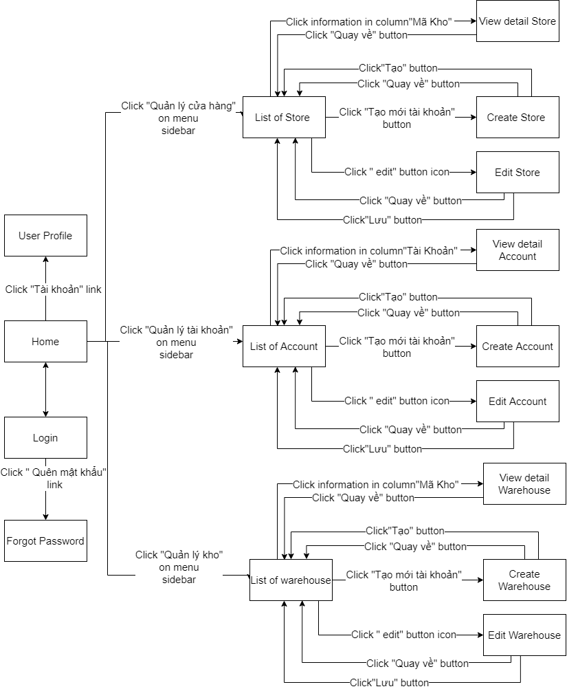

Figure 3: <Admin> Screen flow

- <Seller> Screen Flow

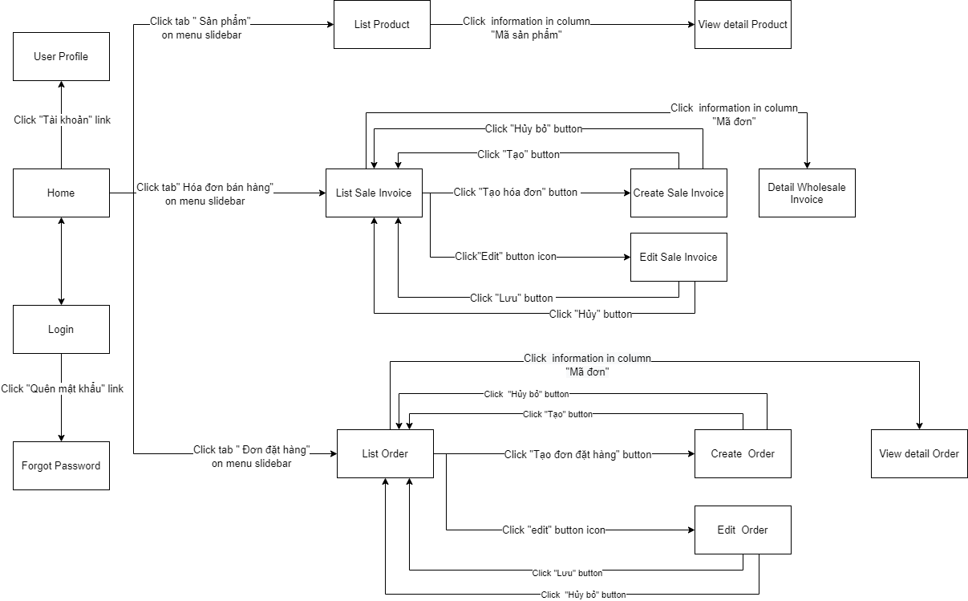



Figure 4: <Seller> Screen Flow

- <Store Manager> Screen Flow

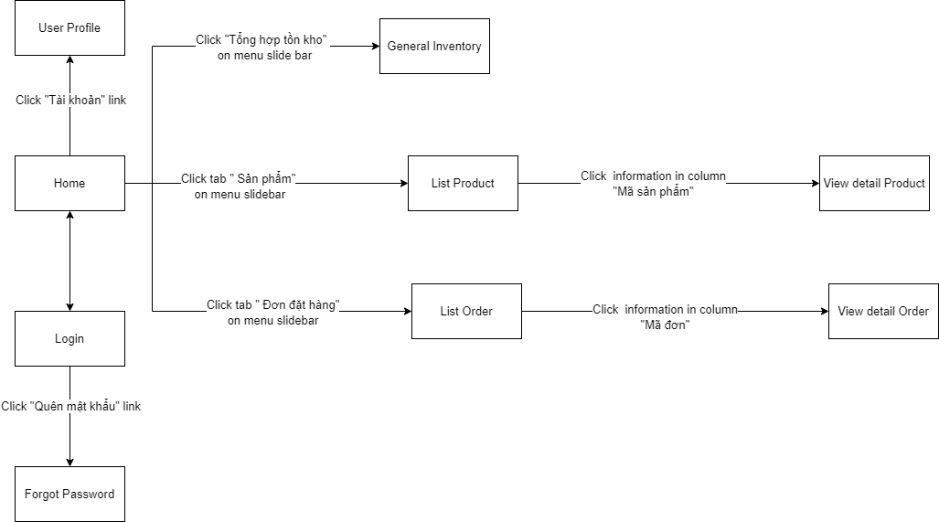

Figure 5: <Store Manager> Screen Flow

- <Sale Accountant> Screen Flow

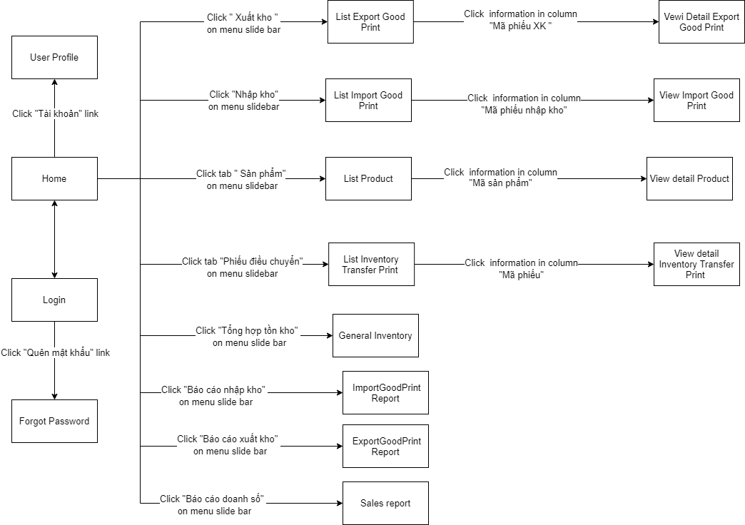

Figure 6: <Sale Accountant> Screen Flow

- <Warehouse Accountant> Screen Flow

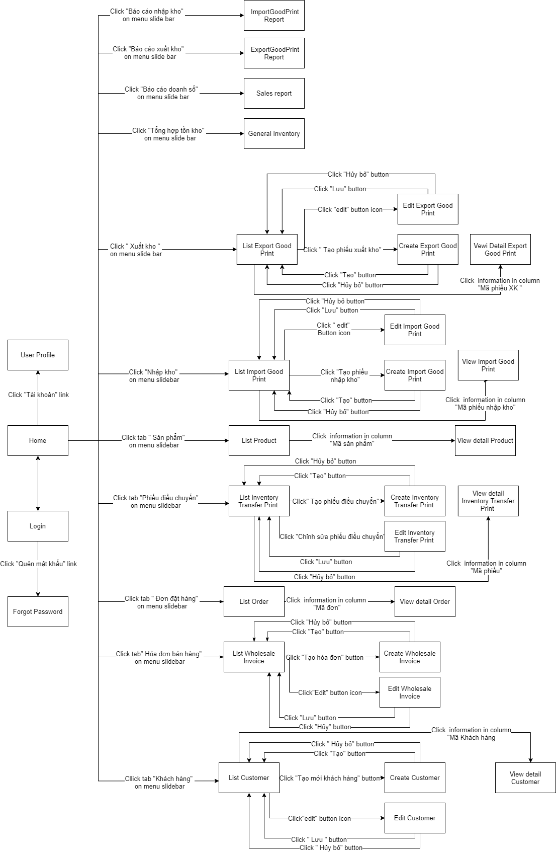

Figure 7:<Warehouse Accountant> Screen Flow

- <Receivable Accountant> Screen Flow

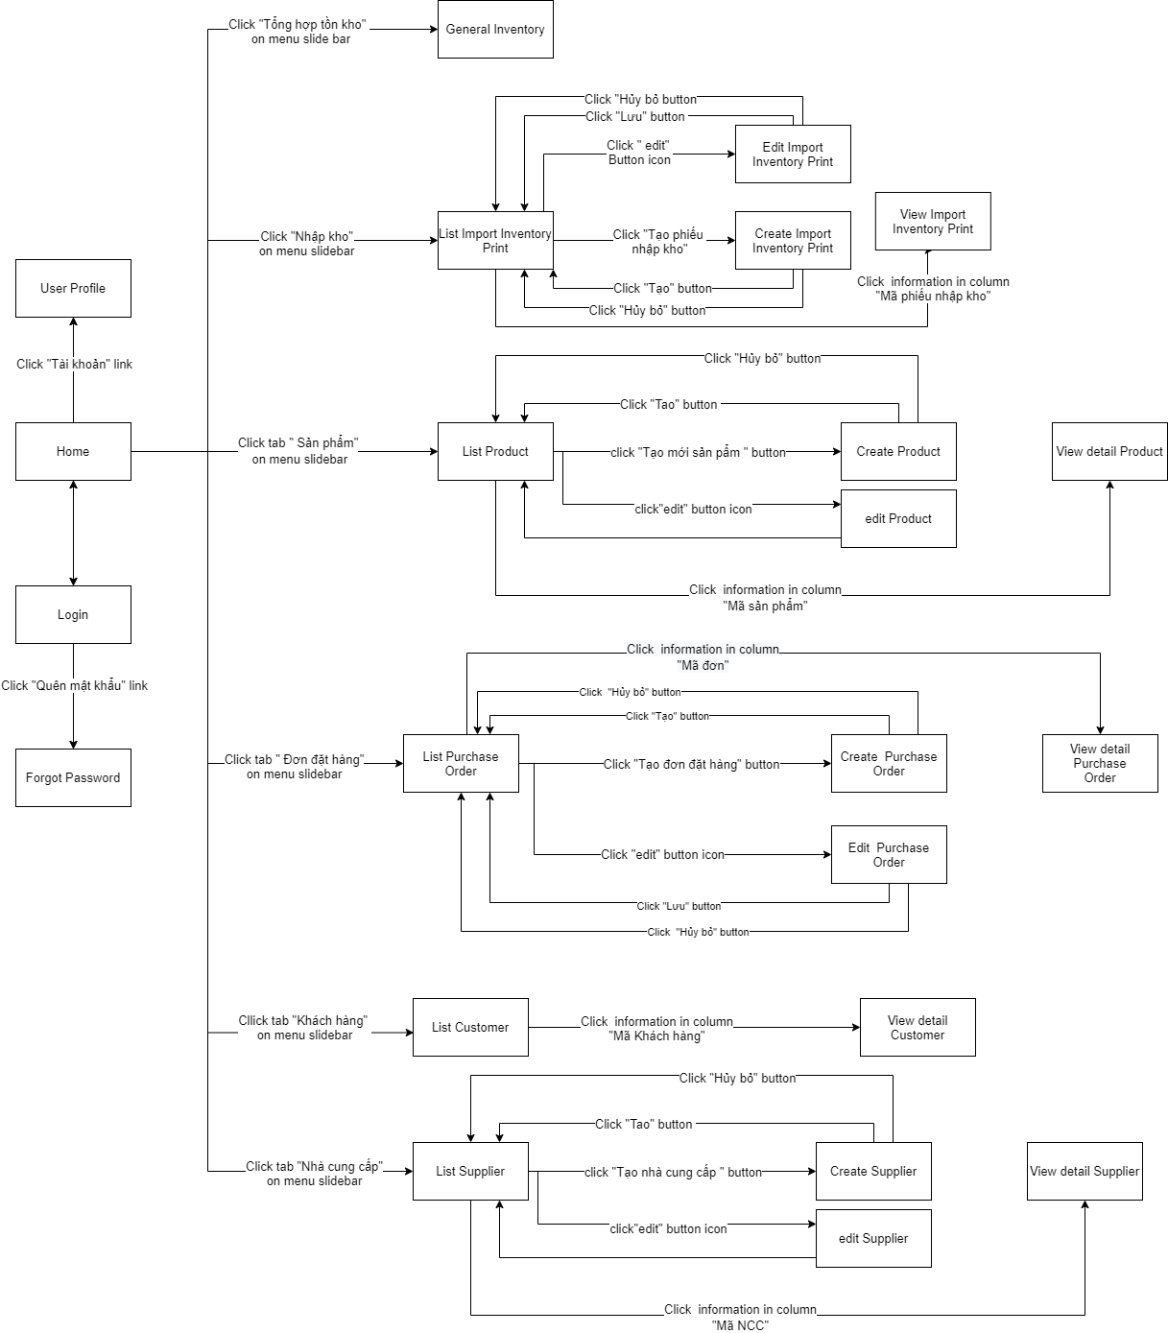

Figure 8:<Receivable Accountant> Screen Flow

#### b. Screen Details

|  |  |  |  |
| --- | --- | --- | --- |
| **Id** | **Feature** | **Screen** | **Description** |
| 1 | Create account | Create account | Create account in the system |
| 2 | Search account | Account management | Search account in the system |
| 3 | View list account | Account management | View list account in the system |
| 4 | View account detail | View account detail | View account detail in the system |
| 5 | Edit account | Edit account | Edit account in the system |
| 6 | Create warehouse | Create warehouse | Create warehouse in the system |
| 7 | Search warehouse | Warehouse management | Search warehouse in the system |
| 8 | View list warehouse | Warehouse management | View list warehouse in the system |
| 9 | View warehouse detail | View warehouse detail | View warehouse detail in the system |
| 10 | Edit warehouse | Edit warehouse | Edit warehouse in the system |
| 11 | Create store warehouse | Create store warehouse | Create store warehouse in the system |
| 12 | Search store warehouse | Store warehouse  management | Search store warehouse in the system |
| 13 | View list store warehouse | Store warehouse  management | View list store warehouse in the system |
| 14 | View store warehouse detail | View store warehouse detail | View store warehouse detail in the system |
| 15 | Edit store warehouse | Edit store warehouse | Edit store warehouse in the system |
| 16 | Login | Login | Login in the system |
| 17 | Logout | Logout | Logout in the system |
| 18 | Search product | Product  management | Search product in the system |
| 19 | View list product | Product  management | View list product in the system |
| 20 | View product detail | View product detail | View product detail in the system |
| 21 | Create purchase order | Create purchase order | Create purchase order in the system |
| 22 | Search purchase order | Purchase order  management | Search purchase order in the system |
| 23 | Edit purchase order | Edit purchase order | Edit purchase order in the system |
| 24 | View list purchase order | Purchase order  management | View list purchase order in the system |
| 25 | View purchase order detail | View purchase order detail | View purchase order detail in the system |
| 26 | Print purchase order | Purchase order  management | Print purchase order in the system |
| 27 | Cancel purchase order | Purchase order  management | Cancel purchase order in the system |
| 28 | Create account receivable | Create account receivable | Create account receivable in the system |
| 29 | View list account receivable | Account receivable  management | View list account receivable in the system |
| 30 | Update account receivable | Account receivable  management | Update account receivable in the system |
| 31 | Create account payable | Create account payable | Create account payable in the system |
| 32 | View list account payable | Account receivable  management | View list account payable in the system |
| 33 | Update account payable | Update account payable | Update account payable in the system |
| 34 | Create imported Inventory print | Create imported Inventory print | Create imported inventory print in the system |
| 35 | View list imported Inventory print | Imported Inventory print  management | View list imported inventory print in the system |
| 36 | View imported Inventory print detail | Imported Inventory print  management | View imported inventory print detail in the system |
| 37 | Confirm imported inventory print | Imported Inventory print  management | Confirm imported inventory print in the system |
| 38 | Print QR code | Print QR code | Print qr code in the system |
| 39 | Search imported inventory print | Imported Inventory print  management | Search imported inventory print in the system |
| 40 | Cancel imported inventory print | Imported Inventory print  management | Cancel imported inventory print in the system |
| 41 | Create supplier | Create supplier | Create supplier in the system |
| 42 | View list supplier | Supplier  management | View list supplier in the system |
| 43 | View supplier detail | View supplier detail | View supplier detail in the system |
| 44 | Search supplier | Supplier  management | Search supplier in the system |
| 45 | Edit supplier | Edit supplier | Edit supplier in the system |
| 46 | Create product | Create product | Create product in the system |
| 47 | Edit product | Edit product | Edit product in the system |
| 48 | Create inventory transfer print | Create inventory transfer print | Create inventory transfer print in the system |
| 49 | View list inventory transfer print | Inventory transfer print  management | View list inventory transfer print in the system |
| 50 | View inventory transfer print detail | View inventory transfer print detail | View inventory transfer print detail in the system |
| 51 | Search inventory transfer print | Inventory transfer print  management | Search inventory transfer print in the system |
| 52 | Edit inventory transfer print | Edit inventory transfer print | Edit inventory transfer print in the system |
| 53 | Print inventory transfer print | Inventory transfer print  management | Print inventory transfer print in the system |
| 54 | Cancel inventory transfer print | Inventory transfer print  management | Cancel inventory transfer print in the system |
| 55 | Confirm inventory transfer print | Inventory transfer print  management | Confirm inventory transfer print in the system |
| 56 | Create wholesale invoice | Create wholesale invoice | Create wholesale invoice in the system |
| 57 | Search wholesale invoice | Wholesale invoice  management | Search wholesale invoice in the system |
| 58 | View list wholesale invoice | Wholesale invoice  management | View list wholesale invoice in the system |
| 59 | View wholesale invoice detail | View wholesale invoice detail | View wholesale invoice detail in the system |
| 60 | Edit wholesale invoice | Edit wholesale invoice | Edit wholesale invoice in the system |
| 61 | Cancel wholesale invoice | Wholesale invoice  management | Cancel wholesale invoice in the system |
| 62 | Print wholesale invoice | Wholesale invoice  management | Print wholesale invoice in the system |
| 63 | Create customer | Create customer | Create customer in the system |
| 64 | View list customer | Customer  management | View list customer in the system |
| 65 | View customer detail | View customer detail | View customer detail in the system |
| 66 | Edit customer | Edit customer | Edit customer in the system |
| 67 | Search customer | Customer  management | Search customer in the system |
| 68 | Print exported goods print | Exported goods print management | Print exported goods print in the system |
| 69 | Cancel exported goods print | Exported goods print management | Cancel exported goods print in the system |
| 70 | Search exported goods print | Exported goods print management | Search exported goods print in the system |
| 71 | Confirm exported goods print | Exported goods print management | Confirm exported goods print in the system |
| 72 | View exported goods print detail | View exported goods print detail | View exported goods print detail in the system |
| 73 | View list exported goods print | exported goods print  management | View list exported goods print in the system |
| 74 | Edit exported goods print | Edit exported goods print | Edit exported goods print in the system |
| 75 | Create exported goods print | Create exported goods print | Create exported goods print in the system |
| 76 | Confirm imported goods print | Imported goods print management | Confirm imported goods print in the system |
| 77 | View imported goods print detail | View imported goods print detail | View imported goods print detail in the system |
| 78 | Cancel imported goods print | Imported goods print management | Cancel imported goods print in the system |
| 79 | View list imported goods print | Imported goods print management | View list imported goods print in the system |
| 80 | Print imported goods print | Imported goods print management | Print imported goods print in the system |
| 81 | Edit imported goods print | Edit imported goods print | Edit imported goods print in the system |
| 82 | Search imported goods print | Imported goods print management | Search imported goods print in the system |
| 83 | Create imported goods print | Create imported goods print | Create imported goods print in the system |
| 84 | Create order | Create order | Create order in the system |
| 85 | Search order | Order management | Search order in the system |
| 86 | Edit order | Edit order | Edit order in the system |
| 87 | View list order | Order management | View list order in the system |
| 88 | View order detail | View order detail | View order detail in the system |
| 89 | Cancel order | Order management | Cancel order in the system |
| 90 | Confirm order | Order management | Confirm order in the system |
| 91 | Reject order | Order management | Reject order in the system |
| 92 | Create invoice | Create invoice | Create invoice in the system |
| 93 | Edit invoice | Edit invoice | Edit invoice in the system |
| 94 | Search invoice | Invoice management | Search invoice in the system |
| 95 | Confirm invoice | Invoice management | Confirm invoice in the system |
| 96 | View invoice detail | View invoice detail | View invoice detail in the system |
| 97 | View list invoice | Invoice management | View list invoice in the system |
| 98 | Print invoice | Invoice management | Print invoice detail in the system |
| 99 | Cancel invoice | Invoice management | Cancel invoice in the system |

Table 131: Screen Details

#### c. Screen Authorization

|  |  |  |  |  |  |  |  |  |
| --- | --- | --- | --- | --- | --- | --- | --- | --- |
| **Screen** | **Role1** | **Role2** | **Role3** | **Role4** | **Role5** | **Role6** | **Role7** | **Role8** |
| Create account |  |  | X |  |  |  |  |  |
| Search account |  |  | X |  |  |  |  |  |
| View list account |  |  | X |  |  |  |  |  |
| View account detail |  |  | X |  |  |  |  |  |
| Edit account |  |  | X |  |  |  |  |  |
| Create warehouse |  |  | X |  |  |  |  |  |
| Search warehouse |  |  | X |  |  |  |  |  |
| View list warehouse |  |  | X |  |  |  |  |  |
| View warehouse detail |  |  | X |  |  |  |  |  |
| Edit warehouse |  |  | X |  |  |  |  |  |
| Create store warehouse |  |  | X |  |  |  |  |  |
| Search store warehouse |  |  | X | X |  |  |  |  |
| View list store warehouse |  |  | X | X |  |  |  |  |
| View store warehouse detail |  |  | X | X |  |  |  |  |
| Edit store warehouse |  |  | X |  |  |  |  |  |
| Login | X |  | X |  |  |  |  |  |
| Logout |  | X | X |  |  |  |  |  |
| Search product |  | X |  |  |  |  |  |  |
| View list product |  | X |  |  |  |  |  |  |
| View product detail |  | X |  |  |  |  |  |  |
| Create purchase order |  |  |  | X |  |  |  |  |
| Search purchase order |  |  |  | X |  |  |  |  |
| Edit purchase order |  |  |  | X |  |  |  |  |
| View list purchase order |  |  |  | X |  |  |  |  |
| View purchase order detail |  |  |  | X |  |  |  |  |
| Print purchase order |  |  |  | X |  |  |  |  |
| Cancel purchase order |  |  |  | X |  |  |  |  |
| Create account receivable |  |  |  | X |  |  |  |  |
| View list account receivable |  |  |  | X |  |  |  |  |
| Update account receivable |  |  |  | X |  |  |  |  |
| Create account payable |  |  |  | X |  |  |  |  |
| View list account payable |  |  |  | X |  |  |  |  |
| Update account payable |  |  |  | X |  |  |  |  |
| Create imported Inventory print |  |  |  | X |  |  |  |  |
| View list imported Inventory print |  |  |  | X |  |  |  |  |
| View imported Inventory print detail |  |  |  | X |  |  |  |  |
| Confirm imported inventory print |  |  |  | X |  |  |  |  |
| Print QR code |  |  |  | X |  |  |  |  |
| Search imported inventory print |  |  |  | X |  |  |  |  |
| Cancel imported inventory print |  |  |  | X |  |  |  |  |
| Create supplier |  |  |  | X |  |  |  |  |
| View list supplier |  |  |  | X |  |  |  |  |
| View supplier detail |  |  |  | X |  |  |  |  |
| Search supplier |  |  |  | X |  |  |  |  |
| Edit supplier |  |  |  | X |  |  |  |  |
| Create product |  |  |  | X |  |  |  |  |
| Edit product |  |  |  | X |  |  |  |  |
| Create inventory transfer print |  |  |  |  | X |  |  |  |
| View list inventory transfer print |  |  |  |  | X |  |  |  |
| View inventory transfer print detail |  |  |  |  | X |  |  |  |
| Search inventory transfer print |  |  |  |  | X |  |  |  |
| Edit inventory transfer print |  |  |  |  | X |  |  |  |
| Print inventory transfer print |  |  |  |  | X |  |  |  |
| Cancel inventory transfer print |  |  |  |  | X |  |  |  |
| Confirm inventory transfer print |  |  |  |  | X |  |  |  |
| Create wholesale invoice |  |  |  |  | X |  |  |  |
| Search wholesale invoice |  |  |  |  | X |  |  |  |
| View list wholesale invoice |  |  |  |  | X |  |  |  |
| View wholesale invoice detail |  |  |  |  | X |  |  |  |
| Edit wholesale invoice |  |  |  |  | X |  |  |  |
| Cancel wholesale invoice |  |  |  |  | X |  |  |  |
| Print wholesale invoice |  |  |  |  | X |  |  |  |
| Create customer |  |  |  |  | X |  |  |  |
| View list customer |  |  |  | X | X |  |  |  |
| View customer detail |  |  |  | X | X |  |  |  |
| Edit customer |  |  |  |  | X |  |  |  |
| Search customer |  |  |  | X | X |  |  |  |
| Print exported goods print |  |  |  |  | X | X |  |  |
| Cancel exported goods print |  |  |  |  | X | X |  |  |
| Search exported goods print |  |  |  |  | X | X |  |  |
| Confirm exported goods print |  |  |  |  | X | X |  |  |
| View exported goods print detail |  |  |  |  | X | X |  |  |
| View list exported goods print |  |  |  |  | X | X |  |  |
| Edit exported goods print |  |  |  |  | X | X |  |  |
| Create exported goods print |  |  |  |  | X | X |  |  |
| Confirm imported goods print |  |  |  |  | X | X |  |  |
| View imported goods print detail |  |  |  |  | X | X |  |  |
| Cancel imported goods print |  |  |  |  | X | X |  |  |
| View list imported goods print |  |  |  |  | X | X |  |  |
| Print imported goods print |  |  |  |  | X | X |  |  |
| Edit imported goods print |  |  |  |  | X | X |  |  |
| Search imported goods print |  |  |  |  | X | X |  |  |
| Create imported goods print |  |  |  |  | X | X |  |  |
| Create order |  |  |  |  |  |  | X |  |
| Search order |  |  |  |  | X |  | X | X |
| Edit order |  |  |  |  |  |  | X |  |
| View list order |  |  |  |  | X |  | X | X |
| View order detail |  |  |  |  | X |  | X | X |
| Cancel order |  |  |  |  | X |  | X |  |
| Confirm order |  |  |  |  |  |  |  | X |
| Reject order |  |  |  |  |  |  |  | X |
| Create invoice |  |  |  |  |  |  | X |  |
| Edit invoice |  |  |  |  |  |  | X |  |
| Search invoice |  |  |  |  |  |  | X |  |
| Confirm invoice |  |  |  |  |  |  | X |  |
| View invoice detail |  |  |  |  |  |  | X |  |
| View list invoice |  |  |  |  |  |  | X |  |
| Print invoice |  |  |  |  |  |  | X |  |
| Cancel invoice |  |  |  |  |  |  | X |  |

Table 132: Screen Authorization

In which:

* Role1: Unauthenticated User
* Role2: Authenticated User
* Role3: Admin
* Role4: Receivable Accountant
* Role5: Warehouse Accountant
* Role6: Sale Accountant
* Role7: Seller
* Role8: Store Manager

#### d. Non-Screen Functions

|  |  |  |
| --- | --- | --- |
| **#** | **System Function** | **Description** |
| 1 | Check overdue receivables. | The system will change the status of the receivable. |
| 2 | Check overdue payable. | The system will change the status of the payable. |
| 3 | Calculate invoice statistic | The system will calculate prices, the total number of products in the invoice. |

Table 133: Non-screen Functions

#### e. Entity Relationship Diagram

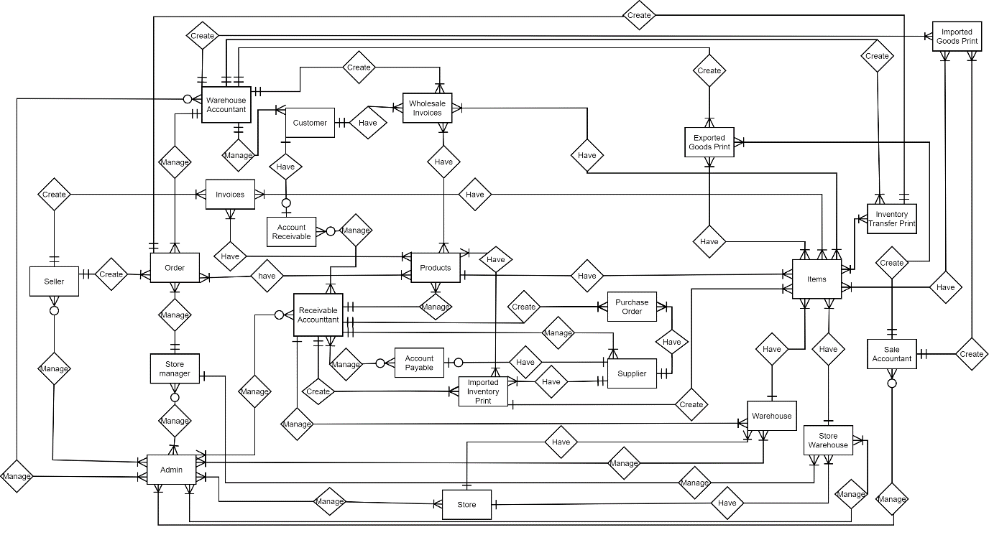

Figure 9: Entity Relationship Diagram

|  |  |  |
| --- | --- | --- |
| **#** | **Entity** | **Description** |
| 1 | Seller | The seller is the one who will enter the sale orders after the end of an order to record the repository. In addition, they can order orders from the total warehouse to enter more goods |
| 2 | Order | Order is an order from store to order from the total warehouse |
| 3 | Store manager | The store manager is the one who can inventory and browse Orders before sending the order. In addition, they can edit prices and promotions of products |
| 4 | Warehouse Accountant | The warehouse Accountant is the one who can accept orders from the store. In addition, they also created wholesale invoices, and eventually, they can view the inventory of stores and the main warehouse. |
| 5 | Invoices | Invoices are orders sold from salespeople selling products at the store for retail customers |
| 6 | Account Receivable | Account Receivable is a list of receivables when postpaid customers |
| 7 | Customer | Customers are people who can order wholesale. They can be clippers or contract customers at supermarkets, malls. |
| 8 | Wholesale Invoices | Wholesale invoices are orders for wholesale customers. They can be clippers or contract customers at supermarkets, malls. |
| 9 | Products | Products of the store will include product code, product name, color, size, product type. |
| 10 | Receivable Accountant | The receivable accountant is the manager of the receivable account, payable account, order from supplier, and import inventory in the main warehouse |
| 11 | Account Payable | Imported Inventory Print is a list of imported invoices when new products are transferred from one repository to another |
| 12 | Admin | Admin is the one who can manage information of accounts, warehouses, and stores |
| 13 | Imported Inventory Print | Imported Inventory Print is a list of products imported goods purchased from the supplier. |
| 14 | Supplier | Supplier is a list of product suppliers for companies including domestic and foreign suppliers |
| 15 | Purchase Order | Purchase Order is ordered from suppliers |
| 16 | Warehouse | The warehouse is a list of the main warehouses to distribute products to stores and agents |
| 17 | Store Warehouse | Store Warehouse is a list of product in-store warehouses for sales for end-users |
| 18 | Items | Item is a list of product SKU codes. |
| 19 | Sale Accountant | Sales accountants are people who can export or import warehouses at stores, and view inventory at the store |
| 20 | Inventory Transfer Print | Inventory Transfer Print is a list of product transfers between warehouses |
| 21 | Imported Goods Print | Imported Goods Print is a list of imported goods from transfer between warehouses |
| 22 | Exported Goods Print | Exported Goods Print is a product for exporting products. Product canceling or exporting products. |

Table 134: Entity Relationship

## 4. Non-Functional Requirements

### 4.1 External Interfaces

#### a. User Interfaces

UI-1: The warehouse management system screen displays shall conform to the Process Impact Internet Application User Interface Standard, Version 2.0 [3]

#### b. Software Interfaces

No software interfaces have been identified

#### c. Hardware Interfaces

Barcode scanner: YHD-1100DW

#### d. Communications Interfaces

CI-1: The system will send an email to provide the reset password to the admin in case the admin forgets the password.

### 4.2 Quality Attributes

#### a. Usability

U-1: Interface should be simple and clearly for user to understand

U-2: Users can use the app after 1 training day.

#### b. Reliability

System monitor:

* 7 days operation - error 2 hours, 9 days operation - error 3 hours, 8 days operation - error 1 hour.

mtbf:

#### c. Performance

P-1: The system has an average response time of about 3-4 seconds

P-2: The system has a maximum response time of about 6 seconds

P-2: The system has an average of 150 users at a time.

#### d. Dependability

Application is built and developed in Amazon web services.

##### d1. Security

- The system uses encryption for password to protect accounts.

##### d2. Safety

* Backup databases daily.

#### e. Supportability

- Naming conventions:

+ Package names should be in lowercase

+ Class names should be nouns, in mixed case with the first letter of each internal word capitalized.

+ Use camel case for variable and function names.

+ The first word of a variable name should be a noun. The first word of a function name should be a verb.

+ Constants should be formatted using all uppercase letters with words separated by a single underscore.

+ Object properties follow the same naming conventions as variables. Object methods follow the same naming conventions as functions.

#### f. Design Constraints

- The language which we use in the project: java.

- Project uses java framework: Spring Boot.

- The database which we use is a relational database (MS SQL Server)

## 5. Other Requirements

### 5.1 Messages List

|  |  |  |  |  |
| --- | --- | --- | --- | --- |
| **#** | **Message code** | **Message Type** | **Context** | **Content** |
| 1 | MSG01 | In line | There is not any search result | *Không tìm thấy kết quả* |
| 2 | MSG02 | In red, under the text box | Input-required fields are empty | *Nhập thông tin đầy đủ !* |
| 3 | MSG03 | Toast message | Update asset(s) information successfully | *Cập nhật thông tin thành công* |
| 4 | MSG04 | Toast message | Adding new asset successfully | *Tạo thành công* |
| 5 | MSG04 | Toast message | Editing new asset successfully | *Chỉnh sửa thành công* |
| 6 | MSG05 | In red, under the text box | Adding new account duplicate username | *Tài khoản này đã được đăng tạo* |
| 7 | MSG06 | In red, under the text box | Adding new warehouse duplicate id warehouse | *Mã kho đã được tạo* |
| 8 | MSG07 | In red, under the text box | Adding new store warehouse duplicate id store warehouse | *Mã cửa hàng đã được tạo* |
| 9 | MSG09 | In line | Username or password is not correct when clicking log-in | *Tài khoản hoặc mật không đúng, vui lòng nhập lại* |
| 10 | MSG10 | In line | Cancel asset(s) successfully | *Hủy thành công* |
| 11 | MSG014 | In red,under the text box | Input acreage value wrong format (required, number, value > 0) | *Vui lòng nhập giá trị lớn hơn 0* |
| 12 | MSG011 | In red,under the text box | Input value wrong phone number format | *Vui lòng nhập đúng số điện thoại* |
| 13 | MSG012 | In red,under the text box | Input value wrong email format | *Vui lòng nhập đúng email* |

Table 135: Messages list

# **IV. Software Design Document**

## **1. Overall Description**

### 1.1 Assumptions

|  |  |
| --- | --- |
| **Operating system** | Windows 10 |
| **DBMS** | MS SQL Server |
| **IDEs/Editors** | Visual Studio Code, IntelliJ Idea |
| **UML tools** | Diagram.nets |
| **Version Control** | Git |
| **Deployment server** | Amazon |
| **End user** | Lug’s staff |

Table 136: Assumptions

### 1.2 Design Constraints

* Use RESTful API to transfer data from browser to server.
* Every process in this system must be less than 10s.
* Web-based platform accessible from any browser.

## **2. System Architecture Design**

### 2.1 Overall Architecture

The system is designed based on Three-tier architecture. Three-tier architecture is a well-established software application architecture that organizes applications into three logical and physical computing tiers: the presentation tier, or user interface; the application tier, where data is processed; and the data tier, where the data associated with the application is stored and managed.

### 2.2 System Architecture

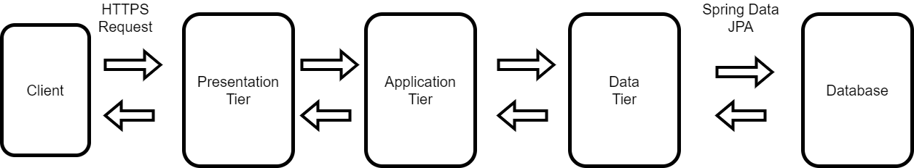

Figure 10: System Architecture

### 2.3 Package Diagram

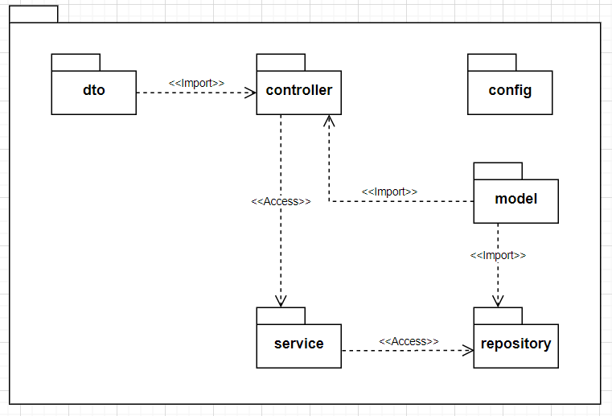

Figure 11: Package Diagram

|  |  |  |
| --- | --- | --- |
| **No** | **Package** | **Description** |
| 01 | dto | This contains data built in the form of a object class |
| 02 | controller | This is the layer you communicate with the end user, all data sent up and down goes through here |
| 03 | service | That contains calculation and processing codes. When the Controller requests, the corresponding Service will receive and return data to the Controller. |
| 04 | model | Data structures of the whole program |
| 05 | repository | Repository is directly interacting, reading and writing data in the DB and return for the service |
| 06 | config | The package contains all configuration of the project such as security configuration, swagger configuration, cors configuration |

Table 137: Package Diagram

## **3. System Detailed Design**

### 3.1 Class Diagram

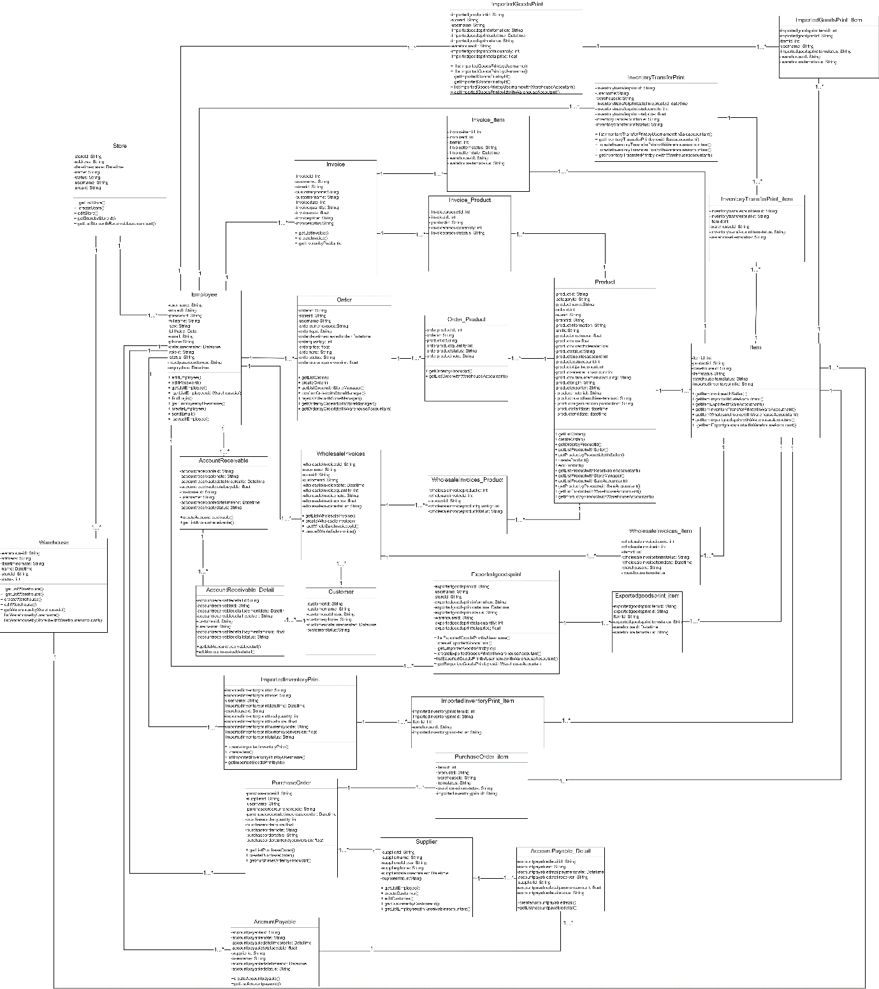

Table 138: Class diagram

### 3.2 Class Specification

|  |  |
| --- | --- |
| **Class Name** | **Description** |
| Employee | Contains all information of employee |
| Order | Contains all information of order |
| Order_Product | Contains all information of order_Product |
| Employee_Store | Contains all information of employee_store |
| WholesaleInvoices | Contains all information of wholesale invoices |
| WholesaleInvoice_Item | Contains all information of wholesale_Item |
| WholesaleInvoice_Product | Contains all information of wholesale_Product |
| ImportedInventoryPrint | Contains all information of imported inventory print |
| ImportedInventoryPrint_Product | Contains all information of imported Inventory Print Product |
| PurchaseOrder | Contains all information of purchase order |
| PurchaseOrder_Product | Contains all information of purchase order product |
| ExportedGoodsPrint | Contains all information of exported goods prints |
| ExportedGoodsPrint_Item | Contains all information of exported goods prints item |
| InventoryTransferPrint | Contains all information of inventory transfer print |
| InventoryTransferPrint_Item | Contains all information of inventory transfer print item |
| Invoices | Contains all information of invoice |
| Invoices_Item | Contains all information of invoice item |
| Products | Contains all information of product |
| Supplier | Contains all information of supplier |
| Warehouse | Contains all information of warehouse |
| StoreWarehouse | Contains all information of store warehouse |
| Items | Contains all information of each product item |
| ImportedGoodsPrint | Contains all information of imported goods print |
| Customer | Contains all information of customer |
| AccountReceivable | Contains all information of account receivable |
| AccountReceivable_Detail | Contains all information of account receivable detail |
| AccountPayable | Contains all information of account payable |
| AccountPayable_Detail | Contains all information of account payable detail |

Table 139: Class Specification

#### 3.2.1 AccountPayable Class

|  |  |  |  |
| --- | --- | --- | --- |
| **Attribute** | **Type** | **Visibility** | **Description** |
| accountpayableid | String | private |  |
| accountpayablenote | String | private |  |
| accountpayabledatetimecreate | String | private |  |
| accountpayabletotalpayable | BigDecimal | private |  |
| supplierid | String | private |  |
| username | String | Private |  |
| accountpayabledatetimeend | String | private |  |
| accountpayabledstatus | String | private |  |

Table 140: AccountPayable Class

#### 3.2.2 AccountPayableDetail Class

|  |  |  |  |
| --- | --- | --- | --- |
| **Attribute** | **Type** | **Visibility** | **Description** |
| accountpayabledetailid | Integer | private |  |
| accountpayableid | String | private |  |
| accountpayabledetailpaymentdate | String | private |  |
| accountpayabledetailreceiver | String | private |  |
| supplierid | String | private |  |
| accountpayabledetailpaymentamount | BigDecimal | Private |  |
| accountpayabledetailstatus | String | private |  |

Table 141: AccountPayableDetail Class

#### 3.2.3 AccountReceivable Class

|  |  |  |  |
| --- | --- | --- | --- |
| **Attribute** | **Type** | **Visibility** | **Description** |
| accountreceivableid | String | private |  |
| accountreceivablenote | String | private |  |
| accountreceivabledatetimecreate | String | private |  |
| accountreceivabletotalpayable | BigDecimal | private |  |
| customerid | String | private |  |
| username | String | Private |  |
| accountreceivabledatetimeend | String | private |  |
| accountreceivablestatus | String | private |  |

Table 142: AccountReceivable Class

#### 3.2.4 AccountReceivableDetail Class

|  |  |  |  |
| --- | --- | --- | --- |
| **Attribute** | **Type** | **Visibility** | **Description** |
| accountreceivabledetailid | Integer | private |  |
| accountreceivableid | String | private |  |
| accountreceivabledetailpaymentdate | String | private |  |
| accountreceivabledetailreceiver | String | private |  |
| customerid | String | private |  |
| accountreceivabledetailpaymentamount | BigDecimal | Private |  |
| accountreceivabledetailstatus | String | private |  |

Table 143: AccountReceivableDetail Class

#### 3.2.5 AccountReceivableDetail Class

|  |  |  |  |
| --- | --- | --- | --- |
| **Attribute** | **Type** | **Visibility** | **Description** |
| accountreceivabledetailid | Integer | private |  |
| accountreceivableid | String | private |  |
| accountreceivabledetailpaymentdate | String | private |  |
| accountreceivabledetailreceiver | String | private |  |
| customerid | String | private |  |
| accountreceivabledetailpaymentamount | BigDecimal | Private |  |
| accountreceivabledetailstatus | String | private |  |

Table 144: AccountReceivableDetail Class

#### 3.2.6 Area Class

|  |  |  |  |
| --- | --- | --- | --- |
| **Attribute** | **Type** | **Visibility** | **Description** |
| areaid | String | private |  |
| areaname | String | private |  |
| areastatus | String | private |  |

Table 145: Area Class

#### 3.2.7 Brand Class

|  |  |  |  |
| --- | --- | --- | --- |
| **Attribute** | **Type** | **Visibility** | **Description** |
| brandid | String | private |  |
| brandname | String | private |  |
| brandstatus | String | private |  |

Table 146: Brand Class

#### 3.2.8 Category Class

|  |  |  |  |
| --- | --- | --- | --- |
| **Attribute** | **Type** | **Visibility** | **Description** |
| categoryid | String | private |  |
| categoryname | String | private |  |
| categorystatus | String | private |  |

Table 147: Category Class

#### 3.2.9 Color Class

|  |  |  |  |
| --- | --- | --- | --- |
| **Attribute** | **Type** | **Visibility** | **Description** |
| colorid | String | private |  |
| colorname | String | private |  |
| colorstatus | String | private |  |

Table 148: Color Class

#### 3.2.10 Customer Class

|  |  |  |  |
| --- | --- | --- | --- |
| **Attribute** | **Type** | **Visibility** | **Description** |
| customerid | String | private |  |
| customername | String | private |  |
| customeraddress | String | private |  |
| customerstatus | String | private |  |

Table 149: Customer Class

#### 3.2.11 Employee Class

|  |  |  |  |
| --- | --- | --- | --- |
| **Attribute** | **Type** | **Visibility** | **Description** |
| username | String | private |  |
| storeid | String | private |  |
| password | String | private |  |
| fullname | String | private |  |
| sex | String | private |  |
| birthday | Date | private |  |
| phone | String | private |  |
| email | String | private |  |
| datetimecreated | Date | private |  |
| roleid | String | private |  |
| status | String | private |  |
| resetpasswordtoken |  |  |  |
| expirydate |  |  |  |

Table 150: Brand Class

#### 3.2.12 EmployeeStore Class

|  |  |  |  |
| --- | --- | --- | --- |
| **Attribute** | **Type** | **Visibility** | **Description** |
| employeestoreid | Integer | private |  |
| username | String | private |  |
| storeid | String | private |  |
| employeestorestatus | String | private |  |
| employeestoreatetimecreate | String | private |  |

Table 151: EmployeeStore Class

#### 3.2.13 ExportedGoodsPrint Class

|  |  |  |  |
| --- | --- | --- | --- |
| **Attribute** | **Type** | **Visibility** | **Description** |
| exportedgoodsprintid | String | private |  |
| username | String | private |  |
| storeid | String | private |  |
| exportedgoodsprintinfomation | String | private |  |
| exportedgoodsprintdatetime | String | private |  |
| exportedgoodsprintstatus | String | private |  |
| warehouseid | String | private |  |
| exportedgoodsprinttotalquantity | Integer | private |  |
| exportedgoodsprinttotalprice | Float | private |  |

Table 152: ExportedGoodsPrint Class

#### 3.2.14 ExportedGoodsPrintItem Class

|  |  |  |  |
| --- | --- | --- | --- |
| **Attribute** | **Type** | **Visibility** | **Description** |
| exportedgoodsprintitemid | Integer | private |  |
| exportedgoodsprintid | String | private |  |
| itemid | Integer | private |  |
| exportedgoodsprintitemstatus | String | private |  |
| warehouseid | String | private |  |
| warehouseitemstatus | String | private |  |

Table 153: ExportedGoodsPrintItem Class

#### 3.2.15 ImportedGoodsPrint Class

|  |  |  |  |
| --- | --- | --- | --- |
| **Attribute** | **Type** | **Visibility** | **Description** |
| importedgoodsprintid | String | private |  |
| username | String | private |  |
| storeid | String | private |  |
| importedgoodsprintinfomation | String | private |  |
| importedgoodsprintdatetime | String | private |  |
| exportedgoodsprintstatus | String | private |  |
| warehouseid | String | private |  |
| importedgoodsprinttotalquantity | Integer | private |  |
| importedgoodsprinttotalprice | Float | private |  |

Table 154: ImportedGoodsPrint Class

#### 3.2.16 ExportedGoodsPrintItem Class

|  |  |  |  |
| --- | --- | --- | --- |
| **Attribute** | **Type** | **Visibility** | **Description** |
| importedgoodsprintitemid | Integer | private |  |
| importedgoodsprintid | String | private |  |
| itemid | Integer | private |  |
| importedgoodsprintitemstatus | String | private |  |
| warehouseid | String | private |  |
| warehouseitemstatus | String | private |  |

Table 155: ExportedGoodsPrintItem Class

#### 3.2.17 ImportedInventoryPrint Class

|  |  |  |  |
| --- | --- | --- | --- |
| **Attribute** | **Type** | **Visibility** | **Description** |
| importedinventoryprintid | String | private |  |
| username | String | private |  |
| supplierid | String | private |  |
| importedinventoryprintnote | String | private |  |
| importedinventoryprintdatetime | String | private |  |
| warehouseid | String | private |  |
| importedinventoryprinttotalquantity | Integer | private |  |
| importedinventoryprinttotalprice | Float | private |  |
| importedinventoryprintcurrencycode | String | private |  |
| importedinventoryprintcurrencyconversion | Float |  |  |
| importedinventoryprinttypename | String |  |  |
| importedinventoryprintstatus | String |  |  |

Table 156: ImportedInventoryPrint Class

#### 3.2.18 ImportedInventoryPrintPruduct Class

|  |  |  |  |
| --- | --- | --- | --- |
| **Attribute** | **Type** | **Visibility** | **Description** |
| importedinventoryprintproductid | Integer | private |  |
| importedinventoryprintid | String | private |  |
| productid | String | private |  |
| importedinventoryprintproductquantity | Integer | private |  |
| importedinventoryprintproductprice | String | private |  |
| importedinventoryprintproductstatus | String | private |  |

Table 157: ImportedInventoryPrintPruduct Class

#### 3.2.19 InventoryTransferPrint Class

|  |  |  |  |
| --- | --- | --- | --- |
| **Attribute** | **Type** | **Visibility** | **Description** |
| inventorytransferprintid | String | private |  |
| username | String | private |  |
| inventorytransferprintdatetimecreated | String | private |  |
| inventorytransferprinttotalquantity | Integer | private |  |
| inventorytransferprinttotalprice | Float | private |  |
| warehouseid | String | private |  |
| inventorytransferprintnote | String | private |  |
| inventorytransferprintstatus | String | private |  |

Table 158: InventoryTransferPrint Class

#### 3.2.20 InventoryTransferPrintItem Class

|  |  |  |  |
| --- | --- | --- | --- |
| **Attribute** | **Type** | **Visibility** | **Description** |
| inventorytransferprintitemid | Integer | private |  |
| inventorytransferprintid | String | private |  |
| itemid | Integer | private |  |
| warehouseid | String | private |  |
| inventorytransferprintitemstatus | String | private |  |

Table 159: InventoryTransferPrintItem Class

#### 3.2.21 Invoice Class

|  |  |  |  |
| --- | --- | --- | --- |
| **Attribute** | **Type** | **Visibility** | **Description** |
| invoiceid | Integer | private |  |
| username | String | private |  |
| storeid | String | private |  |
| customername | String | private |  |
| customerphone | String | private |  |
| invoicedate | datetime | private |  |
| invoicequantity | int | private |  |
| invoicenote | String | private |  |
| invoiceprice | float | private |  |
| invoicestatus | String | private |  |

Table 160: Invoice Class

#### 3.2.22 InvoiceItem Class

|  |  |  |  |
| --- | --- | --- | --- |
| **Attribute** | **Type** | **Visibility** | **Description** |
| invoiceitemid | Integer | private |  |
| invoiceid | Integer | private |  |
| itemid | Integer | private |  |
| invoiceitemstatus | String | private |  |
| invoiceitemdate | String | private |  |
| warehouseid | datetime | private |  |
| warehouseitemstatus | int | private |  |
| invoicestatus | String | private |  |

Table 161: InvoiceItem Class

#### 3.2.23 InvoiceProduct Class

|  |  |  |  |
| --- | --- | --- | --- |
| **Attribute** | **Type** | **Visibility** | **Description** |
| invoiceproductid | Integer | private |  |
| invoiceid | Integer | private |  |
| productid | String | private |  |
| invoiceproductquantity | Integer | private |  |
| invoiceproductstatus | String | private |  |

Table 162: InvoiceProduct Class

#### 3.2.24 ItemClass

|  |  |  |  |
| --- | --- | --- | --- |
| **Attribute** | **Type** | **Visibility** | **Description** |
| itemid | Integer | private |  |
| productid | String | private |  |
| warehouseid | String | private |  |
| itemstatus | String | private |  |
| warehouseitemstatus | String | private |  |
| importedinventoryprintid | String | private |  |

Table 163: Item Class

#### 3.2.25 OrderClass

|  |  |  |  |
| --- | --- | --- | --- |
| **Attribute** | **Type** | **Visibility** | **Description** |
| orderid | Integer | private |  |
| storeid | String | private |  |
| username | String | private |  |
| ordercurrencycode | String | private |  |
| ordertype | String | private |  |
| orderdatetimecreatedorder | datetime | private |  |
| orderquantity | Int | private |  |
| orderprice | float | private |  |
| ordernote | String | private |  |
| orderstatus | String | private |  |
| ordercurrencyconversion | String | private |  |

Table 164: OrderClass

#### 3.2.26 Order_Product Class

|  |  |  |  |
| --- | --- | --- | --- |
| **Attribute** | **Type** | **Visibility** | **Description** |
| orderproductid | Integer | private |  |
| orderid | String | private |  |
| productid | String | private |  |
| orderproductquantity | int | private |  |
| orderproductstatus | String | private |  |
| orderproductnote | String | private |  |

Table 165: Order_Product Class

#### 3.2.27 Product Class

|  |  |  |  |
| --- | --- | --- | --- |
| **Attribute** | **Type** | **Visibility** | **Description** |
| productid | String | private |  |
| categoryid | String | private |  |
| productname | String | private |  |
| colorid | String | private |  |
| sizeid | String | private |  |
| brandid | String | private |  |
| productinformation | String | private |  |
| unitid | String | private |  |
| productpriceimport | float | private |  |
| productprice | float | private |  |
| productpricewholesale | float | private |  |
| productstatus | String | private |  |
| productsuppliesaccount | int | private |  |
| productcostaccount | int | private |  |
| productobjectaccount | int | private |  |
| productsalesreturnaccount | int | private |  |
| productoutsourcemanufacturing | String | private |  |
| productorigin | String | private |  |
| productexporter | String | private |  |
| productmaterial | String | private |  |
| productbrandfranchisestandard | String | private |  |
| productorganizationofproduction | String | private |  |
| productstartdate | datetime | private |  |
| productenddate | datetime | private |  |

Table 166: Product Class

#### 3.2.28 PurchaseOrder Class

|  |  |  |  |
| --- | --- | --- | --- |
| **Attribute** | **Type** | **Visibility** | **Description** |
| purchaseorderid | String | private |  |
| supplierid | String | private |  |
| username | String | private |  |
| purchaseordercurrencycode | String | private |  |
| purchaseorderdatetimecreatedorder | String | private |  |
| purchaseorderquantity | int | private |  |
| purchaseorderprice | float | private |  |
| purchaseordernote | String | private |  |
| purchaseordertatus | String | private |  |
| purchaseordercurrencyconversion | float | private |  |

Table 167: PurchaseOrder Class

#### 3.2.29 PurchaseOrder_Product Class

|  |  |  |  |
| --- | --- | --- | --- |
| **Attribute** | **Type** | **Visibility** | **Description** |
| purchaseorderproductid | int | private |  |
| purchaseorderid | String | private |  |
| productid | String | private |  |
| purchaseorderproductquantity | int | private |  |
| purchaseorderproductstatus | String | private |  |
| purchaseorderproductnote | String | private |  |

Table 168: PurchaseOrder_Product Class

#### 3.2.30 Store Class

|  |  |  |  |
| --- | --- | --- | --- |
| **Attribute** | **Type** | **Visibility** | **Description** |
| purchaseorderproductid | int | private |  |
| purchaseorderid | String | private |  |
| productid | String | private |  |
| purchaseorderproductquantity | int | private |  |
| purchaseorderproductstatus | String | private |  |
| purchaseorderproductnote | String | private |  |

Table 169: Store Class

#### 3.2.31 Supplier Class

|  |  |  |  |
| --- | --- | --- | --- |
| **Attribute** | **Type** | **Visibility** | **Description** |
| supplierid | String | private |  |
| suppliername | String | private |  |
| supplieraddress | String | private |  |
| supplierphone | String | private |  |
| supplierdatetimecreated | datetime | private |  |
| supplierstatus | String | private |  |

Table 170: Supplier Class

#### 3.2.32 Warehouse Class

|  |  |  |  |
| --- | --- | --- | --- |
| **Attribute** | **Type** | **Visibility** | **Description** |
| warehouseid | String | private |  |
| address | String | private |  |
| datetimecreate | datetime | private |  |
| name | String | private |  |
| status | String | private |  |
| storeid | String | private |  |

Table 171: Warehouse Class

#### 3.2.33 WholesaleInvoice_Item Class

|  |  |  |  |
| --- | --- | --- | --- |
| **Attribute** | **Type** | **Visibility** | **Description** |
| wholesaleinvoiceitemid | int | private |  |
| wholesaleinvoiceid | int | private |  |
| itemid | int | private |  |
| wholesaleinvoiceitemstatus | String | private |  |
| wholesaleinvoiceitemdate | datetime | private |  |
| warehouseid | String | private |  |
| warehouseitemstatus | String | private |  |

Table 172: WholesaleInvoice_Item Class

#### 3.2.34 WholesaleInvoice_Product Class

|  |  |  |  |
| --- | --- | --- | --- |
| **Attribute** | **Type** | **Visibility** | **Description** |
| wholesaleinvoiceproductid | int | private |  |
| wholesaleinvoiceid | int | private |  |
| productid | String | private |  |
| wholesaleinvoiceproductquantity | int | private |  |
| wholesaleinvoiceproductstatus | datetime | private |  |

Table 173: WholesaleInvoice_Product Class

#### 3.2.35 Supplier Class

|  |  |  |  |
| --- | --- | --- | --- |
| **Attribute** | **Type** | **Visibility** | **Description** |
| wholesaleinvoiceid | int | private |  |
| username | String | private |  |
| storeid | String | private |  |
| customerid | String | private |  |
| wholesaleinvoicedate | datetime | private |  |
| wholesaleinvoicequantity | int | private |  |
| wholesaleinvoicenote | String | private |  |
| wholesaleinvoiceprice | float | private |  |
| wholesaleinvoicestatus | String | private |  |

Table 174: Supplier Class

### 3.3 Sequence Diagram

#### 3.3.1. Create employee

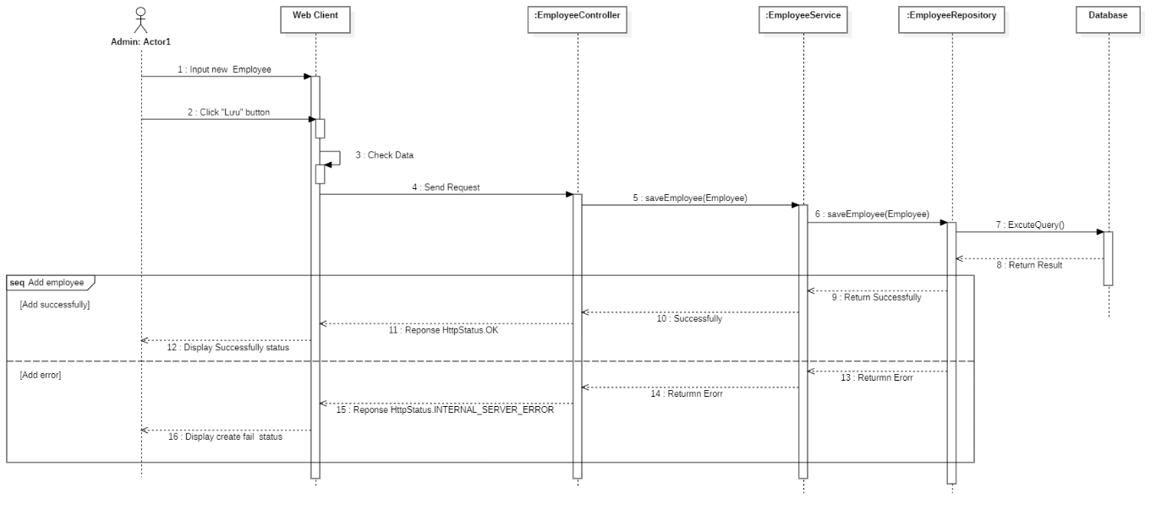

Figure 12: Create employee

#### 3.3.2. Edit employee

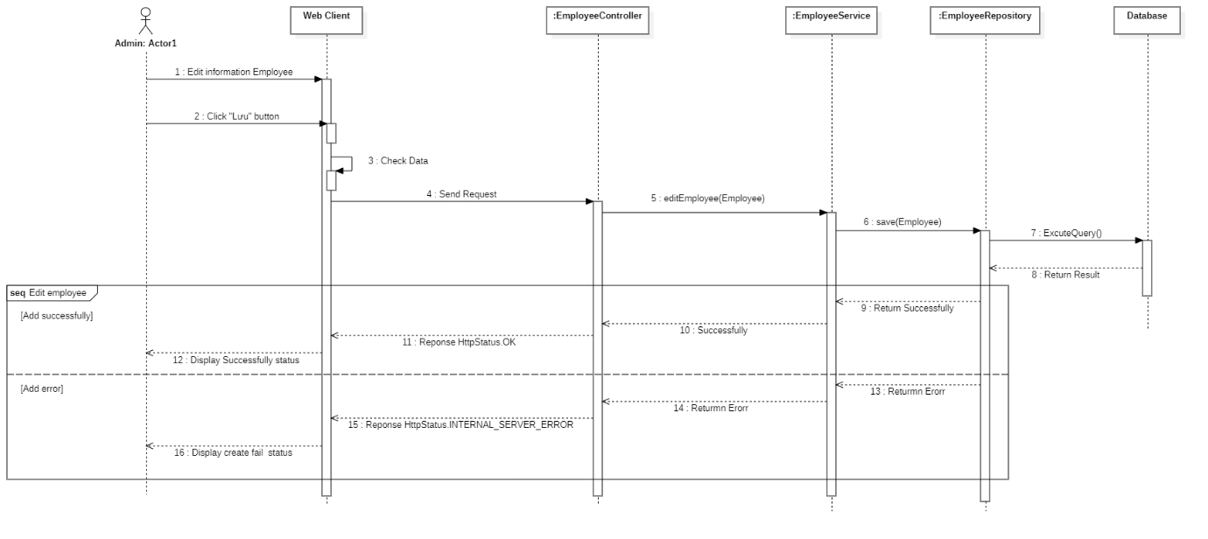

Figure 13: Edit employee

#### 3.3.3. Get list employee

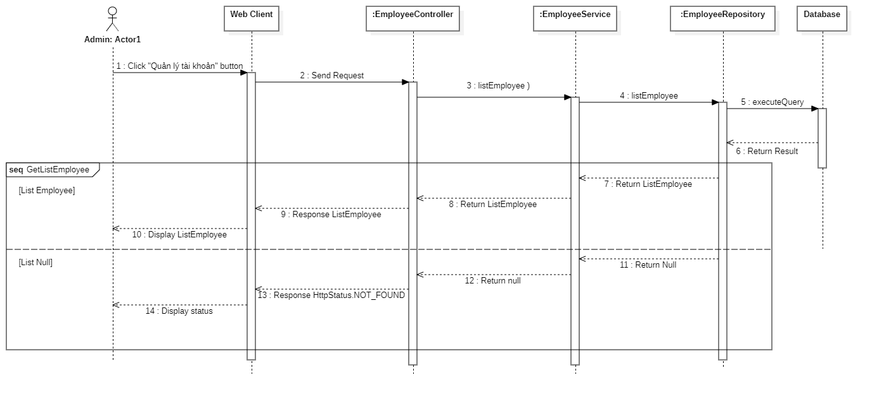

Figure 14: Get list employee

#### 3.3.4. Get employee detail

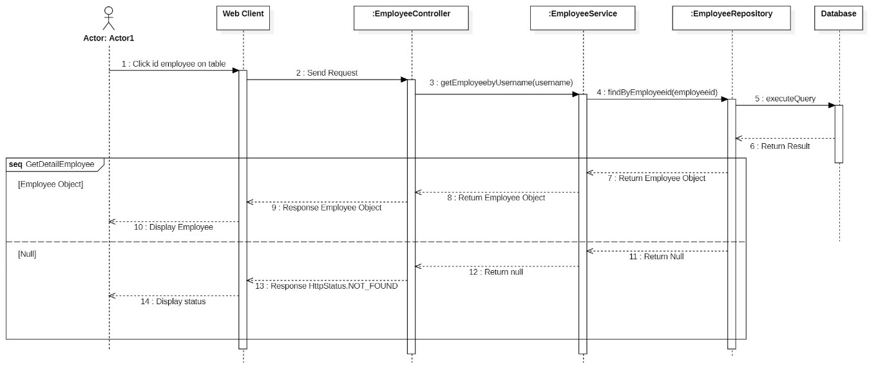

Figure 15: Get employee detail

#### 3.3.5. Add store

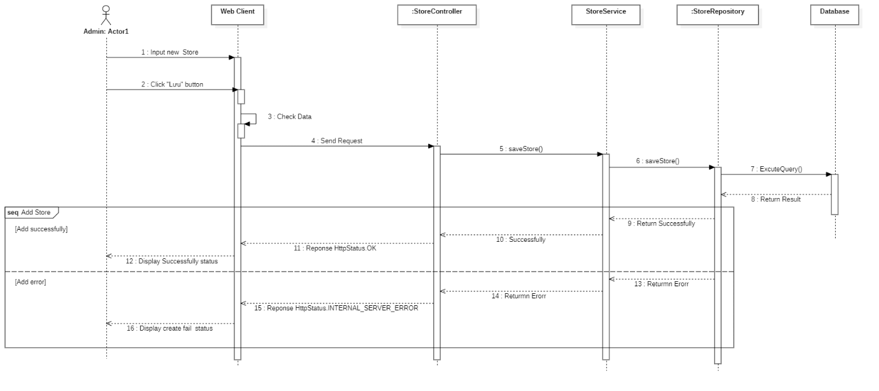

Figure 16: Add store

#### 3.3.6. Edit store

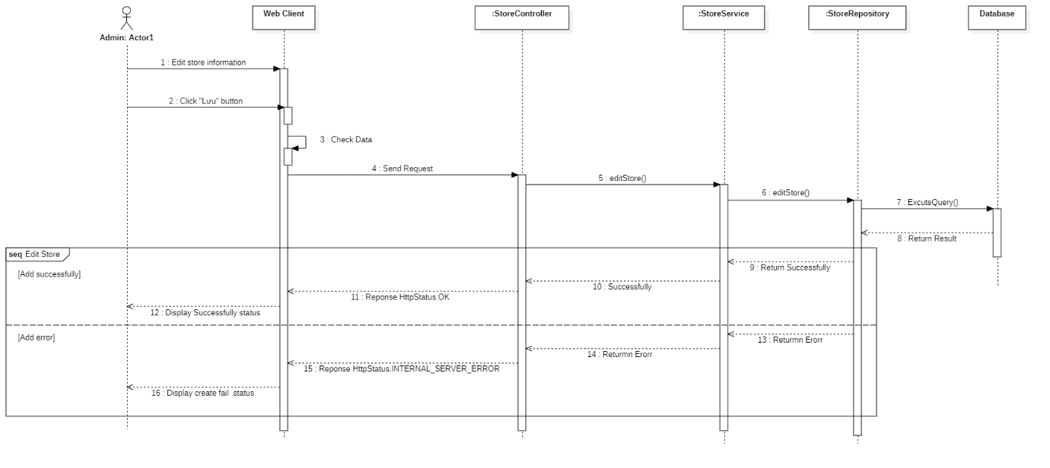

Figure 17: Edit store

#### 3.3.7. Get list store

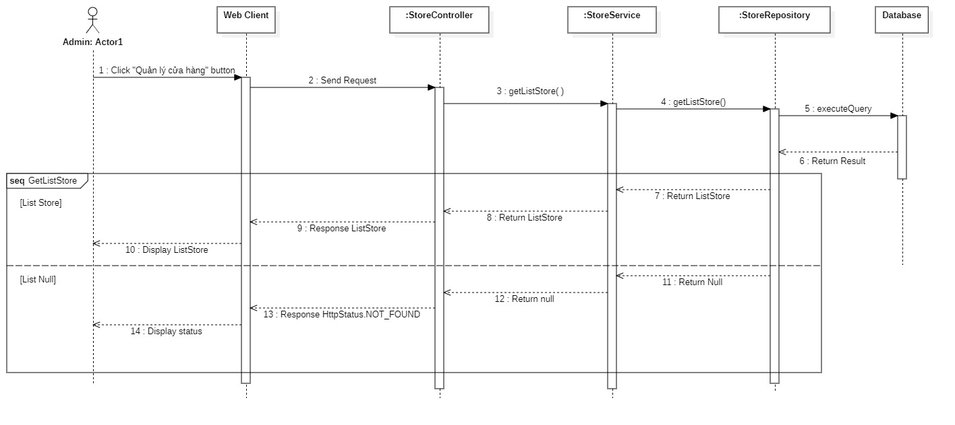

Figure 18: Get list store

#### 3.3.8. Get store detail

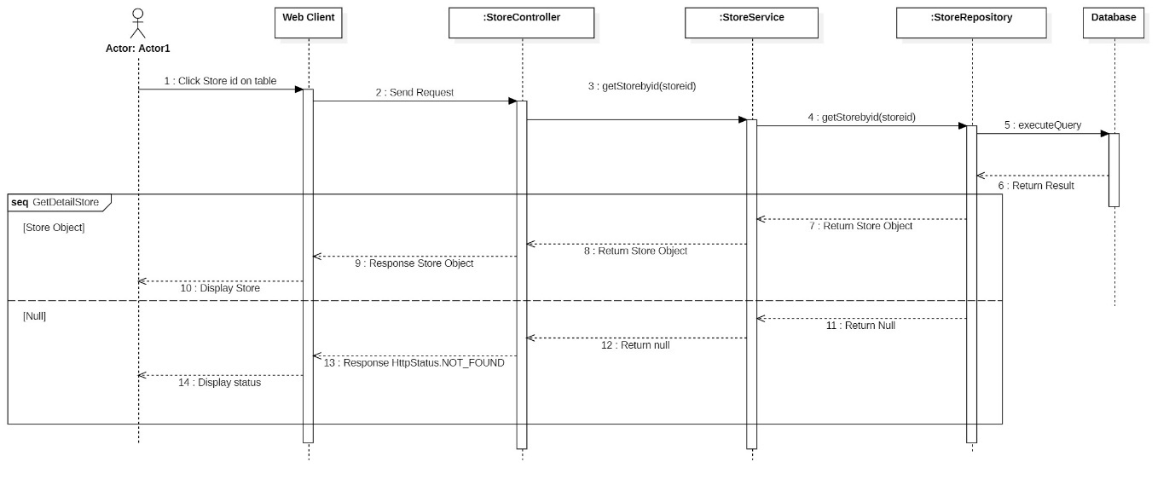

Figure 19: Get store detail

#### 3.3.9. Add warehouse

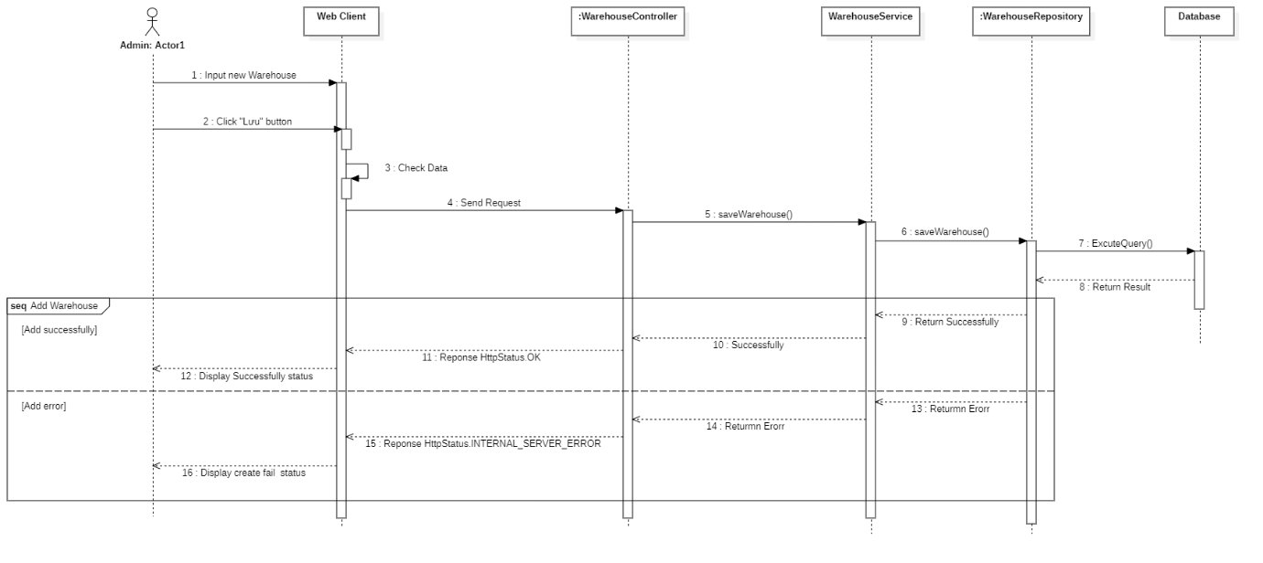

Figure 20: Add warehouse

#### 3.3.10. Edit warehouse

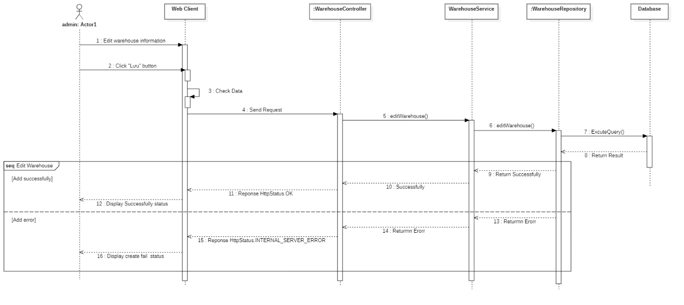

Figure 21: Edit warehouse

#### 3.3.11. Get list warehouse

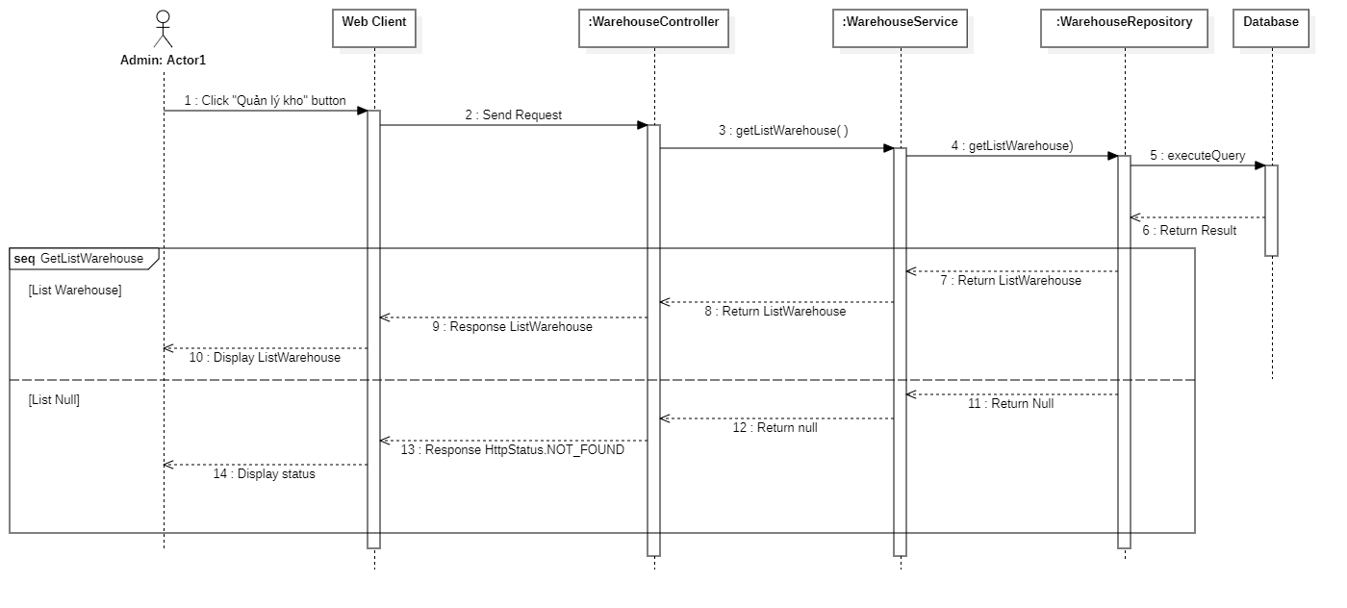

Figure 22: Get list warehouse

#### 3.3.12. Get warehouse detail

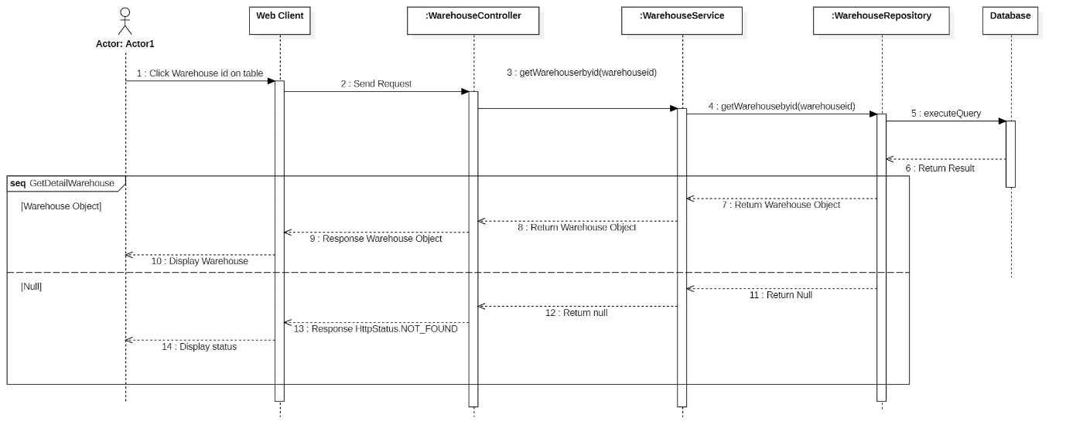

Figure 23: Get warehouse detail

#### 3.3.13 Create order

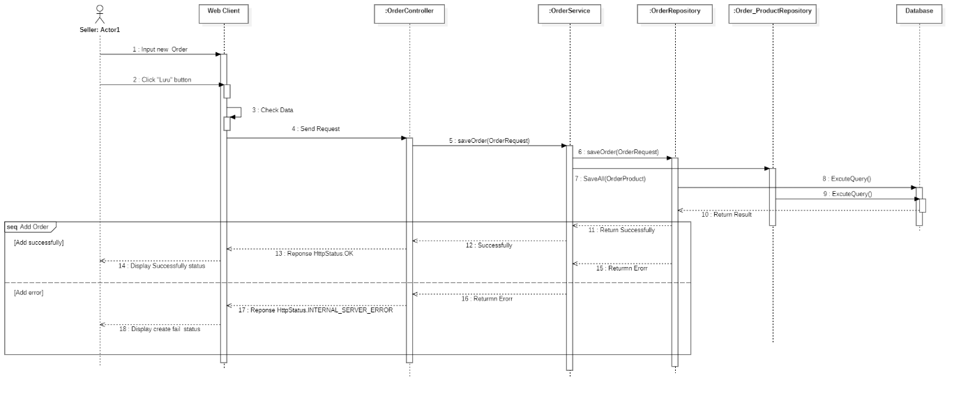

Figure 24: Create order

#### 3.3.14 Edit order

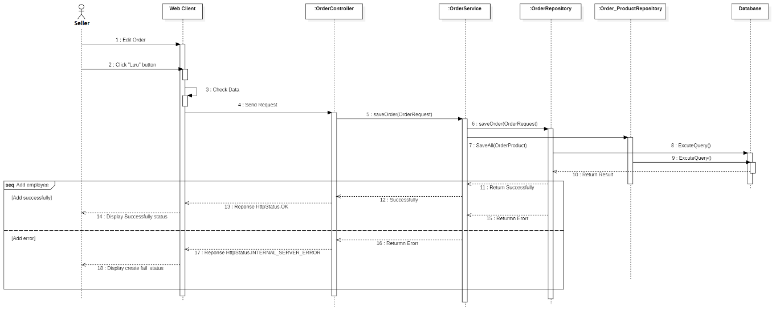

Figure 25: Edit order

#### 3.3.15 Get list order

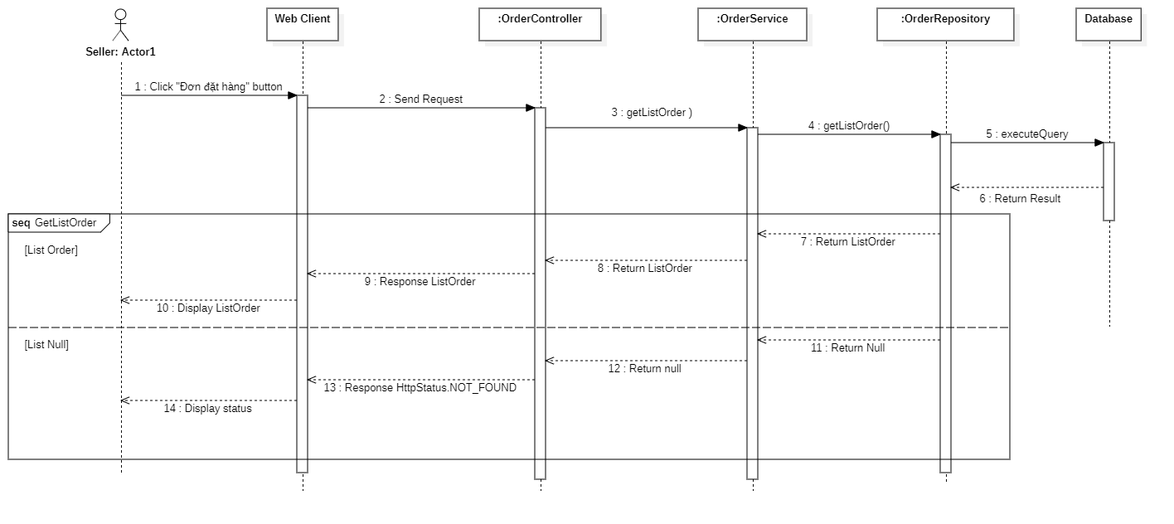

Figure 26: Get list order

#### 3.3.16 Get order detail

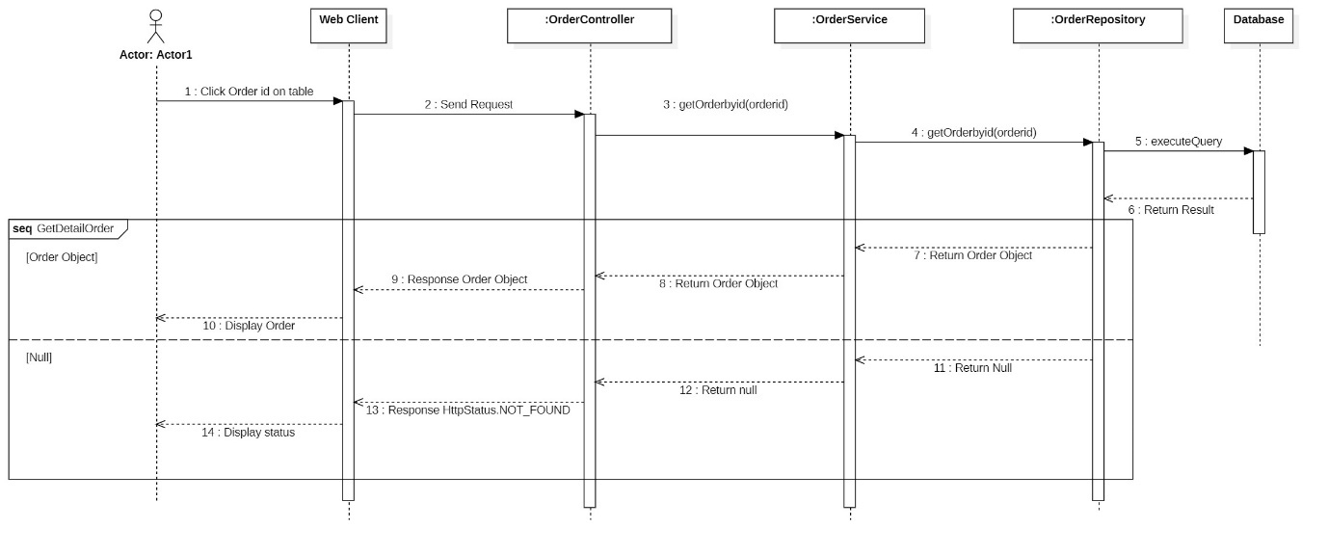

Figure 27: Get order detail

#### 3.3.17 Create invoice

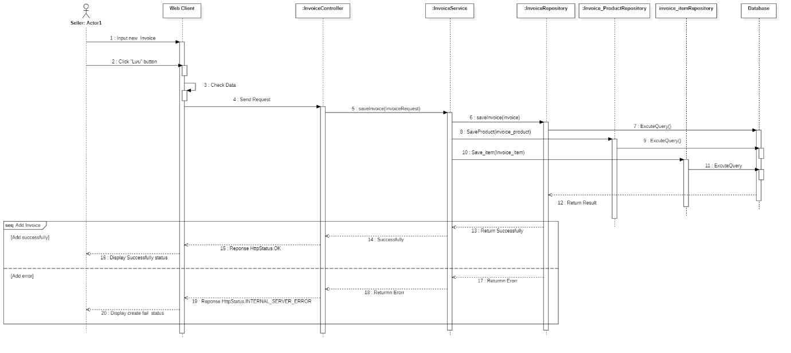

Figure 28: Create invoice

#### 3.3.18 Edit invoice

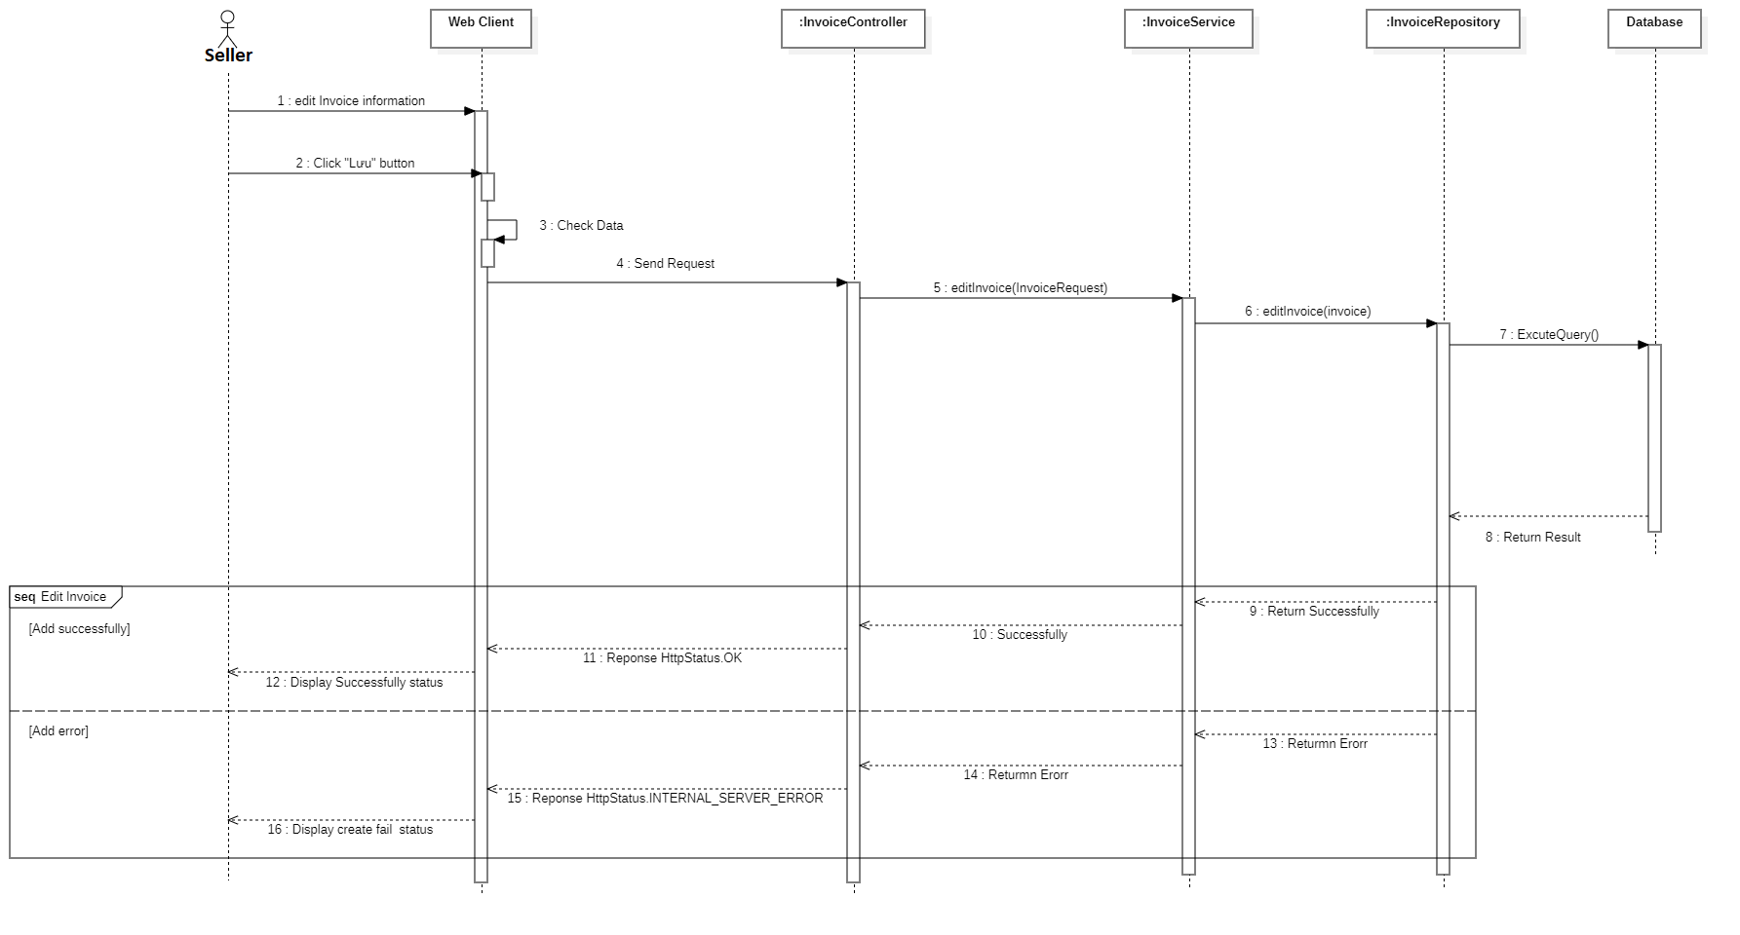

Figure 29: Edit invoice

#### 3.3.19 Get list invoice

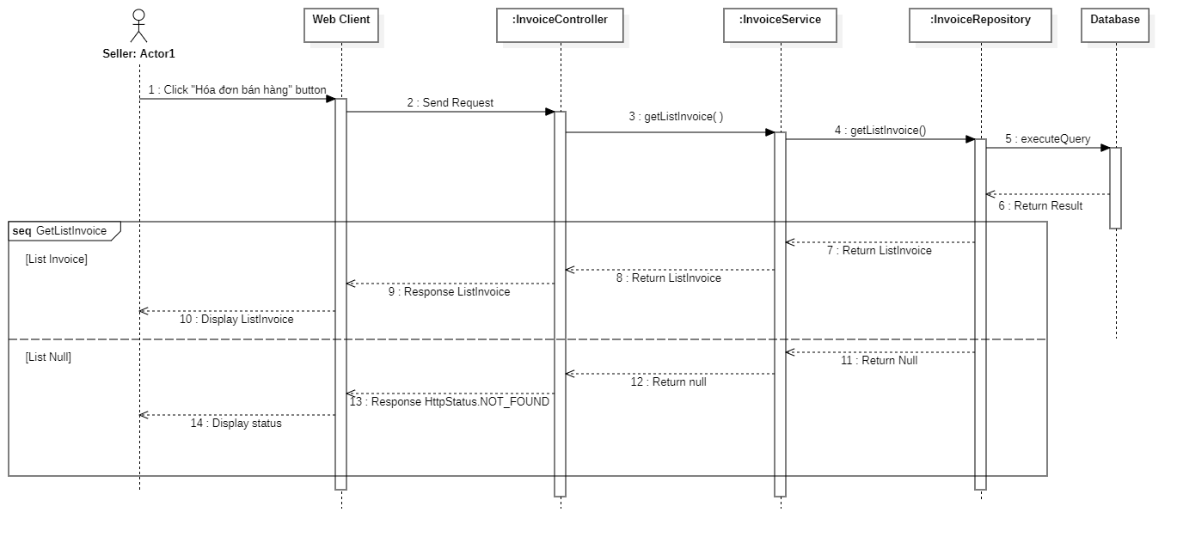

Figure 30: Get list invoice

#### 3.3.20 Get invoice detail

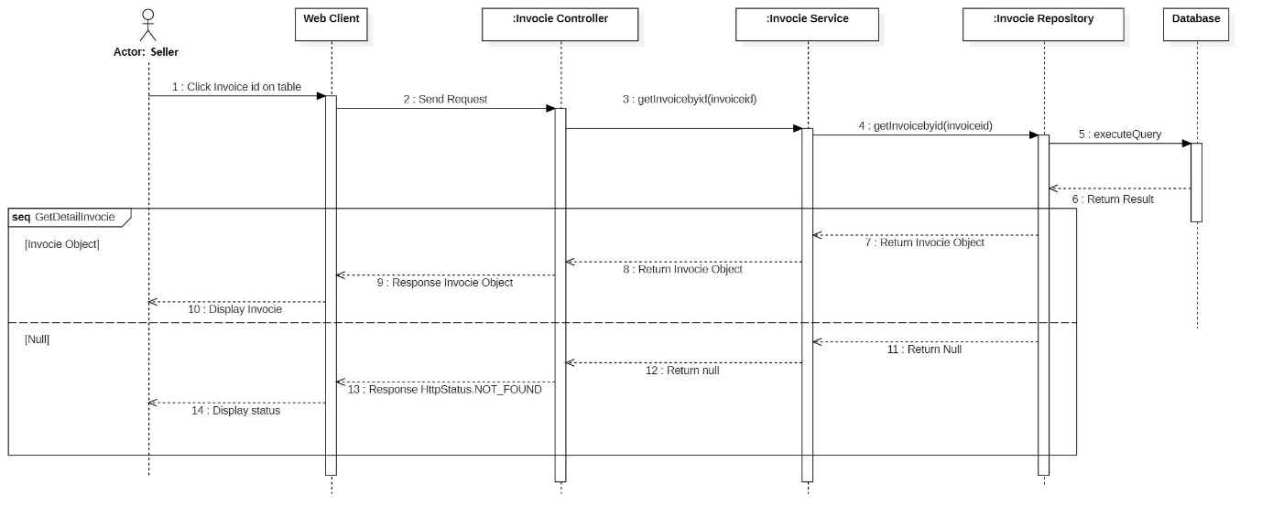

Figure 31: Get invoice detail

#### 3.3.21 Get list product by seller

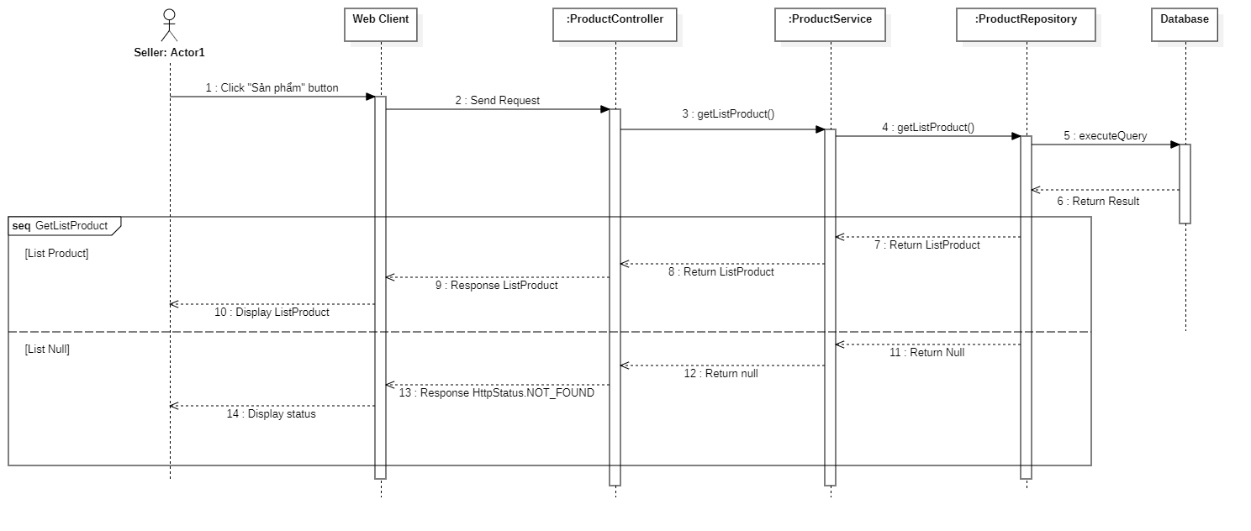

Figure 32: Get list product by seller

#### 3.3.22 Get product detail by seller

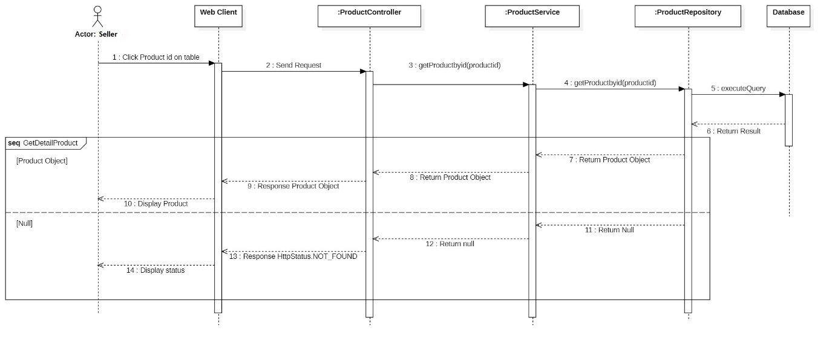

Figure 33: Get product detail by seller

#### 3.3.23 Get list order by store manager

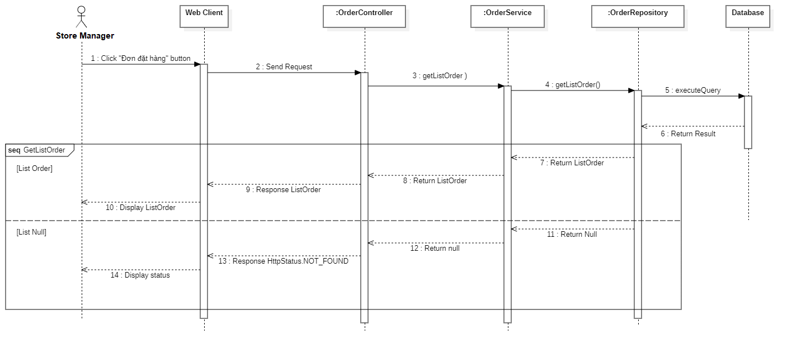

Figure 34: Get list order by store manager

#### 3.3.24 Get list product by store manager

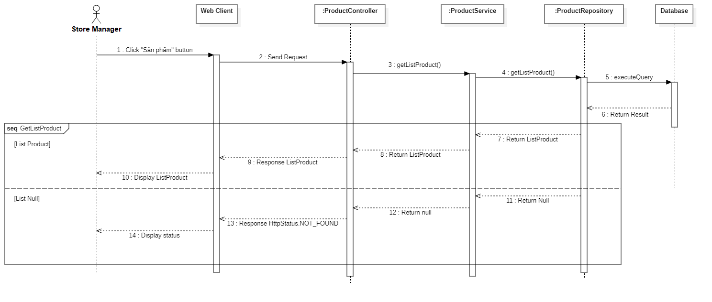

Figure 35: Get list product by store manager

#### 3.3.25 Get product detail by store manager

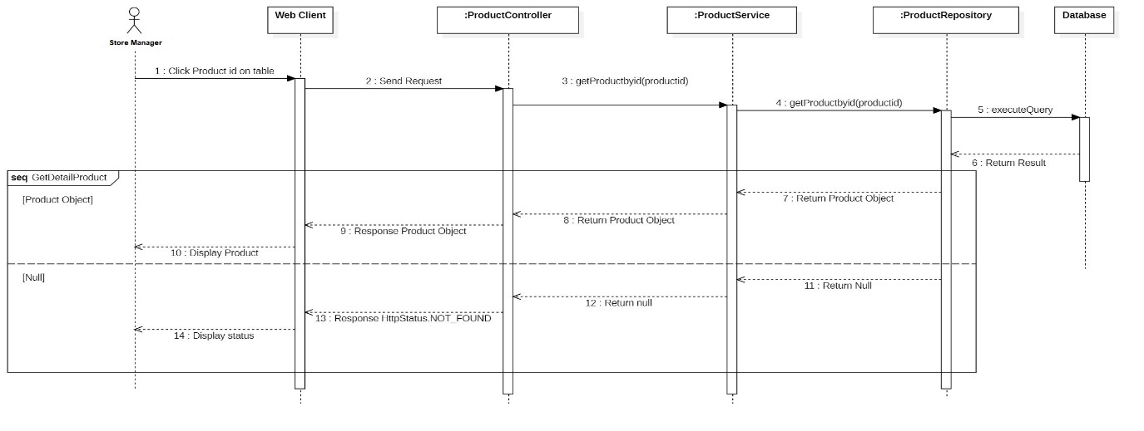

Figure 36: Get product detail by store manager

#### 3.3.26 Get list customer

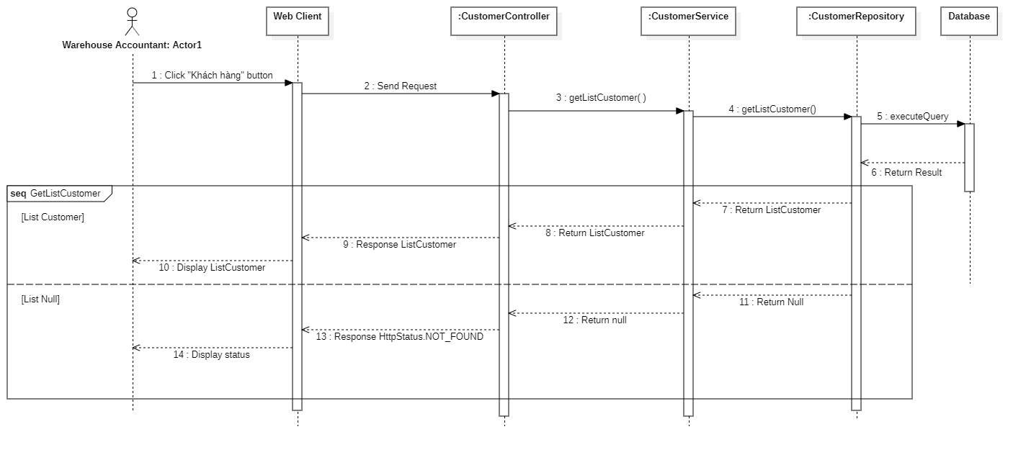

Figure 37: Get list customer

#### 3.3.27 Get customer detail

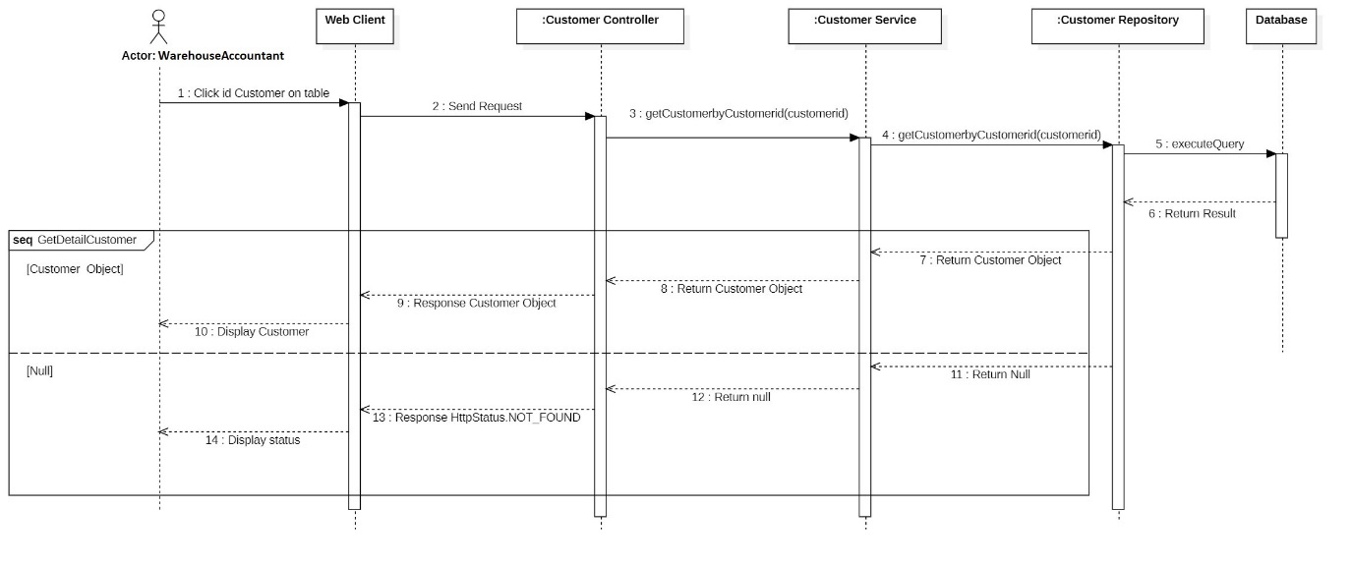

Figure 38: Get customer detail

#### 3.3.28 Create wholesale invoice

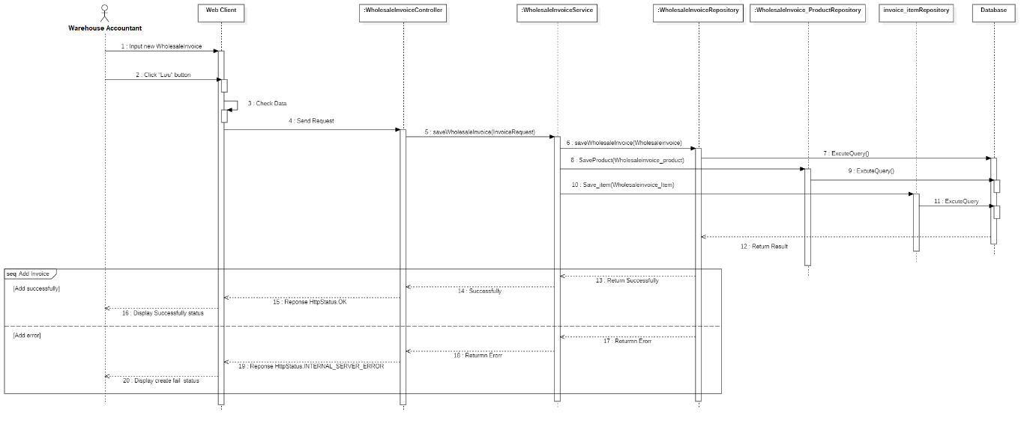

Figure 39: Create wholesale invoice

#### 3.3.29 Get list wholesale invoice

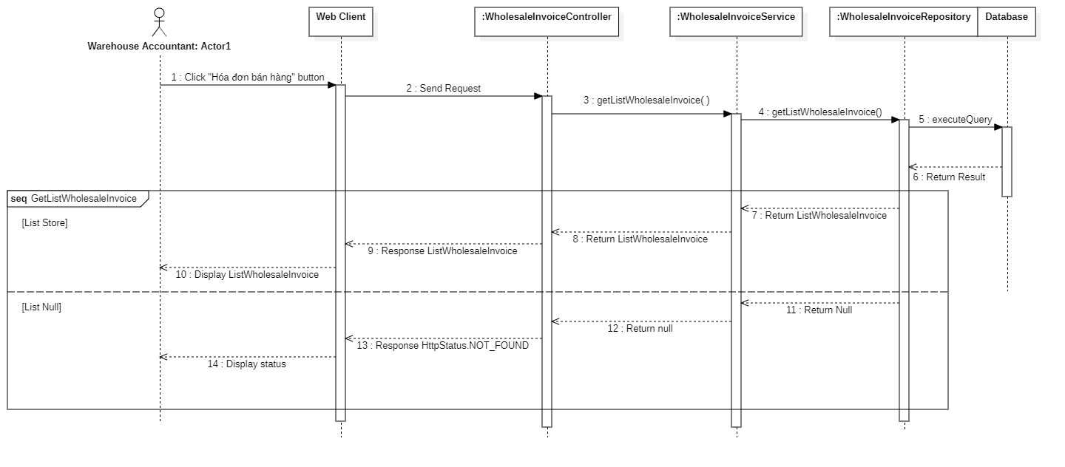

Figure 40: Get list wholesale invoice

#### 3.3.30 Get wholesale invoice detail

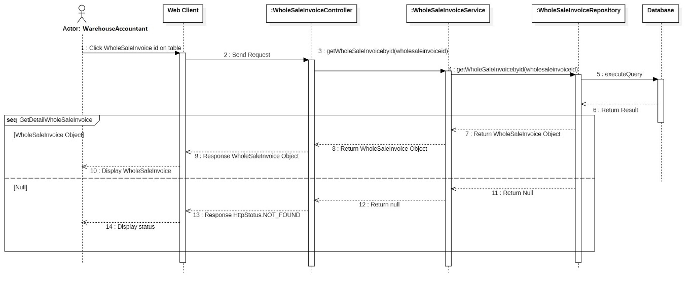

Figure 41: Get wholesale invoice detail

#### 3.3.31 Get list inventory transfer print

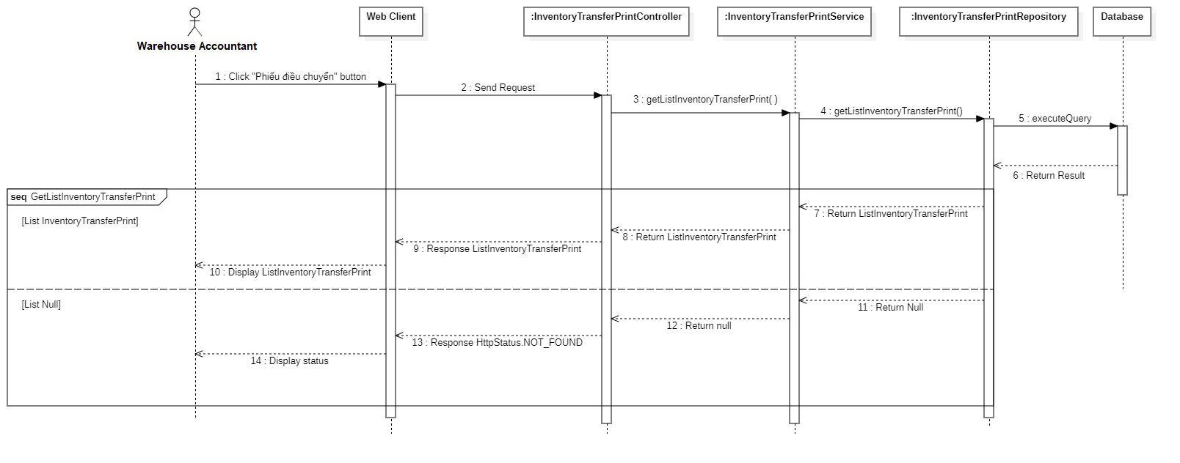

Figure 42: Get list inventory transfer print

#### 3.3.32 Get inventory transfer print detail

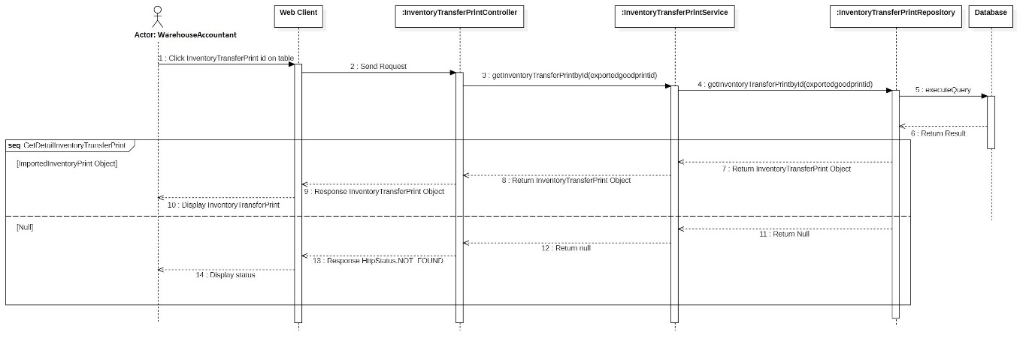

Figure 43: Get inventory transfer print detail

#### 3.3.33 Get list imported goods print

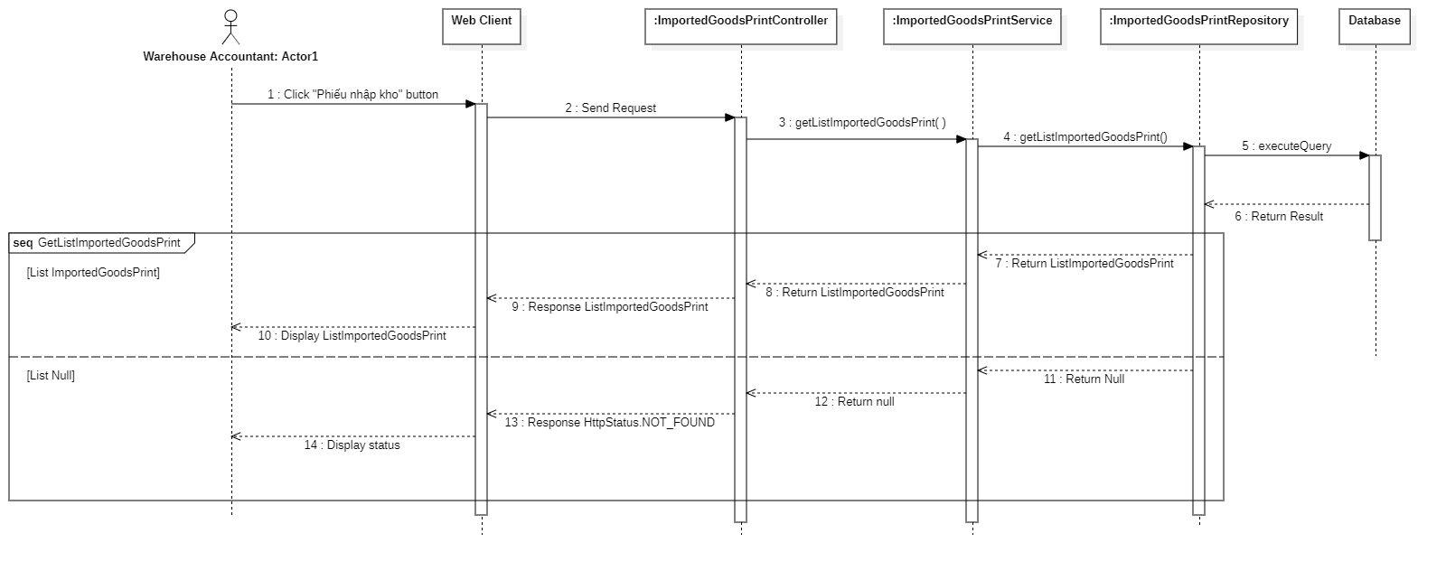

Figure 44: Get list imported goods print

#### 3.3.34 Get imported goods print detail

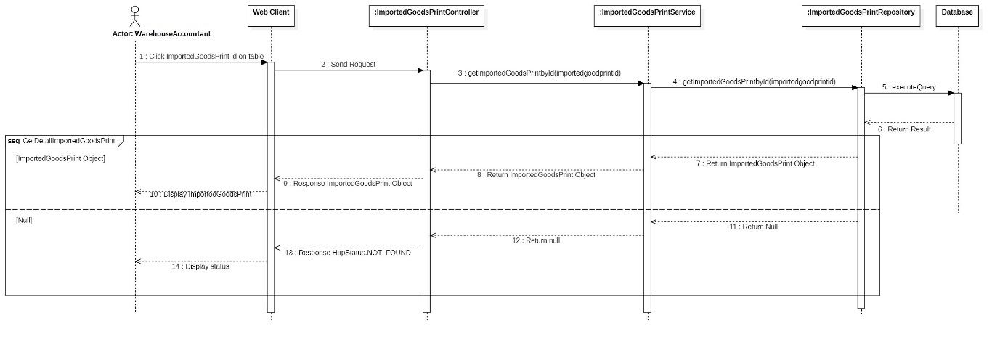

Figure 45: Get imported goods print detail

#### 3.3.35 Get list exported goods print

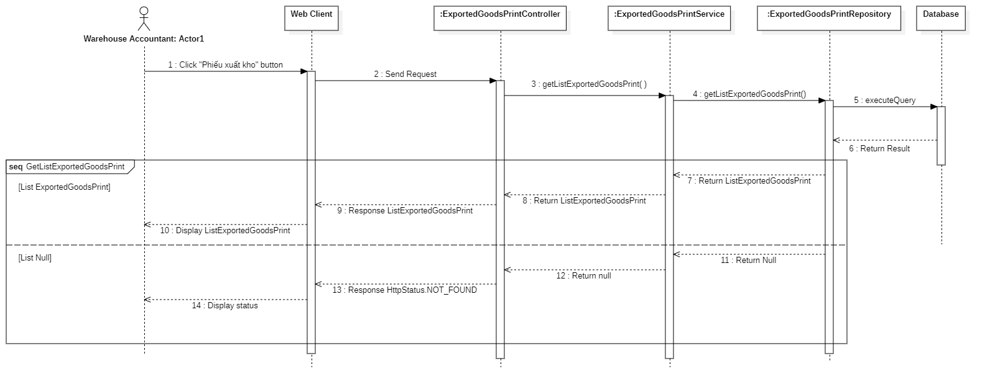

Figure 46: Get list exported goods print

#### 3.3.36 Get exported goods print detail

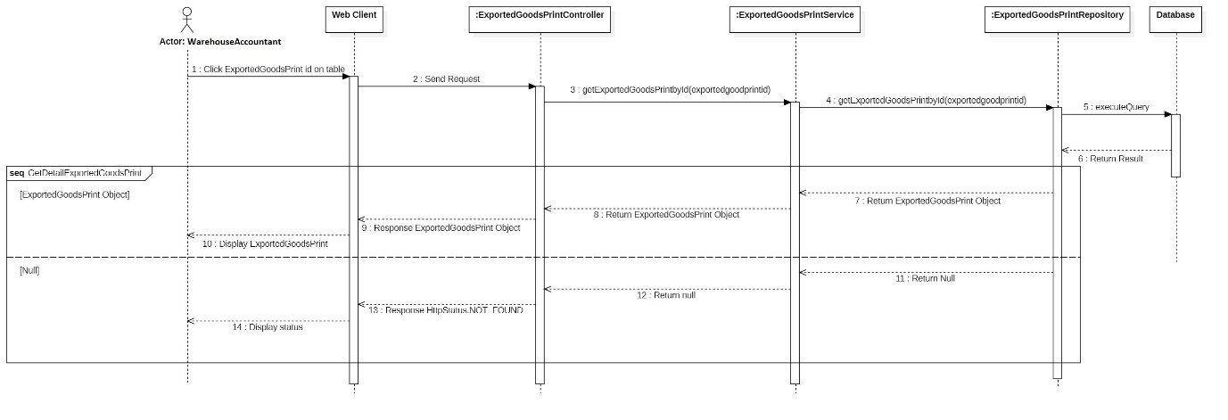

Figure 47: Get exported goods print detail

#### 3.3.37 Get list product

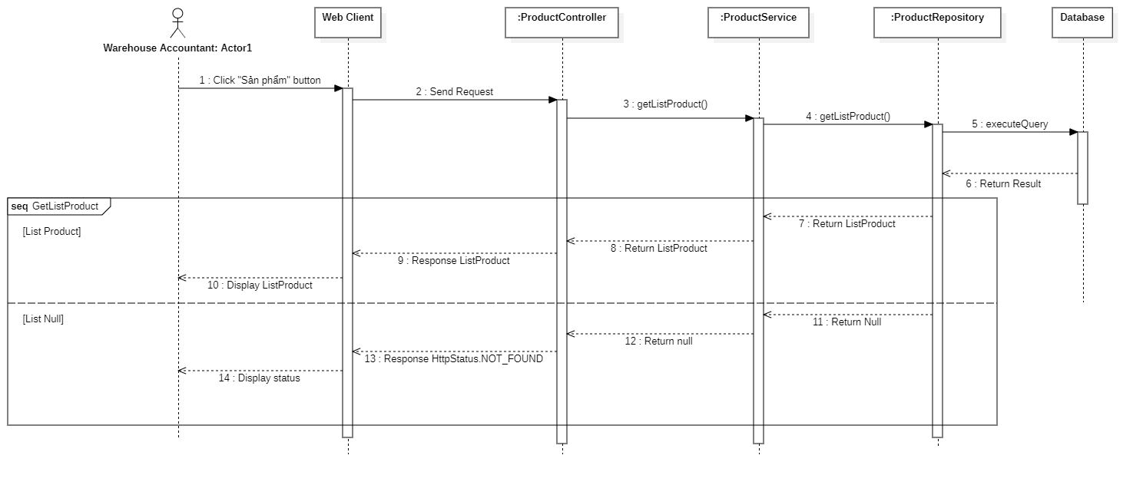

Figure 48: Get list product

#### 3.3.38 Get list account payable

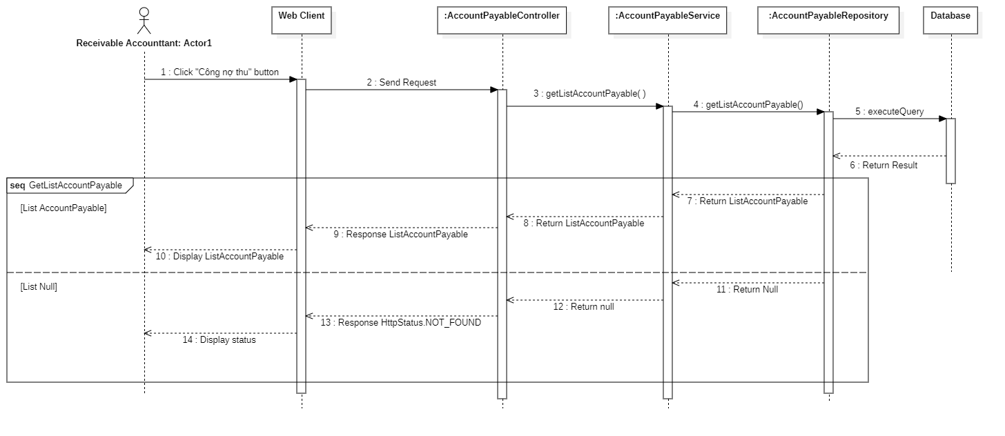

Figure 49: Get list account payable

#### 3.3.39 Get list account receivable



Figure 50: Get list account receivable

#### 3.3.40. Get list store by receivable accountant

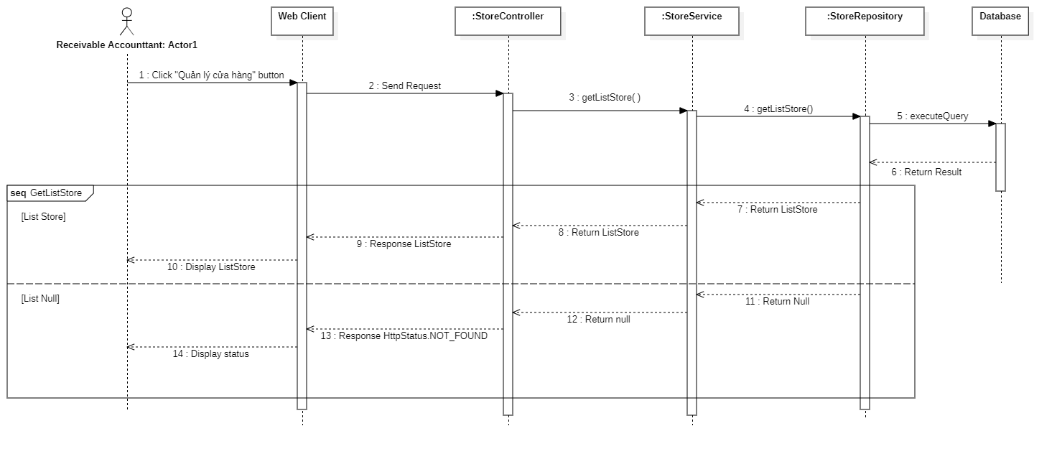

Figure 51: Get list store by receivable accountant

#### 3.3.41 Get list customer by receivable accountant

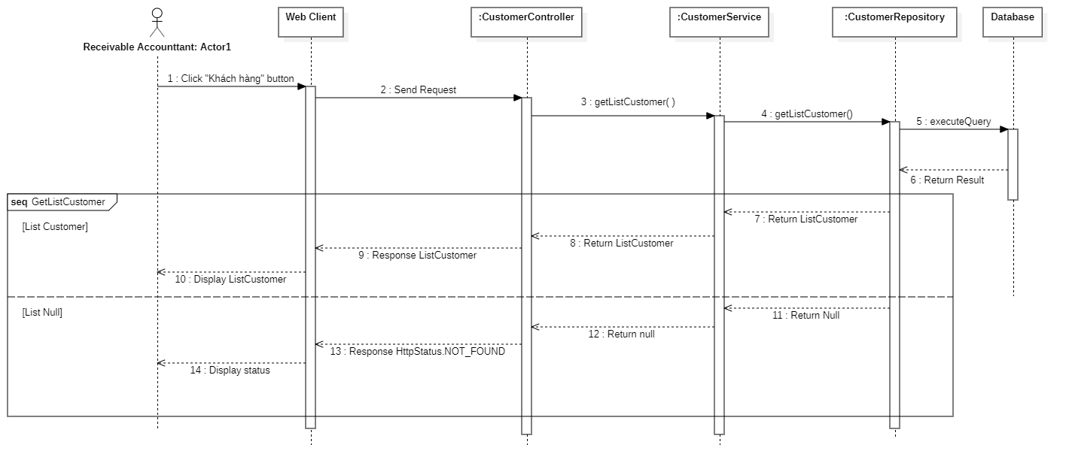

Figure 52: Get list customer by receivable accountant

#### 3.3.42 Get list purchase order

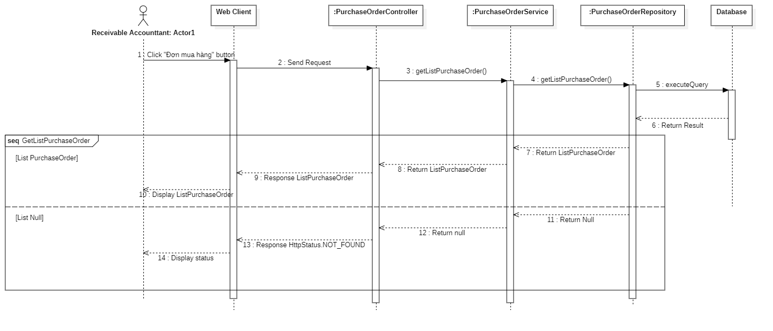

Figure 53: Get list purchase order

#### 3.3.43 Get purchase order detail

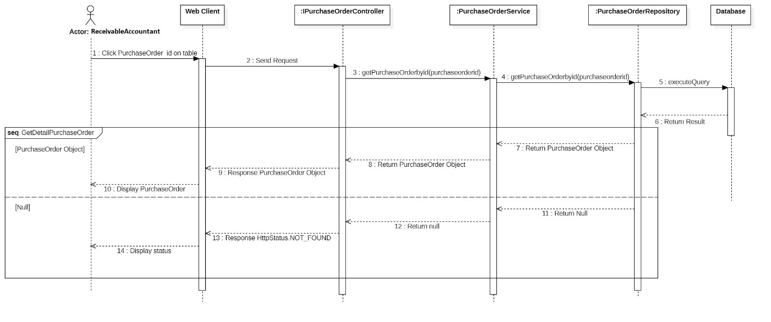

Figure 54: Get purchase order detail

#### 3.3.44 Create imported inventory print

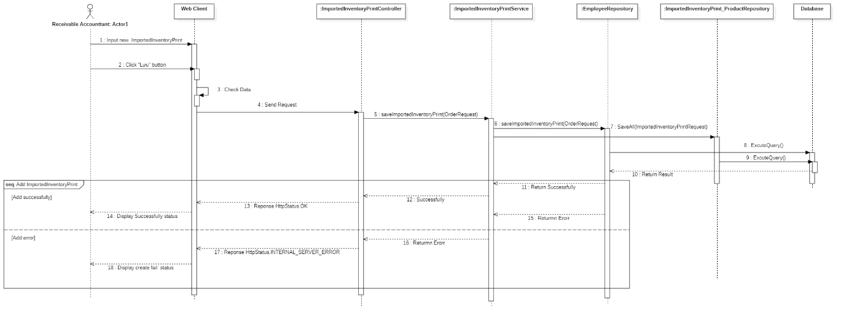

Figure 55: Create imported inventory print

#### 3.3.45 Get list imported inventory print

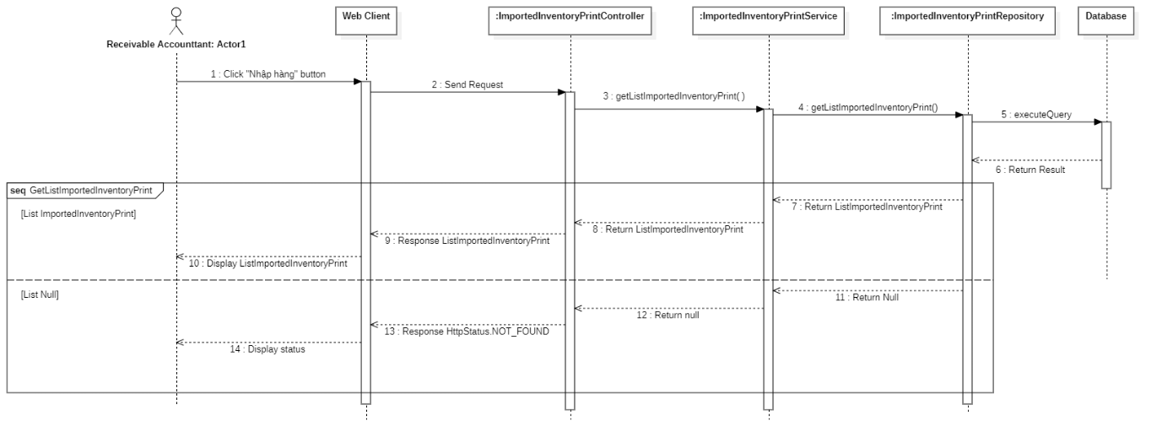

Figure 56: Get list imported inventory print

#### 3.3.46 Get imported inventory print detail

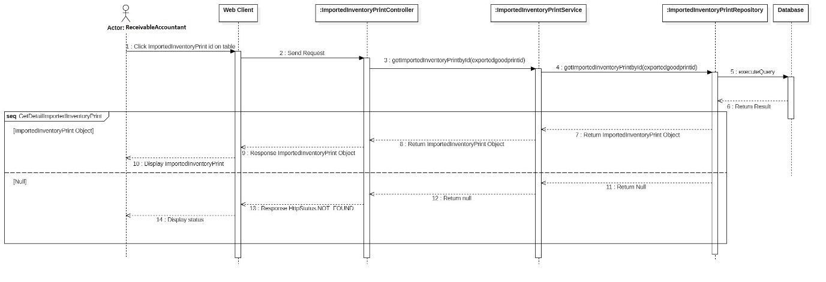

Figure 57: Get imported inventory print detail

#### 3.3.47 Create supplier

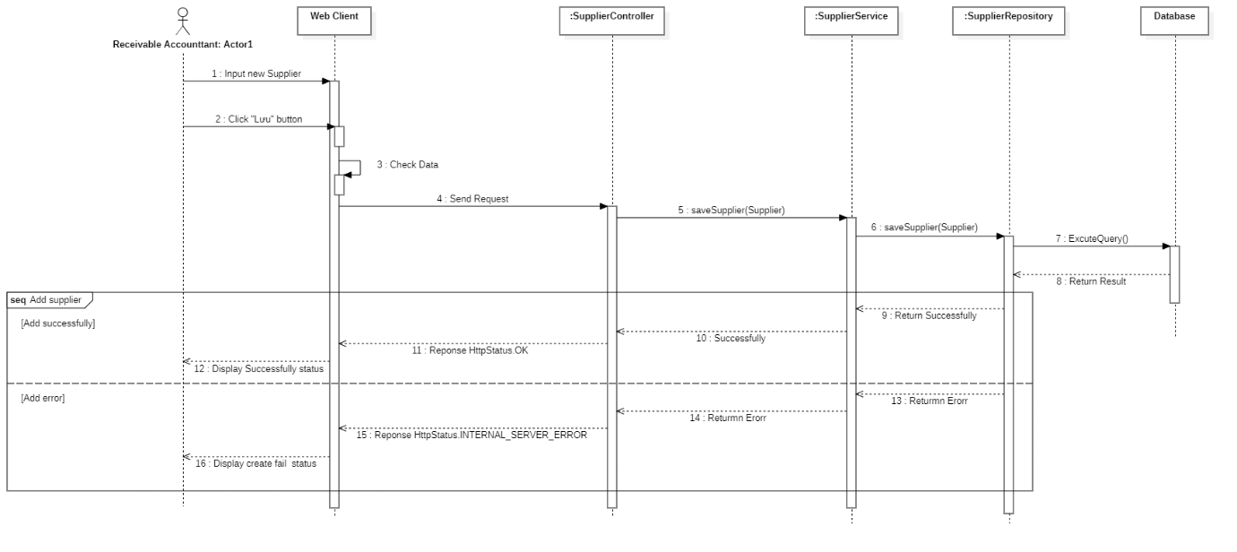

Figure 58: Create supplier

#### 3.3.48 Get list supplier

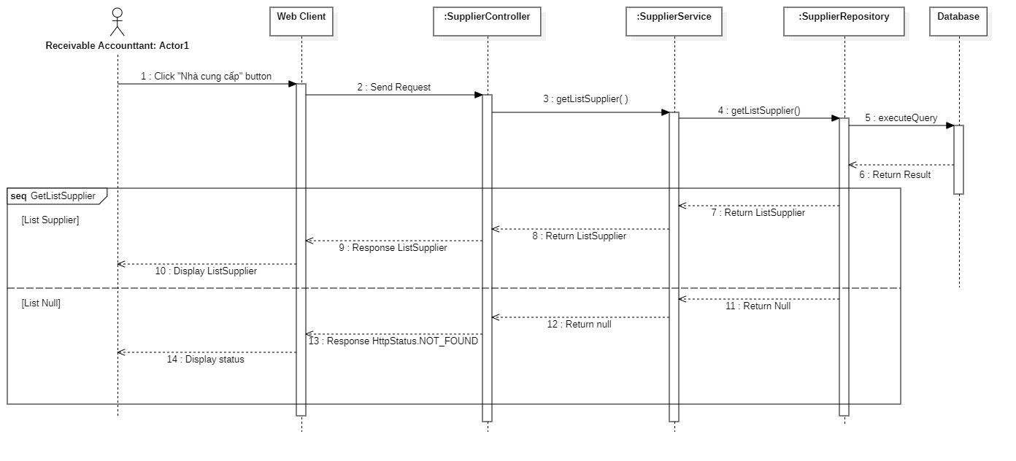

Figure 59: Get list supplier

#### 3.3.49 Get supplier detail

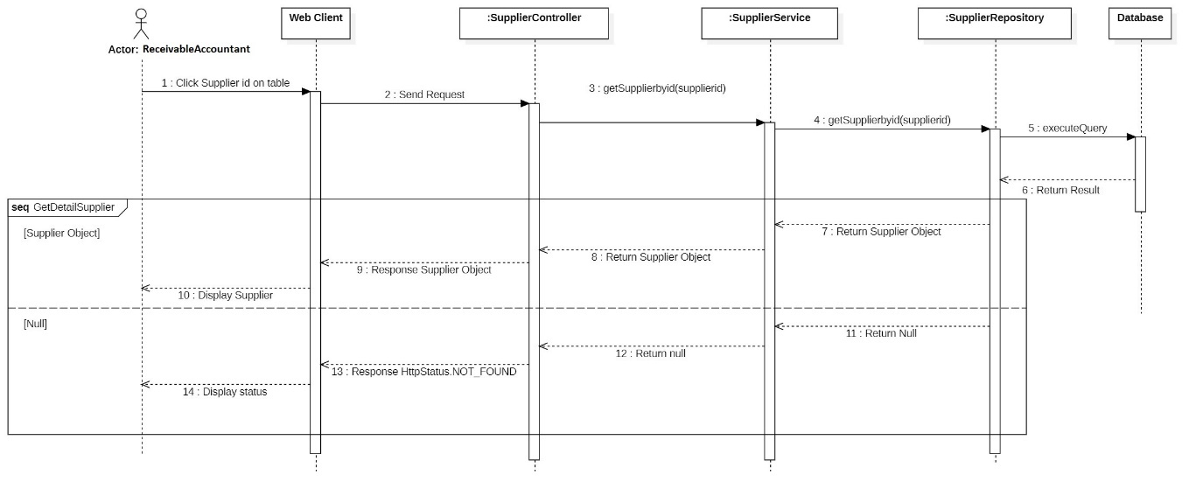

Figure 60: Get supplier detail

#### 3.3.50 Edit supplier

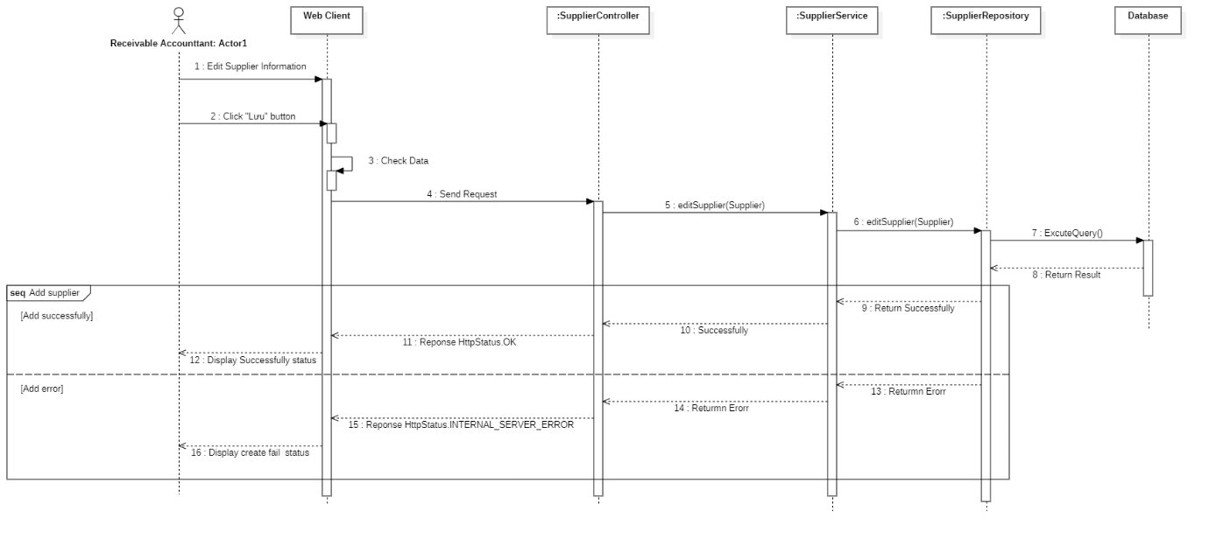

Figure 61: Edit supplier

#### 3.3.51 Create product

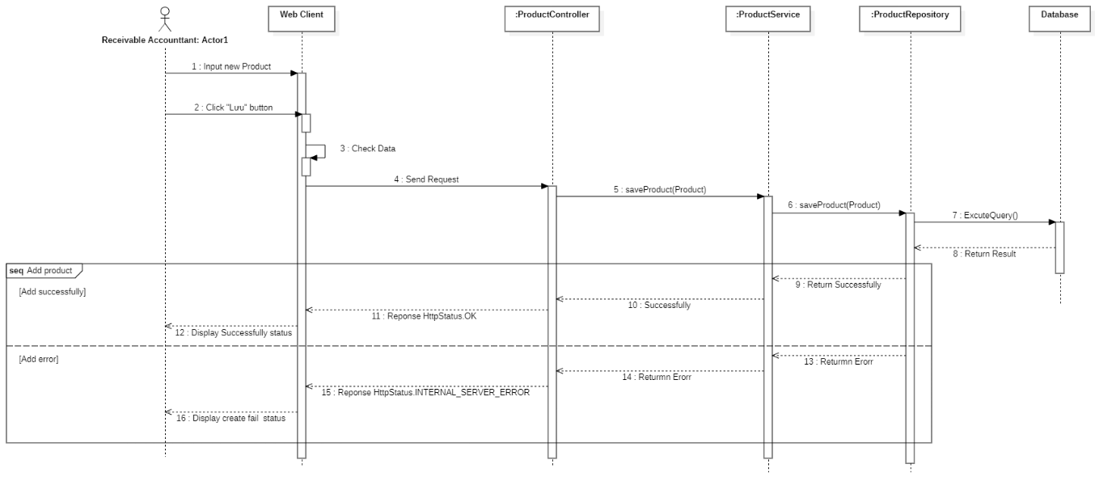

Figure 62: Create product

#### 3.3.52 Edit product

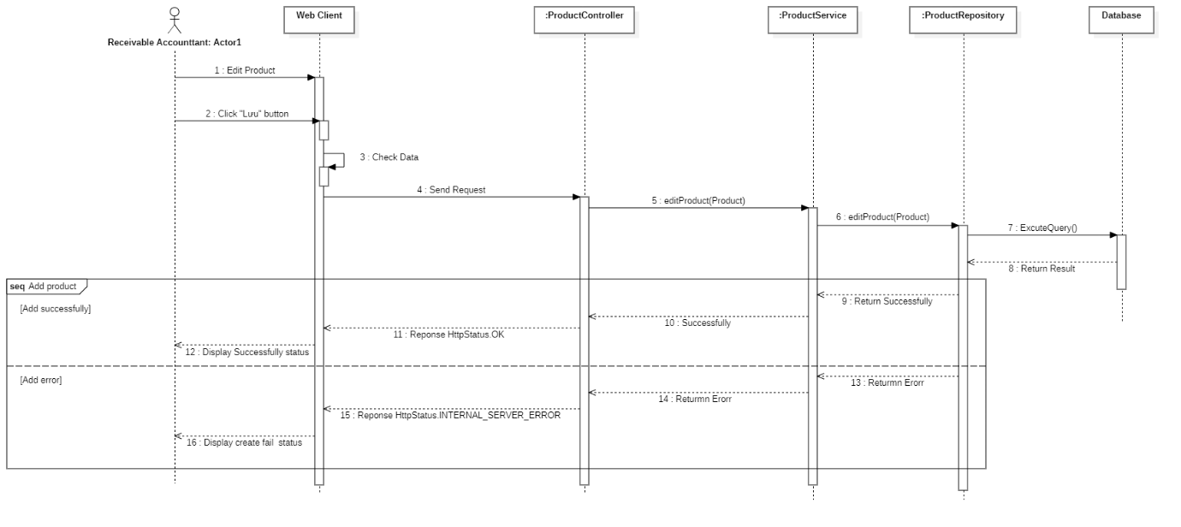

Figure 63: Edit product

#### 3.3.53 Get list product by receivable accountant

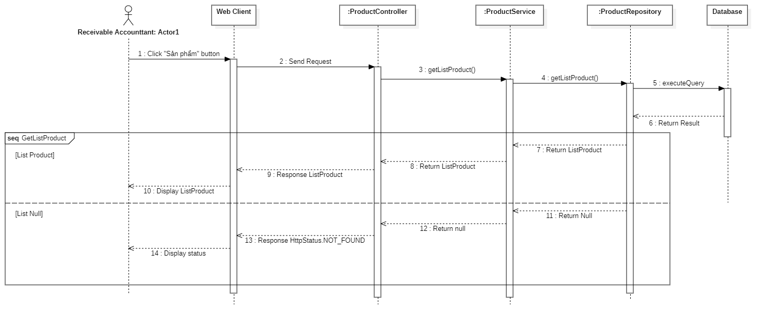

Figure 64: Get list product by receivable accountant

#### 3.3.54 Get product detail by receivable accountant

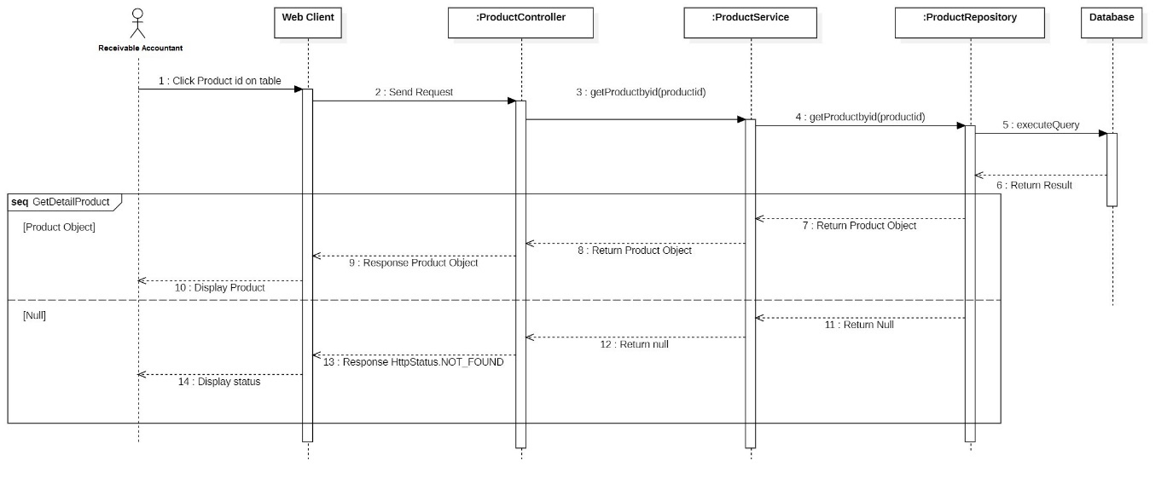

Figure 65: Get list product by receivable accountant

#### 3.3.55 Login

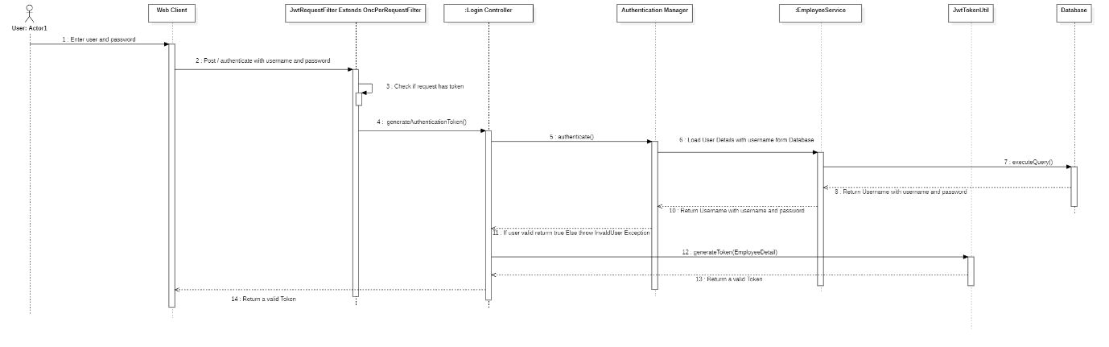

Figure 66: Login

## 4. Data & Database Design

### 4.1 Database Design

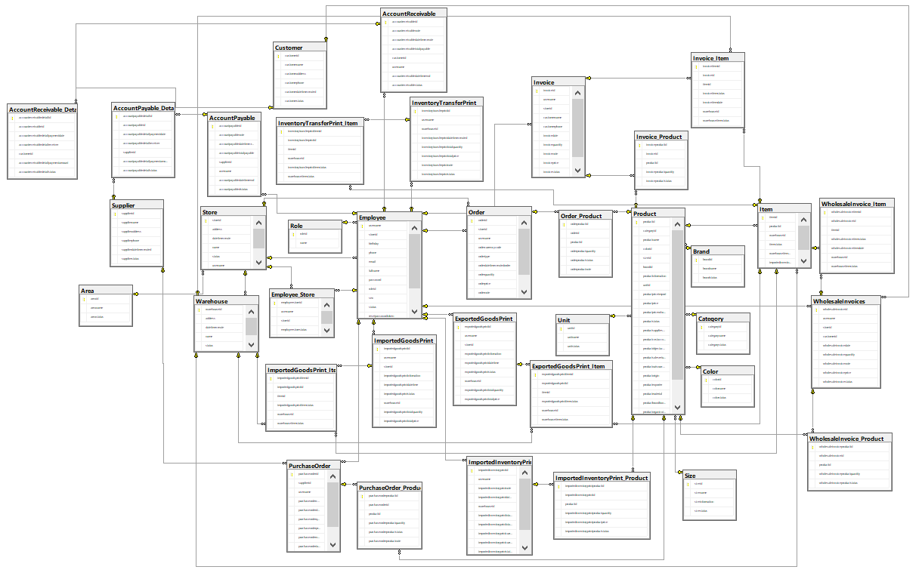

Figure 67: Database Design

#### 4.1.1. Employee

|  |  |  |  |  |  |  |
| --- | --- | --- | --- | --- | --- | --- |
| **Field name** | **Type** | **Size** | **Unique** | **Not Null** | **PK/FK** | **Notes** |
| username | nvarchar | 50 |  | X | PK |  |
| storeid | nvarchar | 20 |  |  | FK |  |
| phone | nvarchar | 50 |  |  |  |  |
| password | nvarchar | 250 |  |  |  |  |
| warehouseid | nvarchar | 50 |  |  | FK |  |
| fullname | nvarchar | 50 |  |  |  |  |
| sex | nvarchar | 10 |  |  |  |  |
| birthday | date |  |  |  |  |  |
| email | nvarchar | 50 |  |  |  |  |
| datetimecreated | datetime |  |  |  |  |  |
| roleid | nvarchar | 50 |  |  | FK |  |
| status | nvarchar | 20 |  |  |  |  |
| resetpasswordtoken | nvarchar | 50 |  |  |  |  |
| expirydate | datetime |  |  |  |  |  |

Table 175: Employee

#### 4.1.2. Area

|  |  |  |  |  |  |  |
| --- | --- | --- | --- | --- | --- | --- |
| **Field name** | **Type** | **Size** | **Unique** | **Not Null** | **PK/FK** | **Notes** |
| areaid | nvarchar | 50 |  | X | PK |  |
| areaname | nvarchar | 100 |  |  |  |  |
| areastatus | nvarchar | 50 |  |  |  |  |
|  |  |  |  |  |  |  |

Table 176: Area

#### 4.1.3. AccountPayable

|  |  |  |  |  |  |  |
| --- | --- | --- | --- | --- | --- | --- |
| **Field name** | **Type** | **Size** | **Unique** | **Not Null** | **PK/FK** | **Notes** |
| accountpayableid | nvarchar | 50 |  | X | PK |  |
| accountpayablenote | nvarchar | 3000 |  |  |  |  |
| accountpayabledatetimecreate | datetime |  |  |  |  |  |
| accountpayabletotalpayable | float |  |  |  |  |  |
| supplierid | nvarchar | 50 |  |  | FK |  |
| username | nvarchar | 20 |  |  | FK |  |
| accountpayabledatetimeend | datetime |  |  |  |  |  |
| accountpayabledstatus | nvarchar | 50 |  |  |  |  |

Table 177: AccountPayable

#### 4.1.4. AccountPayable_Detail

|  |  |  |  |  |  |  |
| --- | --- | --- | --- | --- | --- | --- |
| **Field name** | **Type** | **Size** | **Unique** | **Not Null** | **PK/FK** | **Notes** |
| accountpayabledetailid | int |  |  | X | PK |  |
| accountpayableid | nvarchar | 50 |  |  | FK |  |
| accountpayabledetailpaymentdate | datetime |  |  |  |  |  |
| accountpayabledetailreceiver | nvarchar | 100 |  |  |  |  |
| supplierid | nvarchar | 50 |  |  | FK |  |
| accountpayabledetailpaymentamount | float |  |  |  |  |  |
| accountpayabledetailstatus | nvarchar | 50 |  |  |  |  |

Table 178: AccountPayable_Detail

#### 4.1.5. AccountReceivable

|  |  |  |  |  |  |  |
| --- | --- | --- | --- | --- | --- | --- |
| **Field name** | **Type** | **Size** | **Unique** | **Not Null** | **PK/FK** | **Notes** |
| accountreceivableid | nvarchar | 50 |  | X | PK |  |
| accountreceivablenote | nvarchar | 3000 |  |  |  |  |
| accountreceivabledatetimecreate | datetime |  |  |  |  |  |
| accountreceivabletotalpayable | float |  |  |  |  |  |
| customerid | nvarchar | 50 |  |  | FK |  |
| username | nvarchar | 20 |  |  | FK |  |
| accountreceivabledatetimeend | datetime |  |  |  |  |  |
| accountreceivablestatus | nvarchar | 50 |  |  |  |  |

Table 179: AccountReceivable

#### 4.1.6. AccountReceivable_Detail

|  |  |  |  |  |  |  |
| --- | --- | --- | --- | --- | --- | --- |
| **Field name** | **Type** | **Size** | **Unique** | **Not Null** | **PK/FK** | **Notes** |
| accountreceivabledetailid | int |  |  | X | PK |  |
| accountreceivableid | nvarchar | 50 |  |  | FK |  |
| accountreceivabledetailpaymentdate | datetime |  |  |  |  |  |
| accountreceivabledetailreceiver | nvarchar | 100 |  |  |  |  |
| customerid | nvarchar | 50 |  |  | FK |  |
| accountreceivabledetailpaymentamount | float |  |  |  |  |  |
| accountreceivabledetailstatus | nvarchar | 50 |  |  |  |  |

Table 180: AccountReceivable_Detail

#### 4.1.7. Brand

|  |  |  |  |  |  |  |
| --- | --- | --- | --- | --- | --- | --- |
| **Field name** | **Type** | **Size** | **Unique** | **Not Null** | **PK/FK** | **Notes** |
| brandid | nvarchar | 50 |  | X | PK |  |
| brandname | nvarchar | 100 |  |  |  |  |
| brandstatus | nvarchar | 20 |  |  |  |  |

Table 181: Brand

#### 4.1.8. Category

|  |  |  |  |  |  |  |
| --- | --- | --- | --- | --- | --- | --- |
| **Field name** | **Type** | **Size** | **Unique** | **Not Null** | **PK/FK** | **Notes** |
| categoryid | nvarchar | 100 |  | X | PK |  |
| categoryname | nvarchar | 100 |  |  |  |  |
| categorystatus | nvarchar | 50 |  |  |  |  |

Table 182: Category

#### 4.1.9. Color

|  |  |  |  |  |  |  |
| --- | --- | --- | --- | --- | --- | --- |
| **Field name** | **Type** | **Size** | **Unique** | **Not Null** | **PK/FK** | **Notes** |
| colorid | nvarchar | 50 |  | X | PK |  |
| colorname | nvarchar | 50 |  |  |  |  |
| colorstatus | nvarchar | 50 |  |  |  |  |

Table 183: Color

#### 4.1.10. Customer

|  |  |  |  |  |  |  |
| --- | --- | --- | --- | --- | --- | --- |
| **Field name** | **Type** | **Size** | **Unique** | **Not Null** | **PK/FK** | **Notes** |
| customerid | nvarchar | 50 |  | X | PK |  |
| customername | nvarchar | 50 |  |  |  |  |
| customeraddress | nvarchar | 500 |  |  |  |  |
| customerphone | nvarchar | 20 |  |  |  |  |
| customerdatetimecreated | datetime |  |  |  |  |  |
| customerstatus | nvarchar | 50 |  |  |  |  |

Table 184: Customer

#### 4.1.11. Employee_Store

|  |  |  |  |  |  |  |
| --- | --- | --- | --- | --- | --- | --- |
| **Field name** | **Type** | **Size** | **Unique** | **Not Null** | **PK/FK** | **Notes** |
| employeestoreid | int |  |  | X | PK |  |
| username | nvarchar | 20 |  |  | FK |  |
| storeid | nvarchar | 20 |  |  | FK |  |
| employeestorestatus | nvarchar | 20 |  |  |  |  |
| employeestoreatetimecreate | datetime |  |  |  |  |  |

Table 185: Employee_Store

#### 4.1.12. ExportedGoodPrint

|  |  |  |  |  |  |  |
| --- | --- | --- | --- | --- | --- | --- |
| **Field name** | **Type** | **Size** | **Unique** | **Not Null** | **PK/FK** | **Notes** |
| exportedgoodsprintid | nvarchar | 20 |  | X | PK |  |
| username | nvarchar | 20 |  |  | FK |  |
| storeid | nvarchar | 20 |  |  | FK |  |
| exportedgoodsprintinfomation | nvarchar |  |  |  |  |  |
| exportedgoodsprintdatetime | datetime |  |  |  |  |  |
| exportedgoodsprintstatus | nvarchar |  |  |  |  |  |
| warehouseid | nvarchar |  |  |  | FK |  |
| exportedgoodsprinttotalquantity | int |  |  |  |  |  |
| exportedgoodsprinttotalprice | float |  |  |  |  |  |

Table 186: ExportedGoodPrint

#### 4.1.13. ExportedGoodsPrint_Item

|  |  |  |  |  |  |  |
| --- | --- | --- | --- | --- | --- | --- |
| **Field name** | **Type** | **Size** | **Unique** | **Not Null** | **PK/FK** | **Notes** |
| exportedgoodsprintitemid | int |  |  | X | PK |  |
| exportedgoodsprintid | nvarchar | 20 |  |  | FK |  |
| itemid | int |  |  |  | FK |  |
| exportedgoodsprintitemstatus | nvarchar | 20 |  |  |  |  |
| warehouseid | nvarchar | 20 |  |  | FK |  |
| warehouseitemstatus | nvarchar | 20 |  |  |  |  |

Table 187: ExportedGoodsPrint_Item

#### 4.1.14. ImportedGoodsPrint

|  |  |  |  |  |  |  |
| --- | --- | --- | --- | --- | --- | --- |
| **Field name** | **Type** | **Size** | **Unique** | **Not Null** | **PK/FK** | **Notes** |
| importedgoodsprintid | nvarchar | 20 |  | X | PK |  |
| username | nvarchar | 20 |  |  | FK |  |
| storeid | nvarchar | 20 |  |  | FK |  |
| importedgoodsprintinfomation | nvarchar | 250 |  |  |  |  |
| importedgoodsprintdatetime | datetime |  |  |  |  |  |
| importedgoodsprintstatus | nvarchar | 20 |  |  |  |  |
| warehouseid | nvarchar | 20 |  |  | FK |  |
| importedgoodsprinttotalquantity | int |  |  |  |  |  |
| importedgoodsprinttotalprice | float |  |  |  |  |  |

Table 188: ImportedGoodsPrint

#### 4.1.15. ImportedGoodsPrint_Item

|  |  |  |  |  |  |  |
| --- | --- | --- | --- | --- | --- | --- |
| **Field name** | **Type** | **Size** | **Unique** | **Not Null** | **PK/FK** | **Notes** |
| importedgoodsprintitemid | int |  |  | X | PK |  |
| importedgoodsprintid | nvarchar | 20 |  |  | FK |  |
| itemid | int | 20 |  |  | FK |  |
| importedgoodsprintitemstatus | nvarchar | 20 |  |  |  |  |
| warehouseid | nvarchar | 20 |  |  | FK |  |
| warehouseitemstatus | nvarchar | 20 |  |  |  |  |

Table 189: ImportedGoodsPrint_Item

#### 4.1.16. ImportedInventoryPrint

|  |  |  |  |  |  |  |
| --- | --- | --- | --- | --- | --- | --- |
| **Field name** | **Type** | **Size** | **Unique** | **Not Null** | **PK/FK** | **Notes** |
| importedinventoryprintid | nvarchar | 20 |  | X | PK |  |
| username | nvarchar | 20 |  |  | FK |  |
| importedinventoryprintnote | nvarchar | 250 |  |  |  |  |
| importedinventoryprintdatetime | datetime |  |  |  |  |  |
| warehouseid | nvarchar | 20 |  |  | FK |  |
| importedinventoryprinttotalquantity | int |  |  |  |  |  |
| importedinventoryprinttotalprice | float |  |  |  |  |  |
| importedinventoryprintcurrencycode | nvarchar | 50 |  |  |  |  |
| importedinventoryprintcurrencyconversion | float |  |  |  |  |  |
| importedinventoryprinttypename | nvarchar | 50 |  |  |  |  |
| importedinventoryprintstatus | nvarchar | 20 |  |  |  |  |
| supplierid | nvarchar | 50 |  |  | FK |  |

Table 190: ImportedInventoryPrint

#### 4.1.17. ImportedInventoryPrint_Product

|  |  |  |  |  |  |  |
| --- | --- | --- | --- | --- | --- | --- |
| **Field name** | **Type** | **Size** | **Unique** | **Not Null** | **PK/FK** | **Notes** |
| importedinventoryprintproductid | int |  |  | X | PK |  |
| importedinventoryprintid | nvarchar | 20 |  |  | FK |  |
| productid | nvarchar | 100 |  |  | FK |  |
| importedinventoryprintproductquantity | int |  |  |  |  |  |
| importedinventoryprintproductprice | float |  |  |  |  |  |
| importedinventoryprintproductstatus | nvarchar | 20 |  |  |  |  |

Table 191: ImportedInventoryPrint_Product

#### 4.1.18. InventoryTransferPrint

|  |  |  |  |  |  |  |
| --- | --- | --- | --- | --- | --- | --- |
| **Field name** | **Type** | **Size** | **Unique** | **Not Null** | **PK/FK** | **Notes** |
| inventorytransferprintid | nvarchar | 20 |  | X | PK |  |
| username | nvarchar | 20 |  |  | FK |  |
| warehouseid | nvarchar | 50 |  |  | FK |  |
| inventorytransferprintdatetimecreated | datetime |  |  |  |  |  |
| inventorytransferprinttotalquantity | int |  |  |  |  |  |
| inventorytransferprinttotalprice | float |  |  |  |  |  |
| inventorytransferprintnote | nvarchar | 500 |  |  |  |  |
| inventorytransferprintstatus | nvarchar | 50 |  |  |  |  |

Table 192: InventoryTransferPrint

#### 4.1.19. InventoryTransferPrint_Item

|  |  |  |  |  |  |  |
| --- | --- | --- | --- | --- | --- | --- |
| **Field name** | **Type** | **Size** | **Unique** | **Not Null** | **PK/FK** | **Notes** |
| inventorytransferprintitemid | int |  |  | X | PK |  |
| inventorytransferprintid | nvarchar | 20 |  |  | FK |  |
| itemid | int |  |  |  | FK |  |
| warehouseid | nvarchar | 20 |  |  | FK |  |
| inventorytransferprintitemstatus | nvarchar | 20 |  |  |  |  |
| warehouseitemstatus | nvarchar | 20 |  |  |  |  |

Table 193: InventoryTransferPrint_Item

#### 4.1.20. Invoice

|  |  |  |  |  |  |  |
| --- | --- | --- | --- | --- | --- | --- |
| **Field name** | **Type** | **Size** | **Unique** | **Not Null** | **PK/FK** | **Notes** |
| invoiceid | int |  |  | X | PK |  |
| username | nvarchar | 20 |  |  | FK |  |
| storeid | nvarchar | 20 |  |  | FK |  |
| customername | nvarchar | 50 |  |  |  |  |
| customerphone | nvarchar | 15 |  |  |  |  |
| invoicedate | datetime |  |  |  |  |  |
| invoicequantity | int |  |  |  |  |  |
| invoicenote | nvarchar | 150 |  |  |  |  |
| invoiceprice | float |  |  |  |  |  |
| invoicestatus | nvarchar | 20 |  |  |  |  |

Table 194: Invoice

#### 4.1.21. Invoice_Item

|  |  |  |  |  |  |  |
| --- | --- | --- | --- | --- | --- | --- |
| **Field name** | **Type** | **Size** | **Unique** | **Not Null** | **PK/FK** | **Notes** |
| invoiceitemid | int |  |  | X | PK |  |
| invoiceid | int |  |  |  | FK |  |
| itemid | int |  |  |  | FK |  |
| invoiceitemstatus | nvarchar | 50 |  |  |  |  |
| invoiceitemdate | datetime |  |  |  |  |  |
| warehouseid | nvarchar | 20 |  |  | FK |  |
| warehouseitemstatus | nvarchar | 20 |  |  |  |  |

Table 195: Invoice_Item

#### 4.1.22. Invoice_Product

|  |  |  |  |  |  |  |
| --- | --- | --- | --- | --- | --- | --- |
| **Field name** | **Type** | **Size** | **Unique** | **Not Null** | **PK/FK** | **Notes** |
| invoiceproductid | int | 50 |  | X | PK |  |
| invoiceid | int |  |  |  | FK |  |
| productid | nvarchar | 100 |  |  | FK |  |
| invoiceproductquantity | int |  |  |  |  |  |
| invoiceproductstatus | nvarchar | 20 |  |  |  |  |

Table 196: Invoice_Product

#### 4.1.23. Item

|  |  |  |  |  |  |  |
| --- | --- | --- | --- | --- | --- | --- |
| **Field name** | **Type** | **Size** | **Unique** | **Not Null** | **PK/FK** | **Notes** |
| itemid | int |  |  | X | PK |  |
| productid | nvarchar | 100 |  |  | FK |  |
| warehouseid | nvarchar | 20 |  |  | FK |  |
| itemstatus | nvarchar | 50 |  |  |  |  |
| warehouseitemstatus | nvarchar | 50 |  |  |  |  |
| importedinventoryprintid | nvarchar | 50 |  |  |  |  |

Table 197: Item

#### 4.1.23. Order

|  |  |  |  |  |  |  |
| --- | --- | --- | --- | --- | --- | --- |
| **Field name** | **Type** | **Size** | **Unique** | **Not Null** | **PK/FK** | **Notes** |
| orderid | nvarchar | 20 |  | X | PK |  |
| storeid | nvarchar | 20 |  |  | FK |  |
| username | nvarchar | 20 |  |  | FK |  |
| ordercurrencycode | nvarchar | 10 |  |  |  |  |
| ordertype | nvarchar | 50 |  |  |  |  |
| orderdatetimecreatedorder | datetime |  |  |  |  |  |
| orderquantity | int |  |  |  |  |  |
| orderprice | float |  |  |  |  |  |
| ordernote | nvarchar | 100 |  |  |  |  |
| orderstatus | nvarchar | 20 |  |  |  |  |
| ordercurrencyconversion | float |  |  |  |  |  |

Table 198: Order

#### 4.1.24. Order_Product

|  |  |  |  |  |  |  |
| --- | --- | --- | --- | --- | --- | --- |
| **Field name** | **Type** | **Size** | **Unique** | **Not Null** | **PK/FK** | **Notes** |
| orderproductid | int |  |  | X | PK |  |
| orderid | nvarchar | 20 |  |  | FK |  |
| productid | nvarchar | 100 |  |  | FK |  |
| orderproductquantity | int |  |  |  |  |  |
| orderproductstatus | nvarchar | 20 |  |  |  |  |
| orderproductnote | nvarchar | 150 |  |  |  |  |

Table 199: Order_Product

#### 4.1.25. Product

|  |  |  |  |  |  |  |
| --- | --- | --- | --- | --- | --- | --- |
| **Field name** | **Type** | **Size** | **Unique** | **Not Null** | **PK/FK** | **Notes** |
| productid | nvarchar | 100 |  | X | PK |  |
| categoryid | nvarchar | 100 |  |  | FK |  |
| productname | nvarchar | 50 |  |  | FK |  |
| colorid | nvarchar | 50 |  |  | FK |  |
| sizeid | nvarchar | 20 |  |  | FK |  |
| brandid | nvarchar | 50 |  |  | FK |  |
| productinformation | nvarchar | 4000 |  |  |  |  |
| unitid | nvarchar | 50 |  |  | FK |  |
| productpriceimport | float |  |  |  |  |  |
| productprice | float |  |  |  |  |  |
| productpricewholesale | float |  |  |  |  |  |
| productstatus | nvarchar | 20 |  |  |  |  |
| productsuppliesaccount | int |  |  |  |  |  |
| productcostaccount | int |  |  |  |  |  |
| productobjectaccount | int |  |  |  |  |  |
| productsalesreturnaccount | int |  |  |  |  |  |
| productoutsourcemanufacturing | nvarchar | 50 |  |  |  |  |
| productorigin | nvarchar | 50 |  |  |  |  |
| productexporter | nvarchar | 50 |  |  |  |  |
| productmaterial | nvarchar | 50 |  |  |  |  |
| productbrandfranchisestandard | nvarchar | 50 |  |  |  |  |
| productorganizationofproduction | nvarchar | 50 |  |  |  |  |
| productstartdate | datetime |  |  |  |  |  |
| productenddate | datetime |  |  |  |  |  |

Table 200: Product

#### 4.1.26. PurchaseOrder

|  |  |  |  |  |  |  |
| --- | --- | --- | --- | --- | --- | --- |
| **Field name** | **Type** | **Size** | **Unique** | **Not Null** | **PK/FK** | **Notes** |
| purchaseorderid | nvarchar | 20 |  | X | PK |  |
| supplierid | nvarchar | 50 |  |  | FK |  |
| username | nvarchar | 20 |  |  | FK |  |
| purchaseordercurrencycode | nvarchar | 10 |  |  |  |  |
| purchaseorderdatetimecreatedorder | datetime |  |  |  |  |  |
| purchaseorderquantity | int |  |  |  |  |  |
| purchaseorderprice | float |  |  |  |  |  |
| purchaseordernote | nvarchar | 100 |  |  |  |  |
| purchaseordertatus | nvarchar | 20 |  |  |  |  |
| purchaseordercurrencyconversion | float |  |  |  |  |  |

Table 201: PurchaseOrder

#### 4.1.27. PurchaseOrder_Product

|  |  |  |  |  |  |  |
| --- | --- | --- | --- | --- | --- | --- |
| **Field name** | **Type** | **Size** | **Unique** | **Not Null** | **PK/FK** | **Notes** |
| purchaseorderproductid | int |  |  | X | PK |  |
| purchaseorderid | nvarchar | 20 |  |  | FK |  |
| productid | nvarchar | 100 |  |  | FK |  |
| purchaseorderproductquantity | int |  |  |  |  |  |
| purchaseorderproductstatus | nvarchar | 20 |  |  |  |  |
| purchaseorderproductnote | nvarchar | 150 |  |  |  |  |

Table 202: PurchaseOrder_Product

#### 4.1.28. Role

|  |  |  |  |  |  |  |
| --- | --- | --- | --- | --- | --- | --- |
| **Field name** | **Type** | **Size** | **Unique** | **Not Null** | **PK/FK** | **Notes** |
| roleid | nvarchar | 50 |  | X | PK |  |
| name | nvarchar | 50 |  |  |  |  |

Table 203: Role

#### 4.1.29. Size

|  |  |  |  |  |  |  |
| --- | --- | --- | --- | --- | --- | --- |
| **Field name** | **Type** | **Size** | **Unique** | **Not Null** | **PK/FK** | **Notes** |
| sizeid | nvarchar | 20 |  | X | PK |  |
| sizename | nvarchar | 50 |  |  |  |  |
| sizeinformation | nvarchar | 50 |  |  |  |  |
| sizestatus | nvarchar | 50 |  |  |  |  |

Table 204: Size

#### 4.1.30. Store

|  |  |  |  |  |  |  |
| --- | --- | --- | --- | --- | --- | --- |
| **Field name** | **Type** | **Size** | **Unique** | **Not Null** | **PK/FK** | **Notes** |
| storeid | nvarchar | 20 |  | X | PK |  |
| address | nvarchar | 250 |  |  |  |  |
| datetimecreate | datetime |  |  |  |  |  |
| name | nvarchar | 250 |  |  |  |  |
| status | nvarchar | 250 |  |  |  |  |
| username | nvarchar | 250 |  |  | FK |  |
| areaid | nvarchar | 50 |  |  | FK |  |

Table 205: Store

#### 4.1.31. Supplier

|  |  |  |  |  |  |  |
| --- | --- | --- | --- | --- | --- | --- |
| **Field name** | **Type** | **Size** | **Unique** | **Not Null** | **PK/FK** | **Notes** |
| supplierid | nvarchar | 50 |  | X | PK |  |
| suppliername | nvarchar | 50 |  |  |  |  |
| supplieraddress | nvarchar | 500 |  |  |  |  |
| supplierphone | nvarchar | 20 |  |  |  |  |
| supplierdatetimecreated | datetime |  |  |  |  |  |
| supplierstatus | nvarchar | 50 |  |  |  |  |

Table 206: Supplier

#### 4.1.32. Unit

|  |  |  |  |  |  |  |
| --- | --- | --- | --- | --- | --- | --- |
| **Field name** | **Type** | **Size** | **Unique** | **Not Null** | **PK/FK** | **Notes** |
| unitid | nvarchar | 50 |  | X | PK |  |
| unitname | nvarchar | 50 |  |  |  |  |
| unitstatus | nvarchar | 50 |  |  |  |  |

Table 207: Unit

#### 4.1.33. Warehouse

|  |  |  |  |  |  |  |
| --- | --- | --- | --- | --- | --- | --- |
| **Field name** | **Type** | **Size** | **Unique** | **Not Null** | **PK/FK** | **Notes** |
| warehouseid | nvarchar | 20 |  | X | PK |  |
| address | nvarchar | 250 |  |  |  |  |
| datetimecreate | datetime |  |  |  |  |  |
| name | nvarchar | 100 |  |  |  |  |
| status | nvarchar | 20 |  |  |  |  |
| storeid | nvarchar | 20 |  |  |  |  |

Table 208: Warehouse

#### 4.1.35. WholesaleInvoice_Item

|  |  |  |  |  |  |  |
| --- | --- | --- | --- | --- | --- | --- |
| **Field name** | **Type** | **Size** | **Unique** | **Not Null** | **PK/FK** | **Notes** |
| wholesaleinvoiceitemid | int |  |  | X | PK |  |
| wholesaleinvoiceid | int |  |  |  | FK |  |
| itemid | int |  |  |  | FK |  |
| wholesaleinvoiceitemstatus | nvarchar | 50 |  |  |  |  |
| wholesaleinvoiceitemdate | datetime |  |  |  |  |  |
| warehouseid | nvarchar | 20 |  |  | FK |  |
| warehouseitemstatus | nvarchar | 20 |  |  |  |  |
|  |  |  |  |  |  |  |

Table 209: WholesaleInvoice_Item

#### 4.1.36. WholesaleInvoice_Product

|  |  |  |  |  |  |  |
| --- | --- | --- | --- | --- | --- | --- |
| **Field name** | **Type** | **Size** | **Unique** | **Not Null** | **PK/FK** | **Notes** |
| wholesaleinvoiceproductid | int |  |  | X | PK |  |
| wholesaleinvoiceid | int |  |  |  | FK |  |
| productid | nvarchar | 100 |  |  | FK |  |
| wholesaleinvoiceproductquantity | int |  |  |  |  |  |
| wholesaleinvoiceproductstatus | nvarchar | 100 |  |  |  |  |

Table 210: WholesaleInvoice_Product

#### 4.1.37. WholesaleInvoices

|  |  |  |  |  |  |  |
| --- | --- | --- | --- | --- | --- | --- |
| **Field name** | **Type** | **Size** | **Unique** | **Not Null** | **PK/FK** | **Notes** |
| wholesaleinvoiceid | int |  |  | X | PK |  |
| username | nvarchar | 20 |  |  | FK |  |
| storeid | nvarchar | 20 |  |  | FK |  |
| customerid | nvarchar | 50 |  |  | FK |  |
| wholesaleinvoicedate | datetime |  |  |  |  |  |
| wholesaleinvoicequantity | int |  |  |  |  |  |
| wholesaleinvoicenote | nvarchar | 150 |  |  |  |  |
| wholesaleinvoiceprice | float |  |  |  |  |  |
| wholesaleinvoicestatus | nvarchar | 20 |  |  |  |  |

Table 211: WholesaleInvoices

# V. Project Management Plan

## 1. Overall Description

### 1.1 Test Model

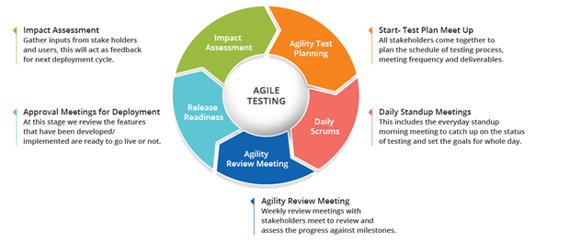

Figure 68: Agile Testing

We decided to use the Agile Testing model for the following reasons

- Agile testing is well suited for small projects.

- As testing begins at the start of the project, errors can be fixed in the middle of the project.

- There is very little documentation required for agile testing

- In this approach, every iteration has its own testing phase.

- Our team members are both developer and tester

### 1.2 Testing Levels

* UNIT TESTING: Unit Testing is done to check whether the individual modules of the source code are working properly. i.e. testing each and every unit of the application separately by the developer in the developer’s environment.
* INTEGRATION TESTING: Integration Testing is the process of testing the connectivity or data transfer between a couple of unit tested modules.
* SYSTEM TESTING (END TO END TESTING): It’s a black box testing. Testing the fully integrated application is also called as an end to end scenario testing. To ensure that the software works in all intended target systems. Verify thorough testing of every input in the application to check for desired outputs. Testing of the users’ experiences with the application.
* ACCEPTANCE TESTING: To obtain customer sign-off so that software can be delivered and payments received. Types of Acceptance Testing are Alpha, Beta & Gamma Testing.

Alpha testing is mostly like performing usability testing which is done by the in-house developers who developed the software. Sometimes this alpha testing is done by the client or outsiders with the presence of developers or testers.Beta testing is done by a limited number of end-users before delivery, the change request would be fixed if the user gives feedback or reports defects. Gamma testing is done when the software is ready for release with specified requirements; this testing is done directly by skipping all the in-house testing activities.

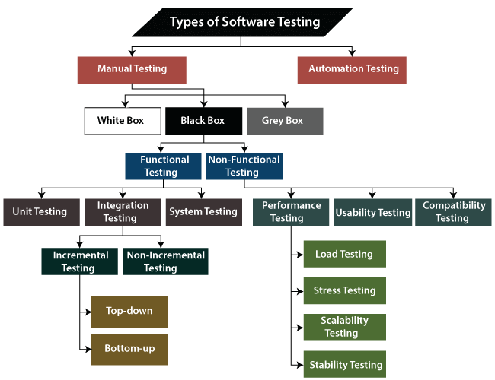1.3 Testing Types

Figure 69: Testing Types

## 2. Test Plan

### 2.1 Test Stages

|  |  |  |  |  |
| --- | --- | --- | --- | --- |
| **Type of Test** | **Stage of Test** | | | |
| ***Unit*** | ***Integration*** | ***System*** | ***Acceptance*** |
| Function Test | X | X | X | X |
| User Interface test |  |  | X | X |
| Performance Tests | X | X |  |  |
| Load |  |  | X | X |

Figure 70: Test Stages

### 2.2 Resources

#### a. Human Resources

|  |  |  |
| --- | --- | --- |
| **Worker/Doer** | **Role** | **Specific Responsibilities/Comments** |
| Võ Hoàng Phúc | Leader | - Functional testing  - Non-Functional testing |
| Trần Đăng Khoa | Member | - Functional testing  - Non-Functional testing |
| Trần Trung Kiên | Member | - Functional testing  - Non-Functional testing |
| Nguyễn Huy Hoàng | Member | - Functional testing  - Non-Functional testing |

Table 212: Human Resources

#### b. Environment

|  |  |  |  |
| --- | --- | --- | --- |
| **Purpose** | **Tool** | **Provider** | **Version** |
| Black-box testing | Chrome | Google LLC | 87.0.4280.66 |
| White-box testing | IntelliJ IDEA Ultimate | JetBrains | 2020.2.4 |
|  | Postman | Postman, Inc | 7.36.0 |

Table 213: Environment

### 2.3 Test Milestones

|  |  |  |  |
| --- | --- | --- | --- |
| **Milestone Task** | **Effort (md)** | **Start Date** | **End Date** |
| Functional testing |  | September 30, 2021 | November 20, 2021 |
| Non-functional testing |  | October 15, 2021 | November 20, 2021 |

Table 214: Test Milestones

### 2.4 Deliverables

|  |  |  |
| --- | --- | --- |
| **No** | **Deliverables** | **Due Date** |
| 1 | Black-box test document | November 20, 2021 |
| 2 | White-box test document | November 20, 2021 |

Table 215: Deliverables

## 3. Test Cases

- Black-box test case, reference: [System test case](https://docs.google.com/spreadsheets/d/1XvZYkD4xUOQtnbKfQZ7UxDSbCP2CzFDn/edit#gid=16626267)

- White-box test case, reference: [Unit test case](https://docs.google.com/spreadsheets/d/1sfWwcP5-tUDzqHploMDioLAfUeR-_C2u/edit#gid=2026396977)

# VI. Release Package & User Guides

# 1. Deliverable Package

### 1.1 Source codes & documents

| **No.** | **Items** | **Sub-Items** | **Type** | **Version** |
| --- | --- | --- | --- | --- |
| ***Code Package*** | | | | |
| 1 | Back-end | SangTamDMS_BE | Modify | 1.0.0 |
| 2 | Front-end | SangTamDMS_FE | Modify | 1.0.0 |
| ***Database*** | | | | |
| 1 | Database | SangTamDMS.sql | New | N/A |
| ***Documents*** | | | | |
| 1 | Requirement | SRS_SangTamDMS.doc | Modify | 1.0 |
| 2 | Deployment | Depolyment_DMS.doc | Modify | 1.0 |
| 3 | User guide | UserGuide_DMS.doc | Modify | 1.0 |

Table 216: Source codes & documents

### 1.2 Known Issues, Limitations & Restrictions

Currently, the application has not been developed on mobile devices. Import and export automation

## 2. Installation Guides

### 2.1 System Requirements

#### 2.1.1 Hardware requirements

Personal computer for developing with the minimum configuration:

|  |  |  |
| --- | --- | --- |
| **Name** | **Minimum Requirements** | **Recommended** |
| CPU | CPU Intel® Core™ 2.70GHz | CPU Intel® Core™ 5.00GHz |
| Computer Memory | 4GB of RAM | 16GB of RAM or more per machine |
| Internet Connection | Cable, Wi-Fi (10 Mbps) | Cable, Wi-Fi (50 Mbps) |

Table 217: Hardware requirements

#### 2.1.2 Software requirements

|  |  |  |
| --- | --- | --- |
| **Name** | **Software** | **Description** |
| Operating System for Product | Window 10 64-bit | Operating system and platform for developing the product |
| IDE | Visual Studio Code and Eclipse/IntelliJ IDEA | Code editor tools |
| Web browser | Chrome version 81 or more | Browser to run application |
| API Testing | Postman | Testing API Tool |

Table 218:Software requirements

### 2.2 Setup Files

Download and install Java 8 SE

Link download:<https://www.oracle.com/java/technologies/javase/javase-jdk8-downloads.html>

Download and install apache tomcat

Link download: [https://tomcat.apache.org/download-90.cgi](https://maven.apache.org/download.cgi)

Download and install Microsoft SQL Server Management Studio 19

Link download: [https://www.microsoft.com/en-us/sql-server/sql-server-downloads](https://maven.apache.org/download.cgi)

### 2.3 Installation Instruction

#### a. Create database on AWS

Step1: Log in to AWS and select Service and choose RDS

Step2: Click Create Database

Step3: Choose Database want to create, here I choose SQL Server

- Select SQL Server Express Edition and click on ONLY ENABLE OPTIONS Eligible for RDS Free Usage Tier to be used FREE 750H

- Click Next

Step4: Select Version, select SQL Server 2014, select the default.

Step5: Create an instance name for your Database, and username password to log

in. Then select Next

Step6: In the Public Accessibility select Yes, choose to default, or can find out more.

Then drag down to select Create Database.

**After successfully created**

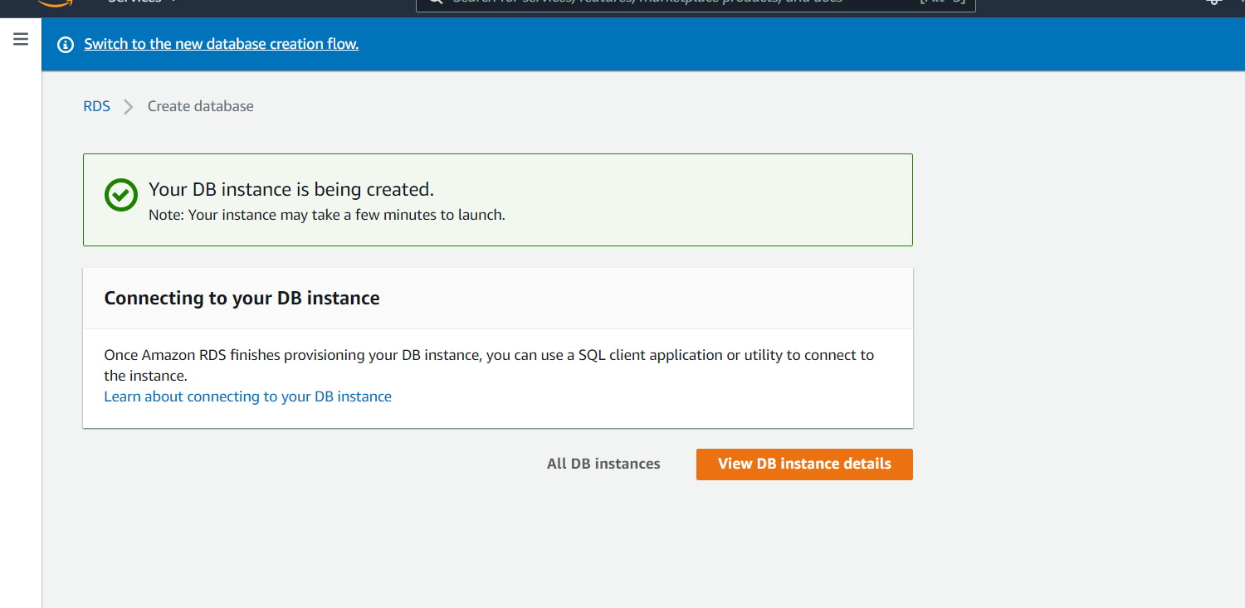

Figure 71: Successfully created

Step7: Copy Endpoint and turn on SQL Server up and paste into SeverName. Login

username password at you create Database instance and connect.

#### b. Deploy Project up AWS with Elastic Beanstalk

Step 1: Go to Service Select Elastic Beanstalk, then go to Applications and choose

Create A New Application.

Step 2: Click Create A New Environment

Step 3: Select Web Server Environment and click Select

Step 4: Select Platform is Tomcat after Create, wait for it to successfully Create

Step 5: After successful you put your code up. Select Upload and Deploy

## 3. User Manual

### 3.1 Application Usage

#### 3.1.1. Overview

Warehouse Management System (WMS) is a system that helps track inventory levels, orders to move warehouses, sales and import purchases from suppliers. Efficiently circulate goods, control inventory data and have a reasonable allocation. Optimize picking and shipping, replenishment, inventory management, and report rendering data quickly and accurately.

#### 3.1.2. Login

- Step 1: The user inputs information of account

- Step 2: The user click “Đăng nhập” button

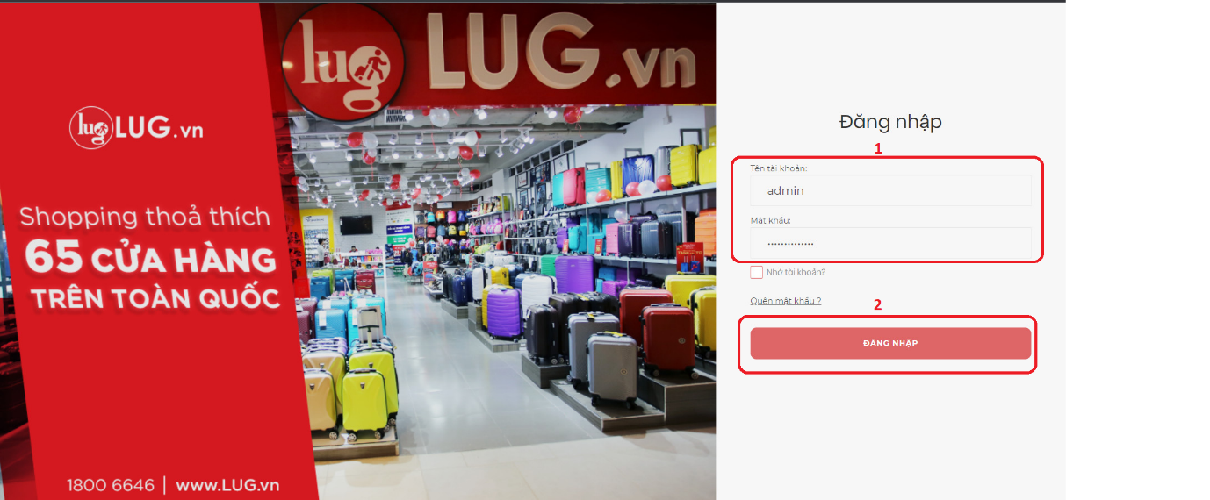

Figure 72: Login Screen

#### 3.1.3. Create account - Admin

The user want to create account, please follow the steps below

- Step 1: The user clicks “Quản lý tài khoản” in tab menu

- Step 2: The user clicks “ Tạo tài khoản”

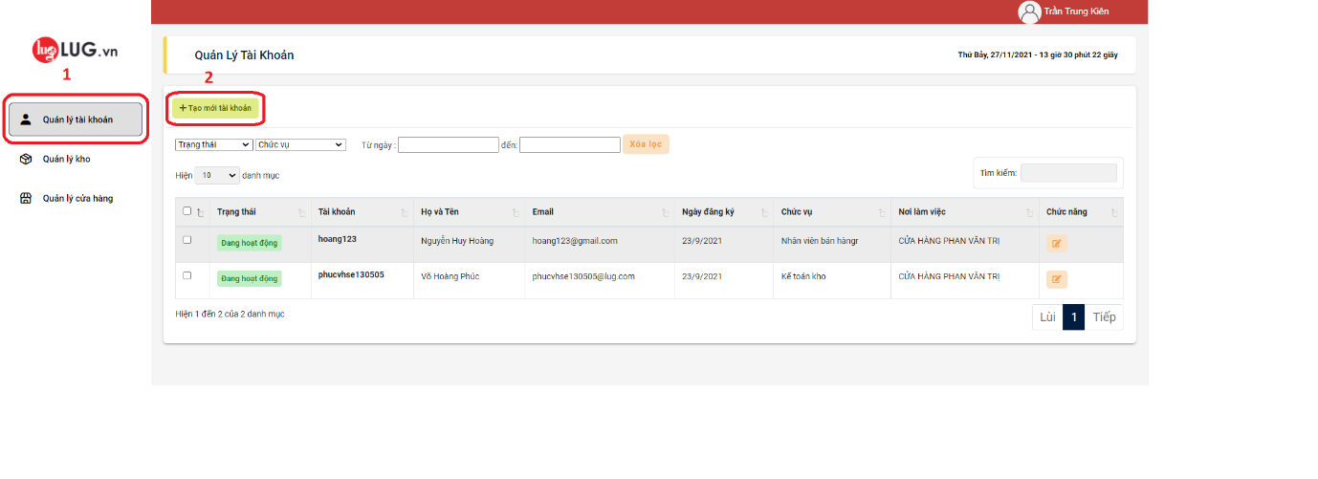

Figure 73: Manager account screen - Admin

- Step 3: The user input information of account

- Step 4: The user click “Tạo” button

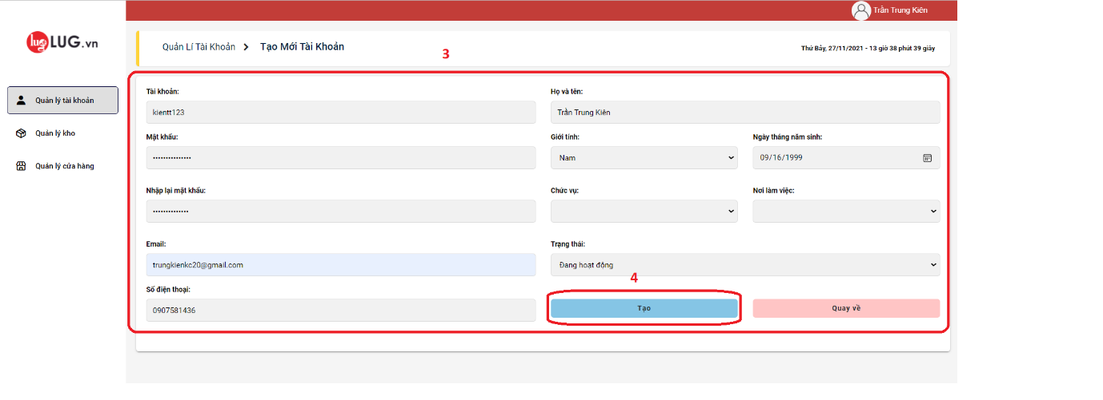

Figure 74: Create account screen - Admin

#### 3.1.4. Create store - Admin

The user want to create warehouse, please follow the steps below:

- Step 1: The user clicks “Quản lý cửa hàng” in tab menu

- Step 2: The user clicks “Tạo cửa hàng” button

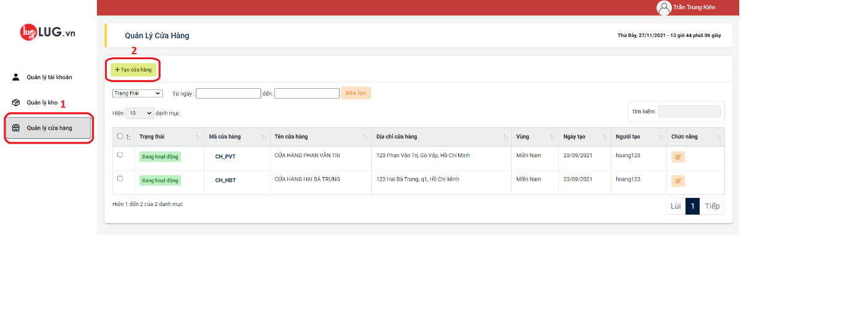

Figure 75: Manager store screen - Admin

- Step 3: The user inputs information of store

- Step 4: The user clicks “Lưu” button

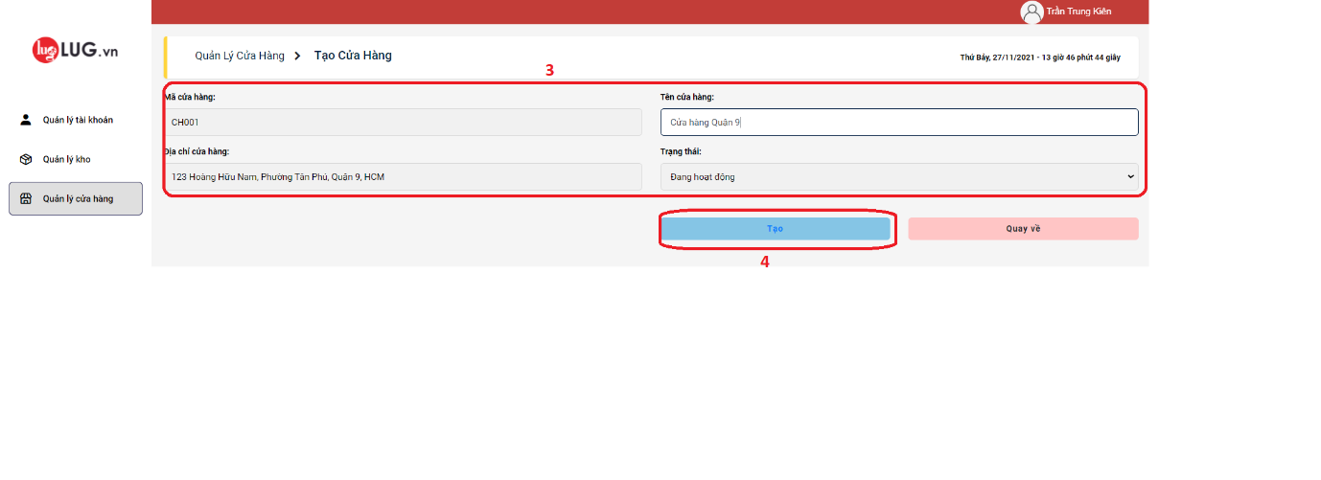

Figure 76: Create store screen - Admin

#### 3.1.5. Create warehouse - Admin

The user want to create warehouse, please follow the steps below

- Step 1: The user click “Quản Lý Kho” in tab menu

- Step 2: The user click “Tạo kho hàng” button

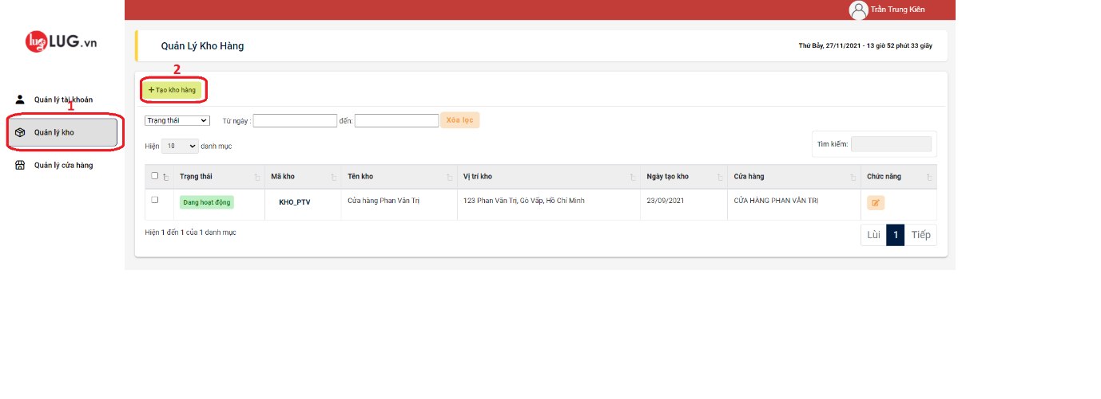

Figure 77: Manage warehouse screen - Admin

- Step 3: The user input information of warehouse

- Step 4: The user click “Lưu” button

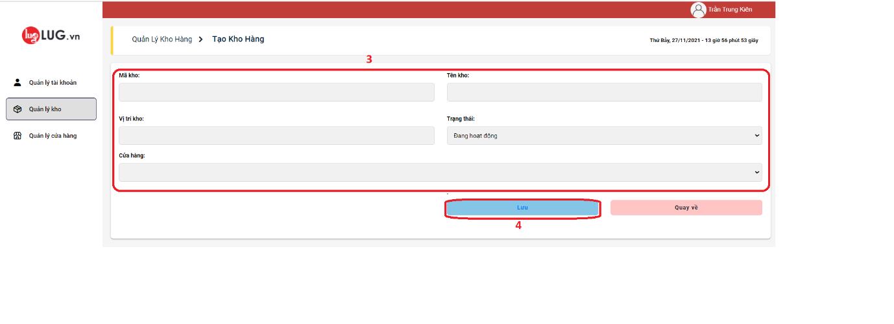

Figure 78: Create warehouse screen - Admin

#### 3.1.6. Create invoice - Seller

The user want to create invoice, please follow the steps below

- Step 1: The user clicks “Hóa đơn bán hàng” in tab menu

- Step 2: The user clicks “Tạo hóa đơn” button

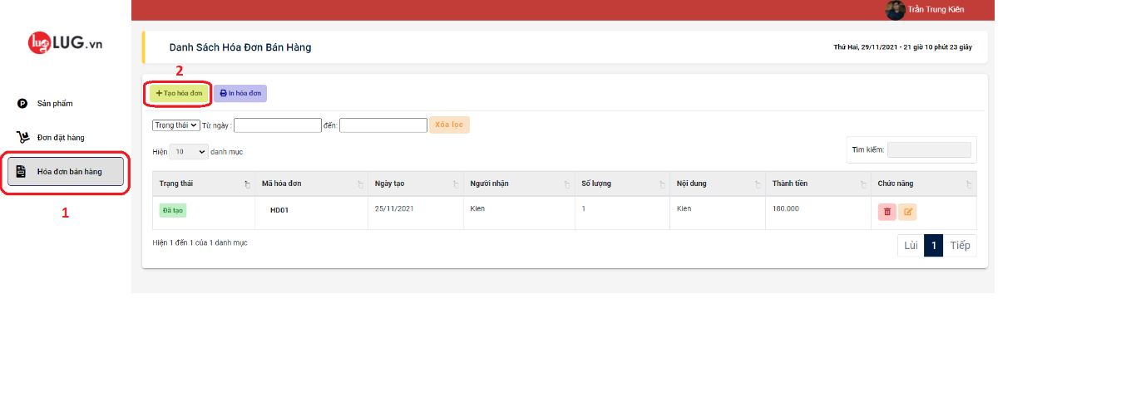

Figure 79: Manage invoice creen - Seller

- Step 3: The user enters information of customer

- Step 4: The user enters information of product

- Step 5: The user clicks “Tạo” button

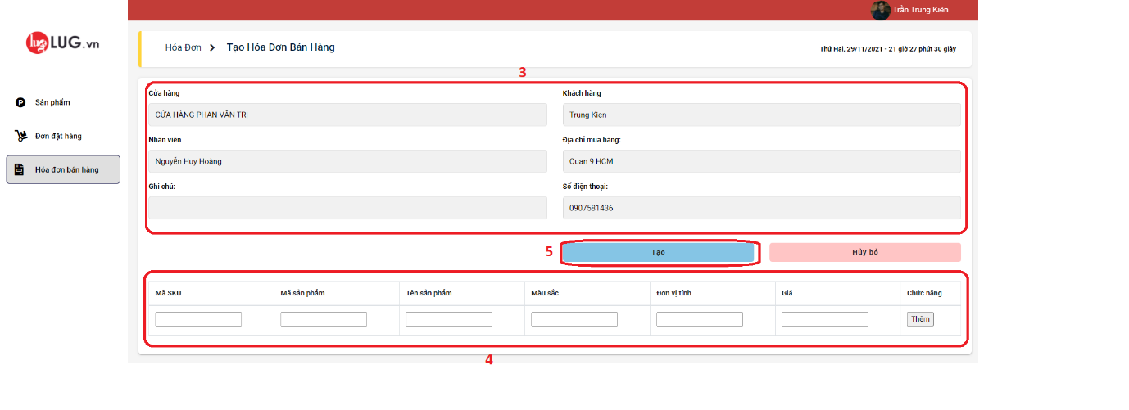

Figure 80: Create invoice screen - Seller

#### 3.1.7. Create order - Seller

The user want to create order, please follow the steps below

- Step 1: The user clicks “Đơn Đặt Hàng” in tab menu

- Step 2: The user clicks “Tạo đơn đặt hàng” button

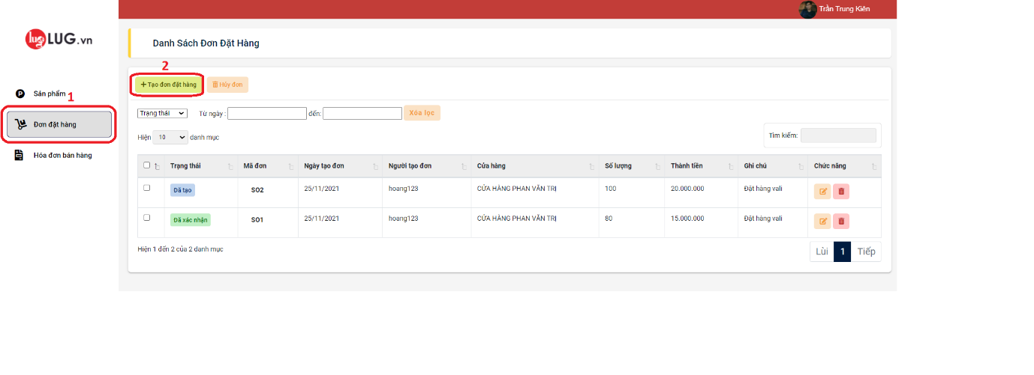

Figure 81: Manage order screen - Seller

- Step 3: The user enters information of order

- Step 4: The user enters information of product

- Step 5: The user clicks “Tạo” button

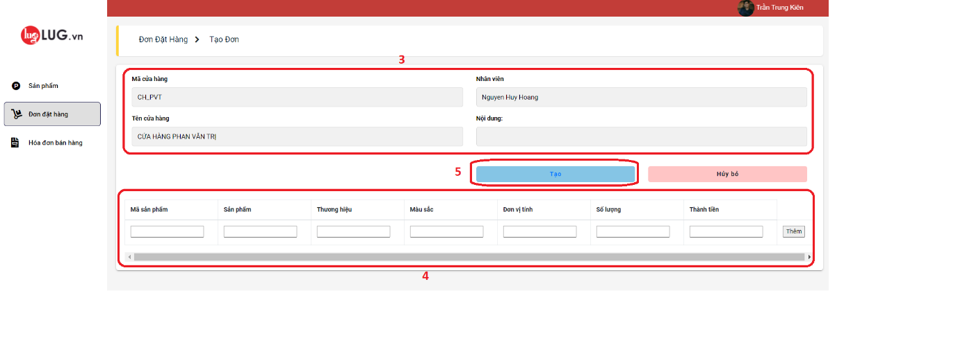

Figure 82: Create order screen - Seller

#### 3.1.8. Create imported goods print – Sale Accountant, Warehouse Accountant

The user want to create imported goods print, please follow the steps below

- Step 1: The user clicks “Nhập kho” in tab menu

- Step 2: The user clicks “Tạo phiếu nhập kho” button

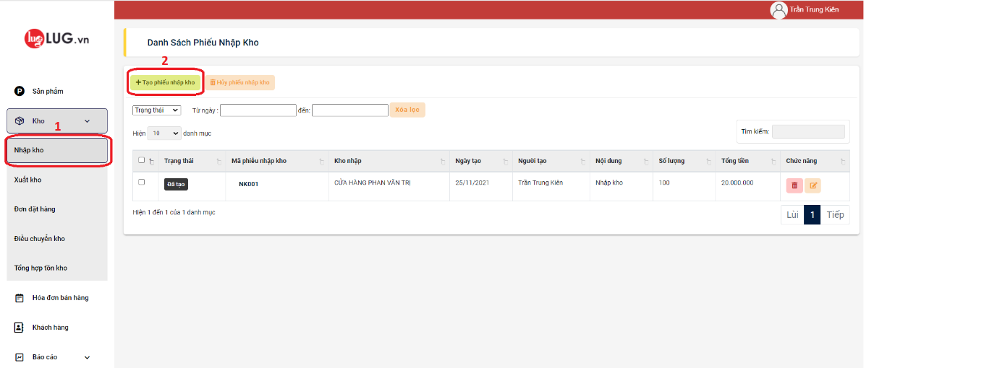

Figure 83: Manage imported goods print screen - Sale Accountant, Warehouse Accountant

- Step 3: The user inputs information of imported goods print

- Step 4: The user inputs information of product

- Step 5: The user clicks “Tạo” button

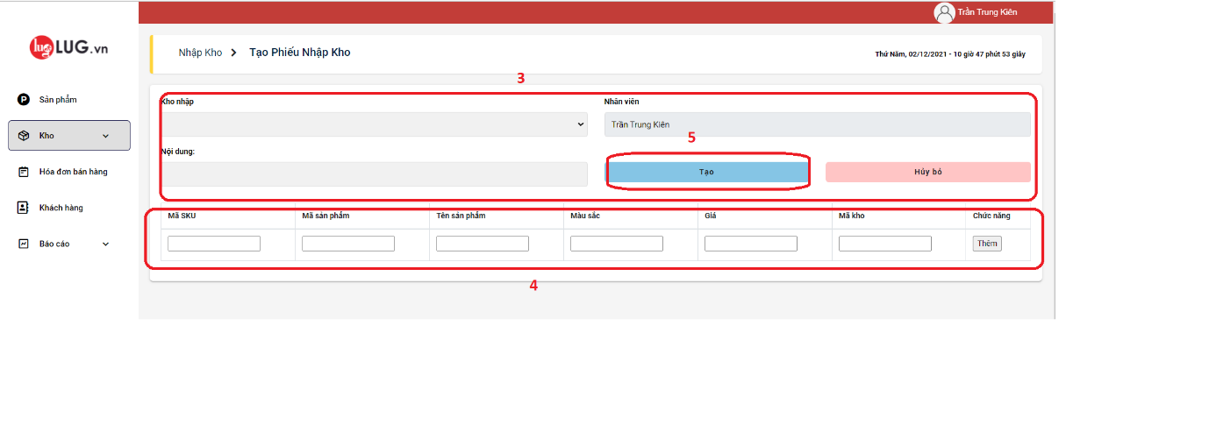

Figure 84: Create imported goods print screen – Sale Accountant, Warehouse Accountant

#### 3.1.9. Create exported goods print – Sale Accountant, Warehouse Accountant

The user want to create imported goods print, please follow the steps below

- Step 1: The user clicks “Xuất kho” in tab menu

- Step 2: The user clicks “Tạo phiếu xuất kho” button

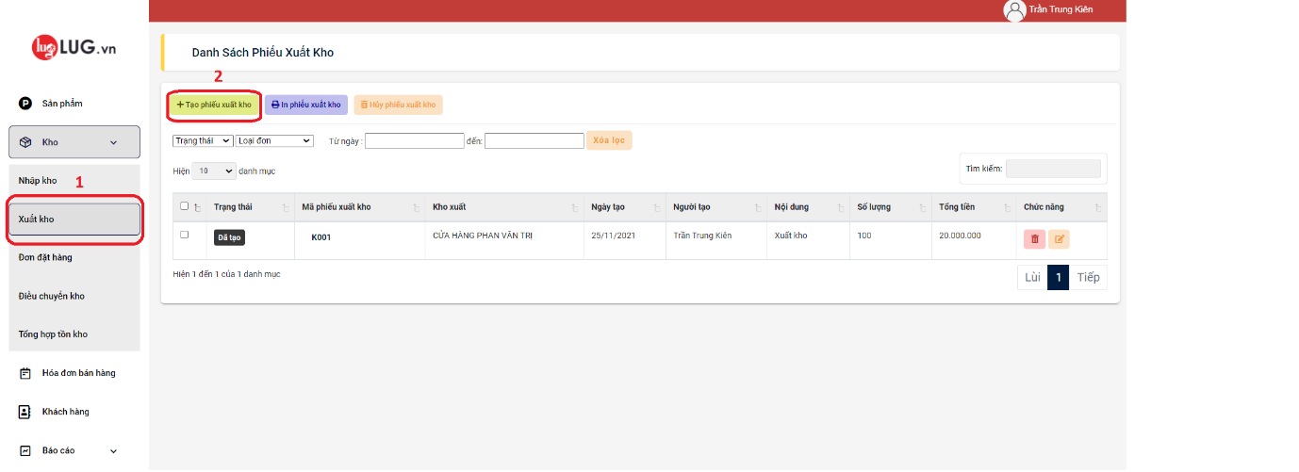

Figure 85: Manage exported goods print srceen – Sale Accountant, Warehouse Accountant

- Step 3: The user inputs information of exported goods print

- Step 4: The user inputs information of product

- Step 5: The user clicks “Tạo” button

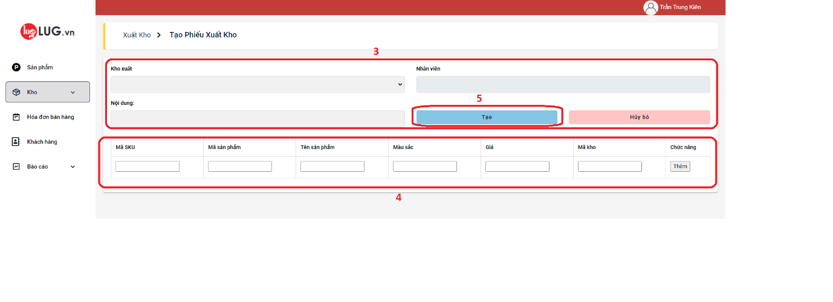

Figure 86: Create exported goods print screen – Sale Accountant, Warehouse Accountant

#### 3.1.10. Create transfer inventory print – Warehouse Accountant

The user want to create transfer inventory print, please follow the steps below

- Step 1: The user clicks “Điều chuyển kho” in tab menu

- Step 2: The user clicks “Tạo phiếu điều chuyển” button

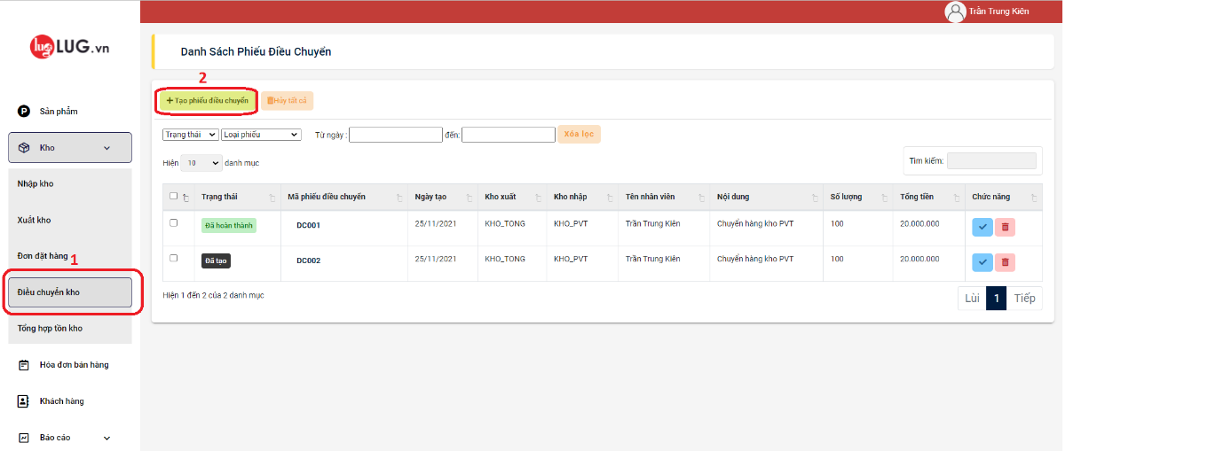

Figure 87: Manage transfer inventory print screen – Warehouse Accountant

- Step 3: The user input information of transfer inventory print.

- Step 4: The user input information of product

- Step 5: The user click “Tạo” button

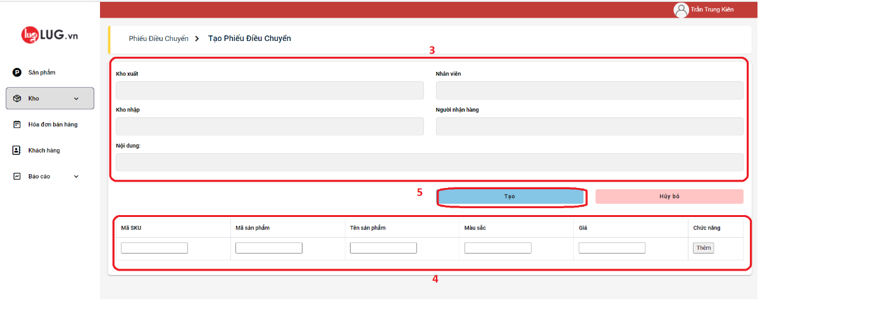

Figure 88: Create transfer inventory print

### 3.2 Troubleshooting

The application will occur some errors in the process of using the system, then contact Administrator